create a folder
cd into the folder
create a file named build.gradle
add plugin, metadata, repository, dependencies and jar
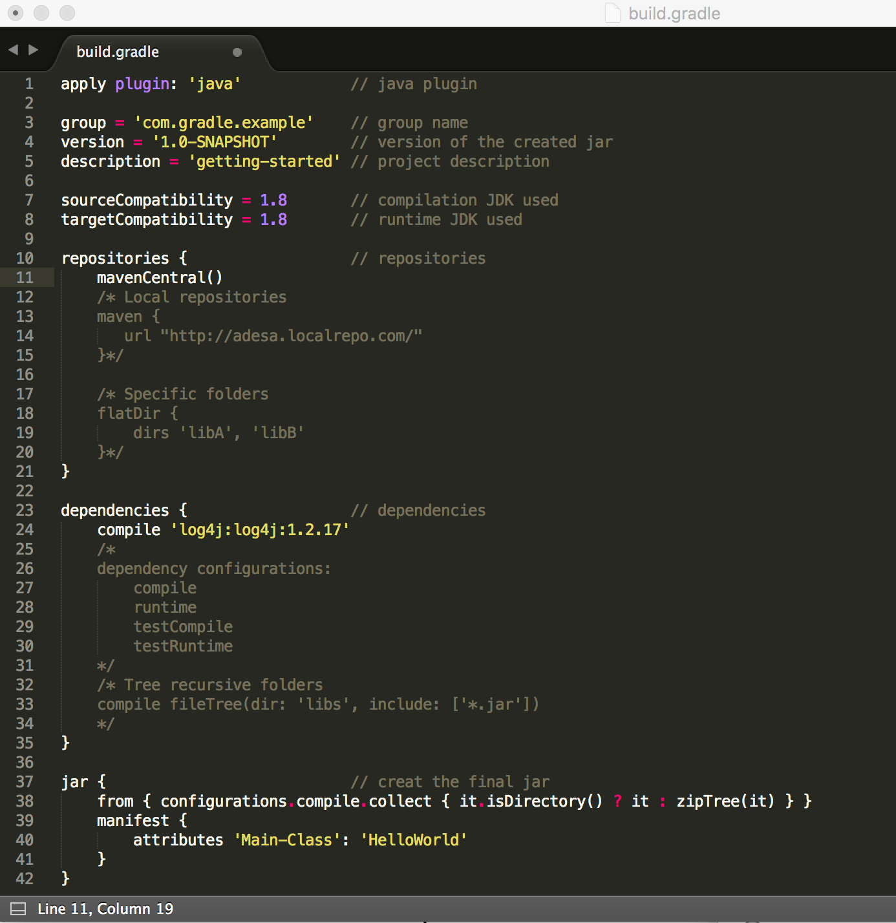
Also create the folder structure as follows:
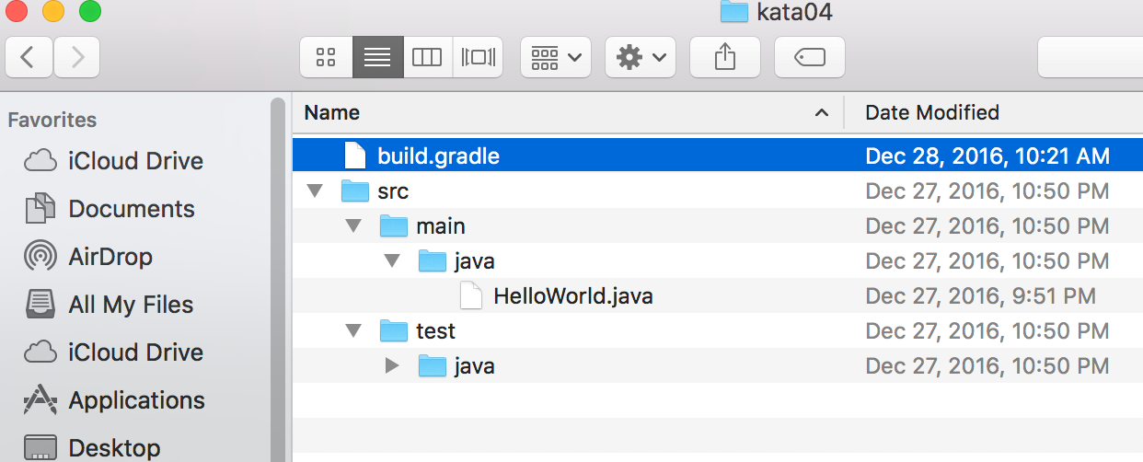
your HelloWorld file would look like:
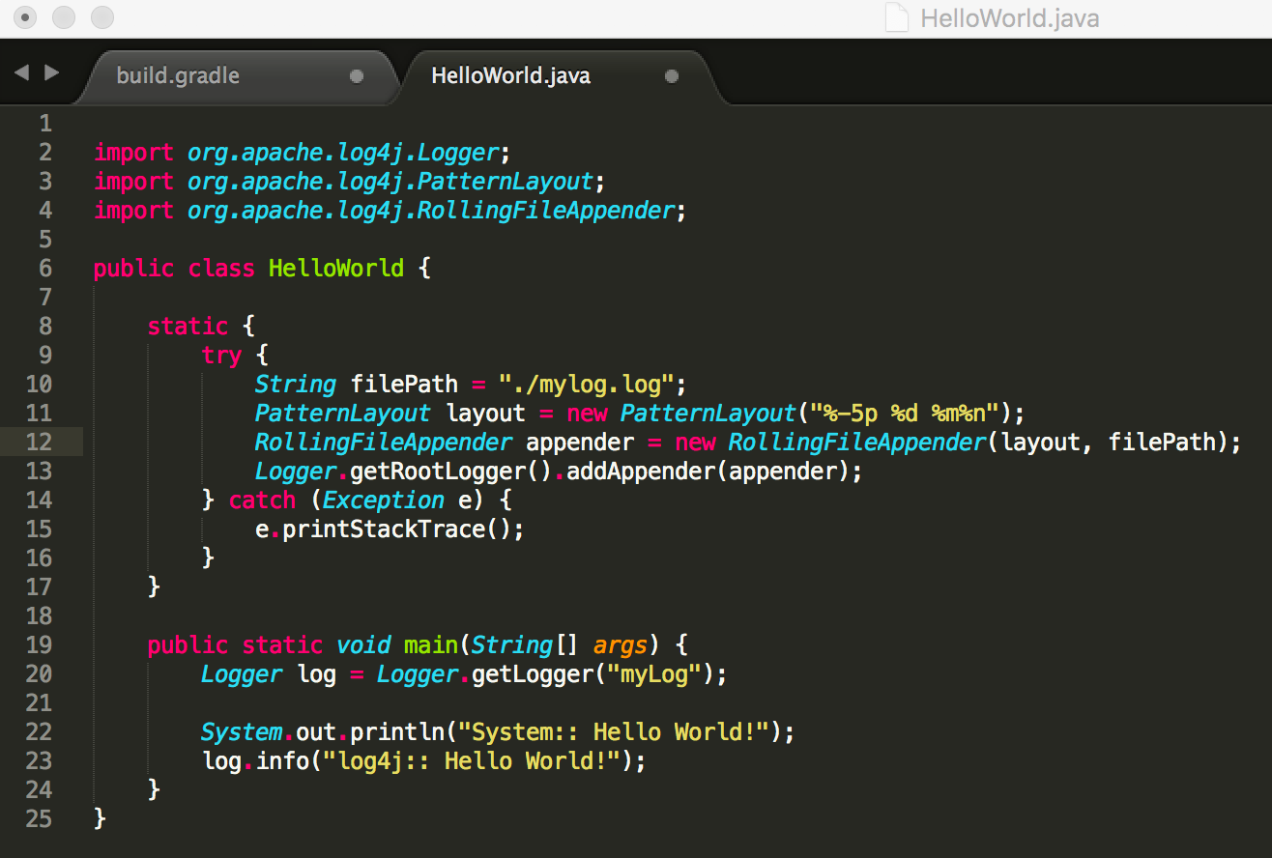
now you can run old way:

javac -d . -cp ~/.m2/repository/log4j/log4j/1.2.17/log4j-1.2.17.jar:. src/main/java/HelloWorld.java
java -cp ~/.m2/repository/log4j/log4j/1.2.17/log4j-1.2.17.jar:. HelloWorld
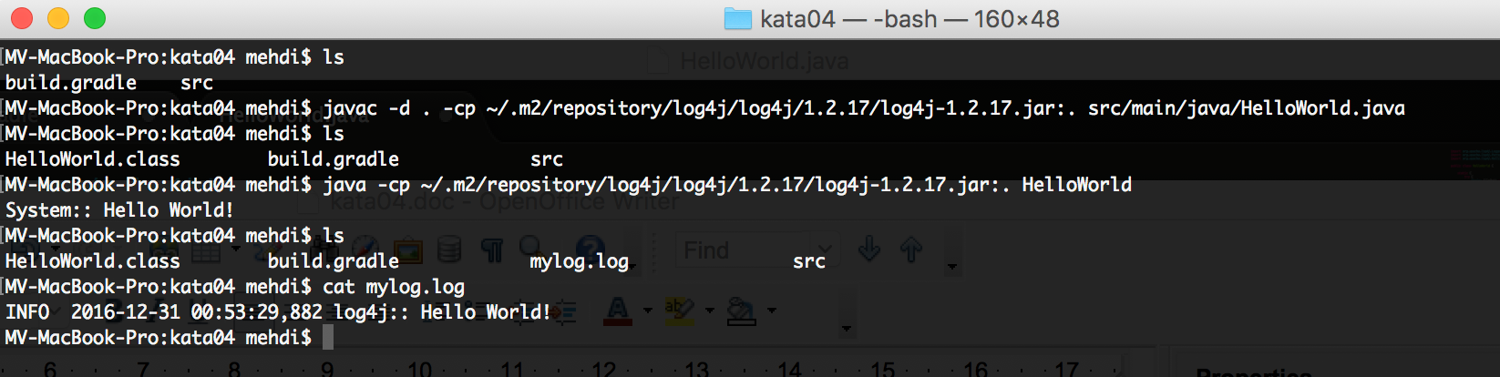
you can also run using the gradle way:
gradle clean
gradle build

Note,
You can have all gradle command in one line
e.g.
Gradle clean build

Now you can run, using the following :
java -jar build/libs/kata03-1.0-SNAPSHOT.jar

Your result should look like this:
