copy kata04 folder as a kata05
cd into the folder
change build.gradle by:
add junit as one of the dependencies
add testLogging.showStandardStreams = true
here is how it would look like:
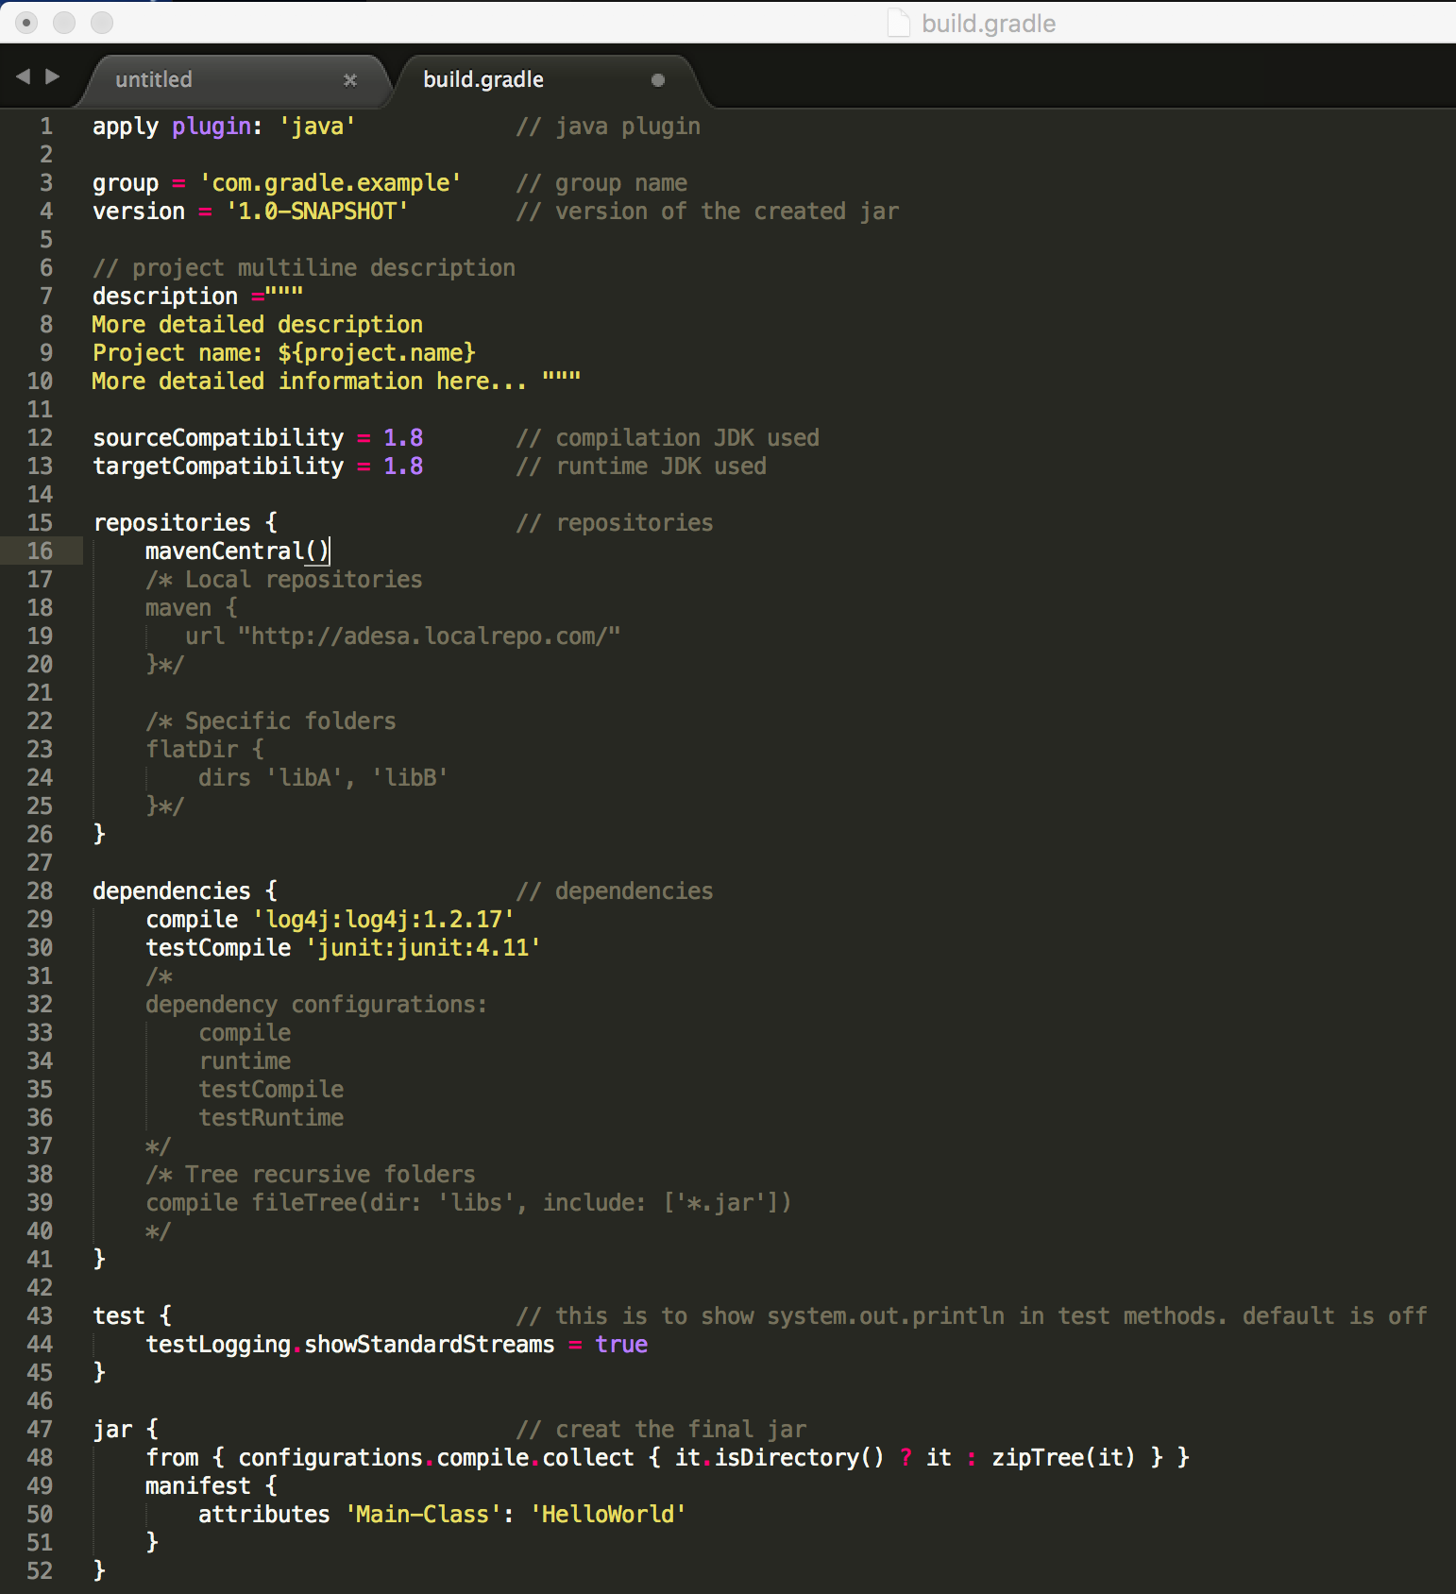
Also add the test file:
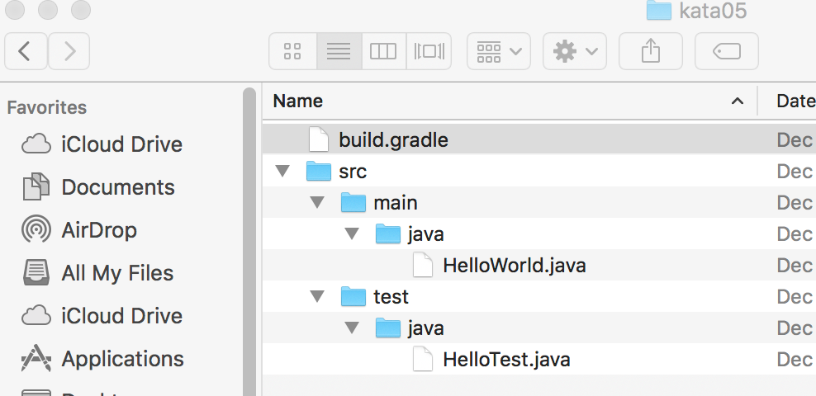
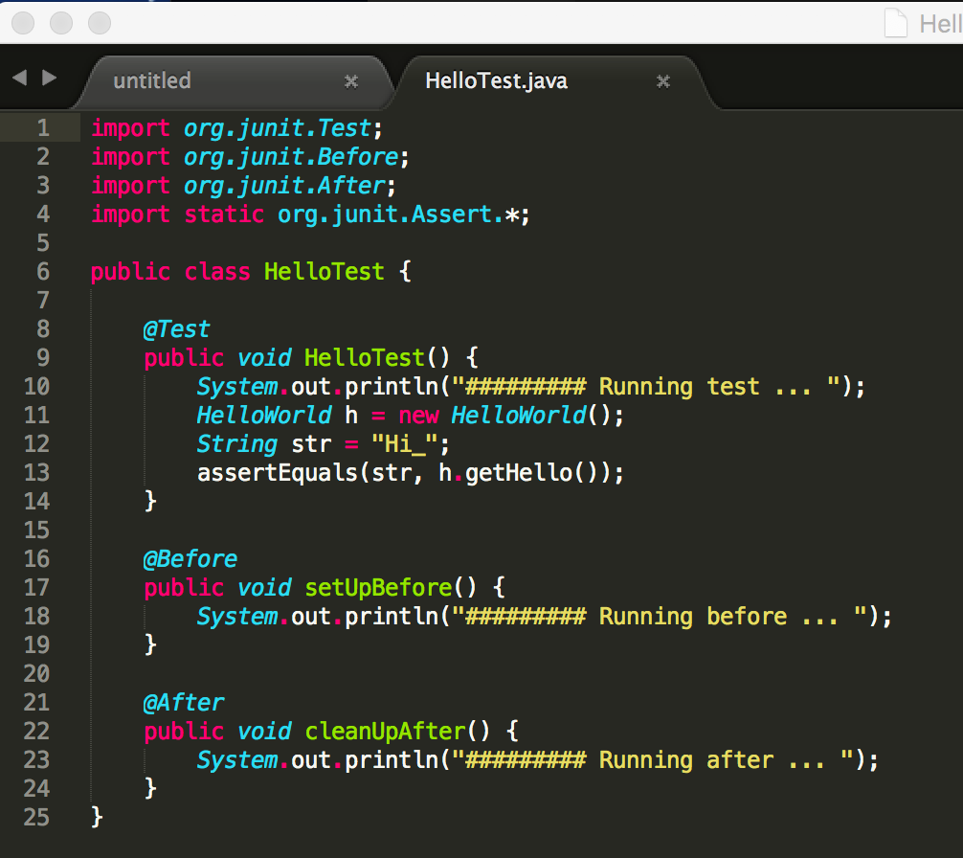
you can clean build and see how the tests run and fail:
