copy kata04 folder as a kata06
cd into the folder
add a plain file called LICENSE with some content
change build.gradle by:
add plugin: 'application'
add mainClassName = 'HelloWorld'
add task copyLicense
remove jar task

Note that this time we have used multiline description.
here is how it would look like:
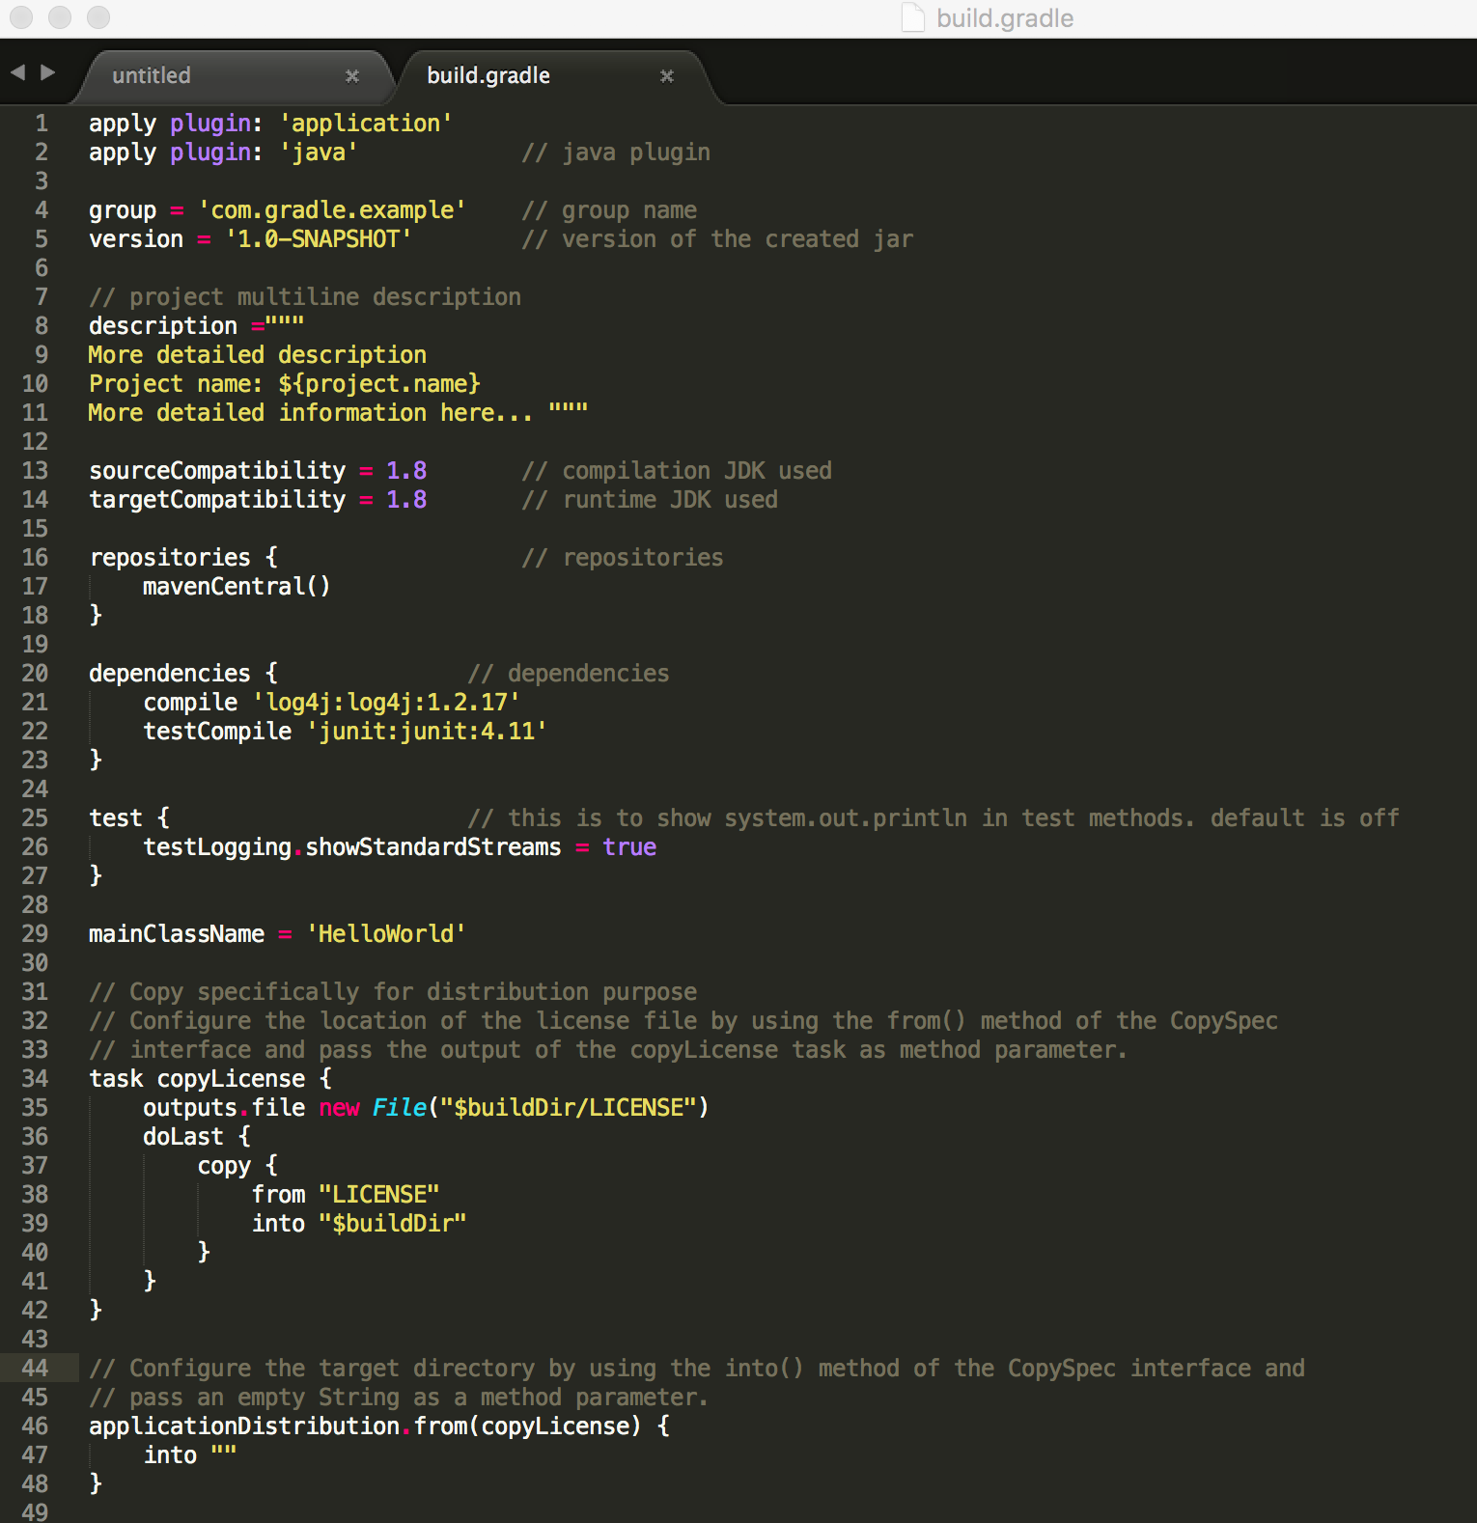
Now run it as follows:
gradle clean
gradle distZip or distTar
This will give us a compressed file under distribution folder of your build folder.
When you open it you have a bin and lib folder with startup script inside bin
When you run here is how it should look like:
