copy kata06 folder as a kata07
cd into the folder
change build.gradle by:
add buildscript
apply plugin: 'spring-boot'
remove application plugin
add springboot dependencies
here is how it would look like:
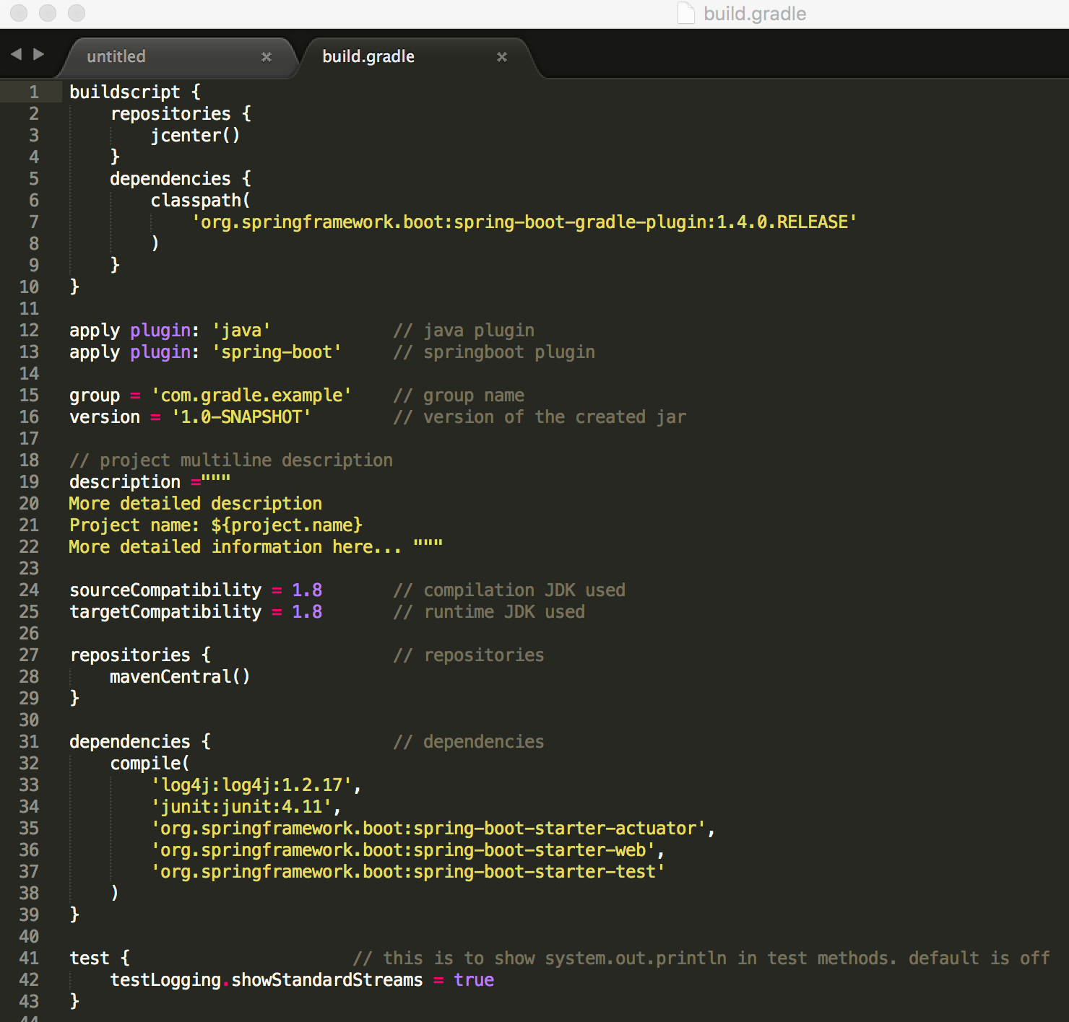
Now here is how you can clean compile and run it:
gradle clean build bootRun
Now you can go to your browser and run:
