create kata08 folder
cd into the folder
initiate a gradle project similar to kata01
create a new folder called conf inside gradle folder for config files
create 2 files (boot.gradle and misc.gradle) here
create a new folder called test inside gradle/conf folder for config files related to test
create a file named unit.gradle here
create a new file in main folder called gradle.properties
your structure should look like this:
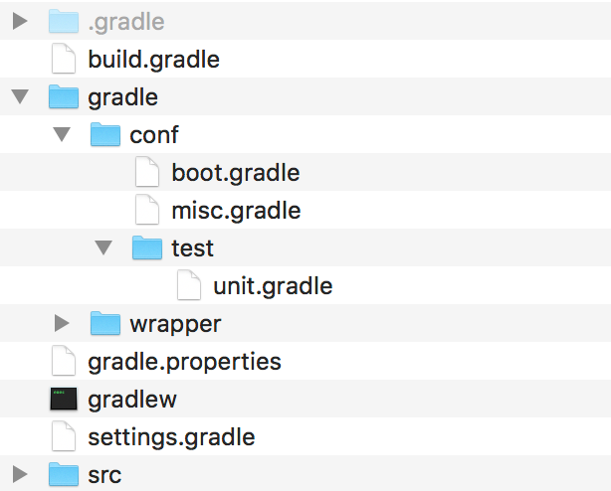
edit the build.gradle as follows:
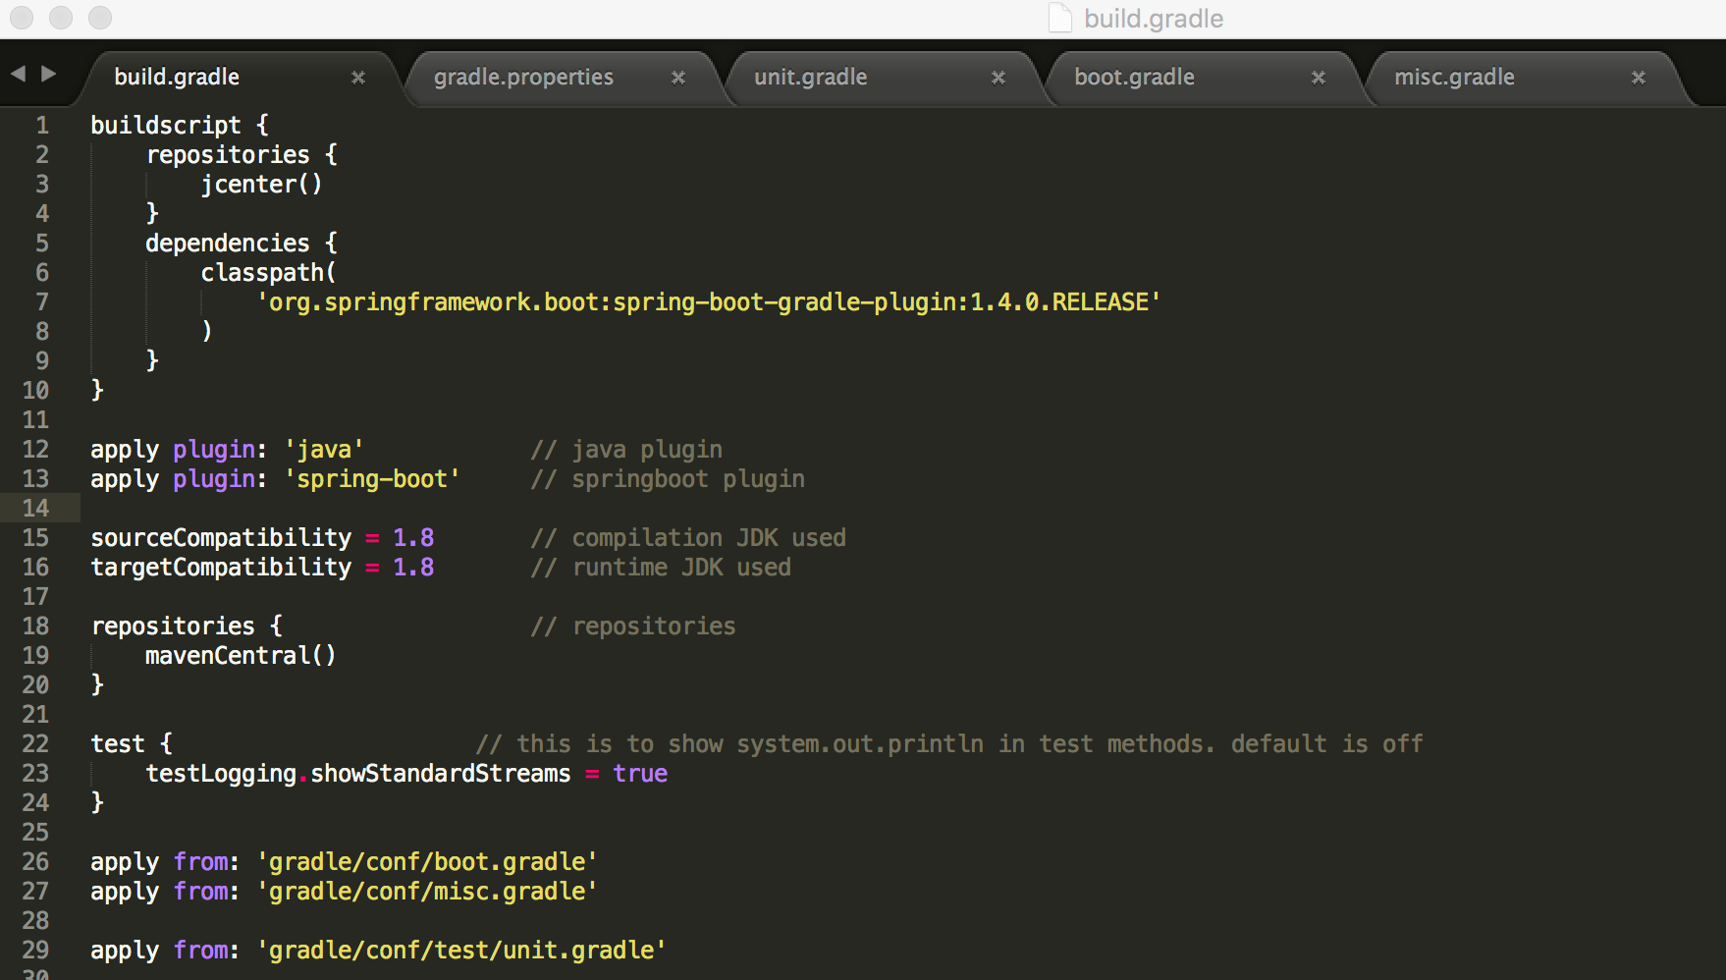
Here are the contents of gradle.properties, unit.gradle, boot.gradle and misc.gradle:
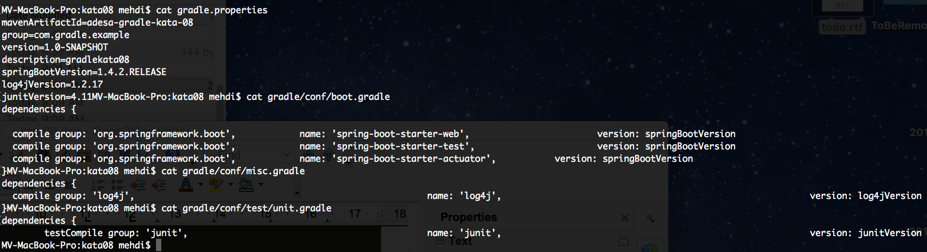
This is a better way to organize gradle and everything should work as it used to
clean compile and run it by:
gradle clean build bootRun
You should see the same result in your browser:
