TravelMate Software Design Description
TRAVELMATE
Cordova Public College
College of Computer Studies
Cordova, Cebu, Philippines
Bachelor of Science in Information Technology
Final proponents [TO BE CONFIRMED]
Academic year [TO BE CONFIRMED]
Submission date [TO BE CONFIRMED]
Documentation baseline 15 October 2026 | Version 2.0

Document control and reading guide
Prepared for the TravelMate team, adviser and panel. This is a source-reconciled review baseline, not a signed acceptance record. Original project documents remain untouched. Supported facts are retained and unconfirmed administrative details are labeled.
Document control
Version | Date | Change and approval
2.0 | 15 October 2026 | Current-system reconciliation and completed documentation package; reviewer approval pending.

Word field and rendering notice: the packaged renderer could not run because soffice.exe was unavailable. The editable text, tables, fields and package structure are checked, but Word pagination is not visually certified. Update all fields and contents/list fields in Word, then inspect every page before submission. The companion PDF is independently typeset from the same content and has its own verified page references.
Evidence key: [1] frontend, [2] backend, [3] old SRS, [4] old SPMP, [5] format reference, [6] current documentation tests/screenshots, [7] historical reports. Requirements, features and cases use TM-FR/TM-NFR, TM-F and TM-TC/TM-XT/TM-QT IDs consistently.

Review and signature record
This standalone document accompanies the version 2.0 manuscript. It is prepared for review; no approval or signature is asserted. Use the manuscript appendices and supporting registers for complete cross-document traceability.
Review fields
Capacity | Name | Signature and date
Prepared by final team | [TO BE CONFIRMED] | [NOT SIGNED]
Reviewed by adviser | [TO BE CONFIRMED] | [NOT SIGNED]
Accepted by authorized panel | [TO BE CONFIRMED] | [NOT SIGNED]

Table of contents
Software Design Description
SDD 1 Introduction
SDD 2 System architecture
SDD 3 Database design
SDD 4 Module and interface design
SDD 5 User interface design
SDD 6 Algorithms and workflows
SDD 7 Access failures and privacy
SDD 8 Deployment and requirement mapping
References
Supporting registers
[Refresh Word fields to calculate page references.]

List of figures
Figure 1 Layered request and persistence architecture from the inspected frontend and backend [1][2]
Figure 2 Actor and use case groups for the current supported interfaces [1][2]
Figure 3 Active planning and traveler data relationships using declared foreign keys [2]
Figure 4 Identity and access support [2]
Figure 5 Notification, audit and moderation relations; scalar identifiers are not foreign keys [2]
Figure 6 Retained marketplace relations with no current owner or payment workflow [2]
Figure 7 Grounded generation activity flow and honest failure paths [2]
Figure 8 Generation and separate autosave sequence with source and persistence boundaries [1][2]
Figure 9 Remaining-day replan preview and revision-checked acceptance [1][2]
Figure 10 Trip status transitions and separate actual visited-history recording [2]
Figure 11 Software responsibilities and data types without inventing ORM service classes [1][2]

List of tables
Table 1 Declared technology baseline
Table 2 Entity register and current responsibility
Table 3 Public discovery feature implementation map
Table 4 Accounts and access feature implementation map
Table 5 Destination selection feature implementation map
Table 6 Trip planning and enrichment feature implementation map
Table 7 Saved trips and traveler records feature implementation map
Table 8 Saved trip maps feature implementation map
Table 9 Managed day activities feature implementation map
Table 10 Administration feature implementation map
Table 11 Technical services feature implementation map
Table 12 Compatibility and excluded scope feature implementation map
Table 13 Important request and response contracts
Table 14 Failure and recovery design
[Refresh Word fields to calculate page references.]

Software Design Description
Version 2.0. This design describes the inspected implementation and the interfaces needed to understand its limits. Source paths and symbols in the inventory locate each feature; retained schema and API-only compatibility are explicitly identified.

SDD 1 Introduction
This revision documents the inspected working files on 15 October 2026. “Complete” in the inventory means a code path was located across its applicable layers; it does not mean end-to-end acceptance passed. Static inspection, historical reports, current isolated tests and unexecuted acceptance procedures have separate evidence records. [1][2][6][7]

SDD 2 System architecture
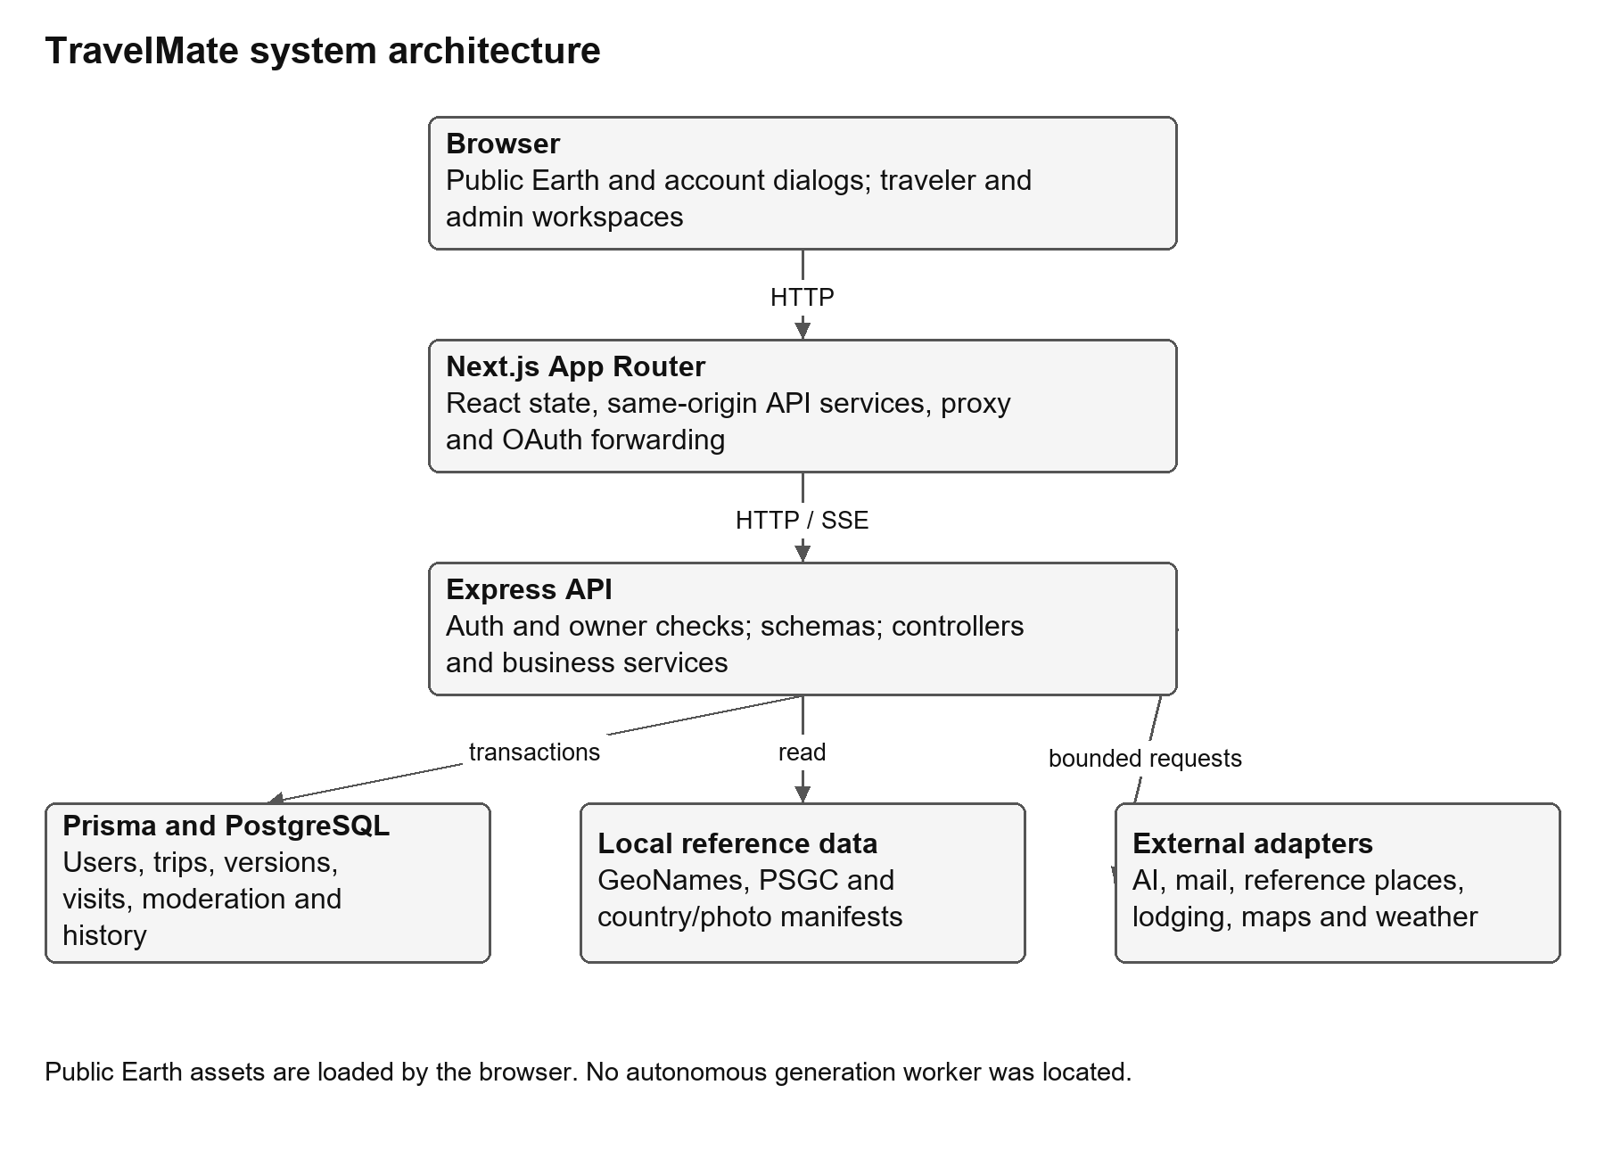
Figure 1 Layered request and persistence architecture from the inspected frontend and backend [1][2]
The browser renders Next.js App Router pages, account dialogs and stateful traveler/admin workspaces. The Earth canvas uses Three.js with geometric country hit testing; Leaflet handles saved-trip maps. Frontend services send same-origin JSON requests through the Next API origin/proxy layer to Express routes. Controllers perform schema, role, owner and state validation, services apply business rules, and repository/Prisma operations transact with PostgreSQL. Read-only local geography and external provider adapters supply reference evidence. No separate autonomous generation worker was located. [1][2]
Table 1 Declared technology baseline
Layer | Inspected dependency declarations | Interpretation
Frontend | Next 16.3.8; React 19.2.4; TypeScript ^5; Tailwind ^4; Three 0.186.1; Leaflet 1.9.4; GSAP ^3.15.0. | package.json declarations; caret ranges are not claimed as installed exact versions.
Backend | Node >=22.13; Express ^5.2.1; Prisma/client/adapter-pg ^7.10.0; pg ^8.23.0; Zod ^4.6.1. | ES modules; generated Prisma client; relational PostgreSQL.
Identity/mail | google-auth-library ^11.1.0; nodemailer ^10.0.15; server crypto. | Google optional; Resend production email, explicit Gmail development alternative.
Verification | Node test runner; Playwright ^1.63.0; ESLint ^9; CI with disposable Postgres. | Definitions do not prove a pipeline ran this task.

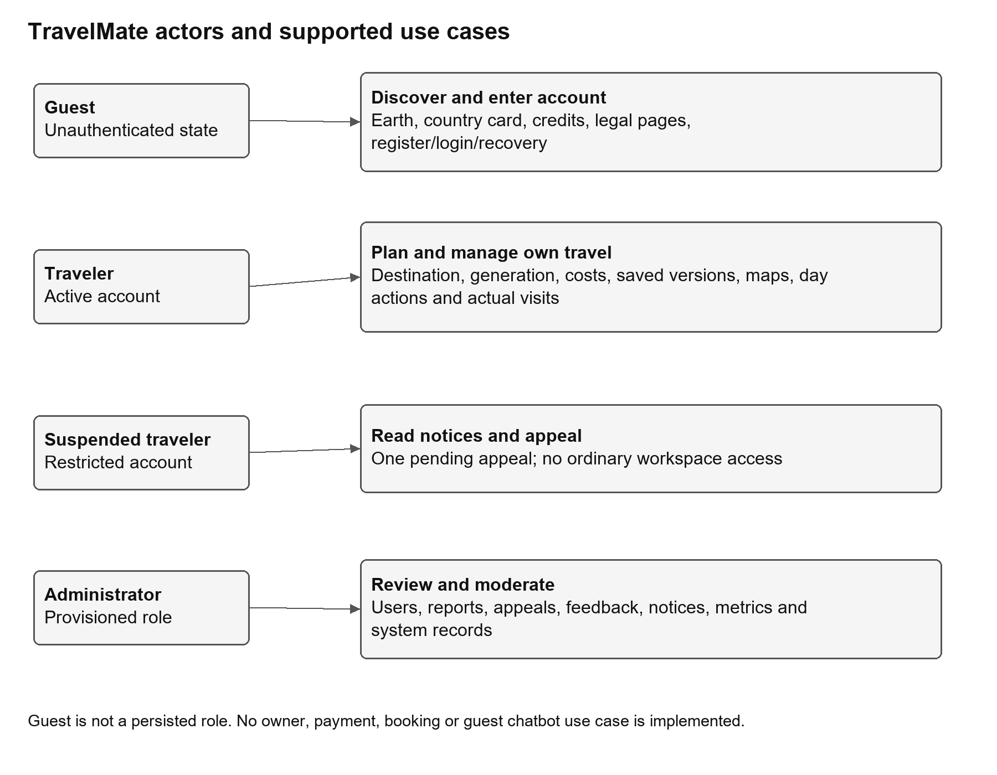
Figure 2 Actor and use case groups for the current supported interfaces [1][2]

SDD 3 Database design

SDD 3.1 Entity relationships
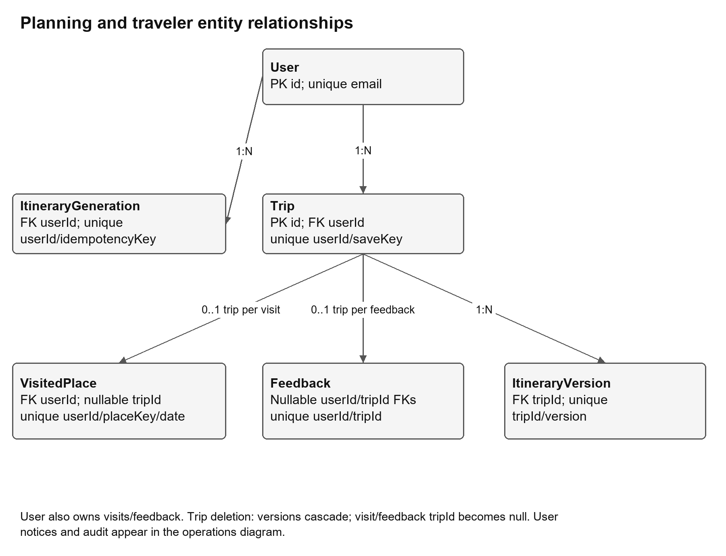
Figure 3 Active planning and traveler data relationships using declared foreign keys [2]
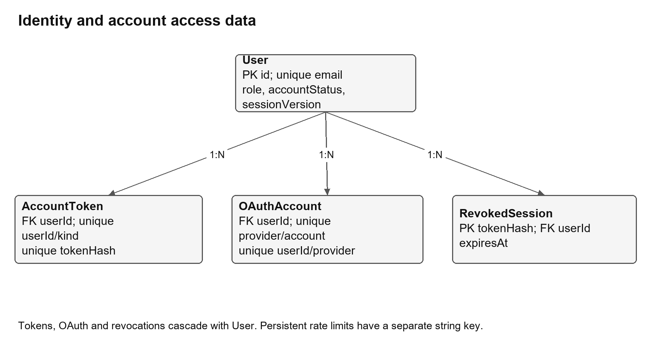
Figure 4 Identity and access support [2]
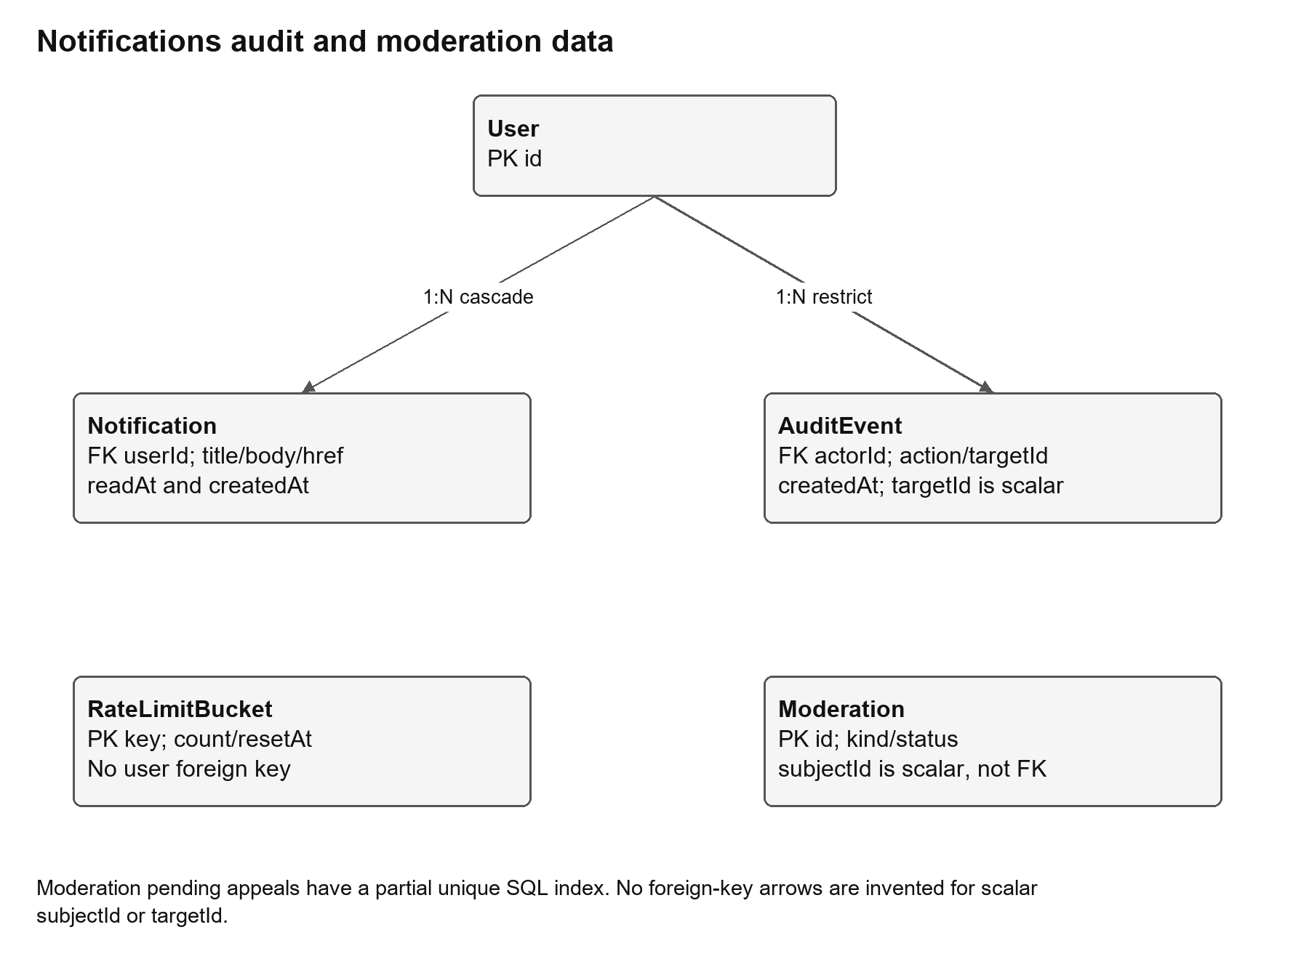
Figure 5 Notification, audit and moderation relations; scalar identifiers are not foreign keys [2]
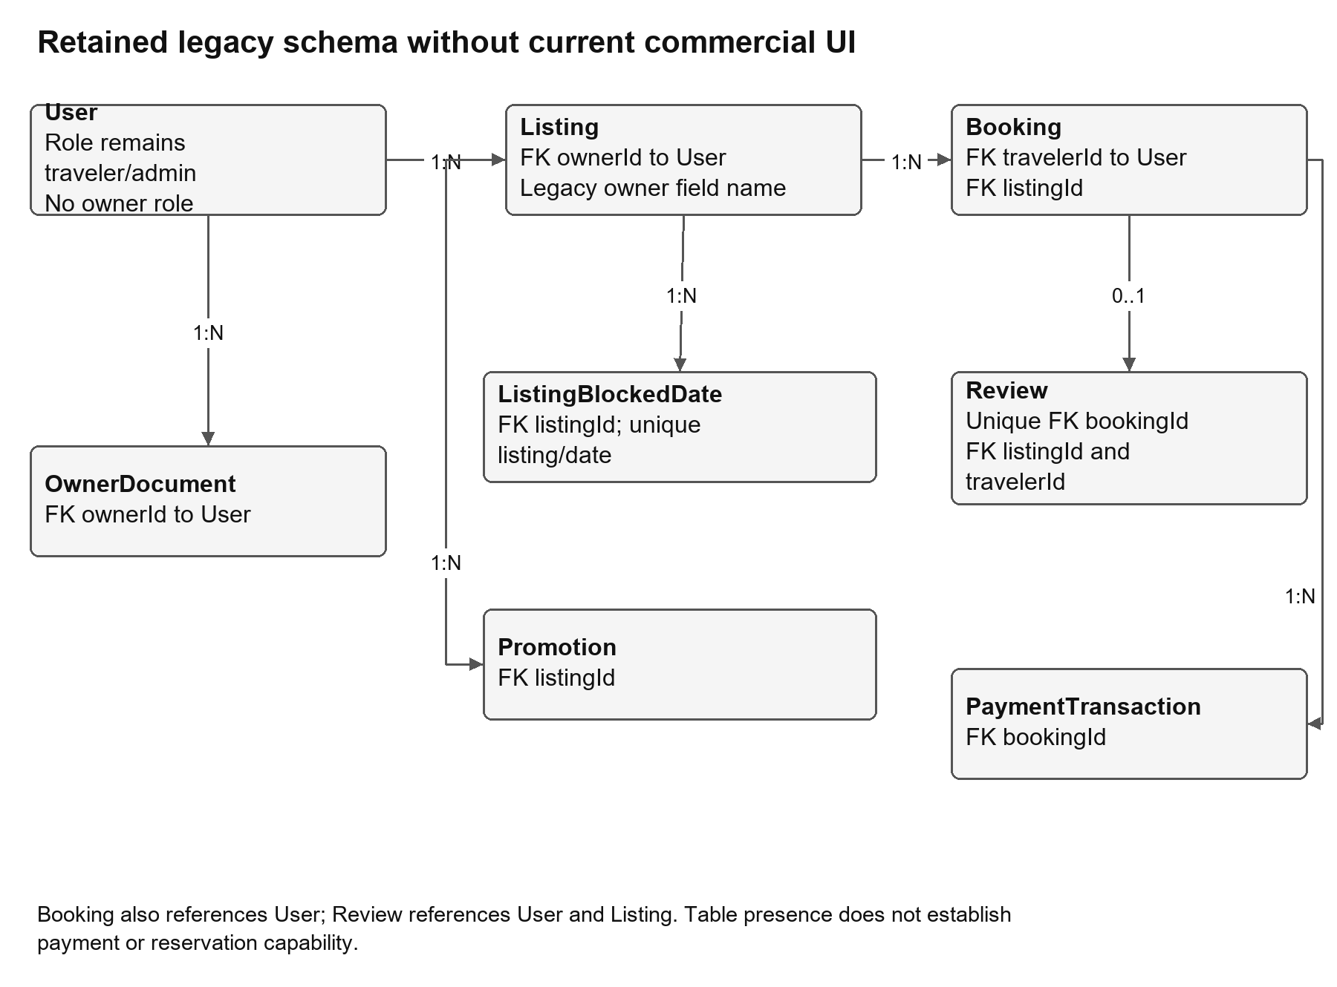
Figure 6 Retained marketplace relations with no current owner or payment workflow [2]
There are twenty Prisma models. Foreign keys, nullable relations and deletion behavior are taken from schema.prisma, not inferred from labels. Moderation.subjectId and AuditEvent.targetId are scalar identifiers, not declared foreign keys. AuditEvent.actorId references User with Restrict semantics. Moderation’s pending-appeal uniqueness is strengthened by a partial SQL index in migrations. Itinerary details, activity history, ground-truth proof and pricing evidence remain nested JSON rather than separate relational activity rows. [2]
Table 2 Entity register and current responsibility
Entity | Use and important keys
User | Email unique; traveler/admin role; emailVerified separate from legacy profileStatus; accountStatus and sessionVersion.
AccountToken | Account/kind unique; tokenHash unique; expiry/attempt count and consumed state.
OAuthAccount | Unique provider/account and user/provider pairs; User cascade.
RevokedSession | tokenHash primary key; expiry; User cascade.
RateLimitBucket | String key primary key, count/resetAt; no User foreign key.
Trip | Owner, group budget Decimal(12,2), dates, currency(3), coords Decimal(9,6), party, JSON itinerary/weather, status/completedAt/archivedAt; unique user/saveKey.
ItineraryGeneration | Owner/idempotencyKey unique; requestHash, attemptId, status/response/error; destination varchar(120).
ItineraryVersion | Trip/version unique; kind, snapshot JSON, weather, createdAt; Trip cascade.
VisitedPlace | User/placeKey/date unique; optional Trip SetNull; destination/place/media provenance.
Feedback | Nullable User/Trip SetNull; user/trip unique; rating/category; sentiment default not_analyzed.
Notification | Owned title/body/href/readAt and createdAt; User cascade.
AuditEvent | Actor FK Restrict; action and scalar targetId with createdAt; no immutability mechanism claimed.
Moderation | Report/appeal kind; scalar subjectId, details, status; pending appeal partial uniqueness in SQL.
Listing | Legacy owner-named User FK; price/capacity/status and location/media.
Booking | Legacy traveler User and listing FKs; guest/night/amount/status/date fields.
ListingBlockedDate | Legacy listing/date unique; Listing cascade.
Promotion | Legacy listing FK; percent/date/active.
Review | Legacy unique booking FK plus listing/traveler FKs and rating.
PaymentTransaction | Legacy booking FK, kind/status/amount; no accessible payment settlement workflow.
OwnerDocument | Legacy owner-named User FK and file/status; no current owner role.

SDD 3.2 Constraints and migrations
Twenty-four migration directories were inspected as schema history; their presence does not prove they were applied to any live database. SQL checks include bounded trust score, nonnegative listing/booking amounts and capacity rules, trip budget greater than zero, travelers 1-20, ordered dates within a thirty-one-day inclusive span and coordinate ranges. Later role migration converts legacy owner accounts to traveler and increments session version. Unique constraints cover generation/save keys, itinerary version numbers, visited identity/date and feedback user/trip. The schema field register preserves every declared model field and constraint for review. [2]

SDD 3.3 Transactions and concurrency
Generation uses owner/idempotency key plus normalized request hash. A completed request replays its saved response; mismatched input conflicts; pending attempts younger than ten minutes block duplicates; failed/stale attempts obtain a new attemptId and compare-and-set fencing rejects late completion. This limits duplicate records and stale overwrites but cannot guarantee that remote computation stopped or was unbilled. [2]
Trip saves validate signed grounding and use owner/saveKey identity and request hash to avoid duplicate autosaves. Version writes transact with the trip. Restores use complete request envelopes, create a new version, and lock the current row; older snapshots missing required context may be blocked. Managed activities use a revision fingerprint, stable activity IDs, explicit confirmation and row locking. Batch visits verify candidate fingerprints and use a PostgreSQL advisory lock plus de-duplication. Appeals and decisions lock account/state and preserve transactionally related notices/audit. [2]

SDD 4 Module and interface design

SDD 4.1 Public discovery
The discovery canvas loads local country geometry and a code-keyed curated photo manifest. A ray/coordinate hit resolves a geographic record, including small-area proximity targets, and the same record owns its boundary, English name, flag and async photo request. Animation-frame hit refresh maintains the identity beneath a stationary pointer as Earth turns. The overlay is bounded inside the globe stage, uses pointer-events none, and clears on exit/drag conditions without moving layout. The permanent destination panel, flight arcs, markers and bottom caption are removed; attribution is exposed in the footer credits. Coverage is 264/265 geographic areas: all 249 ISO entries plus Kosovo are covered, and Bir Tawil is an explicit non-national missing-photo record. Flags follow the available ISO/code mapping and are not invented for Antarctica/non-national areas. [1][2]
Table 3 Public discovery feature implementation map
Feature and requirement | Source flow and persistence
TM-F-001 / TM-FR-001 Landing and navigation | travelmate-frontend-new/components/features/home/TravelMateLanding.tsx:109 (TravelMateLanding); None; public presentation
TM-F-002 / TM-FR-002 Interactive Earth controls | travelmate-frontend-new/components/features/home/TravelDiscoverySection.tsx:32 (TravelDiscoverySection) -> travelmate-frontend-new/components/features/home/DiscoveryGlobeCanvas.tsx:17 (DiscoveryGlobeCanvas); Static geographic assets
TM-F-003 / TM-FR-003 Country hit detection and border identity | travelmate-frontend-new/lib/discovery-countries.ts:54 (countryAt) -> travelmate-frontend-new/lib/discovery-globe.ts:18 (countryBoundaryPositions) -> travelmate-frontend-new/components/features/home/DiscoveryGlobeCanvas.tsx:81 (setOutline); 265 local geographic records
TM-F-004 / TM-FR-004 Country destination photo and identity card | travelmate-frontend-new/lib/discovery-country-photos.ts:22 (loadCountryPhoto) -> travelmate-frontend-new/lib/discovery-country-flags.ts:4 (discoveryCountryFlag) -> travelmate-frontend-new/components/features/home/DiscoveryGlobeCanvas.tsx:1; Local country-photos.v2.json; 500 WebP assets
TM-F-005 / TM-FR-005 Image and map credits | travelmate-frontend-new/components/features/home/DiscoveryCredits.tsx:6 (DiscoveryCredits); Public attribution manifests
TM-F-006 / TM-FR-006 Privacy and terms pages | travelmate-frontend-new/app/privacy/page.tsx:1 -> travelmate-frontend-new/app/terms/page.tsx:1; None

SDD 4.2 Accounts and access
Account action dispatch separates register, login, verify/resend, forgot/reset and logout. Password hashing is salted scryptSync with a 64-byte output; sessions sign a base64url payload with HMAC-SHA256. Current-user middleware consults the database, including revocations and sessionVersion. Google uses state/nonce/PKCE with a ten-minute flow cookie, token audience/nonce and verified-email checks; authoritative Gmail/hosted-domain identity permits guarded linking, while unsafe email association requires local verification. Reset consumes a token and increments sessionVersion. Resend/mail failures never silently switch providers. A suspended account uses the dedicated appeals view. [1][2]
Table 4 Accounts and access feature implementation map
Feature and requirement | Source flow and persistence
TM-F-007 / TM-FR-007 Traveler registration | travelmate-frontend-new/components/features/home/TravelMateLanding.tsx:46 (register) -> travelmate-backend-api/src/controllers/auth-controller.ts:15 (register) -> travelmate-backend-api/src/services/auth/auth-service.ts:60 (registerUser) -> travelmate-backend-api/src/schemas/auth/registration-schema.ts:3 (registrationDetails); User, AccountToken; email unique; transaction
TM-F-008 / TM-FR-008 Email verification | travelmate-frontend-new/components/features/home/TravelMateLanding.tsx:328 (verify-email) -> travelmate-backend-api/src/controllers/auth-controller.ts:44 (verify-email) -> travelmate-backend-api/src/services/auth/auth-service.ts:104 (verifyEmail); AccountToken, User; single-use transaction
TM-F-009 / TM-FR-009 Resend verification | travelmate-frontend-new/components/features/home/TravelMateLanding.tsx:367 (resend-verification) -> travelmate-backend-api/src/controllers/auth-controller.ts:44 (resend-verification) -> travelmate-backend-api/src/services/auth/auth-service.ts:176 (reissueVerificationCode); AccountToken, RateLimitBucket
TM-F-010 / TM-FR-010 Password sign-in and role redirect | travelmate-frontend-new/components/features/home/TravelMateLanding.tsx:48 (login) -> travelmate-backend-api/src/controllers/auth-controller.ts:44 (login) -> travelmate-backend-api/src/services/auth/auth-service.ts:54 (authenticateUser); User, AuditEvent, RateLimitBucket
TM-F-011 / TM-FR-011 Google OAuth | travelmate-frontend-new/app/api/auth/oauth/google/route.ts:1 -> travelmate-frontend-new/app/api/auth/oauth/google/callback/route.ts:1 -> travelmate-backend-api/src/controllers/google-oauth-controller.ts:55 (GOOGLE_CALLBACK) -> travelmate-backend-api/src/services/auth/google-oauth-service.ts:160 (findOrCreateGoogleUser); User, OAuthAccount; provider identity unique
TM-F-012 / TM-FR-012 Authoritative sessions and access control | travelmate-frontend-new/proxy.ts:4 (proxy) -> travelmate-frontend-new/services/session.service.ts:1 -> travelmate-backend-api/src/middlewares/auth-middleware.ts:53 (currentUser); User, RevokedSession
TM-F-013 / TM-FR-013 Logout and local cleanup | travelmate-frontend-new/services/session.service.ts:4 (signOut) -> travelmate-backend-api/src/controllers/auth-controller.ts:44 (logout) -> travelmate-backend-api/src/middlewares/auth-middleware.ts:70 (revokeRequestSession); RevokedSession, best-effort AuditEvent
TM-F-014 / TM-FR-014 Forgot/reset password | travelmate-frontend-new/components/features/home/TravelMateLanding.tsx:333 (forgot-password) -> travelmate-backend-api/src/controllers/auth-controller.ts:44 (reset-password) -> travelmate-backend-api/src/services/auth/auth-service.ts:184 (resetPassword); AccountToken, User.sessionVersion
TM-F-015 / TM-FR-015 Suspension appeal access | travelmate-frontend-new/app/account/appeal/page.tsx:1 -> travelmate-backend-api/src/controllers/appeal-controller.ts:1 -> travelmate-backend-api/src/services/platform/appeal-service.ts:12 (submitAppeal); Moderation(kind=appeal), Notification, AuditEvent, User lock

SDD 4.3 Destination selection
Destination search uses local GeoNames SQLite when available, fallback compressed records, and Philippine PSGC hierarchy. The SQLite metadata records 5,721,309 records across 250 source-country entries; the bounded fallback has 132,826 records and 252 country/territory entries. These source counts do not prove exhaustive current administrative coverage. Parent/type/country and source IDs distinguish namesakes. Country/admin-area selections must resolve to a locality for generation. Nominatim is invoked for explicit manual resolution with pacing, not unrestricted keystroke autocomplete. Multi-area comparisons accept one to six choices and remain source-backed. [1][2]
Table 5 Destination selection feature implementation map
Feature and requirement | Source flow and persistence
TM-F-016 / TM-FR-016 Worldwide direct search | travelmate-frontend-new/components/features/traveler/DestinationSelector.tsx:1 -> travelmate-backend-api/src/controllers/locations-controller.ts:12 (GET) -> travelmate-backend-api/src/services/destination/global-location-search.ts:1 -> travelmate-backend-api/src/services/destination/global-catalogue.ts:1; Read-only public GeoNames SQLite + compressed index/PSGC files; no Trip until save
TM-F-017 / TM-FR-017 Country and administrative browsing | travelmate-frontend-new/components/features/traveler/DestinationSelector.tsx:1 -> travelmate-frontend-new/components/features/traveler/DestinationAreaPicker.tsx:1 -> travelmate-backend-api/src/services/destination/global-catalogue.ts:84 (searchCatalogue) -> travelmate-backend-api/src/services/destination/philippine-catalogue.ts:1; Read-only catalogue and PSGC administrative IDs
TM-F-018 / TM-FR-018 Manual resolution and clear | travelmate-frontend-new/components/features/traveler/DestinationSelector.tsx:1 -> travelmate-backend-api/src/controllers/locations-controller.ts:57 (GET_RESOLVE) -> travelmate-backend-api/src/services/destination/location-resolution.ts:1; No personal write; bounded source caches
TM-F-019 / TM-FR-019 Area suggestions and comparison | travelmate-frontend-new/components/features/traveler/DestinationAreaPicker.tsx:1 -> travelmate-frontend-new/hooks/use-destination-areas.ts:1 -> travelmate-backend-api/src/controllers/locations-controller.ts:88 (GET_AREA_COMPARISON) -> travelmate-backend-api/src/services/destination/area-comparison.ts:1; Public geography/cache only
TM-F-020 / TM-FR-020 Starting location and optional geolocation | travelmate-frontend-new/hooks/use-starting-location.ts:1 -> travelmate-frontend-new/components/features/traveler/StartingLocationField.tsx:1 -> travelmate-backend-api/src/controllers/locations-controller.ts:35 (GET_CURRENT) -> travelmate-backend-api/src/services/destination/location-search-service.ts:170 (reverseGeocodeLocation); User-scoped browser origin preference; no live-position database storage in this flow
TM-F-021 / TM-FR-021 Currency detection and fallback | travelmate-frontend-new/hooks/use-destination-planning.ts:1 -> travelmate-frontend-new/lib/domain.ts:1 -> travelmate-backend-api/src/controllers/destination-context-controller.ts:9 (GET) -> travelmate-backend-api/src/services/destination/destination-context-service.ts:58 (resolveDestinationContext); Trip.currency VARCHAR(3) after save
TM-F-022 / TM-FR-022 Reference-currency equivalents | travelmate-frontend-new/hooks/use-exchange-rates.ts:1 -> travelmate-frontend-new/services/exchange-rate-client.ts:1 -> travelmate-frontend-new/components/common/ReferenceAmount.tsx:1 -> travelmate-backend-api/src/services/currency/exchange-rate-service.ts:49 (getExchangeRate); In-process bounded cache; browser display preference
TM-F-023 / TM-FR-023 Destination transport guidance | travelmate-frontend-new/hooks/use-destination-planning.ts:1 -> travelmate-backend-api/src/services/destination/destination-context-service.ts:36 (transportFor); Saved itinerary.preferences.transportation
TM-F-024 / TM-FR-024 Destination inspiration carousel | travelmate-frontend-new/components/features/traveler/DestinationSpotCarousel.tsx:1 -> travelmate-frontend-new/lib/destination-spots.ts:1; Static source-backed spot data; trip only on save

SDD 4.4 Trip planning and enrichment
The trip planner confirms location identity, currency, dates, party and budget, with optional origin, interests, stay and explicit expenses. New generation uses Balanced defaults. It gathers physical catalog venues, obtains constrained AI ordering where available, independently validates it, and reconciles complete/incomplete days deterministically. The response carries schedule, grounding, costs and provider/fallback notices. Autosave is a separate persistence step, and an owner-scoped local draft is retained on save failure. Accommodation is recommendation-only in the current UI, with optional manually retained stay and no booking promise. [1][2]
Table 6 Trip planning and enrichment feature implementation map
Feature and requirement | Source flow and persistence
TM-F-025 / TM-FR-025 Required trip brief and bounds | travelmate-frontend-new/components/features/traveler/TravelerDashboard.tsx:886 (generationRequirements) -> travelmate-backend-api/src/controllers/itinerary-controller.ts:450 (POST); Generation record then Trip only after save
TM-F-026 / TM-FR-026 Preferences with Balanced generation policy | travelmate-frontend-new/components/features/traveler/TravelerDashboard.tsx:139 (preferredActivities) -> travelmate-backend-api/src/services/itinerary/travel-preferences.ts:5 (generationDefaults) -> travelmate-backend-api/src/controllers/itinerary-controller.ts:756 (preferenceResult); Trip itinerary.preferences JSON
TM-F-027 / TM-FR-027 Optional accommodation suggestions | travelmate-frontend-new/components/features/traveler/AccommodationPicker.tsx:1 -> travelmate-frontend-new/hooks/use-destination-planning.ts:1 -> travelmate-backend-api/src/controllers/accommodations-controller.ts:37 (suggestionsOnly) -> travelmate-backend-api/src/services/destination/accommodation-places.ts:1; Trip itinerary.plannedAccommodation when saved
TM-F-028 / TM-FR-028 Manual stay and retained property details | travelmate-frontend-new/components/features/traveler/AccommodationPicker.tsx:1 -> travelmate-frontend-new/components/features/traveler/SavedAccommodation.tsx:1 -> travelmate-backend-api/src/services/destination/planned-accommodation.ts:1; Trip.itinerary plannedAccommodation JSON
TM-F-029 / TM-FR-029 Expense assumptions | travelmate-frontend-new/components/features/traveler/ExpenseAssumptions.tsx:1 -> travelmate-frontend-new/lib/expense-assumptions.ts:1 -> travelmate-backend-api/src/controllers/itinerary-controller.ts:753 (minimumEnteredCosts) -> travelmate-backend-api/src/services/itinerary/grounded-plan.ts:29 (calculateExpense); Trip.itinerary grounding/priceEvidence JSON
TM-F-030 / TM-FR-030 Optional pre-trip expenses | travelmate-frontend-new/components/features/traveler/TravelerDashboard.tsx:179 (preTripCosts) -> travelmate-backend-api/src/services/budget/pre-trip-cost-service.ts:45 (normalizePreTripCosts); Trip.itinerary selectedTravelCosts.preTrip JSON
TM-F-031 / TM-FR-031 Place grounding and geographic validation | travelmate-frontend-new/components/features/traveler/GroundingSummary.tsx:1 -> travelmate-backend-api/src/services/itinerary/grounded-places.ts:374 (loadGroundedPlaces) -> travelmate-backend-api/src/services/itinerary/place-boundaries.ts:1 -> travelmate-backend-api/src/services/itinerary/place-search-policy.ts:1; Source caches; signed evidence saved in Trip JSON
TM-F-032 / TM-FR-032 AI structured schedule and repair | travelmate-frontend-new/services/api.service.ts:129 (fetchTripData) -> travelmate-backend-api/src/services/ai/provider.ts:1 -> travelmate-backend-api/src/services/ai/grounded-schedule.ts:46 (generateGroundedSchedule); ItineraryGeneration response/status; no AI-authored price fields
TM-F-033 / TM-FR-033 Deterministic full-day scheduling | travelmate-frontend-new/components/features/traveler/DayActivityTimeline.tsx:1 -> travelmate-backend-api/src/services/itinerary/generated-day-scheduler.ts:43 (completeGroundedSchedule); Trip.itinerary day scheduleBlocks/planningStatus
TM-F-034 / TM-FR-034 Catalog fallback and incomplete results | travelmate-frontend-new/components/features/traveler/TravelerDashboard.tsx:133 (providerMessage) -> travelmate-backend-api/src/controllers/itinerary-controller.ts:843 (AI scheduling unavailable); ItineraryGeneration, saved Trip if accepted by save validation
TM-F-035 / TM-FR-035 Generation idempotency and fencing | travelmate-frontend-new/components/features/traveler/TravelerDashboard.tsx:190 (generationRequestRef) -> travelmate-backend-api/src/controllers/itinerary-controller.ts:537 (beginGeneration); ItineraryGeneration unique(userId,idempotencyKey), attemptId
TM-F-036 / TM-FR-036 Automatic save after generation | travelmate-frontend-new/components/features/traveler/TravelerDashboard.tsx:521 (It was saved automatically) -> travelmate-backend-api/src/services/platform/platform-service.ts:183 (saveTrip) -> travelmate-backend-api/src/services/platform/save-idempotency.ts:1; Trip, ItineraryVersion(saved/regenerated), AuditEvent
TM-F-037 / TM-FR-037 Activity photographs and provenance | travelmate-frontend-new/components/common/ActivityPhoto.tsx:1 -> travelmate-frontend-new/components/common/ActivityPhotoCredit.tsx:1 -> travelmate-frontend-new/services/activity-photo.service.ts:1 -> travelmate-backend-api/src/services/itinerary/activity-photo-fallback.ts:1 -> travelmate-backend-api/src/services/itinerary/saved-activity-photos.ts:1 -> travelmate-backend-api/src/controllers/activity-photo-controller.ts:1; Trip JSON imageUrl/imageAttribution; optimistic media-only merges
TM-F-038 / TM-FR-038 Date-matched weather | travelmate-frontend-new/lib/conditions.ts:1 -> travelmate-frontend-new/services/provider-response.ts:1 -> travelmate-backend-api/src/controllers/weather-controller.ts:1 -> travelmate-backend-api/src/services/weather/providers.ts:1 -> travelmate-backend-api/src/services/weather/weather-domain.ts:51 (weatherForTripDates); Trip.weather advisory snapshot
TM-F-039 / TM-FR-039 Crowd estimates | travelmate-frontend-new/components/features/traveler/DayActivityTimeline.tsx:1 -> travelmate-backend-api/src/services/crowd/crowd-service.ts:13 (estimateCrowd); Saved day advisory metadata
TM-F-040 / TM-FR-040 Advisory refresh without overwriting edits | travelmate-frontend-new/components/features/traveler/TravelerDashboard.tsx:531 (refreshConditions) -> travelmate-frontend-new/lib/conditions.ts:4 (applyConditionSnapshot) -> travelmate-backend-api/src/controllers/weather-controller.ts:1; Browser draft; persisted snapshot only through supported save path

SDD 4.5 Saved trips and traveler records
Saved trip lists are owned and paginated, and opening a trip renders its stored snapshot without inventing missing visits or regeneration. Manual edits validate and recalculate costs; place identity changes discard stale place media/evidence. Regeneration appends a version; restoring a prior version restores the full available brief. Archive retains the prior completion state. Complete/reopen does not populate visited history. Deletion cascades versions while SetNull preserves linked visits/feedback. Visited recording has a distinct actual-date confirmation, and feedback/report/notice/profile operations are scoped and validated. [1][2]
Table 7 Saved trips and traveler records feature implementation map
Feature and requirement | Source flow and persistence
TM-F-041 / TM-FR-041 Saved-trip list and pagination | travelmate-frontend-new/components/features/traveler/SavedTripLifecycle.tsx:1 -> travelmate-backend-api/src/controllers/platform-controller.ts:24 (GET) -> travelmate-backend-api/src/repositories/trip-workspace-repository.ts:25 (readTripPage); Trip; pages of 20 summary records
TM-F-042 / TM-FR-042 Reopen, day navigation and return | travelmate-frontend-new/hooks/use-itinerary-navigation.ts:1 -> travelmate-frontend-new/components/features/traveler/ItineraryWorkspace.tsx:1 -> travelmate-backend-api/src/repositories/trip-workspace-repository.ts:47 (readTripDetails); Read owned Trip and optional version metadata
TM-F-043 / TM-FR-043 Activity editing | travelmate-frontend-new/components/features/traveler/TravelerItineraryDialogs.tsx:1 -> travelmate-frontend-new/lib/itinerary-editor.ts:1 -> travelmate-backend-api/src/services/itinerary/itinerary-edit-service.ts:92 (applyManualItineraryChanges); Trip JSON + manual_edit version on persisted save
TM-F-044 / TM-FR-044 Add, remove and reorder activities | travelmate-frontend-new/lib/itinerary-editor.ts:1 -> travelmate-frontend-new/components/features/traveler/ItineraryWorkspace.tsx:1 -> travelmate-backend-api/src/services/itinerary/itinerary-edit-service.ts:1; Trip JSON on save; versions preserve earlier snapshot
TM-F-045 / TM-FR-045 Save manual changes and recover drafts | travelmate-frontend-new/lib/itinerary-draft.ts:1 -> travelmate-frontend-new/components/features/traveler/RestoreDraftDialog.tsx:1 -> travelmate-frontend-new/components/features/traveler/UnsavedTripDialog.tsx:1 -> travelmate-backend-api/src/services/platform/platform-service.ts:287 (updateTripItinerary); Trip, ItineraryVersion(manual_edit), AuditEvent; user-scoped localStorage
TM-F-046 / TM-FR-046 Regenerate existing trip | travelmate-frontend-new/components/features/traveler/TravelerDashboard.tsx:159 (regenerationTargetId) -> travelmate-backend-api/src/services/platform/platform-service.ts:243 (updateTrip); Trip, ItineraryVersion(regenerated), AuditEvent
TM-F-047 / TM-FR-047 Version history and whole-version restoration | travelmate-frontend-new/components/features/traveler/SavedTripLifecycle.tsx:41 (versionLabels) -> travelmate-backend-api/src/services/platform/platform-service.ts:348 (restoreItineraryVersion) -> travelmate-backend-api/src/services/itinerary/version-snapshot.ts:1; ItineraryVersion unique(tripId,version), row lock, Trip update
TM-F-048 / TM-FR-048 Archive and restore trip | travelmate-frontend-new/components/features/traveler/SavedTripLifecycle.tsx:1 -> travelmate-backend-api/src/services/platform/platform-service.ts:327 (setTripLifecycleStatus); Trip.status, archivedAt, completedAt; AuditEvent
TM-F-049 / TM-FR-049 Complete and reopen trip | travelmate-frontend-new/components/features/traveler/SavedTripLifecycle.tsx:1 -> travelmate-backend-api/src/services/platform/platform-service.ts:327 (setTripLifecycleStatus); Trip.status/completedAt; AuditEvent
TM-F-050 / TM-FR-050 Delete owned trip | travelmate-frontend-new/components/features/traveler/DeleteTripDialog.tsx:1 -> travelmate-backend-api/src/services/platform/platform-service.ts:309 (deleteTrip); Trip delete; ItineraryVersion cascade; VisitedPlace.tripId and Feedback.itineraryId SetNull; AuditEvent retained
TM-F-051 / TM-FR-051 Saved cover photos and stay details | travelmate-frontend-new/components/features/traveler/SavedTripCoverPhoto.tsx:1 -> travelmate-frontend-new/lib/saved-trip-photo-selection.ts:1 -> travelmate-frontend-new/components/features/traveler/SavedAccommodation.tsx:1 -> travelmate-backend-api/src/services/destination/destination-cover-photo.ts:1 -> travelmate-backend-api/src/controllers/destination-context-controller.ts:45 (GET_PHOTO); Stored Trip media and destination lookup cache
TM-F-052 / TM-FR-052 Manual visited-place recording | travelmate-frontend-new/components/features/traveler/VisitedPlaces.tsx:1 -> travelmate-backend-api/src/services/platform/visited-place-service.ts:89 (recordVisit); VisitedPlace unique(userId,placeKey,visitDate)
TM-F-053 / TM-FR-053 Record places from a saved trip | travelmate-frontend-new/components/features/traveler/RecordTripVisitsDialog.tsx:1 -> travelmate-backend-api/src/services/platform/trip-visit-candidates.ts:23 (buildTripVisitCandidates) -> travelmate-backend-api/src/services/platform/visited-place-service.ts:66 (recordTripVisits); VisitedPlace, owned Trip; advisory lock and transaction
TM-F-054 / TM-FR-054 Visited history search and removal | travelmate-frontend-new/components/features/traveler/VisitedPlaces.tsx:1 -> travelmate-backend-api/src/services/platform/visited-place-service.ts:141 (readVisitedPlaces) -> travelmate-backend-api/src/services/platform/visited-place-service.ts:135 (removeVisit); VisitedPlace; 20 records/page
TM-F-055 / TM-FR-055 Itinerary feedback and updates | travelmate-frontend-new/components/features/traveler/TripFeedbackForm.tsx:1 -> travelmate-backend-api/src/controllers/feedback-controller.ts:22 (POST) -> travelmate-backend-api/src/services/platform/feedback-service.ts:60 (submitFeedback); Feedback unique(userId,itineraryId), Notification, AuditEvent
TM-F-056 / TM-FR-056 Traveler problem reports | travelmate-frontend-new/components/features/traveler/ReportProblem.tsx:1 -> travelmate-backend-api/src/services/platform/report-service.ts:15 (submitReport); Moderation(kind=report), Notification, AuditEvent
TM-F-057 / TM-FR-057 Traveler notifications | travelmate-frontend-new/components/features/traveler/TravelerNotifications.tsx:1 -> travelmate-backend-api/src/controllers/platform-controller.ts:83 (GET_NOTIFICATIONS) -> travelmate-backend-api/src/services/platform/platform-service.ts:386 (readNotification); Notification.userId/readAt; latest 50
TM-F-058 / TM-FR-058 Traveler profile and contact settings | travelmate-frontend-new/components/features/traveler/TravelerAccountCenter.tsx:1 -> travelmate-backend-api/src/controllers/profile-controller.ts:27 (PATCH) -> travelmate-backend-api/src/services/profile/profile-service.ts:17 (validateProfileUpdate); User, AuditEvent transaction

SDD 4.6 Saved trip maps
Saved navigation uses an owned trip manifest with verified/unresolved stops. Exact-stop disambiguation precedes routing. Day routing preserves itinerary order, excludes skipped entries and supports walk/cycle/drive via OSRM; two resolved stops are needed. Provider pacing, 15-second deadline, five-minute cache and payload/stop/snap limits constrain requests. Explicit GPS watch is browser memory state and cleans up on stop/navigation. Per-stop Open-Meteo weather is constrained to provider forecast coverage and quotas. Legacy standalone GPS URLs redirect into Saved trips with valid trip/day context. [1][2]
Table 8 Saved trip maps feature implementation map
Feature and requirement | Source flow and persistence
TM-F-059 / TM-FR-059 Owned saved-trip map and timeline | travelmate-frontend-new/components/features/traveler/SavedTripMapDialog.tsx:1 -> travelmate-frontend-new/components/features/traveler/TripDayMapCanvas.tsx:1 -> travelmate-backend-api/src/controllers/trip-navigation-controller.ts:26 (GET_TRIP_MAP) -> travelmate-backend-api/src/services/navigation/trip-map-service.ts:153 (loadTripMapManifest); Owned Trip read; client per-trip caches
TM-F-060 / TM-FR-060 Exact map-place resolution and photos | travelmate-frontend-new/components/features/traveler/SavedTripMapDialog.tsx:1 -> travelmate-frontend-new/services/trip-navigation.service.ts:1 -> travelmate-backend-api/src/controllers/trip-navigation-controller.ts:32 (POST_TRIP_ACTIVITY) -> travelmate-backend-api/src/services/navigation/trip-map-service.ts:120 (resolveTripMapActivity); Trip read; provider/cache result, not automatic itinerary identity write
TM-F-061 / TM-FR-061 Selected-day ordered route | travelmate-frontend-new/components/features/traveler/SavedTripMapDialog.tsx:1 -> travelmate-backend-api/src/controllers/trip-navigation-controller.ts:41 (POST_TRIP_DAY_ROUTE) -> travelmate-backend-api/src/services/navigation/navigation-service.ts:75 (fetchNavigationRoute); Read Trip; 5-minute route cache
TM-F-062 / TM-FR-062 Location sharing and route guidance | travelmate-frontend-new/hooks/use-trip-location.ts:1 -> travelmate-frontend-new/hooks/use-route-guidance.ts:1 -> travelmate-frontend-new/components/features/traveler/TripLocationMap.tsx:1 -> travelmate-backend-api/src/controllers/navigation-controller.ts:16 (POST_ROUTE) -> travelmate-backend-api/src/services/navigation/navigation-service.ts:1; Live browser position in memory; no location-trace table
TM-F-063 / TM-FR-063 Activity-specific weather | travelmate-frontend-new/services/trip-navigation.service.ts:1 -> travelmate-backend-api/src/controllers/trip-navigation-controller.ts:66 (POST_TRIP_ACTIVITY_WEATHER) -> travelmate-backend-api/src/services/navigation/activity-weather.ts:1; Read Trip; bounded request/cache data
TM-F-064 / TM-FR-064 Retired GPS URL compatibility | travelmate-frontend-new/app/gps/page.tsx:1 -> travelmate-frontend-new/app/dashboard/gps/page.tsx:1 -> travelmate-frontend-new/lib/retired-navigation.ts:1; No standalone GPS records

SDD 4.7 Managed day activities
Managed day actions operate on an active owned saved trip. Complete/skip/restore and bounded edit/reschedule create audited history and preserve cost evidence as appropriate; completion is separate from visited history. Replan My Day may reorder only the remaining permitted IDs/time durations around completed/skipped work and the local remaining window. A preview is not an itinerary/version write; it performs rate-limit/provider work. Acceptance verifies a signed fifteen-minute owner/trip/revision token, explicit confirmation and a fresh locked revision before saving a new version. Canceling leaves the plan unchanged. [1][2]
Table 9 Managed day activities feature implementation map
Feature and requirement | Source flow and persistence
TM-F-065 / TM-FR-065 Confirm completion, skip or restore activity | travelmate-frontend-new/components/features/traveler/SmartDayManager.tsx:1 -> travelmate-backend-api/src/controllers/smart-itinerary-controller.ts:21 (PATCH_ACTIVITY) -> travelmate-backend-api/src/services/itinerary/smart-itinerary-service.ts:53 (applyActivityMutation); Trip JSON status/history, manual_edit version, AuditEvent
TM-F-066 / TM-FR-066 Confirmed activity edit/reschedule | travelmate-frontend-new/components/features/traveler/SmartDayManager.tsx:1 -> travelmate-backend-api/src/services/itinerary/smart-itinerary-service.ts:79 (saveConfirmed) -> travelmate-backend-api/src/services/itinerary/smart-day-planner.ts:68 (validateChangedSchedule); Locked Trip update, version snapshot, AuditEvent
TM-F-067 / TM-FR-067 AI remaining-day preview | travelmate-frontend-new/components/features/traveler/SmartDayManager.tsx:1 -> travelmate-backend-api/src/services/itinerary/smart-itinerary-service.ts:126 (previewManagedDay) -> travelmate-backend-api/src/services/itinerary/smart-day-planner.ts:84 (generateDayProposal); Read Trip/catalogue; 30-second identical preview cache
TM-F-068 / TM-FR-068 Accept or cancel revised day | travelmate-frontend-new/components/features/traveler/SmartDayManager.tsx:1 -> travelmate-backend-api/src/services/itinerary/smart-itinerary-service.ts:158 (acceptManagedDay) -> travelmate-backend-api/src/services/itinerary/smart-itinerary-service.ts:103 (openDayProposal); Trip row lock, ItineraryVersion(manual_edit), AuditEvent
TM-F-069 / TM-FR-069 Activity history and legacy compatibility | travelmate-frontend-new/components/features/traveler/SmartDayManager.tsx:1 -> travelmate-backend-api/src/services/itinerary/activity-management.ts:16 (managedItinerary); Optional Trip.itinerary activity id/status/statusChangedAt/managementHistory

SDD 4.8 Administration
The administrator workspace derives overview metrics from stored records, manages non-admin user state and warnings, resolves reports/appeals, searches feedback, and reads notices/system/audit information. Feedback sentiment remains not_analyzed rather than an AI classification. SystemHealth primarily reports configuration presence plus recent records, not provider uptime or active probes. The SSE stream combines local events with five-second database reconciliation, rotates after five minutes, checks current authorization and cleans up listeners/timers on failure or disconnect. [1][2]
Table 10 Administration feature implementation map
Feature and requirement | Source flow and persistence
TM-F-070 / TM-FR-070 Administrator overview | travelmate-frontend-new/components/features/admin/AdminOverview.tsx:1 -> travelmate-backend-api/src/repositories/admin-overview-repository.ts:11 (readAdminOverview); User, ItineraryGeneration, Feedback aggregate reads
TM-F-071 / TM-FR-071 User search and access state | travelmate-frontend-new/components/features/admin/AdminPanels.tsx:19 (UsersView) -> travelmate-frontend-new/components/features/admin/AccountAccessDialog.tsx:1 -> travelmate-backend-api/src/services/platform/platform-service.ts:399 (adminUserStatus); User, Notification, AuditEvent; pending appeals may resolve on restore
TM-F-072 / TM-FR-072 Send traveler warning | travelmate-frontend-new/components/features/admin/AdminPanels.tsx:19 (UsersView) -> travelmate-backend-api/src/services/platform/user-warning-service.ts:13 (sendUserWarning); Notification, AuditEvent
TM-F-073 / TM-FR-073 Review/resolve problem reports | travelmate-frontend-new/components/features/admin/AdminPanels.tsx:74 (ReportsView) -> travelmate-backend-api/src/services/platform/report-service.ts:28 (resolveReport); Moderation, Notification, AuditEvent
TM-F-074 / TM-FR-074 Review suspension appeals | travelmate-frontend-new/components/features/admin/AdminPanels.tsx:74 (ReportsView) -> travelmate-backend-api/src/services/platform/appeal-service.ts:32 (reviewAppeal); User + Moderation + Notification + AuditEvent transaction
TM-F-075 / TM-FR-075 Live reports and reconnect snapshots | travelmate-frontend-new/components/features/admin/AdminDashboard.tsx:79 (EventSource) -> travelmate-backend-api/src/controllers/admin-reports-stream.ts:9 (streamAdminReports) -> travelmate-backend-api/src/services/platform/report-events.ts:1; Read Moderation, reporter User fields and recipient Notification
TM-F-076 / TM-FR-076 System Health and selected audit activity | travelmate-frontend-new/components/features/admin/AdminPanels.tsx:118 (HealthView) -> travelmate-backend-api/src/controllers/platform-controller.ts:48 (integrations); ItineraryGeneration summaries, latest 100 AuditEvent; config presence booleans
TM-F-077 / TM-FR-077 Feedback filters and exact details | travelmate-frontend-new/components/features/admin/UserFeedbackView.tsx:1 -> travelmate-backend-api/src/services/platform/feedback-service.ts:32 (feedbackQuery) -> travelmate-backend-api/src/controllers/feedback-controller.ts:50 (DETAIL); Feedback with optional User/Trip joins; RepeatableRead; 10/page
TM-F-078 / TM-FR-078 Administrator notifications | travelmate-frontend-new/components/features/admin/AdminNotificationsView.tsx:1 -> travelmate-frontend-new/lib/admin-notifications.ts:1 -> travelmate-backend-api/src/repositories/trip-workspace-repository.ts:71 (readNotificationSnapshot) -> travelmate-backend-api/src/services/platform/admin-notification-service.ts:1; Notification; exact unread count and latest 50 entries
TM-F-079 / TM-FR-079 Administrator own profile | travelmate-frontend-new/components/features/admin/AdminPanels.tsx:135 (AccountSettingsView) -> travelmate-backend-api/src/controllers/profile-controller.ts:27 (PATCH) -> travelmate-backend-api/src/services/profile/profile-service.ts:1; User, AuditEvent

SDD 4.9 Technical services
Express readiness/error handling, database connection retry, shared PostgreSQL rate buckets and request-driven expired-record cleanup support all modules. Provider caches coalesce identical requests in memory and apply per-provider TTL/pacing; they are not a persistent job queue. Next/Express production transport/origin headers and paired contract/build/CI definitions supply deployment controls. The route list includes readiness and OAuth/session helpers even when no screen maps one-to-one to the endpoint. [1][2]
Table 11 Technical services feature implementation map
Feature and requirement | Source flow and persistence
TM-F-080 / TM-FR-080 API error contracts and safe recovery | travelmate-frontend-new/services/api-response.ts:1 -> travelmate-frontend-new/components/common/DashboardLoadState.tsx:1 -> travelmate-backend-api/src/middlewares/http-middleware.ts:1 -> travelmate-backend-api/src/middlewares/web-handler-middleware.ts:1 -> travelmate-backend-api/src/contracts/api-error.ts:1; No new business entity
TM-F-081 / TM-FR-081 Database retries and pooled access | travelmate-backend-api/src/lib/prisma.ts:1 -> travelmate-backend-api/src/lib/database-retry.ts:33 (retryDatabaseOperation); PostgreSQL driver adapter; existing constraints/transactions
TM-F-082 / TM-FR-082 Shared rate limits and request-driven cleanup | travelmate-frontend-new/services/api-response.ts:1 -> travelmate-backend-api/src/middlewares/rate-limit-middleware.ts:7 (allowRequest); RateLimitBucket; RevokedSession expiry cleanup
TM-F-083 / TM-FR-083 Provider cache and unavailable disclosures | travelmate-frontend-new/components/common/ProviderFreshness.tsx:1 -> travelmate-frontend-new/services/provider-response.ts:1 -> travelmate-backend-api/src/services/cache/provider-cache.ts:46 (withProviderCache) -> travelmate-backend-api/src/services/cache/policies.ts:1; Bounded in-process cache, not distributed durable data
TM-F-084 / TM-FR-084 Security headers, HTTPS and same-origin writes | travelmate-frontend-new/next.config.ts:1 -> travelmate-frontend-new/proxy.ts:1 -> travelmate-backend-api/src/middlewares/security-middleware.ts:1 -> travelmate-backend-api/src/config/env.ts:3 (validateRuntimeEnvironment); Current User/session checks; no separate authorization table
TM-F-085 / TM-FR-085 Operational health and graceful shutdown | travelmate-backend-api/src/controllers/system-controller.ts:1 -> travelmate-backend-api/src/server.ts:1; Read-only database readiness query
TM-F-086 / TM-FR-086 Contracts and paired-revision validation | travelmate-frontend-new/scripts/sync-api-contracts.mjs:1 -> travelmate-frontend-new/lib/contracts.ts:1 -> travelmate-backend-api/openapi/travelmate-api.json:1 -> travelmate-backend-api/src/contracts/api-error.ts:1; No runtime business write
TM-F-087 / TM-FR-087 Container deployment and rollback configuration | travelmate-backend-api/Dockerfile:1 -> travelmate-backend-api/docker/docker-compose.yaml:1 -> travelmate-backend-api/scripts/deploy.sh:1 -> travelmate-backend-api/.github/workflows/deploy.yaml:1; Migrations are deployment mutations; database supplied externally

SDD 4.10 Compatibility and excluded scope
Compatibility endpoints retain flight/activity comparison, hotel quote/revalidation and arrival/departure/rest constraint handling, while the current planner UI does not expose those retired controls. Their capability is partial at product level. Legacy Listing/Booking/PaymentTransaction-related schema is not proof of an operational marketplace, owner role or checkout. Removed preference/comparison tabs normalize to Home and old GPS entrypoints redirect. Guest chat, live crowd occupancy and an automatic daily backup worker were not located. [1][2]
Table 12 Compatibility and excluded scope feature implementation map
Feature and requirement | Source flow and persistence
TM-F-088 / TM-FR-088 Flight and activity comparison API | travelmate-frontend-new/components/features/traveler/TravelComparisonWorkspace.tsx:1 -> travelmate-backend-api/src/controllers/travel-options-controller.ts:1 -> travelmate-backend-api/src/services/travel/amadeus-provider.ts:1; Legacy approved Listing reads; provider caches
TM-F-089 / TM-FR-089 Hotel quote/revalidation API | travelmate-frontend-new/components/features/traveler/AccommodationGuests.tsx:1 -> travelmate-backend-api/src/controllers/accommodation-check-controller.ts:1 -> travelmate-backend-api/src/services/travel/hotel-quote.ts:1 -> travelmate-backend-api/src/services/travel/hotel-recommendations.ts:1; HMAC quote tickets; no booking created
TM-F-090 / TM-FR-090 Generation arrival/departure/rest API constraints | travelmate-frontend-new/components/features/traveler/TravelerDashboard.tsx:1 -> travelmate-backend-api/src/services/itinerary/generated-day-scheduler.ts:10 (generationConstraintsSchema) -> travelmate-backend-api/src/controllers/itinerary-controller.ts:629 (constraintsResult); Trip JSON planningStatus/scheduleBlocks
TM-F-091 / TM-FR-091 Removed owner/marketplace/payment workflows | travelmate-frontend-new/docs/Routes.md:1 -> travelmate-backend-api/src/services/platform/platform-service.ts:419 (This workflow is no longer available); Legacy Listing/Booking/Promotion/Review/PaymentTransaction/OwnerDocument tables retained
TM-F-092 / TM-FR-092 Retired preferences/comparison tabs and duplication | travelmate-frontend-new/hooks/use-itinerary-navigation.ts:1 -> travelmate-backend-api/src/services/platform/platform-service.ts:417 (duplicate-trip); Legacy duplicated enum retained only for reading historical versions
TM-F-093 / TM-FR-093 Guest chatbot, live crowd feed and automatic backups | ; No Chat/conversation table, live crowd integration or backup job found

SDD 4.11 API contract patterns
Every API operation is listed in the accompanying 50-row route reconciliation with its actual method/path and controller reference. Where OpenAPI is absent or stale, that register identifies the gap; a generic OpenAPI summary is not treated as proof of a runtime payload. Key request patterns below are conceptual field groups from inspected validators, not copy-paste authenticated requests or a replacement for source types. [2]
Table 13 Important request and response contracts
Operation group | Request and validation | Response and state
Account POST /api/auth | Discriminated action; email/code/password/name fields as required by action. | Public user/notice or safe action error; cookies issued/cleared only for appropriate actions.
Generate itinerary | Confirmed destination identity/context/coords; budget/currency; inclusive dates; travelers/party; bounded interests; explicit costs; idempotency key. | Grounded structured itinerary, provider/fallback notices, costs/assumptions, schedule/day status; separate save step.
Platform trips and versions | Action-dispatched owner-scoped payload; trip ID/save key, validated itinerary and grounding; status/restore request. | Owned trip summaries/full snapshot/version metadata; conflicts rather than stale overwrite.
Managed activity | trip ID; stable activity ID; revision; action/edit values and confirm true. | Recomputed saved itinerary, version/history and new revision; invalid/stale/foreign rejected.
Replan preview and accept | Owned trip/day/revision for preview; signed preview token and confirmation to accept. | Preview permitted moves or bounded failure; accepted update is transactional.
Navigation | Owned trip/day; exact-stop context, mode or weather date as applicable. | Manifest/candidates/verified route/weather provenance; unresolved/no-route/unavailable explicit.
Admin moderation | Current admin session; target, command/status and bounded decision/warning. | Updated status/notices/audit or safe validation/permission/conflict response.

SDD 5 User interface design
The public discovery section keeps left-aligned narrative and a country selector alongside an enlarged right-side Earth; small screens stack them. The card uses a consistent photo crop and a compact English-name/flag row. It is an overlay and cannot capture globe pointers. Pointer exit clears card and outline. The latest requirement includes the name/flag row; earlier image-only instructions are superseded. Credits remain in the existing footer. [1]
Traveler navigation separates creating a brief from managing saved trips, budget evidence, actual visits, feedback, notifications and profile. Activity visit controls and map routing remain attached to owned saved trips. Administrator tabs expose overview/users/reports/feedback/notices/system/profile based on the current account role. Current anonymous screenshots are embedded in the manual; authenticated screenshots are explicitly unavailable in this read-only session rather than replaced by fabricated screens. [1]

SDD 6 Algorithms and workflows

SDD 6.1 Grounded generation
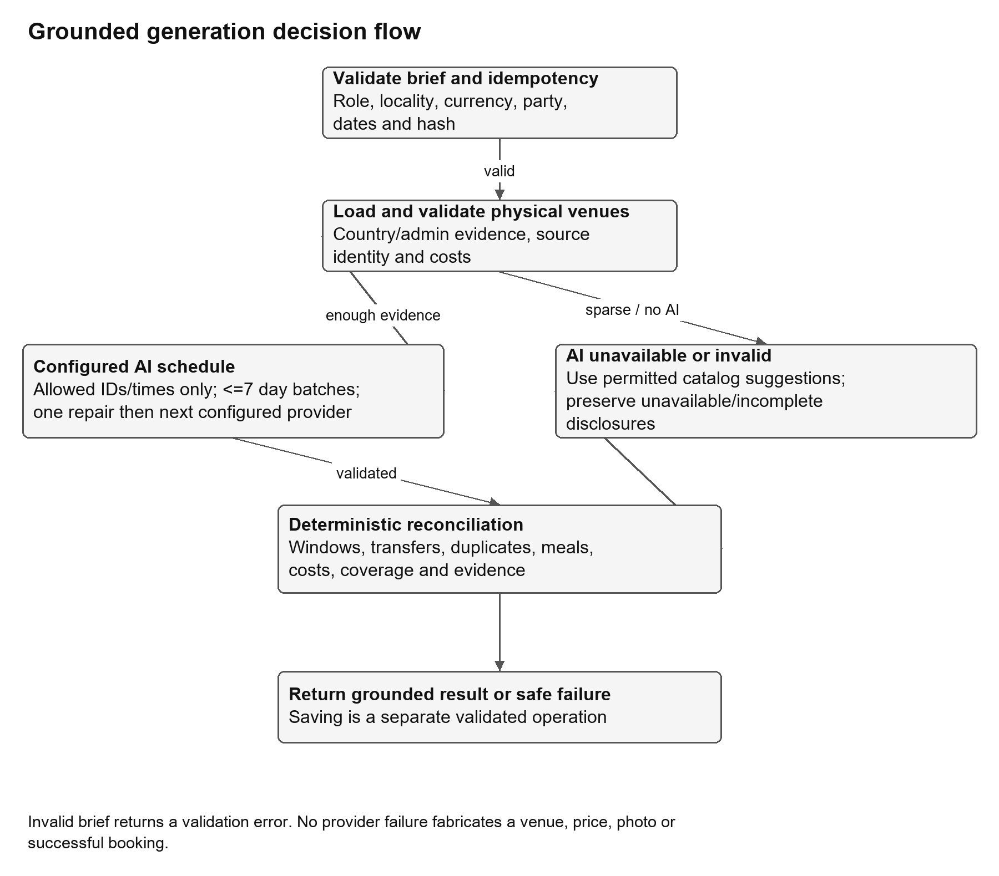
Figure 7 Grounded generation activity flow and honest failure paths [2]
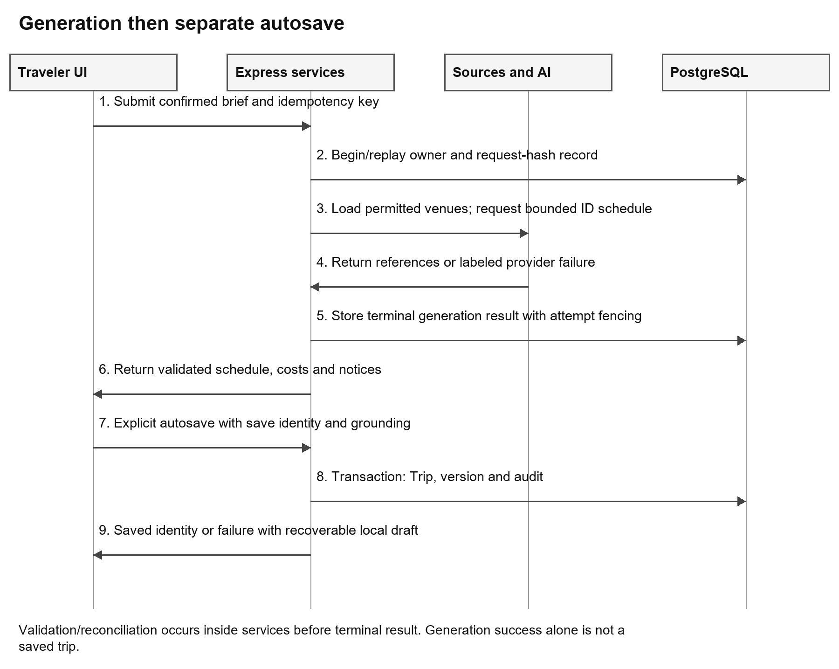
Figure 8 Generation and separate autosave sequence with source and persistence boundaries [1][2]
Grounding obtains Wikipedia/Wikidata physical attractions and OpenStreetMap boundary/membership evidence. It rejects organizations, virtual objects, whole administrative areas and unsupported historical/destroyed/proposed relationships. Coordinates within a maximum thirty-kilometer expansion are only one check; source identity and actual country/admin membership remain necessary. Sparse evidence produces incomplete coverage rather than fabricated attractions. Media uses exact venue/country identity and attribution. [2][8][12]
The configured preferred provider is tried before another configured adapter. OpenAI defaults to gpt-4o-mini with JSON Chat Completions, temperature 0.7 and a lower-temperature repair; Gemini defaults to gemini-3.1-flash-lite with a structured schema. Environment variables can override models. The prompt supplies the allowed place IDs, trip/day windows and constraints, asking only for IDs, start minutes, durations and participants. Trips are processed in consecutive batches of at most seven days, avoiding previously used places. Malformed/invalid output receives one repair attempt per batch; adapter/provider failure falls through to the next configured provider. Each adapter is bounded to 45 seconds; the overall generation signal is 540 seconds, with the frontend proxy at 580 seconds. These are deadlines, not measured latency promises. [2]
A deterministic reconciler checks dates, identity, duplicates, durations, transfer feasibility, usable hours, budget and weather context. Normal Balanced scheduling caps catalog visits at three per day, with a 09:00-18:00 baseline usable day, a 45-minute meal and buffered transfers (more conservative for families). API-only arrival/departure/rest inputs can narrow windows using 90/120-minute buffers, but those fields are absent from the current planner form. Catalog fallback remains labeled and can include honest allowances/incomplete days. Production provider failure does not turn into a fabricated mock itinerary. [2]

SDD 6.2 Cost and currency calculation
Currency selection is explicit and supports PHP, USD, EUR, JPY, KRW, THB, GBP, AUD, CAD, SGD, CNY, HKD, TWD, MYR, IDR, VND, INR, NZD, CHF and AED. JPY/KRW/VND use zero fractional digits; the others use two. Integer minor-unit arithmetic and exact shares avoid lost cents in group displays. FX is a reference from Frankfurter with pair validation, six-hour cache and a twenty-four-hour stale cutoff, not a currency change to the saved trip. [1][2]
The formulas and PHP worked example in SRS 3.4 specify new grounded plans. A retained legacy domain split of 34/22/20/14/10 percent is not the truth for new expense-evidence generation. The current engine sums known accommodation, food, transport, admissions, explicit fees and pre-trip amounts, avoids exact-name double counting, adds rounded contingency, and shows remaining/shortfall. Unknown costs do not enter known subtotal and remain visibly unpriced. Saving manual edits recalculates and downgrades unsupported stale price evidence. [2]

SDD 6.3 Time maps and managed day changes
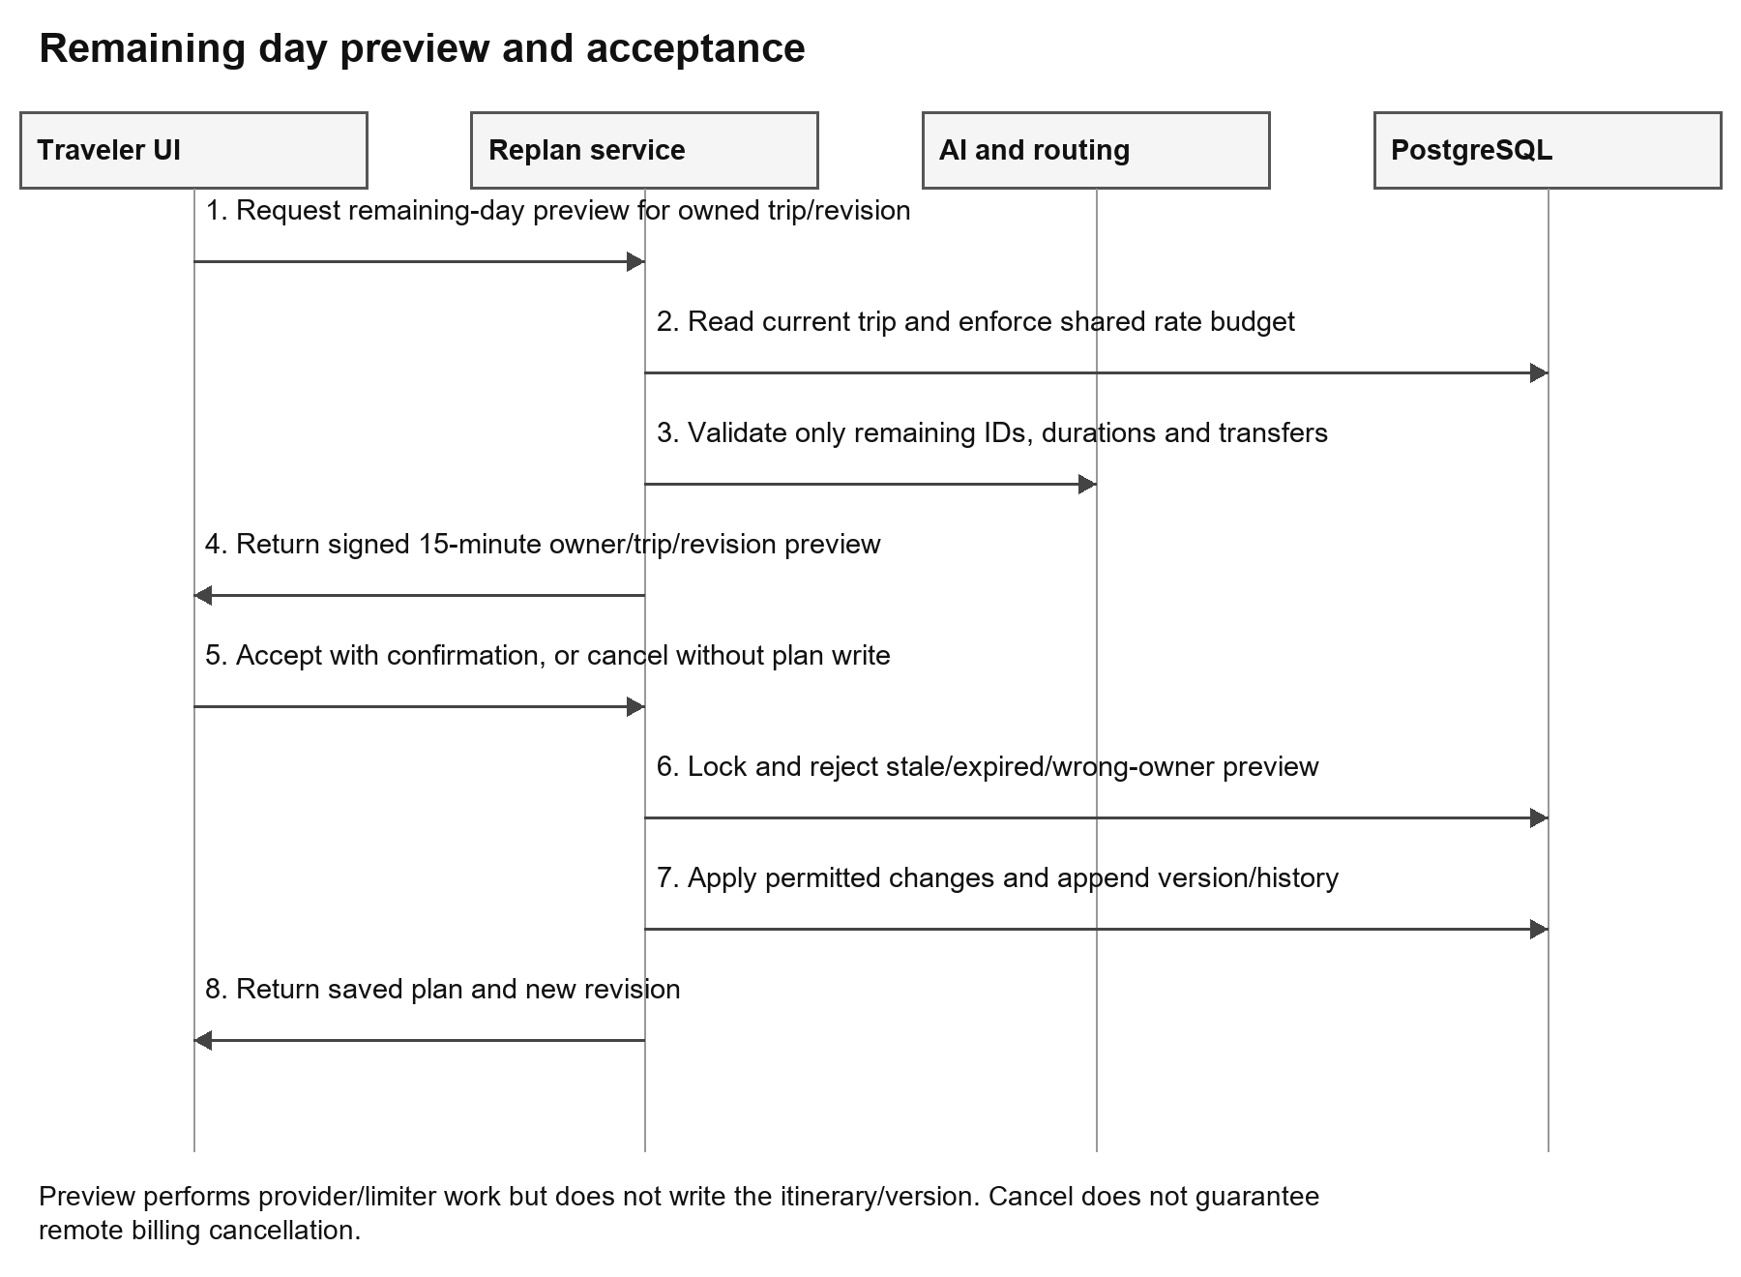
Figure 9 Remaining-day replan preview and revision-checked acceptance [1][2]
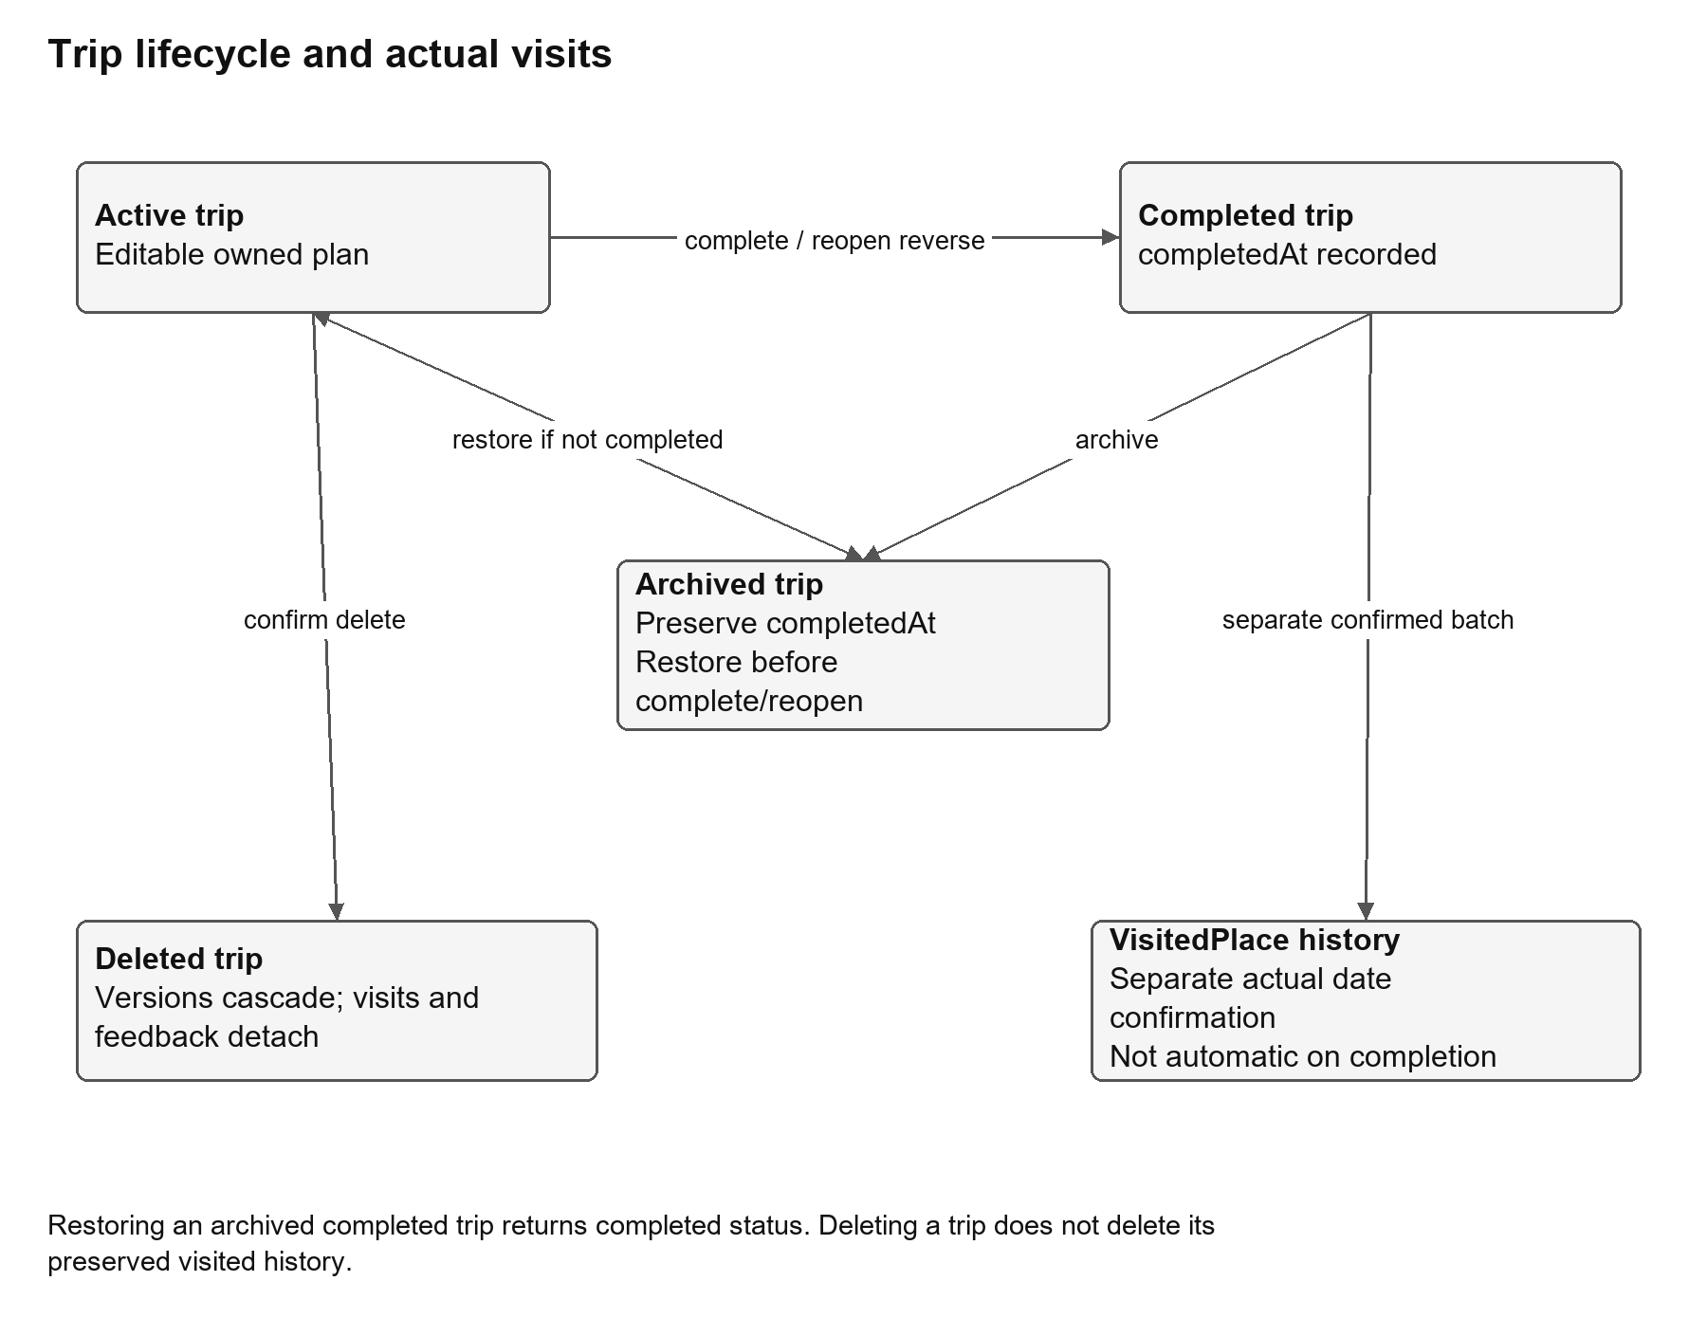
Figure 10 Trip status transitions and separate actual visited-history recording [2]
Dates represent inclusive trip days, while activity clocks are local-day minutes. Weather is limited by provider horizons; future coverage is not current observation. OSRM provides verified route geometry/duration where possible; conservative planning transfer buffers are estimates and not asserted as road navigation. Replan transfer checks use route legs where available or conservative walking at four km/h plus fifteen minutes. Replan uses current allowed activities and a bounded local window, never live traffic, new paid offers or arbitrary invented venues. The local-versus-UTC start-date issue D-03 remains an acceptance concern. [2]

SDD 6.4 Class and component responsibilities
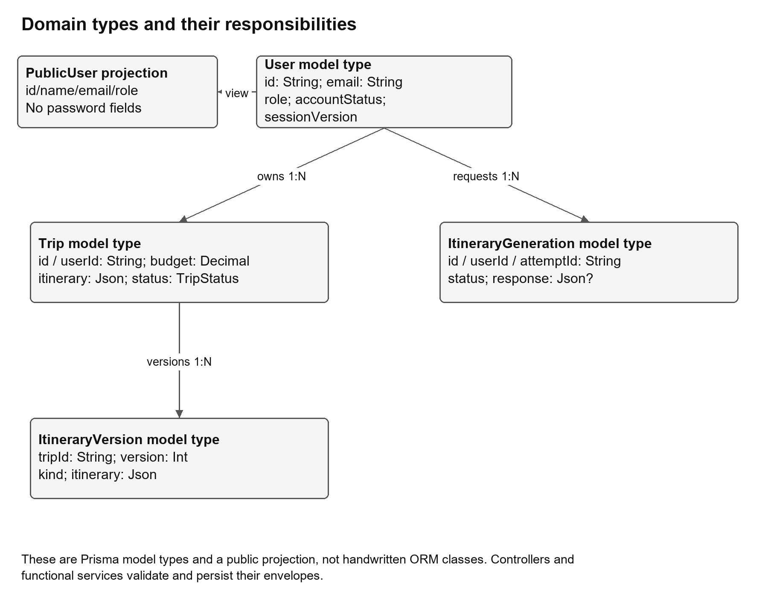
Figure 11 Software responsibilities and data types without inventing ORM service classes [1][2]
This TypeScript implementation primarily uses functional components, exported service functions and Prisma-generated types. The class/component diagram represents those actual software responsibilities rather than claiming a Java-style entity hierarchy. PublicUser is a sanitized account projection, Trip holds the persisted envelope, and ItineraryVersion/ItineraryGeneration represent history and execution state. Controller/service dependencies are module calls, not database foreign keys. [1][2]

SDD 7 Access failures and privacy

SDD 7.1 Access and security
Current-user middleware checks signed payload/expiry, current database role/state/sessionVersion and revocation. Eight-hour HttpOnly/SameSite=Lax sessions become Secure in production. Password salt is sixteen random bytes and scrypt output is sixty-four bytes. Login/register/verify/reset limits differ and use persistent buckets: login 8/15 min, registration 4/hour, verify 8/15 min, forgot 3/hour, reset 6/15 min, with a broader auth IP limit 20/min. Resend requires 60 seconds and no more than three eligible sends/hour. Verification codes expire after five minutes with five attempts; reset after fifteen minutes. [2]
Google state/nonce/PKCE and audience verification protect the callback. Public registration cannot create admin. Production backend transport enforcement returns 426 where appropriate and frontend HTTP redirect uses 308; origin/fetch-site checks protect writes. CSP includes unsafe-inline, so its presence is not a proof that every XSS vector is eliminated. Parameterized ORM queries, allowlisted profile fields and generic production errors are controls, not a completed penetration test. No at-rest AES-256, immutable audit or daily backup claim is supported by code alone. [2]

SDD 7.2 Failure handling and service bounds
Table 14 Failure and recovery design
Boundary | Behavior | User/operator consequence
Mail | Resend production; explicit Gmail development alternative; missing configuration 503/provider failure 502. | Account may exist while the new code is invalidated after send failure; observe cooldown and visible outcome.
AI/catalog | Per-call and whole-generation bounds; schema/identity validation; fallback provider/catalog. | Read source/fallback/incomplete notices; no invented complete schedule.
Search/stay/photos | Paced providers, caches and exact context; sparse/rights-restricted media can remain unavailable. | Do not infer a hotel rate, a wrong-place fallback or complete catalogue coverage.
Maps/weather | Stop/size/forecast/quota bounds; no-route and unavailable states. | Use exact-stop/manual alternatives and independent travel checks.
Database | Bounded connection retry and safe errors; transaction/row-state conflicts. | Retry explicitly safe operations; keep draft if save failed; never equate generated with saved.
Logout | Local cookies clear even if revocation persistence fails; warning is explicit. | Do not claim remote token invalidation was confirmed.
SSE/cache/limiter | Cleanup on disconnect; request-driven 1% expired bucket/revocation cleanup; memory TTL/coalescing. | No scheduled distributed worker or persistent cache guarantee.

SDD 7.3 Data handling and provider boundaries
Registration/login/reset exchange email and authentication data with backend identity/mail providers; generation sends a bounded trip brief and approved venue IDs to the configured AI; map/weather/geocoding providers receive necessary coordinates/query context; optional Google photos require explicit server-side opt-in and billing. Secrets remain backend-only. Existing logs, real account records and secrets were not copied into this deliverable. Retention, cross-border disclosures, legal basis and operator contact require institutional review. [2][11]

SDD 8 Deployment and requirement mapping
The backend Dockerfile uses Node 22 bookworm-slim, a non-root user, build-time Prisma/TypeScript generation and a health check. Local Compose exposes the API on loopback and uses development configuration; production Compose uses an external image/env file and no-new-privileges, with explicit migration tooling. The deployment script pulls an image, applies migrations and waits for health, reverting the image on failure. That image rollback does not reverse database migrations and requires a compatible recovery plan. CI definitions include paired-revision frontend/backend checks and disposable PostgreSQL integration jobs; this documentation task did not execute those deployment jobs. [1][2]
The RTM is the authoritative cross-document register: TM-FR/TM-NFR -> TM-F -> SDD section -> actual source and database reference -> TM-TC/TM-XT/TM-QT -> UM section. Module sections SDD 4.1-4.10 correspond to the feature groups; quality mappings refer to the more detailed security, process, data and operational sections. Complete API/page/process registers resolve entry points with no dedicated screen. The appendices provide setup, editable diagram sources, schema fields and acceptance forms.

References
[1] TravelMate frontend working tree. travelmate-frontend-new; HEAD 1d55ba3c2eb2a9387cb34c0cb6ca5edef8bfbc96 with recorded working changes; inspected 15 October 2026. Source snapshot, status and feature references in the evidence package.
[2] TravelMate backend working tree. travelmate-backend-api; HEAD 234e08d2317526f772854296bfaf6a33ca5dd0fa with recorded working changes; schema, 24 migration directories, controllers/services/config/tests inspected 15 October 2026.
[3] TravelMate. Supplied TravelMate-SRS.docx, documentation/mine. Historical requirements and administrative statements, not proof of present implementation. Original SHA256 26828397f5a0647ae2ecc0175f45ace40b19bf8e5d8212d6fc07db04df8ff9f6. Original ZIP CRC fault repaired in a separate reading copy only; all source media decoded.
[4] TravelMate. Supplied TravelMate-SPMP.docx, documentation/mine. Archived planning baseline. Original SHA256 cf5b9f119ba6cf7c8f39167dd6ff6208b1d881e73811a840665d038c15094f13.
[5] Supplied Herbal AI Pre Defense Manuscript v5 2026-2027, revised 15 October 2026, and its standalone engineering references. Used solely for organization/format by explicit user confirmation. No project facts, names, results or contributions transferred. Main reference SHA256 c8fde03149ba05b2f98b8a7e08b131ede9629313d1ae2b4114ee304d005df42c.
[6] TravelMate documentation execution evidence, 15 October 2026: final isolated frontend/backend logs, network guard, copied-source manifest, execution register and anonymous current screenshots. Included in the evidence bundle.
[7] TravelMate historical engineering reports: audit/2026-10-15/globe-photo-curation/REPORT.md; audit/2026-10-15/itinerary-overview/REPORT.md; audit/2026-10-13/remove-workspace-sections/REPORT.md. Each report is limited to its recorded environment/revision; historical counts are not added to current counts.
[8] TravelMate geographic/media source manifests and read-only catalogue metadata: frontend public discovery assets; backend GeoNames/PSGC/local geography and source metadata. Counts describe these snapshots, not guaranteed worldwide completeness.
[9] NASA Earth Observatory and Natural Earth source/licensing links retained in the current TravelMate image and map credits and asset attribution manifests. External provider/author-specific licenses remain asset-specific; footer attribution is not discarded.
[10] Next.js official App Router documentation, https://nextjs.org/docs/app, accessed 15 October 2026. Used for architectural context; inspected project code and dependency declarations govern this version-specific description.
[11] Republic of the Philippines, Republic Act No. 10173, Data Privacy Act of 2012, Official Gazette, https://officialgazette.gov.ph/2012/08/15/republic-act-no-10173/, accessed 15 October 2026. Legal context only; no compliance certification asserted.
[12] MediaWiki API Etiquette, https://www.mediawiki.org/wiki/API%3AEtiquette, accessed 15 October 2026. Provider identification, pacing and courteous API usage context; actual limits are taken from inspected code/configuration and agreements.

Supporting registers
The complete 20-model field register, actual 50-operation API register, inventory, RTM and editable Mermaid/SVG diagrams are included in the documentation package. Setup and sanitized source excerpts appear in the manuscript appendices.

