# Introduction

During muscle contraction and exertion of strength, small electrical signals are generated by the exchange of ions across muscle fiber membranes. They give information about neuromuscular activities, and overall muscle function and condition. Hence they are becoming increasingly important for clinical diagnosis and biomedical applications.

The EMG signal is a complicated signal, which is controlled by the nervous system and is dependent on the anatomical and physiological properties of muscles. EMG signal acquires noise while traveling through different tissues. Moreover, the EMG detector, particularly if it is at the surface of the skin, collects signals from different motor units at a time which may generate interaction of different signals.

These signals are acquired through Electromyogram (EMG) method. While there are several methods to acquire the EMG signal, this paper focuses on signal acquisition using Surface EMG technology. This involves the use of a surface electrode placed on the skin to obtain the signal.

# Practical Acquisition of the EMG signal

The use of a bioelectric signal acquisition device will be demonstrated to the students, who would then attempt to collect their own surface EMG signals, and display the signals in their reports. Students are encouraged to include discussions on the points they noted for successful acquisition of the bioelectric signals.

Floating electrodes were used to obtain the EMG signal from my bicep. With signal acquisition, the challenge is to obtain a high signal to noise ratio (SNR) which leads to high signal resolution. In doing so, the EMG signal’s response to muscle contractions can be properly monitored and analyzed.

## Strategies to reduce noise in signal acquisition

To develop strategies to eliminate unwanted noise, firstly, the dominant sources of noise have to be identified.

1. Ambient White Noise: Electromagnetic devices such as computers and phones emit an ambient white noise, having a wide range of frequencies. As the noise generated is random, it will be hard to filter by software it if this noise is allowed to contaminate the EMG signals from the bicep. In order to lower the impact of ambient white noise, I was careful not to use my phone and stand further from electronic devices. The distance of the signaling circuit from the signal source was also kept small. This is because power line noise, RF noise and other sources of noise are introduced through that lead wire. Long lead wires also introduces parasitic capacitances, thus increasing the coupled noise. Power line noise of 50Hz is also another source of interference. However, it is easily identified and can be filtered by software, as will be illustrated in the later sections of this report.
2. Transducer Noise: Transducer noise is generated at the electrode – skin junction. Contact impedance between the electrode and skin form a large part of the noise. Though we are unable to completely eliminate the contact impedance, so long as it is significantly lower than the input impedance of the signal conditioning circuit, the signal generated will not be attenuated, thus improving the SNR. It is also important that the contact impedance is as consistent as possible. Failure to do so will create differences in voltage potential. This source of noise was countered against by the following steps: A smooth patch of skin on the bicep muscle not having hairs or roughness from dead skin was chosen, shaved, and cleaned with alcohol. An electrolytic gel was used as a chemical interface between the skin and the electrode.

## Time Domain Signal

As mentioned, the signal was obtained by placing the electrodes on the bicep muscle. The bicep muscle was then contracted and relax repeatedly at a frequency of about 0.5hz. The corresponding EMG signal frequency is between 10 to 20Hz, of a magnitude ranging from 0 to 7.6 mV. The amplifier used to amplify the signal is also set to limit the EMG signal spectrum up to 500Hz as that is the typical range of the bio signals. Higher frequencies are usually noise and hence filtered away.

The EMG signal is a continuous time signal. By sampling this signal at regular intervals, we are able to obtain a discrete time signal. As the collected signal is 500Hz, by the Nyquist sampling theorem, the signal sampling rate was set to be double of that: 1000Hz. Otherwise, aliasing of the signal could occur.

The following diagram shows the time domain signal. As expected, when the bicep muscle was fully contracted, the signal had a magnitude of about 7mV. The signal is periodic, following the periodic contractions of the bicep muscle.

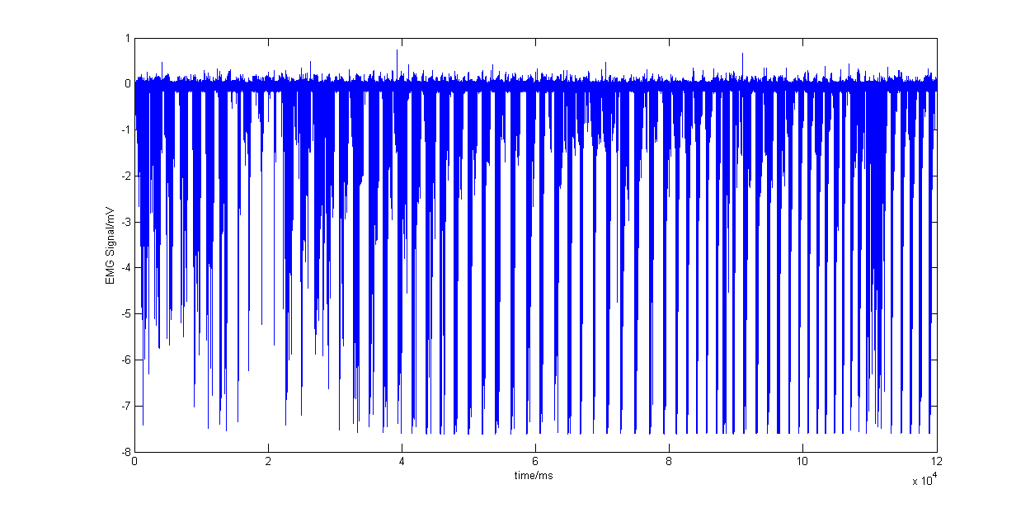

## Power Spectral Density Function

However, the time domain signal is not sufficient for analysis. It is also necessary to remove the noise sources inside the signal. To do so, we need to analyze the signal in the frequency domain. To analyze the signal in the frequency domain, the following code was used to obtain the power spectral density function.

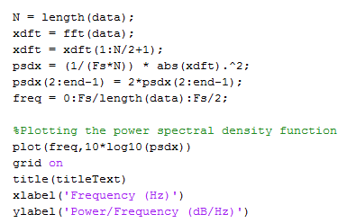

The power spectral density function of the raw data is as follows: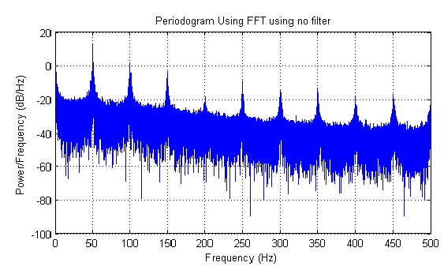

In this power spectral density function, the 50Hz noise is obvious and appears as large spike at 50Hz. Harmonics are also present as these spikes appear at every 50Hz interval. The power of the signal also gradually drops with increasing frequency. The bandwidth of interest of the ECG signal is in the range of 0.05 to 100Hz. However, within that range, the power line interference exists. Hence a simple low pass filtering is inadequate as it would filter away the signal of interest. Next, we will look at various techniques to remove the power line interference.

# Design and implement a suitable filter to remove possible artifacts due to power-line interference.

Interference frequencies can be included in the acquired signals, giving rise to artifacts in both time and frequency domains. Students should note that the interference frequencies could fall within the bandwidth of interest of the bioelectric signals, and hence simple low pass filtering may not be appropriate. These can be removed by suitable notch or comb filters.

As mentioned in the previous section, a simple low pass filter is inadequate for extracting the signal of interest. Notch and comb filters are proposed to filter out specific frequencies.

The notch filter contains deep notches in its frequency response. To do this, a pair of complex conjugate zeroes on a unit circle in the z-domain are introduced. To filter out the 50Hz frequency, the zero is created at . As there are multiple harmonics, multiple conjugate zero pairs are introduced on the z domain, at .

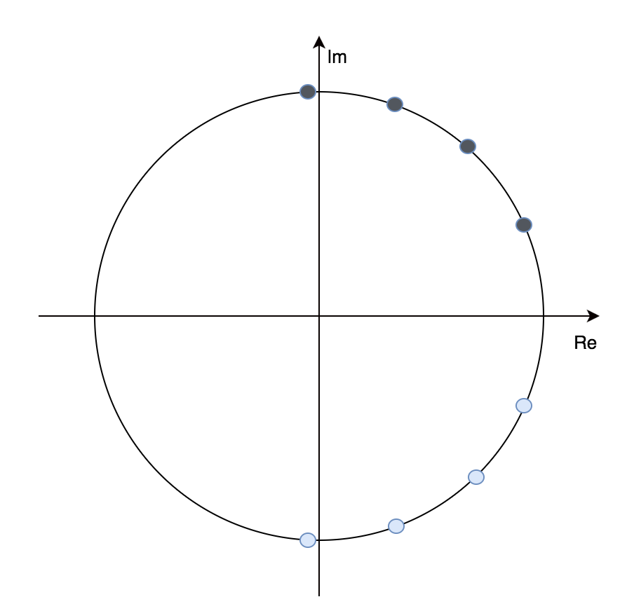

## Filter Design

### Notch Filter

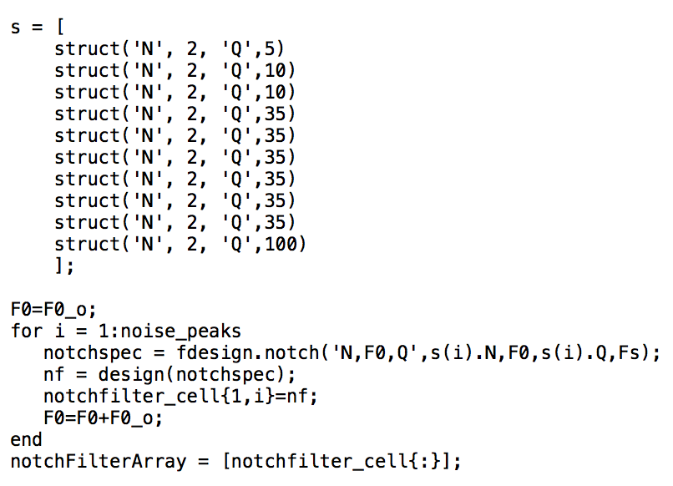

The quality factor or Q-factor of the filter is a measure of how well the desired frequency is isolated from other frequencies. For a fixed filter order, a higher Q-factor is accomplished by pushing the poles closer to the zeros. The higher the Q, the narrower the stop band, leading to better attenuation of a signal at a particular frequency. In the signal obtained however, while the noise is mostly at 50Hz, there are also noise spikes at the surrounding frequencies of . Hence the Q chosen should not be too high otherwise it would not attenuate those frequencies. Neither should it be too low, otherwise the stop-band is too large and even the desired signals are attenuated.

N is the filter order. If greater degrees of attenuation are desired, then the filter order is increased. Since the zeroes are in conjugate pairs, the filter order must be multiples of 2. A 4th order notch filter is simply the cascading of two 2nd order filters.

A filter of order 2 could remove the 50Hz power line interference spikes. Hence Q was adjusted depending on the width of the noise spike.

The notch filter only applies at a particular frequency. To filter away the various harmonics, we needed to cascade multiple notch filters at various frequencies. To do this in Matlab, a for loop was created. With each iteration, the notch filter is given a new set of ‘N’ and ‘Q’. The final notch filter is as follows:



The resulting filtered periodogram is as follows. The 50hz power line interference noise has been removed.

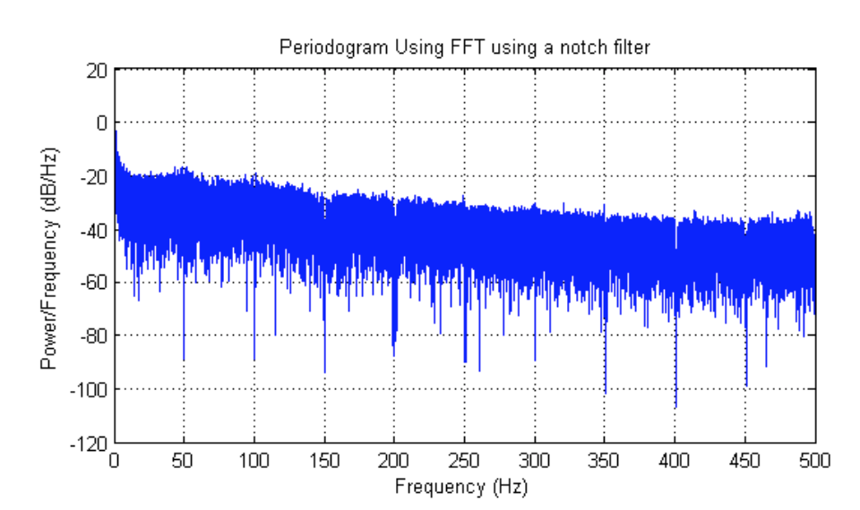

### Notching Comb Filter

Instead of cascading multiple notch filters at various frequencies, a notching comb filter can be designed to achieve a similar effect. The frequency response of the comb filter is hence a series of regularly spaced notches. If harmonics are present, multiple zeroes are required at , where n represents the order of the harmonics. The filter was implemented in Matlab as follow:



The following figure shows a visual representation of the notching comb filter.

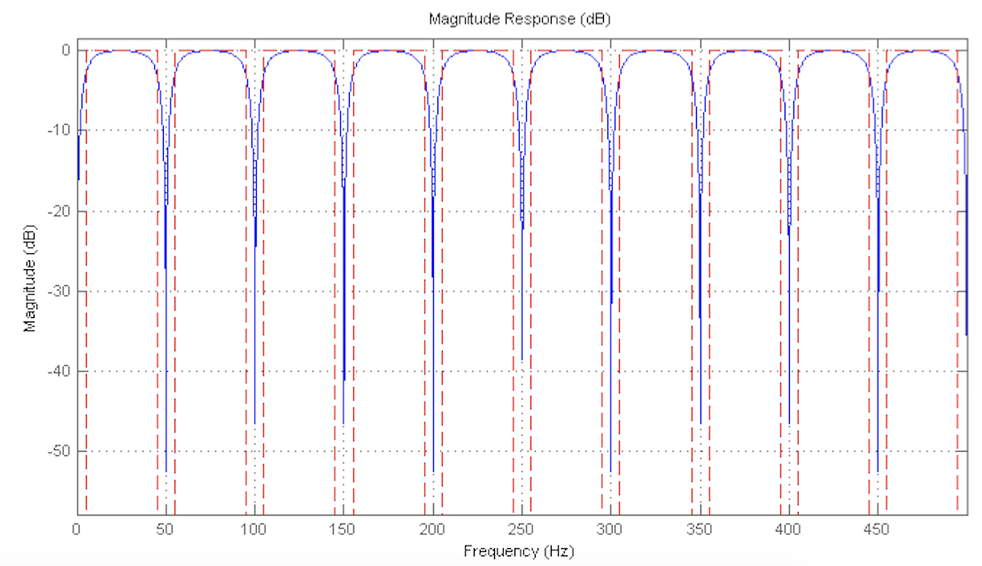

The resulting filtered periodogram is as follows. The 50hz power line interference noise has been removed.

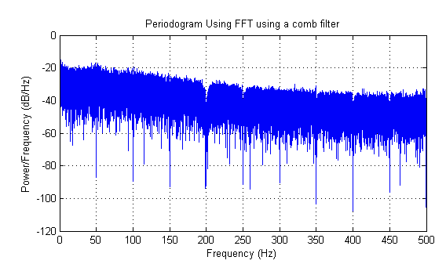

While the comb filter is largely effective in attenuating the 50Hz power line interference. However, it is noted that at 200Hz, there was is a large notch observed. This is because it was not possible to set the parameters for the comb filter at each frequency harmonic. Where the magnitude of power line interference is not constant across each harmonic, it may be more suitable to cascade multiple notch filters together or place a peaking notch filter at 200Hz.

# Time frequency analysis method to study the dynamic characteristics of the EMG

## Methodology for studying the EMG signal

Recognizing that the EMG acquired over a prolonged period should be more appropriately treated as a non-stationary signal, the dynamic characteristics and changes in the signal are the object of interest in the processing and study of such signals. Appropriate segmentation approaches can be implemented with the assumptions of quasi-stationarity within the segments to gain useful insights on the underlying dynamic mechanisms which produces the signal.

The dynamic characteristic of the signal changes over time. The segmentation approach of determining a window size with n overlaps is used to gain useful insights of how the signal response changes over time.

The signal was broken into segments of fixed duration, with the assumption that the signal characteristic does not change characteristics within the duration of the window.

The signal we want to extract has the following characteristics:

Table ‑ Characteristics of EMG signal

|  |  |
| --- | --- |
| Parameter | Value |
| Sampling Frequency | 1000Hz |
| Signal of Interest | 0.5 – 100Hz |
| EMG Spectrum | 500Hz |

The optimum window length depends on the application. The uncertainty principle of the Fourier transform dictates that high resolution can be obtained in either time domain or in the frequency domain but not simultaneously.

Wide band spectrograms have a small window size in the time domain and a large window size in the frequency domain. The converse is true for narrow band spectrograms. Wide band spectrograms have high resolution in the time domain, allowing us to see signal magnitude variations in time. This is useful for detecting formants, the power of the signal around a particular frequency.

The window must give us a good enough frequency resolution. Since the signal of interest is from 0 to 100Hz, the resolution we want should allow us to see the 100Hz signal. The window should be 1/100 = 10ms.

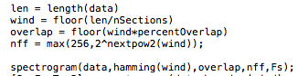

### Methodology for studying the EMG signal

The dynamic characteristics of the EMG signal are best studied using a spectrogram. A spectrogram is a visual representation of the Short Time Fourier Transform. It splits the input signal into small sections and applies a local Fourier Transform onto each section. Each section has a specified width and an associated frequency distribution, allowing us to obtain a series of frequency components. The collection of these individual frequency components is a spectrogram. The fundamental assumption here is that the characteristics of the signal do not change drastically within each section and hence splitting allows us to observe trends in either the time or frequency domain more clearly.

### Implementation of the Spectrogram

Matlab has a spectrogram function that allows us to quickly create a spectrogram for our signal data. The following code was written to make it easy to set the window size, overlap and the number of FFT points are desired for each section.



**Window Function**

When a signal is broken up into sections, and a FFT is performed on each section and replicated in the frequency domain, there will be discontinuities in the signal, causing spectral leakage. Window functions are used in signal processing to minimize the effect of spectral leakages. Basically, what a window function does is that it tapers the finite length sequence at the ends, so that when tiled, it has a periodic structure without discontinuities, and hence less spectral leakage. In this project, a hamming window was used because its larger main lobe with smaller side lobes helps smooth out any discontinuities in the signal and also reduces interferences from frequencies outside of the frequency of interest. The hamming window can be given a number of sample points depending on the window size that is set, which will be elaborated on in the next section.

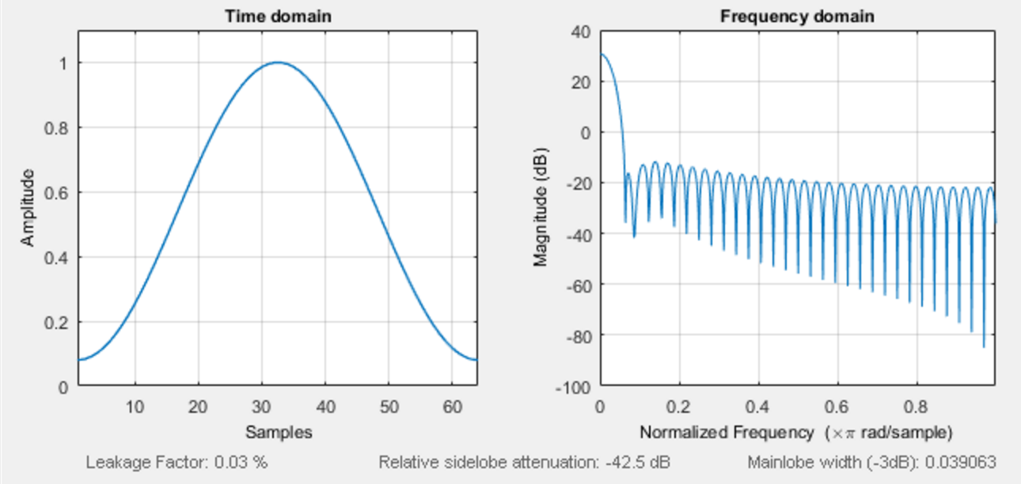

Figure ‑ Hamming window in time and frequency domain

**Window Size**

In the spectrogram, the signal is broken into sections with a specified width, known as the window size. The spectrogram allows us to examine the signal in both time and frequency domain, but there is a tradeoff between the two. A smaller window size allows us to attain better resolution in the time domain but poorer resolution in the frequency domain and vice versa. This follows that to analyze a signal in the frequency domain, we need a larger window size. A good guide to follow is that the duration of the window must be several times longer than the period of the signal, that is T(window) = n*T(signal). In this project, the signal of interest has a maximum frequency of 100Hz, as per . As such, the period of this signal is 10ms. The window size chosen is hence 80ms. For comparison, another spectrogram was set with a window size of 1200ms to illustrate the effect of window size and is discussed in the subsequent section of this report.

**Determining overlap size**

When a window function is applied, information is lost on the tapered ends of the signal. Hence the windows have to be overlapped to obtain an approximation of the original signal. A 50% overlap (which is also the overlap used in this project) is a good ball park because it results in a good approximation to the original signal. The following figure illustrates the effect of overlapping a Hamming window:

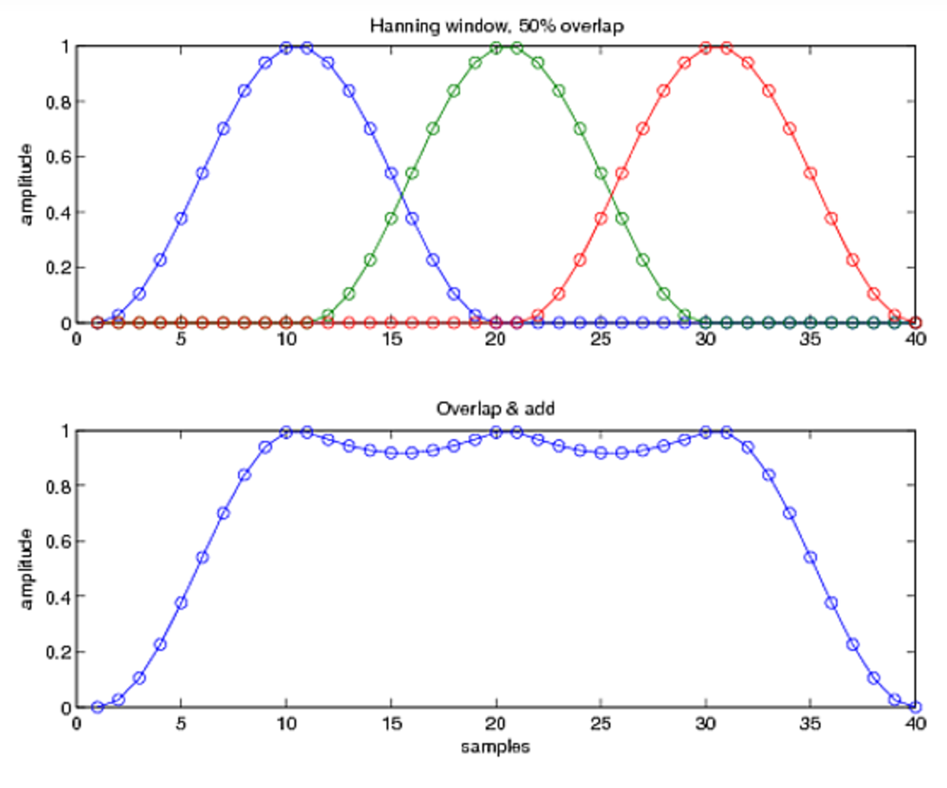

Figure ‑ Overlapping a Hamming window

**Sampling Frequency**

The sampling frequency is set to be 1000Hz, double of 500Hz, which is the highest frequency that is analyzed of the EMG. This is known as the Nyquist frequency and it is important to sample the signal a frequency equal to or higher than the Nyquist frequency to avoid aliasing.

## Results and analysis

### Noise Filtering

Spectrogram analysis was performed for the EMG signal. The spectrogram is sensitive to noise, hence filtering away the 50Hz power line interference noise was important. The following figures compare the periodogram with its respective spectrogram, with and without the 50Hz noise interference.

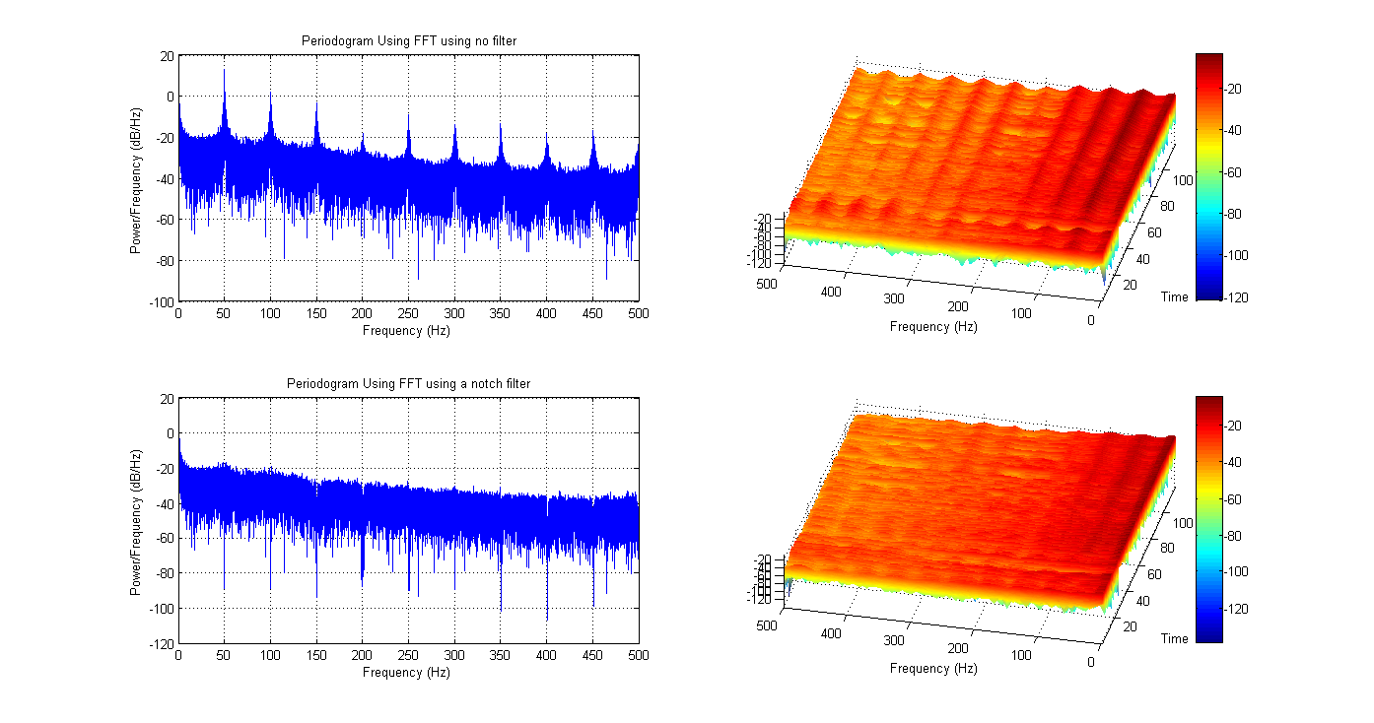

Figure ‑ Periodogram and spectrogram with power line interference



Figure ‑ Periodogram and spectrogram with power line interference filtered away

### Narrow Band Spectrogram Analysis

The signal of interest has a frequency of 100Hz, or a period of 10ms. As such, to obtain good resolution in the frequency domain without compromising too much in the time domain resolution, a window size several times larger than the period of the signal. A spectrogram that has high resolution in the frequency domain is called a narrow band spectrogram. As such, a window size of 100ms with an 80ms overlap was used and the result is shown in . The 100ms window size is noticeable as horizontal lines along the spectrogram parallel to the frequency axis.

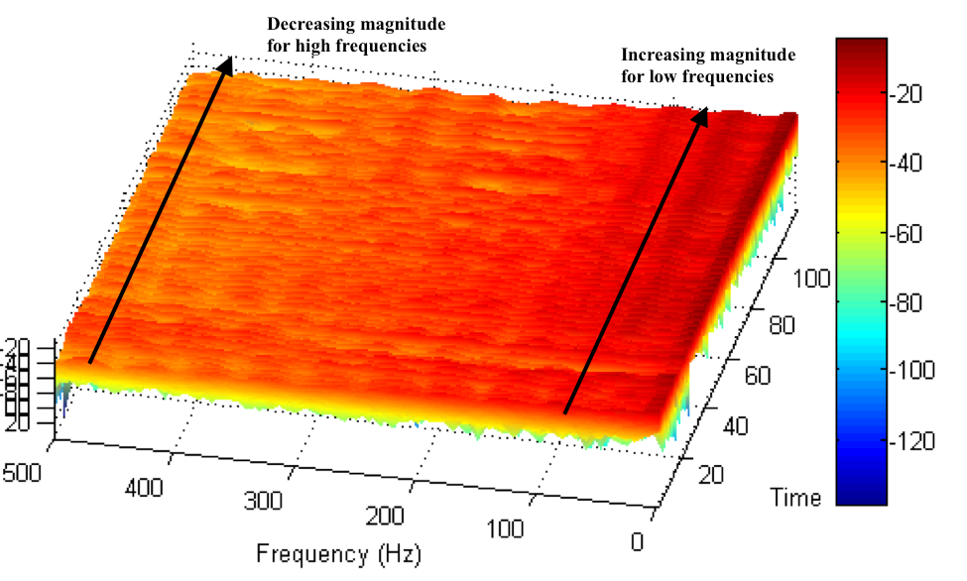

Figure ‑ 100ms window size spectrogram

To see the effect of window size, a spectrogram was taken with a 1200ms window size and a 600ms overlap, as shown in . The sections in the time domain are now far more obvious. In this spectrogram, a lot of resolution is lost in the time domain so it is much harder to see the fine detail in the signal in the time domain and it appears as large uneven sections.

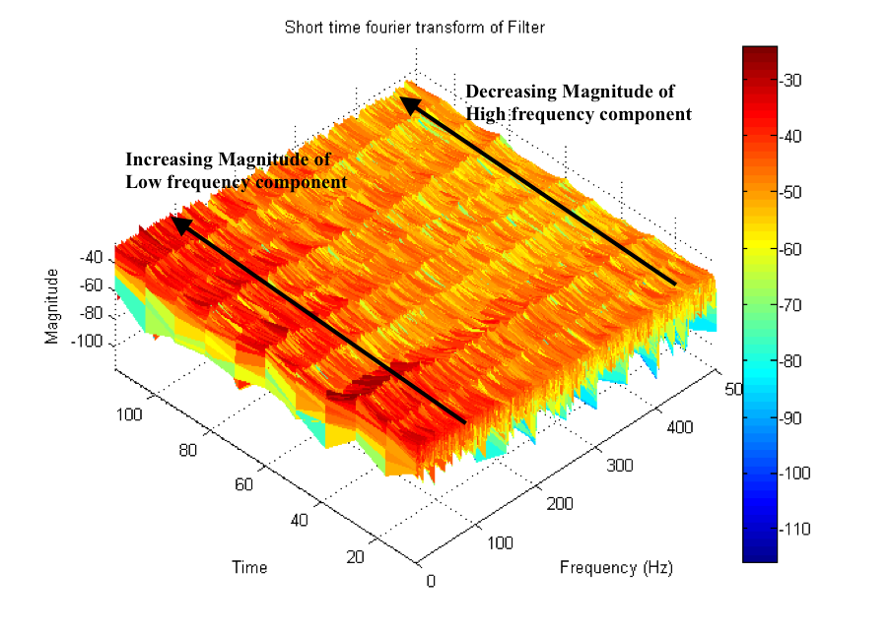

Figure ‑ 1200ms window size spectrogram

A spectrogram was used to analyze the signal. In the following figure, a wide band spectrogram is used. A 100ms window in time domain (10Hz) with a 80ms overlap was used. The formants are obvious and appear as dark red lines in the 3d plane. These formants correspond to the 50Hz power line interference and its harmonics. The color of the 3d spectrogram plane changes from dark red to yellow from 0 to 500Hz, signifying that the magnitude of signal’s power falls as frequency increases. Low frequency signals are more dominant than the high frequency ones. Power line harmonics become weaker as frequency increases as well.

At the beginning, the frequencies are spread across a wide range from 0 to 500Hz. As time went by, we see the magnitude of the signal increase for the low frequency components while the magnitude of the high frequency signal decreases. This distribution indicates a spectral compression because the frequency spread is less as time increases and the low frequency signals increase in magnitude.

A 3d plotting of the signal was done to view the signal’s magnitude value (not in dB). The results are similar, in that the signal’s power is greatest at low frequencies. It also indicates that over time, the amplitude of the signal increases. Over the span of two minutes, repeated contractions of the muscle were performed, which would result in muscle fatigue. The results show that the amplitude of the EMG increases with muscle fatigue.

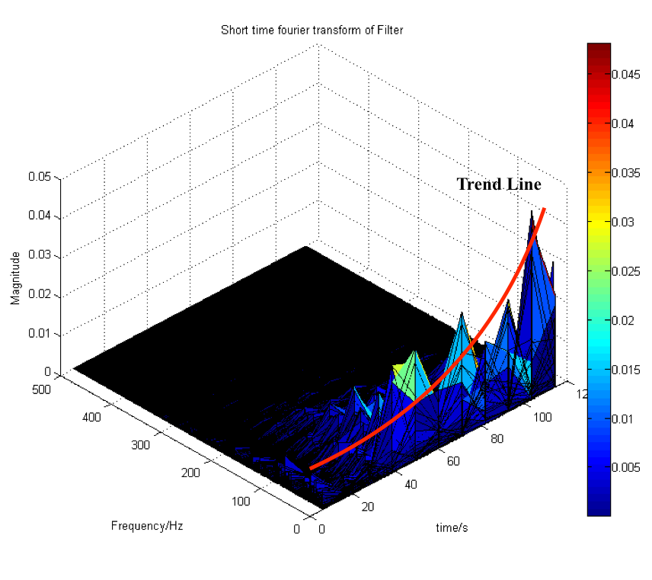

Figure ‑ Spectrogram of dynamic signal

# Discuss how EMG technology can be used in the following applications that are relevant to public health?

## Muscle Fatigue Study for Sportsmen

EMG is useful for Diagnosis of muscle or nerve disorders. Can precisely identify location of the problem. Differentiate between nerve and muscle diseases

The muscle fatigue is considered the incapacity to maintain the desirable level of force performing a specific task. This can be studied using the EMG signal, but several steps must first be taken to pre-process the signal before meaningful analysis can be done.

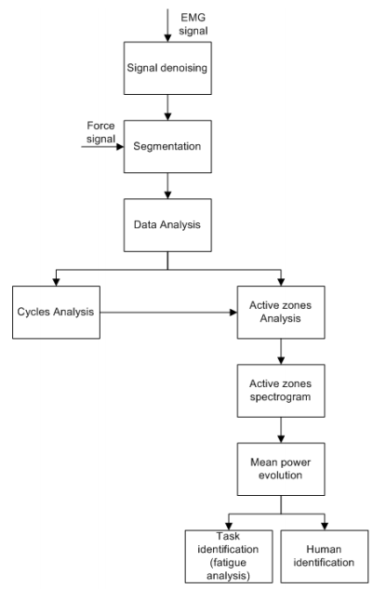

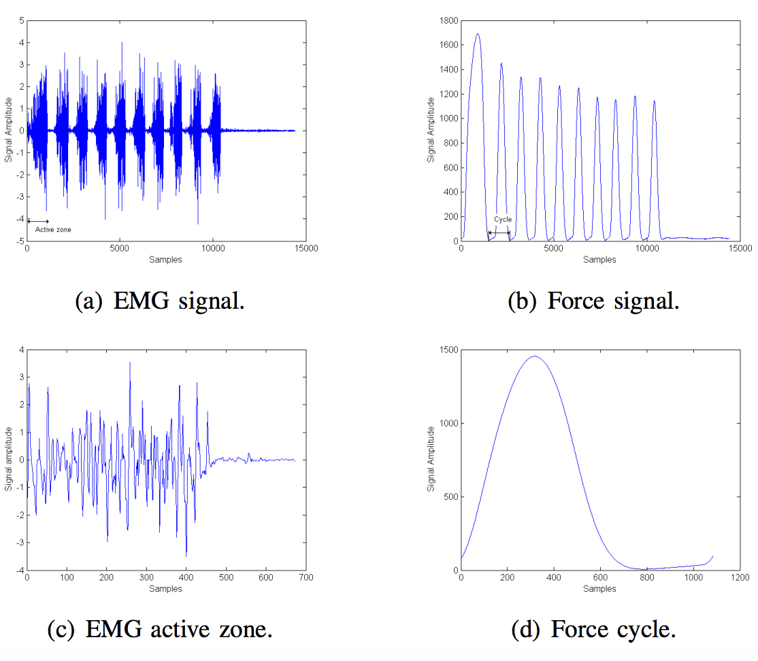

A study done shows that the amplitude of the EMF signals increases progressively over time when the muscle fatigue increases, while the mean power frequency decreases as a function of time.

Another method is to divide the signal into cycles and then monitor the evolution of the mean power across each cycle to detect fatigue and identify individuals.

### Time frequency analysis method

### Cyclical analysis method

Dividing the signal into cycles and characterizing each cycle.

### Diagnosis of muscle or nerve disorders

Can precisely identify location of the problem

Differentiate between nerve and muscle diseases

### Detect muscle fatigue early to avoid irreversible injuries to the subject

A study done shows that the amplitude of the EMF signals increases progressively over time when the muscle fatigue increases, while the mean power frequency decreases as a function of time.

Another method is to divide the signal into cycles and then monitor the evolution of the mean power across each cycle to detect fatigue and identify individuals.

### Dynamic analysis

### Electromyographic analysis can provide information as to the relative amount of muscular activity an exercise requires, as well as the optimal positioning for the exercise

## Muscle Development Monitoring for Children

(i) Muscle fatigue study for sportsman

(ii) Muscle development monitoring for children