# Chapter 1 Introduction

# Chapter 2 Practical Acquisition of the EMG signal

The use of a bioelectric signal acquisition device will be demonstrated to the students, who would then attempt to collect their own surface EMG signals, and display the signals in their reports. Students are encouraged to include discussions on the points they noted for successful acquisition of the bioelectric signals.

Floating electrodes were used to obtain the EMG signal frmop my bicep. With signal acquisition, the challenge is to obtain a high signal to noise ratio (SNR) which leads to high signal resolution. In doing so, the EMG signal’s response to muscle contractions can be properly monitored and analyzed.

To develop strategies to eliminate unwanted noise, firstly, the dominant sources of noise have to be identified.

1. Ambient White Noise: Electromagnetic devices such as computers and phones emit an ambient white noise, having a wide range of frequencies. As the noise generated is random, it will be hard to filter by software it if this noise is allowed to contaminate the EMG signals from the bicep. In order to lower the impact of ambient white noise, I was careful not to use my phone and stand further from electronic devices. The distanceof the signaling circuit from the signal source was also kept small. This is because power line noise, RF noise and other sources of noise are introduced through that lead wire. Long lead wires also introduces parasitic capacitances, thus increasing the coupled noise. Power line noise of 50Hz is also another source of interference. However, it is easily identified and can be filtered by software, as will be illustrated in the later sections of this report.
2. Transducer Noise: Transducer noise is generated at the electrode – skin junction. Contact impedance between the electrode and skin form a large part of the noise. Though we are unable to completely eliminate the contact impedance, so long as it is significantly lower than the input impedance of the signal conditioning circuit, the signal generated will not be attenuated, thus improving the SNR. It is also important that the contact impedance is as consistent as possible. Failure to do so will create differences in voltage potential. This source of noise was countered against by the following steps: A smooth patch of skin on the bicep muscle not having hairs or roughness from dead skin was chosen, shaved, and cleaned with alcohol. An electrolytic gel was used as a chemical interface between the skin and the electrode.

As mentioned, the signal was obtained by placing the electrodes on the bicep muscle. The bicep muscle was then contracted and relax repeatedly at a frequency of about 0.5hz. The corresponding EMG signal frequency is between 10 to 20Hz, of a magnitude ranging from 0 to 7.6 mV. The amplifier used to amplify the signal is also set to limit the EMG signal spectrum up to 500Hz as that is the typical range of the biosignals. Higher frequencies are usually noise and hence filtered away. As the collected signal is 500Hz, by the Nyquist sampling theorem, the signal sampling rate was set to be double of that: 1000Hz.

The following diagram shows the time domain signal. As expected, when the bicep muscle was fully contracted, the signal had a magnitude of about 7mV.

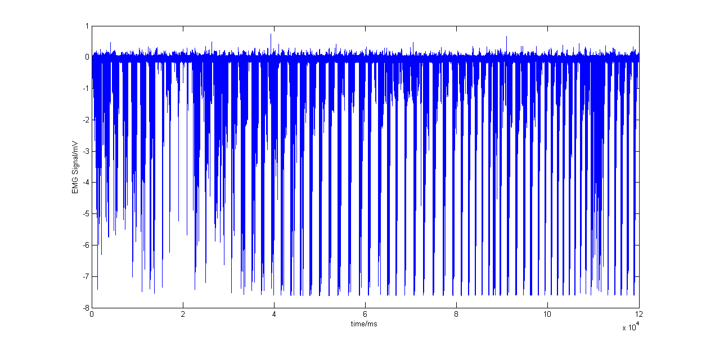

However, the time domain signal is not very useful for analysis. To analyze the signal in the frequency domain, the following code was used to obtain the power spectral density function.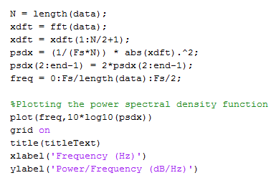

The power spectral density function of the raw data is as follows: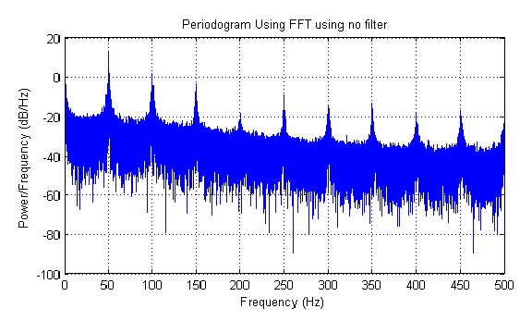

# Chapter3 Design and implement a suitable filter to remove possible artifacts due to power-line interference.

Interference frequencies can be included in the acquired signals, giving rise to artifacts in both time and frequency domains. Students should note that the interference frequencies could fall within the bandwidth of interest of the bioelectric signals, and hence simple low pass filtering may not be appropriate. These can be removed by suitable notch or comb filters.

# Chapter 4 Design and implement a method to appropriately study the dynamic characteristics of the EMG

Recognizing that the EMG acquired over a prolonged period should be more appropriately treated as a non-stationary signal, the dynamic characteristics and changes in the signal are the object of interest in the processing and study of such signals. Appropriate segmentation approaches can be implemented with the assumptions of quasi-stationarity within the segments to gain useful insights on the underlying dynamic mechanisms which produces the signal.

# Chapter 5 Discuss how EMG technology can be used in the following applications that are relevant to public health?

(i) Muscle fatigue study for sportsman

(ii) Muscle development monitoring for children