Yanjun Chen (chen2620) ECE 30862 HW5b

The VFT of the Faculty object that

the student* s erroneously points to

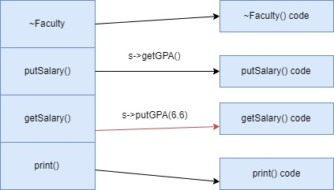

**After calling the function, the result shows the salary value instead of GPA values.** This is because that getSalary() and putGPA(6.6), putSalary() and getGPA() are in the same positions in their respective class’ VFTs.

The VFT of the Student object that

the Faculty* f erroneously points to

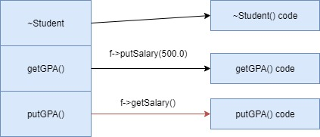

**After calling the function, the result shows the GPA values (output as an address).** This is because that getGPA() and putSalary(500.0), putGPA() and getSalary() are in the same position in their respective class’ VFTs.

The VFT of the Person object that

the Student* s erroneously points to

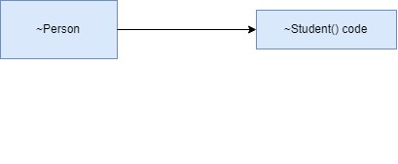

**After calling the function, access violation occurs, and no result shown.** This is because that Person object does not have any function in the same position as Student class.

**mainStaticCast.cpp**

s = static_cast<Student*>(f); //compile time error

f = static_cast<Faculty*>(s); //compile time error

s = static_cast<Student*>(v); //compile, but invalid

**mainDynamicCast.cpp**

s = dynamic_cast<Student*>(f); //compile, but will give a seg fault at runtime

f = dynamic_cast<Faculty*>(s); //compile, but will give a seg fault at runtime

//because f and s are dereferenced

s = dynamic_cast<Student*>(v); //compile time error

//because it casts from non-object pointers (void) to object pointers (student)