UNIVERSITY OF LA SALETTE • COLLEGE OF INFORMATION TECHNOLOGY

WEEK 13

Classroom Issue Reporting System
Step-by-Step Implementation and Screenshot Evidence Workbook
Student name | John Lloyd P. Parong
Section | BSIT_3B
Project | Project 7 — Classroom Issue Reporting System
Assessment | Week 13 — SA7: Automation Foundation
Date tested | _______________________________________
Instructor approval | Approved / Pending (circle one)
Purpose
Follow the steps in order, take screenshots of your real results, and paste each screenshot directly below its corresponding evidence instructions. This is a blank evidence template, not a claim that tests have passed.
Important conditions
Your instructor must approve and register Project 7 before graded implementation. Use fictional classroom and issue details only. Keep the backend running while testing the Flutter frontend. All information in this starter is kept in memory, so restarting the backend clears the sample issues and notification history.
How to paste screenshots in this Word file
1. Perform the step in VS Code / Chrome and confirm the expected output.
2. Press Windows + Shift + S; drag to select the relevant area.
3. Click the matching screenshot placeholder in this document; delete its placeholder text and press Ctrl + V.
4. Resize the screenshot by dragging a corner, keep it readable, and save the DOCX.
5. Also save the original screenshot as a PNG inside the project evidence folder using its exact filename.
Starting folder on your PC (based on your terminal output)
C:\Users\User\Downloads\Project7_Classroom_Issue_Reporting_Week13\Project7_Classroom_Issue_Reporting_Week13

PART A — Setup and run the project

Step A1. Open the correct folder
In VS Code: File > Open Folder. Select the INNER Project7_Classroom_Issue_Reporting_Week13 folder. Explorer should show backend, frontend, docs, and evidence.

Step A2. Start the backend
Terminal > New Terminal. Run these commands one at a time. If you are already inside backend, skip the cd command.
cd "C:\Users\User\Downloads\Project7_Classroom_Issue_Reporting_Week13\Project7_Classroom_Issue_Reporting_Week13\backend"
dart pub get
dart run bin/server.dart
Expected: a backend_started JSON event with http://127.0.0.1:8080. Do NOT press Ctrl+C while collecting the other evidence.

Step A3. Check API health
In Chrome open http://127.0.0.1:8080/health . Expected: a JSON response indicating status ok.

Step A4. Generate and run the Flutter frontend
Open a SECOND VS Code terminal; leave the backend running in the first one.
cd "C:\Users\User\Downloads\Project7_Classroom_Issue_Reporting_Week13\Project7_Classroom_Issue_Reporting_Week13\frontend"
flutter create --platforms=web .
flutter pub get
flutter run -d chrome --web-port 3000
Expected: the Flutter Web app opens in Chrome with the title Classroom Issue Reporting · Week 13. If Flutter asks about overwriting lib/main.dart or pubspec.yaml, do not overwrite the supplied source.

Step A5. Identify the interface
Locate: Report a classroom issue (Room, Issue title, Description), category list, delivery mode list, Submit issue, Issues and routing, Notification delivery queue, Run worker, and summary counters.

Step A6. Prepare a test data set
Room | CIT-201
Title | Broken ceiling light
Description | The sample classroom light is not working.
Category | Electrical
Delivery mode | Normal delivery
For different tests, use fresh titles such as Loose chair, Dusty floor, Test timeout, and Test permanent failure. Do not use personal data.

PART B — Test the Week 13 automation

B1. Normal issue creation
Enter CIT-201 / Broken ceiling light / The sample classroom light is not working. Select Electrical and Normal delivery, then click Submit issue. The issue should appear and be automatically assigned to Electrical Team.

B2. Duplicate check
Enter the SAME room, title, and category as an unresolved issue, fill a description, and click Submit issue. Capture the duplicate warning; the list should not gain another matching issue.

B3. Change issue status
In Issues and routing, find an assigned issue and click the in progress button. You may then move it to resolved and closed using the next status button. Capture the new state and team assignment.

B4. Temporary delivery failure
Create a new issue with delivery mode Simulate temporary failure. Look at Notification delivery queue. Run worker and capture the temporary failure while status is pending and attempts are 1. If the 5-second automatic worker runs quickly, use the backend log or /notifications immediately to capture the first attempt.

B5. Recovered temporary failure
Wait at least 5 seconds; click Run worker or let the automatic worker retry. Refresh if needed. The SAME notification should show delivered and attempts 2.

B6. Permanent failure to manual review
Create another NEW issue with Simulate permanent failure. Let the worker attempt delivery 3 times (about 5 seconds between retry attempts), using Run worker if needed. Capture status manual_review and attempts 3.

B7. Aging and escalation
Create an issue and leave it unresolved for more than 60 seconds. Click Run worker / refresh. The issue should show Escalated: true; the queue may show an escalation notification.

B8. Summary and logs
Open http://127.0.0.1:8080/summary and then http://127.0.0.1:8080/logs in Chrome. Capture counts grouped by team and structured event fields.
Note: This demonstration uses a 5-second retry interval and a 60-second aging threshold so you can collect evidence in class. It does not send actual email or SMS. The daily summary is simulated by a 1-minute demonstration log and an on-demand endpoint.

PART C — Evidence pages
For each entry, perform the action, confirm the expected observation, take a genuine screenshot, and paste it into the bordered area. You can delete unused placeholder text. If a test does not work, write the actual result rather than pretending it passed.

Evidence 01 — Backend running
Filename | W13_01_Backend_Started.png
How to capture | In first VS Code terminal: dart run bin/server.dart
Expected result | Terminal shows backend_started JSON event and local API address.
Actual result | ____________________________________________
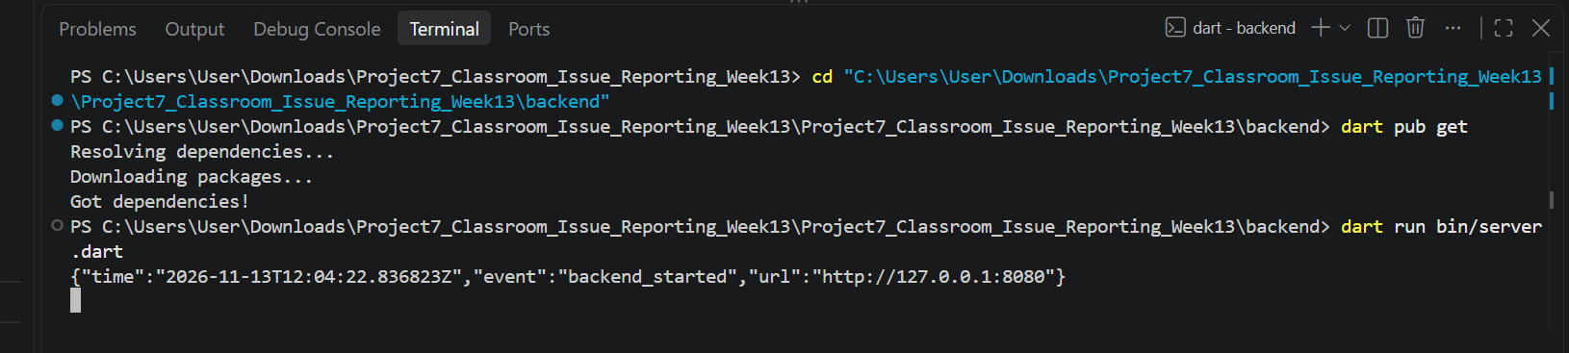

Evidence 02 — Backend API health
Filename | W13_02_Health_API.png
How to capture | Open http://127.0.0.1:8080/health in Chrome
Expected result | JSON response shows status ok.
Actual result | ____________________________________________
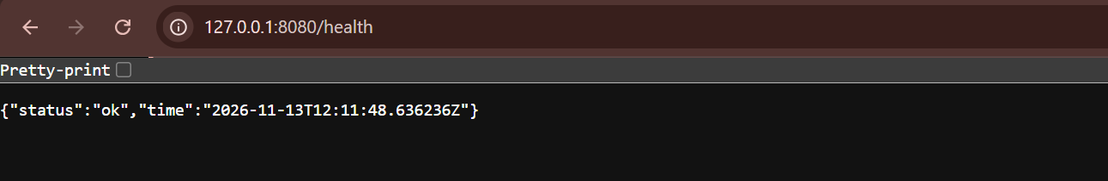

Evidence 03 — Flutter web interface
Filename | W13_03_Flutter_Interface.png
How to capture | Run Flutter Web on Chrome port 3000; show the upper form and page sections.
Expected result | Report form, issues area and notification queue are visible.
Actual result | ____________________________________________
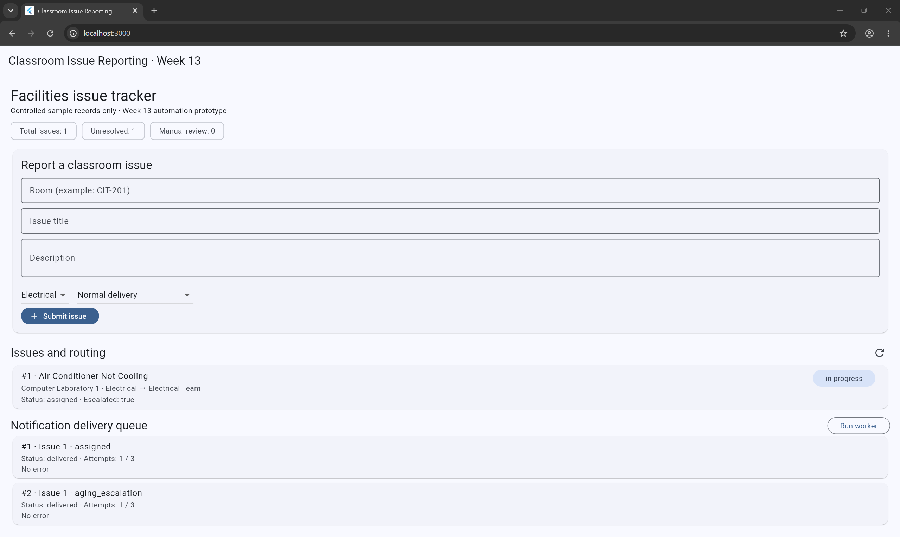

Evidence 04 — Submit a classroom issue
Filename | W13_04_Issue_Submitted.png
How to capture | Submit normal Electrical issue using sample CIT-201 data.
Expected result | Created issue is listed and assigned to Electrical Team.
Actual result | ____________________________________________
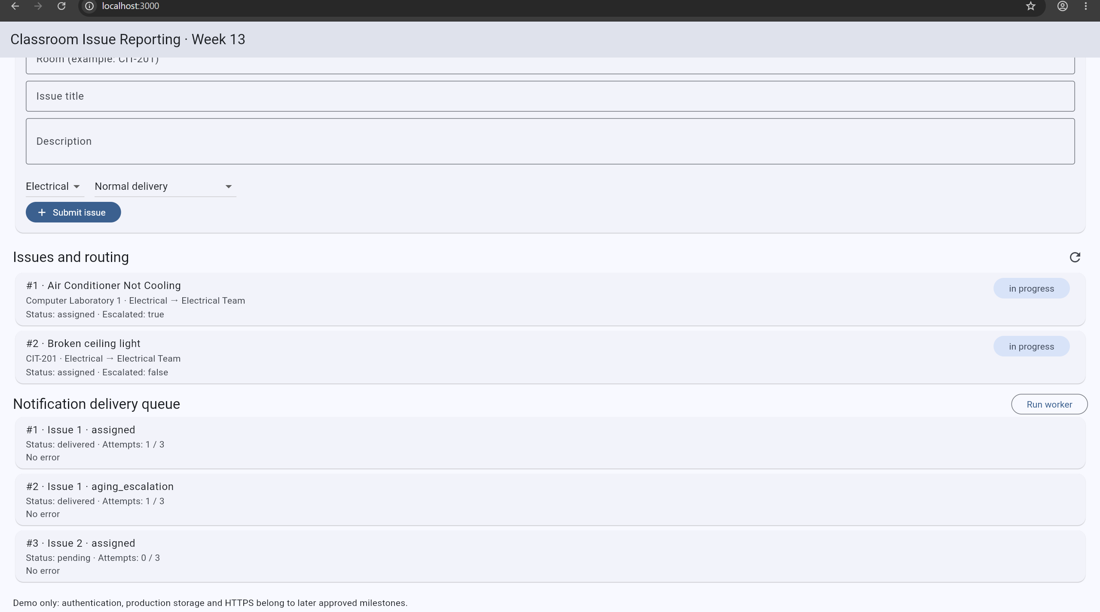

Evidence 05 — Duplicate issue prevention
Filename | W13_05_Duplicate_Blocked.png
How to capture | Submit same unresolved room/title/category as the prior issue.
Expected result | Duplicate warning appears; no second matching issue is created.
Actual result | ____________________________________________
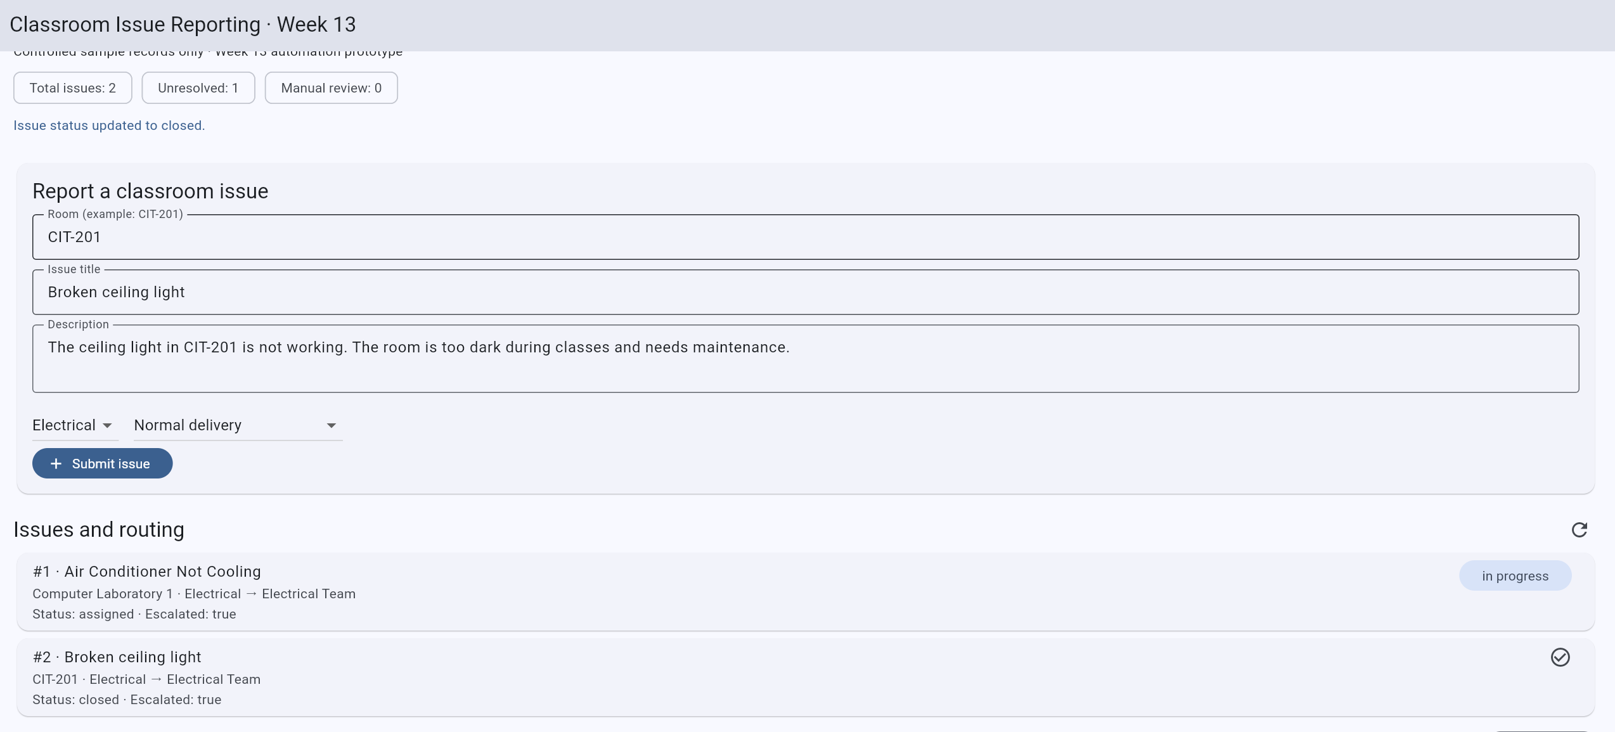

Evidence 06 — Automatic routing and status transition
Filename | W13_06_Routing_And_Status.png
How to capture | Capture an assigned issue, then move to in_progress (or later state).
Expected result | Assigned team and updated status are visible.
Actual result | ____________________________________________

Evidence 07 — First temporary failure
Filename | W13_07_Transient_Attempt_1.png
How to capture | Submit distinct issue using Simulate temporary failure; observe queue quickly.
Expected result | Notification is pending, attempts = 1, and temporary error is shown.
Actual result | ____________________________________________

Evidence 08 — Recovered notification
Filename | W13_08_Transient_Recovered.png
How to capture | After 5+ seconds let worker retry; refresh/click Run worker.
Expected result | Same notification changes to delivered, attempts = 2.
Actual result | ____________________________________________
Screenshot caption: __________________________________________________________
Test status: ☐ PASS ☐ FAIL ☐ NOT RUN Date/time: ___________________

Evidence 09 — Permanent failure: manual review
Filename | W13_09_Permanent_Manual_Review.png
How to capture | Submit distinct issue using Simulate permanent failure; wait for 3 tries.
Expected result | Notification status = manual_review; attempts = 3.
Actual result | ____________________________________________

Evidence 10 — Aging alert and escalation
Filename | W13_10_Aging_Escalation.png
How to capture | Leave an assigned/in-progress issue unresolved for over 60 seconds; run worker.
Expected result | Issue displays Escalated: true and alert is queued.
Actual result | ____________________________________________

Evidence 11 — Unresolved summary API
Filename | W13_11_Summary_API.png
How to capture | Open http://127.0.0.1:8080/summary
Expected result | JSON includes unresolved counts and team grouping.
Actual result | ____________________________________________

Evidence 12 — Structured logs
Filename | W13_12_Structured_Logs.png
How to capture | Open http://127.0.0.1:8080/logs or inspect backend terminal.
Expected result | Events contain timestamp, event name, and relevant IDs.
Actual result | ____________________________________________
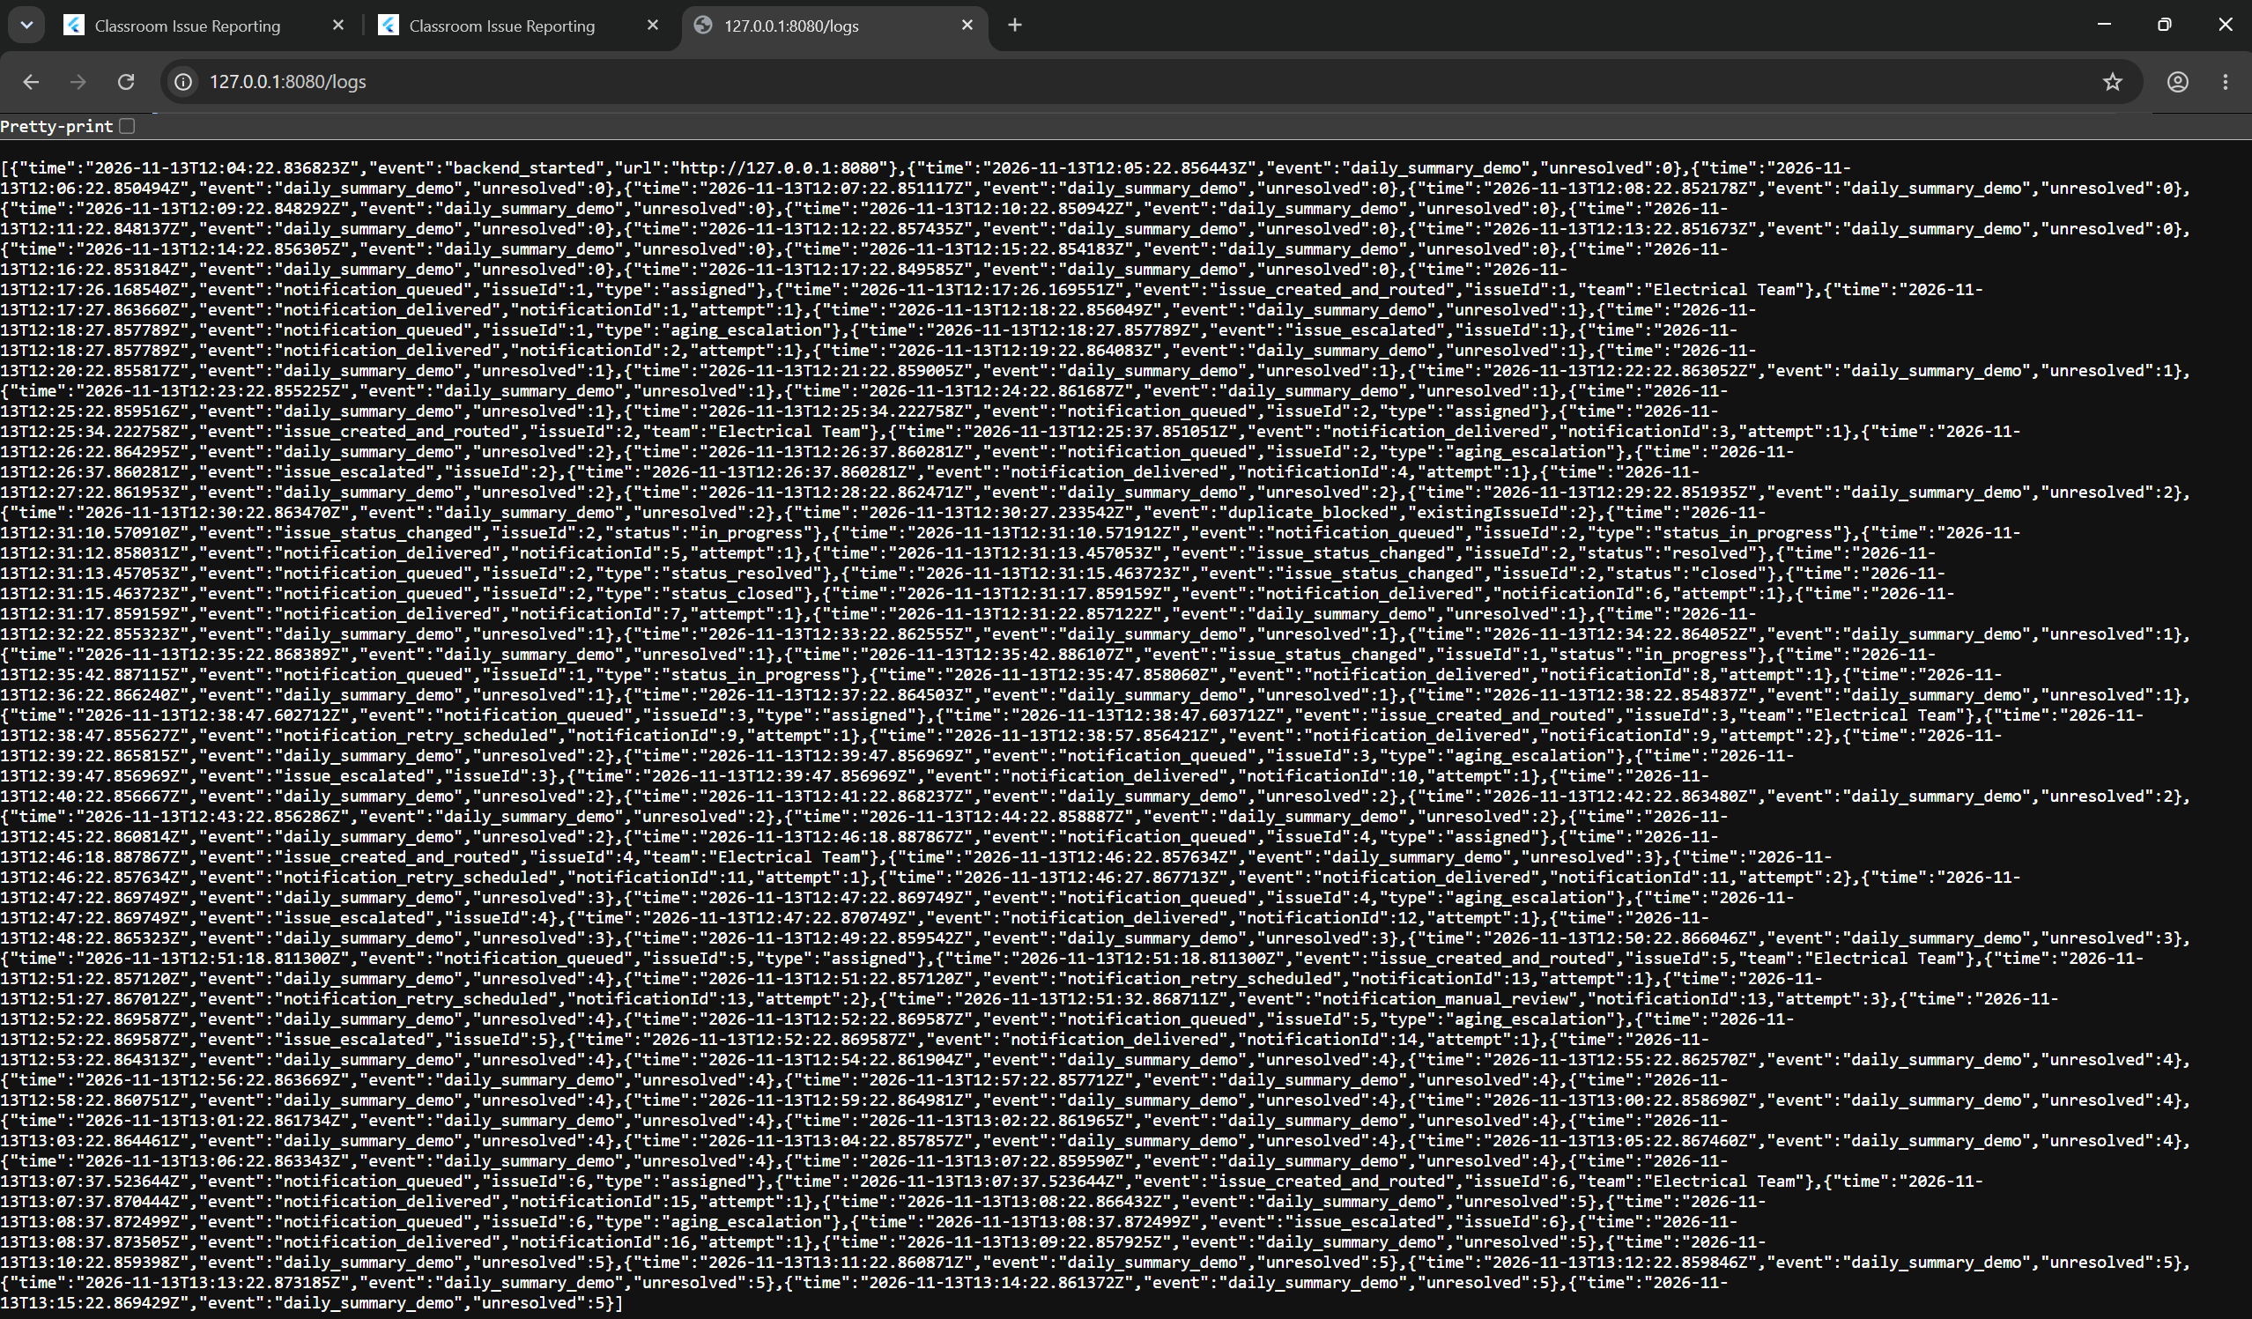

Evidence 13 — Project structure and code
Filename | W13_13_Folder_And_Code.png
How to capture | Open VS Code Explorer showing frontend, backend, docs and evidence.
Expected result | Project file tree is readable and complete.
Actual result | ____________________________________________


