ADDING TWO NUMBERS

PSEUDOCODE

Begin

Enter first number, second number

Accept first number, second number

Compute sum as first number + second number

Display ‘The sum of two number is’ sum

End

AREA OF A CIRCLE

PSEUDOCODE

BEGIN

NUMBER r, area

INPUT r

Area=3.14\*r\*r

OUTPUT area

END

A program that will identify if a number is odd or even

a. Procedure

Step 1: Start

Step 2: Read: Number

Step 3: Check: If Number%2 == 0 Then

Print : N is an Even Number.

Else

Print : N is an Odd Number.

Step 4: Stop

b. Flowchart

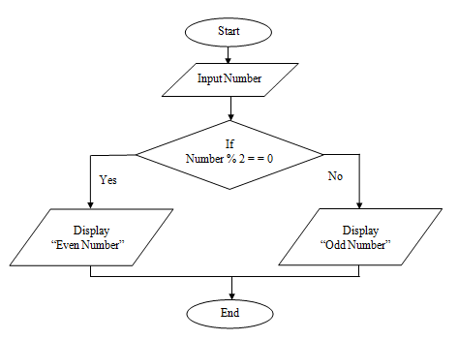

c. Pseudo-code

for n in range(1,11):

if (n% 2 == 0):

print n, &quot;is an even number.&quot;

else:

print n, &quot;is an odd number.&quot;