**Question 3**

(a)

randn('state',100);

%

T = 1.00; %expiry time

sigma = 0.25; %voliatility

mu = .018; %P measure drift

S_init = 90; %initial value

N_sim = 10000; % number of simulations

N=250; % number of timesteps

delt = T/N; % timestep

r = 0.03; % risk-free interest rate

K = S_init;

drift = r*delt; %under risk neutrail

sigma_sqrt_delt = sigma*sqrt(delt);

u = exp(sigma*sqrt(delt));

d = 1/u;

S = linspace(70,110,100); %the stock price at T = N-1

delta_S = 0.01; %initialized the delt_S value

%delta_S(1,:) = S(1,:).*(drift + sigma_sqrt_delt*randn(1,100));

%get simulated V0 price

%V = zeros(1,100); % straddle option payoff initialization

%V(1,:) = max(delta_S(1,:) + delta_S - K,0) + max(K- delta_S - S(1,:),0);

%V0_tao = zeros(1,100);

%V0_tao(1,:) = exp(-r*delt*(N-1)).*V(1,:);

%get V0 price

V0 = zeros(1,100);

[call0,put0] = blsprice(S(1,:), K, r, delt, .25);

V0 = call0 + put0;

[call,put] = blsprice(S(1,:)+delta_S, K, r, delt, .25);

V = call +put;

delta = zeros(1,100);

delta = (V(1,:) - V0(1,:))./delta_S;

%ratio = zeros(1,100);

%ratio(1,:) = delta(1,:)./S(1,:);

plot(S,delta);

title('Figure. delta values versus S from $70 to $110')

xlabel('S');

ylabel('delta');

The plot is shown below,

`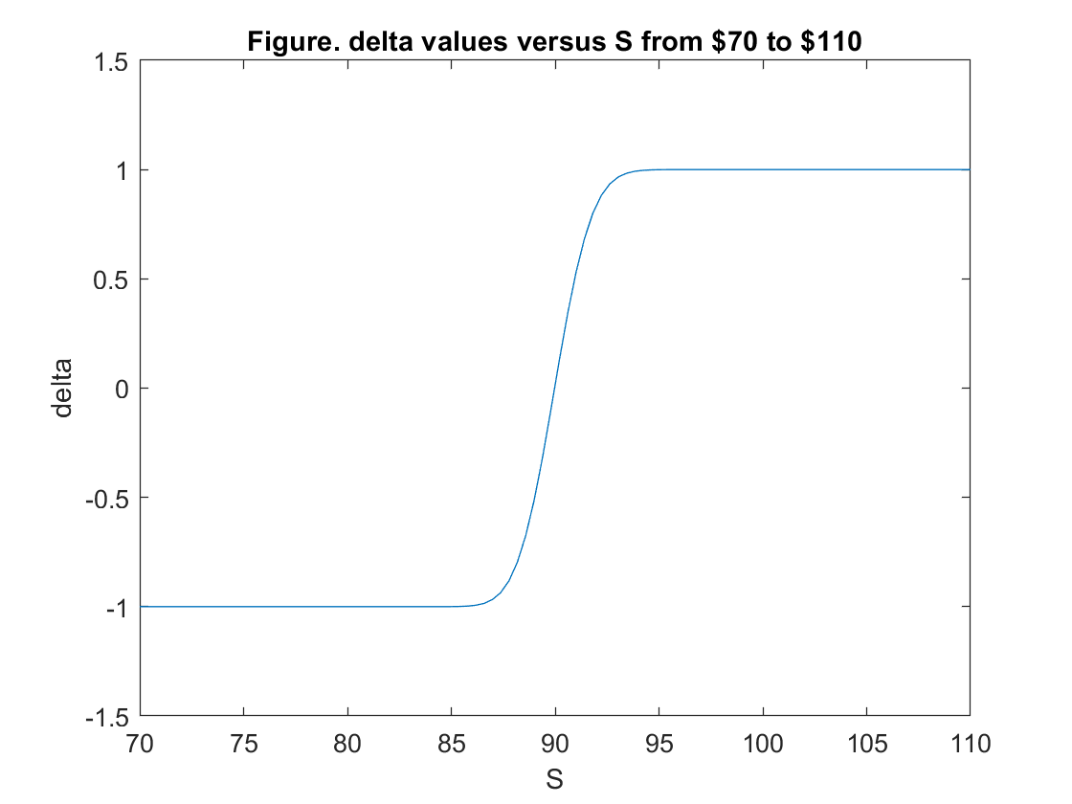

Question 3 (b)

S_init = 90; % initial stock price

K = 90; % strike price

N_sim = 10000; % number of simulation

T = 1.00; % time to expiry

sigma = 0.25; % volatility

r = 0.03; % risk free rate

mu = 0.18; % expected stock return

N = 250; % timesteps

delt = T / N; % time interval

%S_old = S_init * ones(N_sim, 1); % a vector to store simulated stock price

%S_new = zeros(N_sim, 1); % a vector to store simulated stock price

%S_sim = S_old; % a matrix to store all sample paths

% calculating option price using MATLAB function blsprice

[C0,P0] = blsprice(S_init, K, r, T, sigma);

V0 = C0 + P0;

% MC to generate the S prices by BS SDE formula

S_sim = zeros(N_sim,N+1);

S_sim(:,1) = S_init;

for i = 1:N

S_sim(:,i+1) = S_sim(:,i).*exp((mu-0.5*sigma^2)*delt + sigma*sqrt(delt)*randn(N_sim,1));

end

VN = max(S_sim(:, N+1) - K, 0) + max(K - S_sim(:, N+1),0); %calculate the payoff

Delta_sim = zeros(N_sim,N);

for i = 1:N

Delta_sim(:,i) = blsdelta(S_sim(:,i),K,r,delt*(N-i+1),sigma);

end

%for no hedging

B0 = V0; %get initial bond value

pie_T_0 = -VN + B0 .* exp(r*T); %get time T pie value

PL_0 = (pie_T_0) .* exp(-r*T) ./ V0;

figure('Name','No Hedging');

hist(PL_0,50);

% hedging position rebalanced at n = 0

B0 = V0 - Delta_sim(:,1) .* S_sim(:,1); % computing B0

% option value at expiry time

pie_T_1 = -VN + Delta_sim(:,1) .* S_sim(:,N+1) + B0 .* exp(r*T);

% value of portfolio at expiry T

PL_1 = pie_T_1 .* exp(-r*T) ./ V0; % relative hedging error

% plot histogram

figure('Name',' Hedging at n=0');

hist(PL_1,50);

% daily hedging

B1 = B0; % initial hedging position

% computing first hedging

for n = 2 : 1 : N

B1 = exp(r * delt) .* B1 + S_sim(:, n) .* (Delta_sim(:, n-1) - Delta_sim(:, n));

% computing hegding positon of bonds

end

pie_T_2 = -VN + Delta_sim(:, N) .* S_sim(:, N+1) + B1*exp(delt*r);

PL_2 = pie_T_2 .* exp(-r*T) ./ V0;

figure('Name','Daily Hedging ');

hist(PL_2,50);

% hedging position rebalanced weekly

Bw = B0;

for n = 6 : 5 : N

Bw = exp(r * delt * 5) .* Bw + S_sim(:, n) .* (Delta_sim(:, n-5)-Delta_sim(:, n));

% computing hegding positon of bonds

end

% option value at expiry time

pie_T_3 = -VN + Delta_sim(:, n) .* S_sim(:, N+1) + Bw*exp(r*(N-n)*delt);

PL_3 = pie_T_3 .* exp(-r*T) ./ V0;

% plot histogram

figure('Name','Weekly Hedging ');

hist(PL_3,50);

% hedging position rebalanced monthly

Bm = B0;

for n = 21 : 20 : N

Bm = exp(r * delt * 20) .* Bm + S_sim(:, n) .* (Delta_sim(:, n-20) - Delta_sim(:, n) );

% computing hegding positon of bonds

end

% option value at expiry time

pie_T_4 = -VN + Delta_sim(:, n) .* S_sim(:, N+1) + Bm * exp(r * delt * (N-n));

PL_4 = pie_T_4 .* exp(-r*T) ./ V0;

% plot histogram

figure('Name','Monthly Hedging ');

hist(PL_4,50);

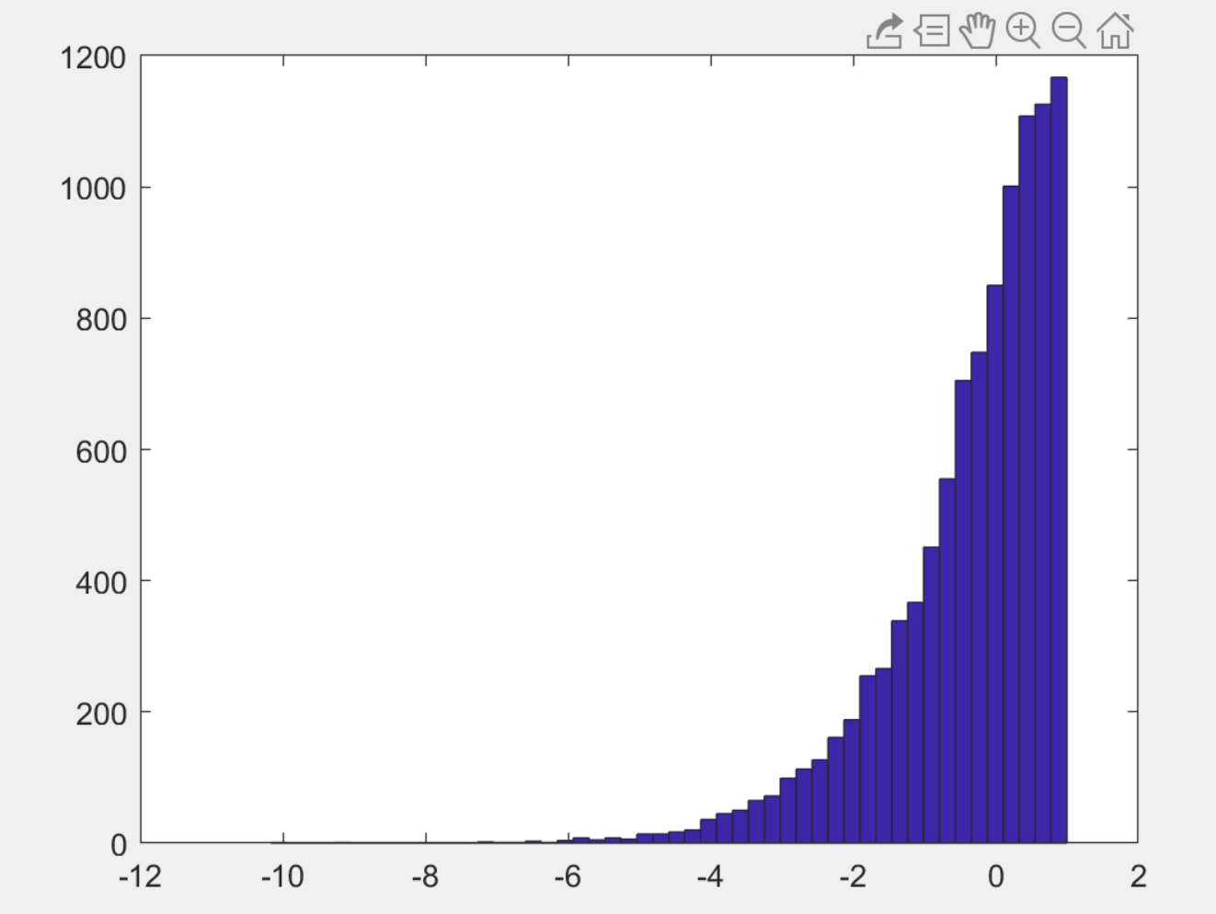

Figure. No hedging

As we can see from the figure above, the Profit and Loss are randomly scattered from about -7 to 1. And there are more portfolio has a positive profit. Later compared to the other hedging strategies, it is easily seen that the profit or loss by other hedging strategy is more closer to 0.

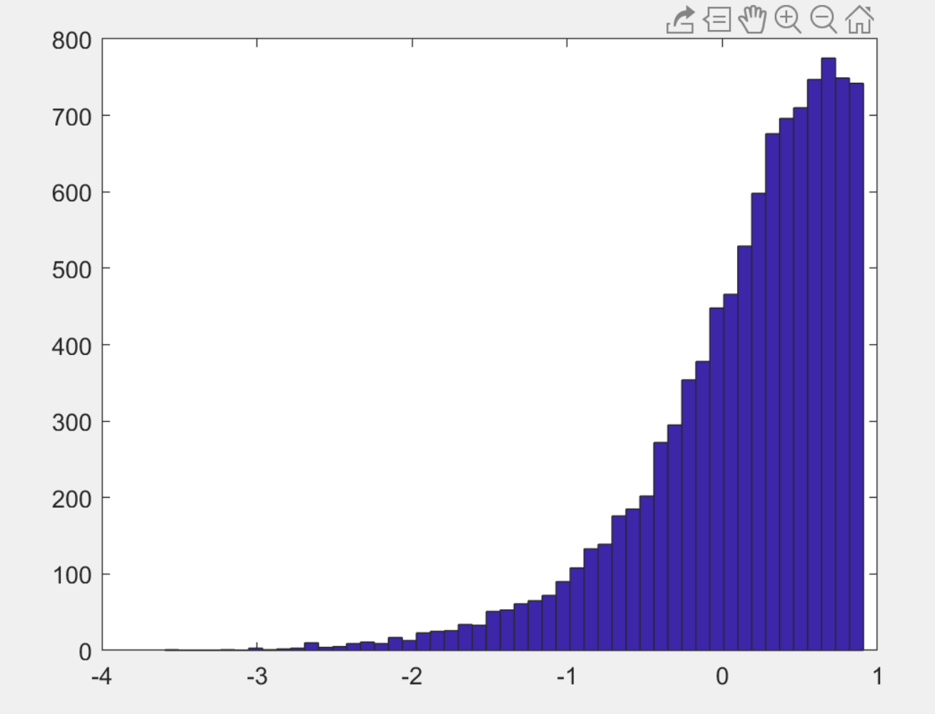

Figure. Hedging at time t = 0

Although there is only one time hedging, we do see improved from the figure above, there is not more portfolio has a more value, more and more portfolio are scattered from -1 to 1. There are very few portfolio has a value less than -3.

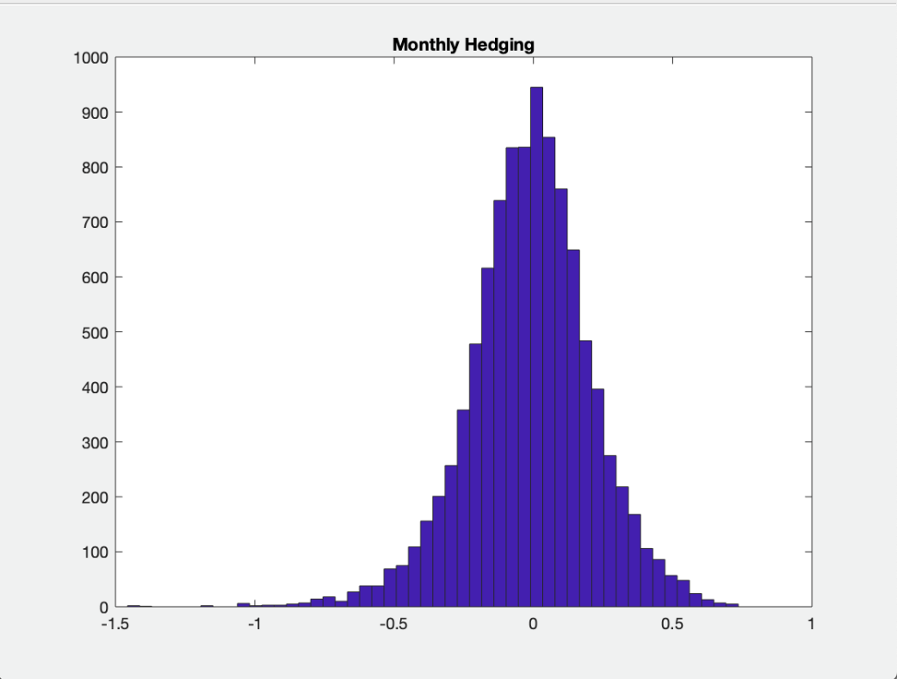

Figure. Monthly Hedging

The above figure is for monthly hedging strategy, as we can see from the figure above, very few portfolio has a value less than -2. And more and more portfolio has a value from -0.5 to 0.5.

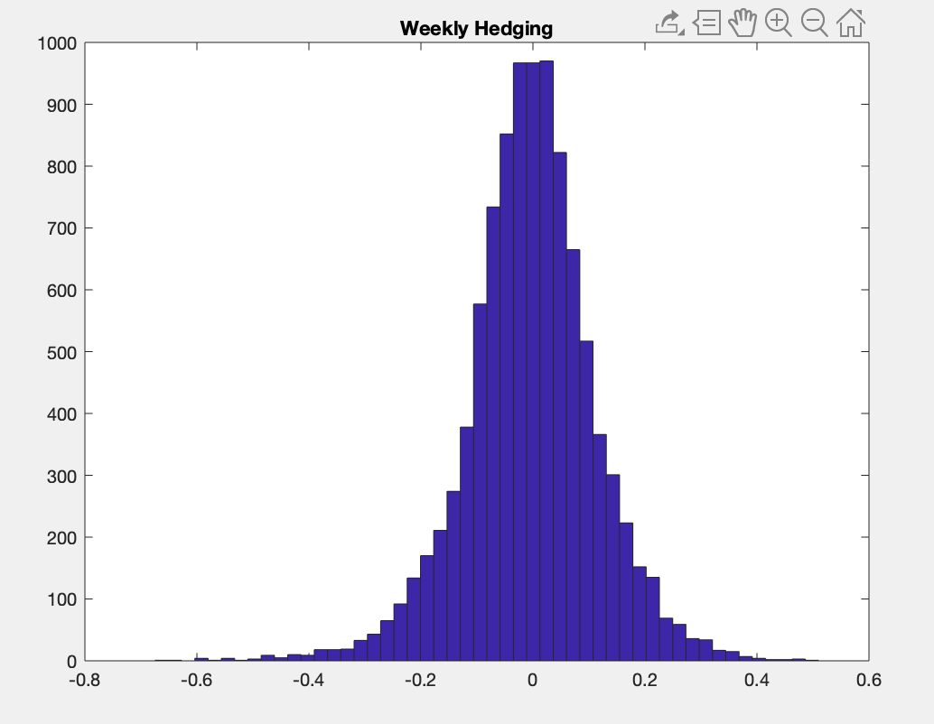

Figure. Weekly Hedging

We see an improvement compared to the monthly hedging, most of portfolio are from -0.5 to 0.5. and very less portfolio have a value less than -1.

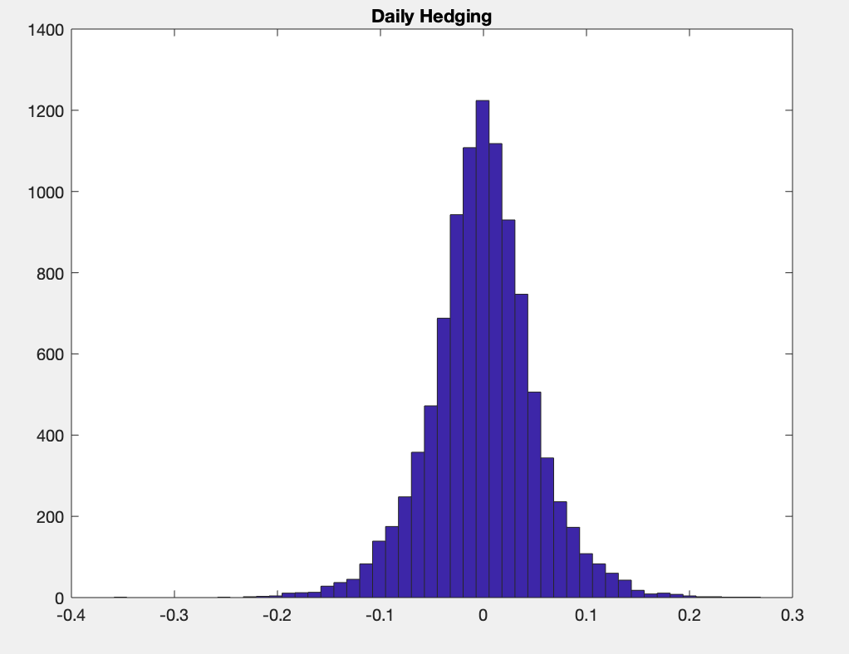

Figure. Daily Hedging

We see an improvement compared to the weekly hedging, most of portfolio are at 0. and very less portfolio have a value less than -1.

(c)

function [Var,CVaR]=dVaRCVaR(PL, beta)

%% this function is used to calculate the VaR and CVaR value

%% It reqiure an input of Profit and Loss and beta

sorted_PL = sort(PL); % sort P&L in increasing order

index = floor((1-beta)*length(PL)); % find the index of M simulated P&L for beta (s.t. index/M <= 1-beta)

Var = sorted_PL(index); % compute VaR

CVaR = mean(sorted_PL(1:index)); %compte CVaR

end

(d)

[var0, cvar0] = dVaRCVaR(PL_0, 0.98)

mean(PL_0)

std(PL_0)

[var1, cvar1] = dVaRCVaR(PL_1, 0.98)

mean(PL_1)

std(PL_1)

[var2, cvar2] = dVaRCVaR(PL_2, 0.98)

mean(PL_2)

std(PL_2)

[var3, cvar3] = dVaRCVaR(PL_3, 0.98)

mean(PL_3)

std(PL_3)

[var4, cvar4] = dVaRCVaR(PL_4, 0.98)

mean(PL_4)

std(PL_4)

|  |  |  |  |  |  |
| --- | --- | --- | --- | --- | --- |
|  |  |  |  |  |  |
|  | No hedge | Hedge once | Monthly hedge | Weekly hedge | Daily hedge |
| mean | -0.3635 | 0.14 | 0.2329 | 0.239 | 0.2397 |
| sd | 1.179 | 0.627 | 0.4154 | 0.4036 | 0.3985 |
| VaR(98%) | -3.6506 | -1.603 | -1.1237 | -1.0917 | -1.0827 |
| CVaR(98%) | -4.5215 | -2.0312 | -1.4234 | -1.3812 | -1.3738 |

Table : The mean, sd, VaR and CVaR for no hedging, heding once, monthly hedging, weekly hedging and daily hedging

As we can see from the table above, we do see an improvement no matter VaR and CVaR (we can see the loss value gradually approaches to 0). And as for the mean and sd, it should congerve to 0, and we do see from no hedging to daily hedging, the mean value and sd value converges to 0.

(e)

In American option, we have to detect the time when point is the optimal exercise time(whether the intrinsic value is greater than continuation value) because American option can be exercised anytime when intrinsic value exceeds continuation value.

The value of American option on the each nodes of binomial tree changes, since American option is more valuable than European option, and thus leading to the changes of delta hedging position, and then the accumulated bond value alters as delta position shifts.