Question 4

1. From the question, we know that the delta = 1 when $S_{t}>K$, which means we will buy one share of the stock, and delta = 0 when $S_{t}<K$, which means we have no more share of stocks in our hand.
$$δ_{t}=\left\{\begin{aligned}0, S_{t}<K \\ 1, S_{t}>K\end{aligned}\right.$$

2. From part a, we know that the writer will borrow money from bank to buy one share of stock if $S_{t}>K$, and this happens immediately after $S_{t}>K$. Therefore, the money we used to buy the stock is K. And since the writer shorts the call option at time t=0, which means we collect $C_{0}$ money at the beginning. Therefore, from the equation of the portfolio, we have

$π_{0}=-C_{0}$ + $B_{0}+K$

Since the initial portfolio has value 0 ($π_{0}=0$). Therefore, we get $B_{0}=C_{0}-K.$ Thu the value of the portfolio

$$δ_{t}S_{t}+B_{t}=S_{t}+ C_{0}-K$$

When $S_{t}<K$, the writer sells the stock at $K$ and pay back to the bank. So the writer has no stock and the only asset left is $B_{t}= C_{0}-K+K= C_{0}$.

Therefore, at any time $0<t<T$, $δ_{t}S_{t}+B_{t}=C_{0}.$

Therefore, we can conclude that the portfolio value $δ_{t}S_{t}+B_{t}$ is either $S_{t}+ C_{0}-K$ or $C_{0}$ at time $0<t<T$.

1. When $S_{T}>K$, the option holder will exercise the option, thus the $-C_{T}= -\left(S_{T}-K\right)=K- S_{T}$. Also, from previous part, we see that when $B_{0}=C_{0}-K$ when $S_{t}>K$. Therefore, at $S_{T}>K$, the hedging error is

$-C_{T}+δ_{T}S_{T}+B_{T}= K- S_{T}+S_{T}+C_{0}-K= C_{0}$.

The hedging error is $\frac{C_{0}}{C_{0}}=1$

When $S_{T}<K$, the option holder will not exercise the option, and the writer will sell the stock to pay back to the bank, from part (b) as well, we can know that

$-C_{T}+δ_{T}S_{T}+B_{T}= 0+ 0+C_{0}= C_{0}$.

The hedging error is $\frac{C_{0}}{C_{0}}=1$ as well.

(d)

S_init = 99; % initial stock price

K = 100; % strike price

T = 1.00; % time to expiry

sigma = 0.25; % volatility

r = 0.03; % risk free rate

mu = 0.18; % expected stock return

N = [100,200,400,800]; % rebalancing times

delt = T ./ N; % time interval

% calculating option price using MATLAB function blsprice

C0 = blsprice(S_init, K, r, T, sigma);

% B0 = C0 at t = 0

B0 = C0;

% simulating sample path

pie = zeros(80000,4); % pie value initialization

for j = 1:4

S_sim = zeros(80000,N(j)+1);

B_sim = zeros(80000,N(j)+1);

S_sim(:,1) = S_init;

B_sim(:,1) = B0;

for i = 1:N(j)

% calculating relative hedging error value

% if currently holding the stock & next period S < K, then sell the stock

% if currently not holding the stock & next period S > K, then buy stock

S_sim(:,i+1) = S_sim(:,i).*exp((mu-0.5*sigma^2)*delt(j) + sigma*sqrt(delt(j))*randn(80000,1));

B_sim(:,i+1) = B_sim(:,i).*exp(r*delt(j)) - ...

(S_sim(:,i+1) > K & S_sim(:,i) <=K).*S_sim(:,i+1) +(S_sim(:,i+1) < K & S_sim(:,i) >= K).*S_sim(:,i+1);

end

pie(:,j) = exp(-r*T).*(-max(S_sim(:,N(j)+1)-K,0) + (S_sim(:,N(j)+1) > K) .*S_sim(:,N(j)+1) +B_sim(:,i))./C0;

end

%mean, standard deviation, VaR and CVaR initialization

mea = zeros(4,1);

sd = zeros(4,1);

VaR = zeros(4,1);

CVaR = zeros(4,1);

for j = 1:4

mea(j) = mean(pie(:,j));

sd(j) = std(pie(:,j));

[VaR(j),CVaR(j)] = dVaRCVaR(pie(:,j),0.95); % call the function that we write in question 3

end

%generate a table

Table = table(mea,sd,VaR,CVaR);

Table.Properties.VariableNames = {'mean','sd','VaR','CVaR'};

Table.Properties.RowNames = {'N=100','N=200','N=400','N=800'};

histogram(pie(:,4));

Thus from above code, we have generated an table to summarize all mean,sd, VaR and CVaR value. From the table, we can see that it’s not really always 0.

mean sd VaR CVaR

__________ ______ _______ _______

N=100 0.0037766 1.6275 -1.4123 -3.7599

N=200 -0.014008 1.4237 -1.3864 -3.2417

N=400 0.00048623 1.2634 -1.3413 -2.8158

N=800 -0.0075547 1.1238 -1.3352 -2.5042

Table 2: mean, sd, VaR and CVaR with timsteps from 100 to 800

No matter how many times the position is rebalanced, we can see that the standard deviation still exists around 1, and the mean value is not always 0 even though we increase the number or rebalancing time. However, we do see the VaR and CVaR value approaches to 0, which means with the increase of the number of rebalancing time, the portfolio is closer and closer to perfect hedging.

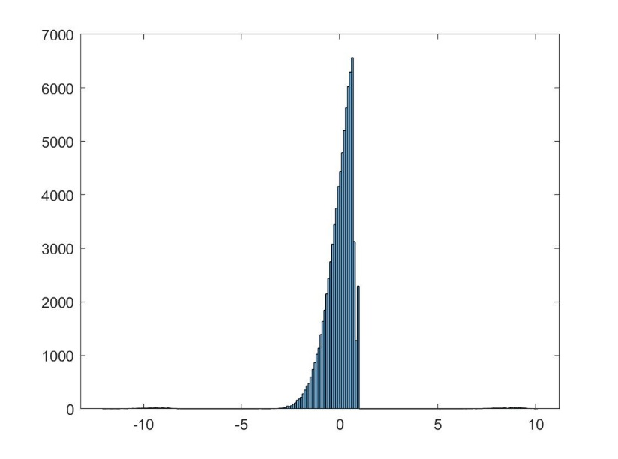

As we can see from the figure above, there seems exist a left tail but does not exist a right tail. Although the peak is at the 0. It has a fatter tail at the left side, which seems reasonable to have the data CVaR = -2.5042.