Question 5

(a)

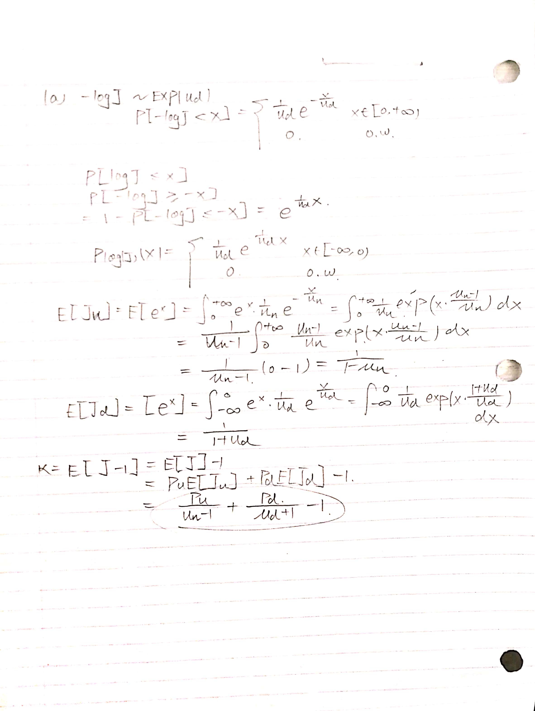

（b）

T = 1.00; % time to expiry

sigma = 0.15; % volatility

r = 0.03; % risk free interest rate

S_init = 90;

K = S_init;

%jump size: log normal distribution

p_u = 0.4; % probability of up jump

lambda = .1; % jump size arrival rate lambda = 0.1

u_u = 0.32; % parameter for up movement

u_d = 0.3; % parameter for down movement

N_sim = 25000;

N=800;

delt = T/N; % delt = 1/1000

jump_up_mean = u_u;

jump_down_mean = u_d;

%

% compenstaed drift E[J-1]

%

%kappa value that we found int question 5 (a)

kappa = p_u/(1-u_u) + (1-p_u)/(u_d + 1) - 1;

%

% compensated drift for X = log(S)

drift = r - delt/2 - lambda*kappa;

%

% X = log(S)

%

X_old(1:N_sim,1) = log(S_init);

X_new(1:N_sim,1) = zeros(N_sim,1);

jump_chek = zeros(N_sim,1);

jump_size = zeros(N_sim,1);

jump_mask = zeros(N_sim,1);

for i = 1:N %timestep loop

jump_chek(:,1) = rand(N_sim,1); % first check to determine lambda*delt

jump_chek2(:, 1) = rand(N_sim, 1); % second check to determine p_u

jump_mask(:,1) = (jump_chek(:,1) <= lambda*delt);

jump_mask2(:, 1) = (jump_chek2(:, 1) <= p_u);

jump_mask3(:, 1) = (jump_chek2(:, 1) > p_u);

jump_size = (jump_mask2 .* exprnd(u_u, N_sim, 1)) -... % determine the jump_size

(jump_mask3 .* exprnd(u_d, N_sim, 1));

jump_size = jump_size .* jump_mask;

X_new(:,1) = X_old(:,1) + drift*delt + sigma*sqrt(delt)*randn(N_sim,1)+...

jump_size(:,1);

X_old(:,1) = X_new(:,1);

end %timestpe loop

S(:,1) = exp(X_new(:,1));

n_bin = 200;

hist(S,n_bin);

W(:,1) = max(K-S,0);

%European put option

Ep = exp(-r*T)*mean(W(:,1));

disp(sprintf('put option price is : %.5g\n', Ep));

|  |  |  |  |
| --- | --- | --- | --- |
|  | 800/25000 | 1600/100000 | 3200/400000 |
| European Put | 5.0515 | 5.0633 | 5.0722 |
|  |  |  |  |

Table: European Put Option price under different timesteps and simulation number

(c)

T = 1.00; % time to expiry

sigma = 0.15; % volatility

r = 0.03; % risk free interest rate

mu = 0.10;

S_init = 90;

K=linspace(70, 120, 20);

%jump size: log normal distribution

p_u = 0.4; % probability of up jump

lambda = .1; % jump size arrival rate lambda = 0.1

u_u = 0.32; % parameter for up movement

u_d = 0.3; % parameter for down movement

N_sim = 25000;

N=800;

delt = T/N; % delt = 1/1000

jump_up_mean = u_u;

jump_down_mean = u_d;

jump_up_vol = u_u^2;

jump_down_vol = u_d^2;

%

% compenstaed drift E[J-1]

%

%kappa = exp(.5*jump_vol*jump_vol + jump_mean) - 1.;

kappa = p_u/(1-u_u) + (1-p_u)/(u_d + 1) - 1;

%

% compensated drift for X = log(S)

drift = r - delt/2 - lambda*kappa;

X_old = zeros(N_sim,20);

X_new = zeros(N_sim,20);

S = zeros(N_sim,20);

W = zeros(N_sim,20);

P = zeros(1,20);

%

% X = log(S)

%

for j = 1:20

X_old(1:N_sim,j) = log(S_init);

X_new(1:N_sim,j) = zeros(N_sim,1);

jump_chek = zeros(N_sim,1);

jump_size = zeros(N_sim,1);

jump_mask = zeros(N_sim,1);

for i = 1:N %timestep loop

jump_chek(:,1) = rand(N_sim,1);

jump_chek2(:, 1) = rand(N_sim, 1);

jump_mask(:,1) = (jump_chek(:,1) <= lambda*delt);

jump_mask2(:, 1) = (jump_chek2(:, 1) <= p_u);

jump_mask3(:, 1) = (jump_chek2(:, 1) > p_u);

jump_size = (jump_mask2 .* exprnd(u_u, N_sim, 1)) -...

(jump_mask3 .* exprnd(u_d, N_sim, 1));

jump_size = jump_size .* jump_mask;

jump_size = jump_size.*jump_mask;

X_new(:,j) = X_old(:,j) + drift*delt + sigma*sqrt(delt)*randn(N_sim,1)+...

jump_size(:,1);

X_old(:,j) = X_new(:,j);

end %timestpe loop

S(:,j) = exp(X_new(:,j));

n_bin = 200;

hist(S,n_bin);

W(:,j) = max(K(j)-S(:,j),0);

%European put option

P(j) = mean(W(:,j));

disp(sprintf('put option price is : %.5g\n', P(j)));

end

Volat = blsimpv(S_init,linspace(70,120,20),r,T,P,[],[],[],false);

plot(linspace(70,120,20),Volat)

xlabel('Strike Price');

ylabel('Implied Volatility');

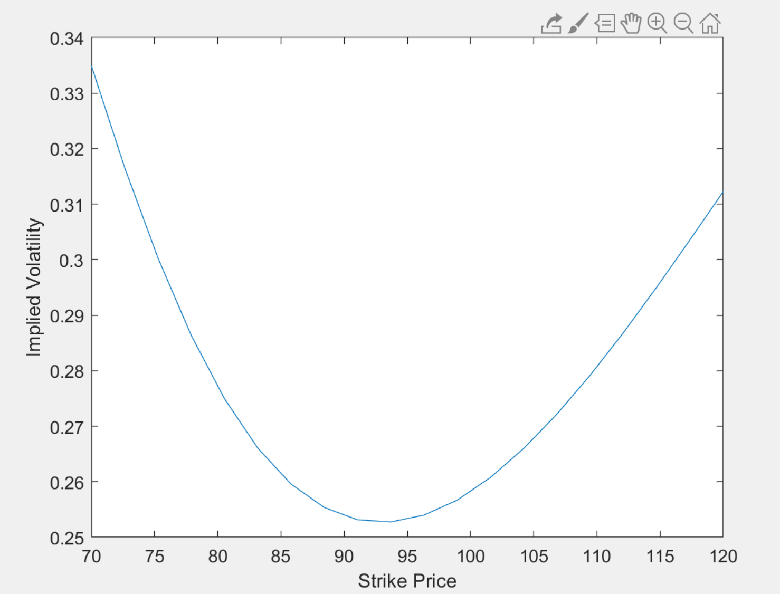

Figure. The Implied Volatility vs the Strike Price

It has shown in the graph, the observed volatility forms a volatility smile over the European Option price. The graph generated by the simulation is reasonable to the implied volatility decreases first and then increases with the increase of strike prices