Data Mining Goal:

Problem:  
To allow an investor to choose a stock to invest and try to get the maximum return and minimum lose.

To do:

Base on the daily stock market activity, identify some stocks which are able to be predicted whether the closing prices will raise or going down.

Activity done in this milestone 4:

1. Quantitative analysis

To archive this, the stocks from the Gas industry are selected. The stocks are 1) GASMSIA 2) SIGGAS, PETGAS, PETGAS-CS and PETGAS-CR.

The daily stock closing data is loaded into SAS Enterprise Miner and the result of the exploration are as below:  
  
a) The closing data for the selected stock (the data has been collected from 22Feb till 26Apr)

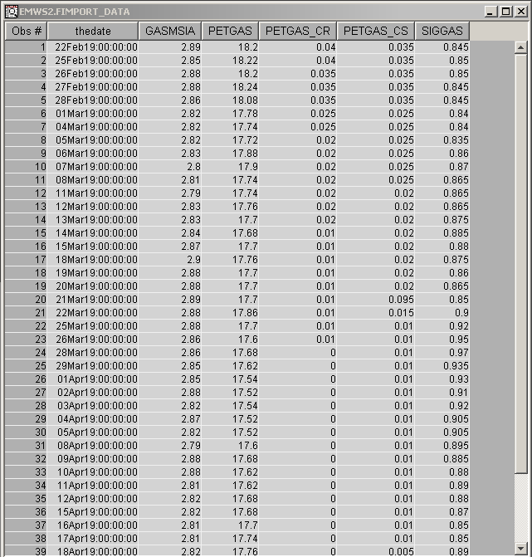

b) The sample data

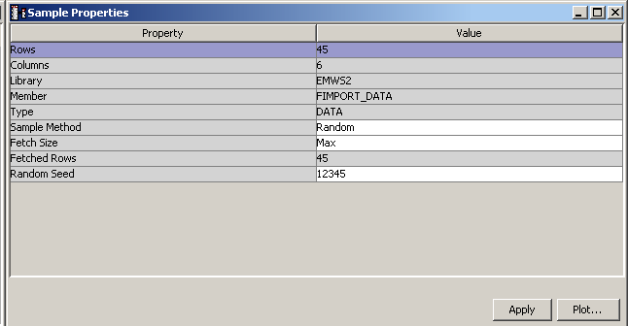

c) The statistical information of the selected stocks are listed as below:  
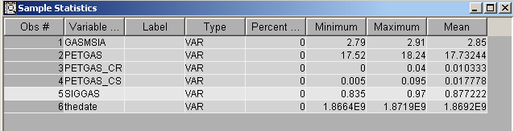

d) Overview the activities of the stocks

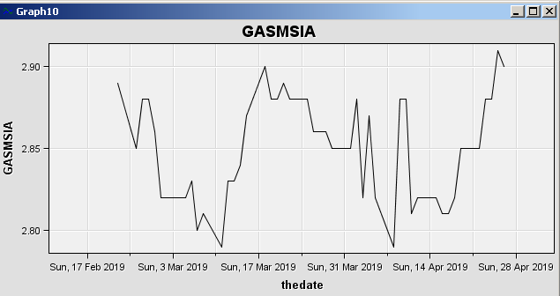 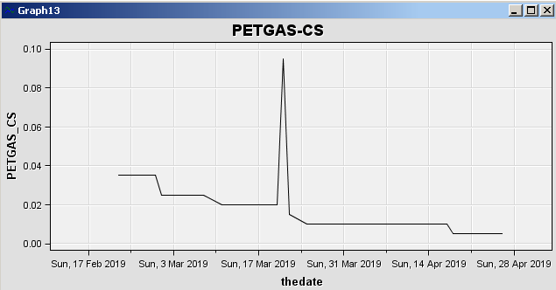

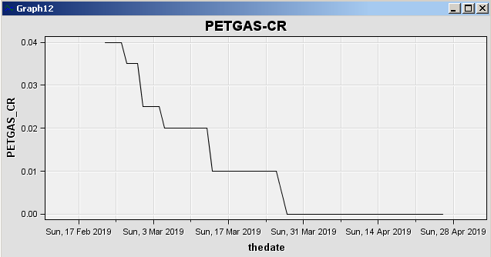 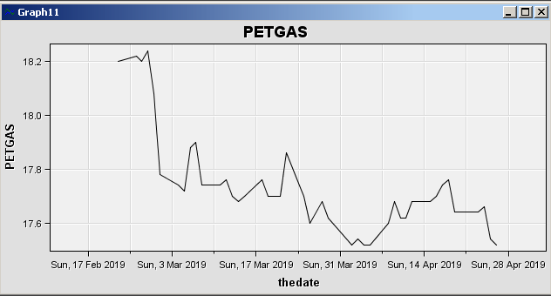

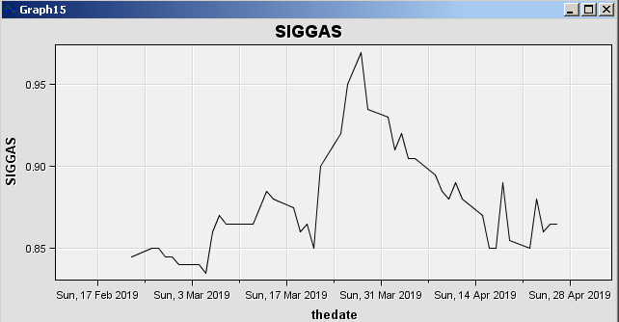

1. Quantitative analysis

Base on the news form headlines of The Edge and Malaysiakini. During the period of the capturing the closing price of the Stocks related to Gas Industry, there are some headlines which is related to the GAS industry.

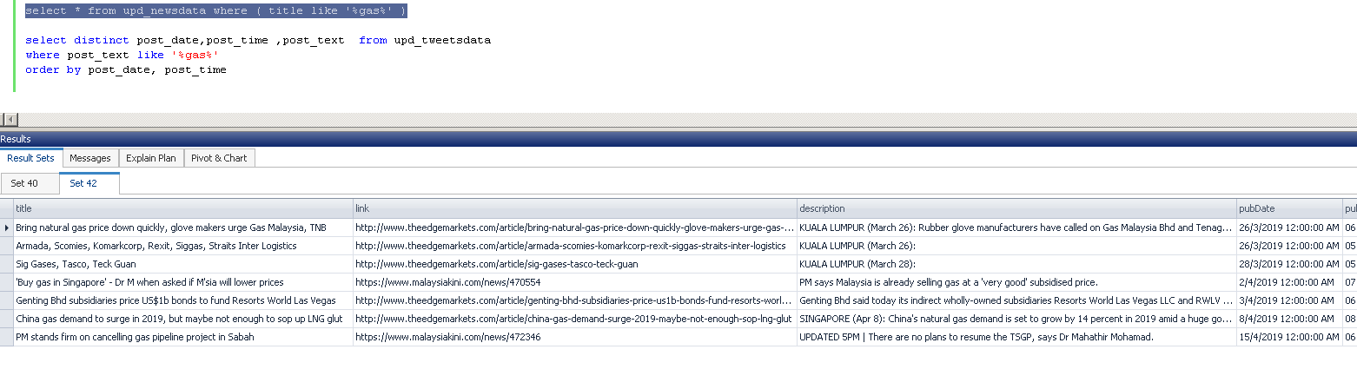

1. On 26th March, the head about:

|  |
| --- |
| KUALA LUMPUR (March 26): Rubber glove manufacturers have called on Gas Malaysia Bhd and Tenaga National Bhd (TNB) to revise the natural gas tariff to be in line with the international prices of liquefied natural gas (LNG) and coal.  <http://www.theedgemarkets.com/article/bring-natural-gas-price-down-quickly-glove-makers-urge-gas-malaysia-tnb> |

This caused the closing prices of GASMSIA and PETGAS to go down in that day. It means there were pressure come from the other industry to interfere the GAS industrial development.   
  
However, GIGGAS was not affected. SIGGAS remain steady on that day because SIGGAS was selected to be an example in article “Stock and momentum”. The article link is <https://www.theedgemarkets.com/article/armada-scomies-komarkcorp-rexit-siggas-straits-inter-logistics>.

The stock closing price chart:  
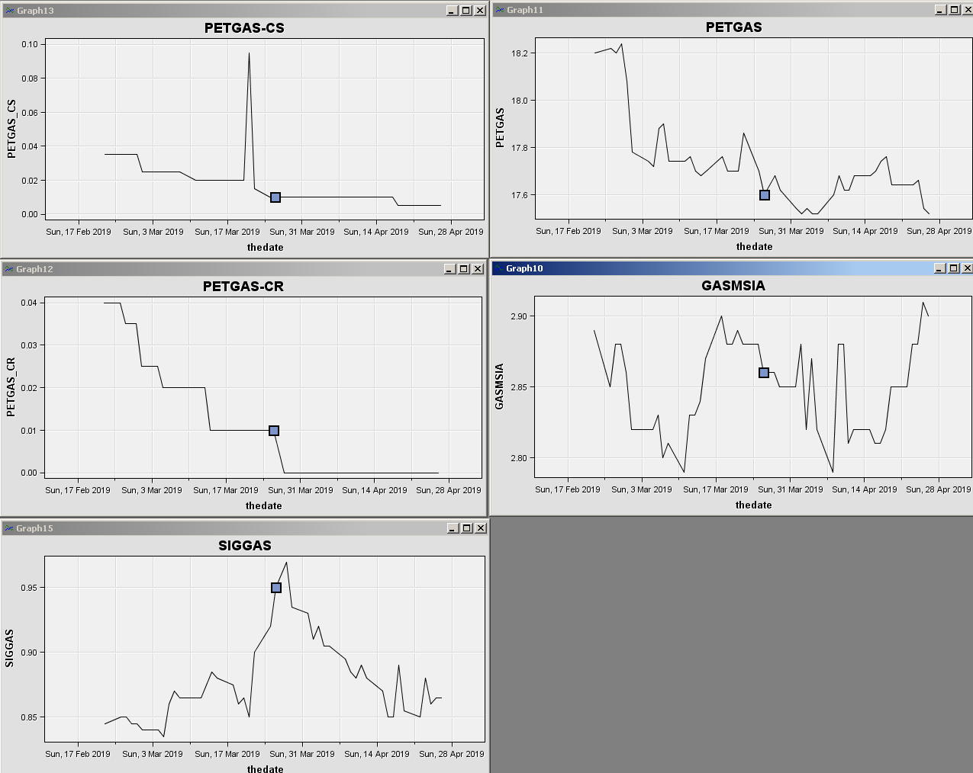

1. On 28th March, SIGGAS again was selected as an example of the article published in The Edge. The link is <http://www.theedgemarkets.com/article/sig-gases-tasco-teck-guan>.

This has help the SIGGAS continuously increase the closing price.

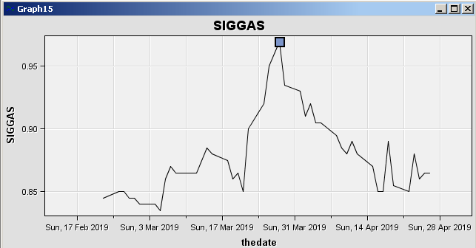

1. On 2nd Apr, the headline about:

|  |
| --- |
| PM says Malaysia is already selling gas at a 'very good' subsidised price.  <https://www.malaysiakini.com/news/470554> |

SIGGAS get the very huge impact and the closing price increased, but then, the next day the closing price dropped.

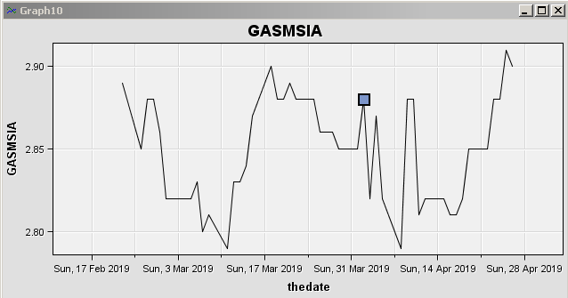

1. On 8th Apr, there is an article released about:

|  |
| --- |
| China gas demand to surge in 2019, but maybe not enough to sop up LNG glut  <http://www.theedgemarkets.com/article/china-gas-demand-surge-2019-maybe-not-enough-sop-lng-glut> |

PETGAS and GASMSIA had great impact by the article. The next day, both of their closing prices had increased. This might because there is new market opportunity from oversea.

1. On 15th Apr, there is a headline about:

|  |
| --- |
| PM stands firm on cancelling gas pipeline project in Sabah  <https://www.malaysiakini.com/news/472346> |

The pipeline was confirmed by PM that it will not be build. The PETGAS, GASMSIA and SIGGAS had increased the stock closing prices next day.  
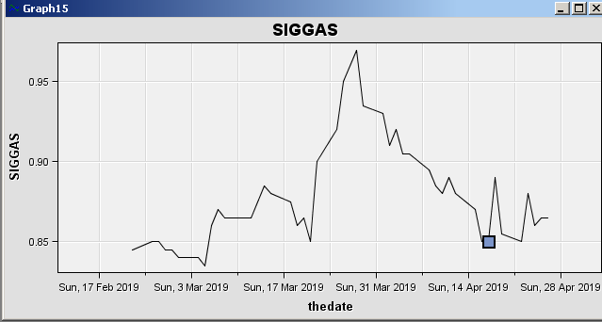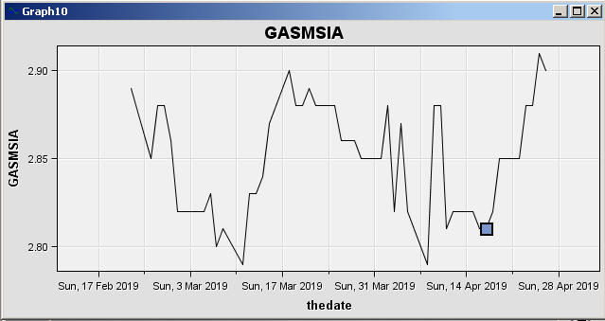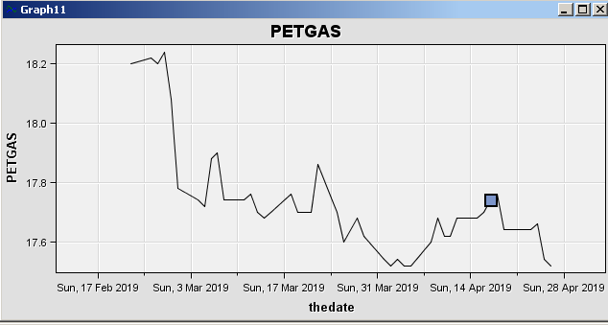  
  
The Sabah gas pipeline might be their new competitor. Therefore, when it was confirmed that the pipeline will be build, the market of the existing Gas are stable.

Conclusion:

The headlines from The Edge and Malaysiakini which are related to the GAS industry can be categorised into 2 categories, Government related (related to Government policy and plan) and market opportunity (market demand). The government related headline mostly will impact more on the closing price of the stock if compare to the market demand head line.