**ACCESS MODIFIERS AND STATIC**

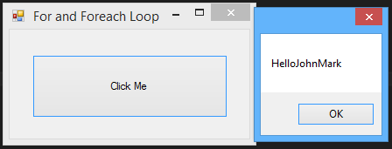

**Syntax:**

***Form1.cs***

private void button1_Click(object sender, EventArgs e)

{

MyClass constructor = new MyClass("JohnMark");

MyClass.ShowMess(constructor.name());

}

***MyClass.cs***

class MyClass

{

string name2;

public MyClass(string name)

{

name2 = name;

}

public string name()

{

return name2;

}

public static void ShowMess(string message)

{

MessageBox.Show("Hello" + message);

}

}