**ARRAY, LIST**

**ARRAY  
Output:**

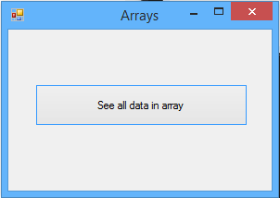 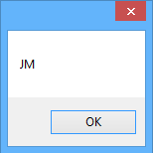

**Syntax:**

int i = 0;

private void button1_Click(object sender, EventArgs e)

{

string[] names = {"JM","MAE","ABRIL"};

while(i<names.Length){

MessageBox.Show(names[i]);

i++;

}

}

**LIST**

**Output:**

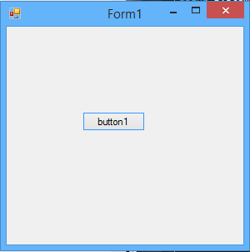 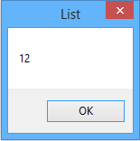

**Syntax:**

int i = 0;

private void button1_Click(object sender, EventArgs e)

{

List<int> numbers = new List<int>();

numbers.Add(12);

numbers.Add(15);

while (i < 2)

{

MessageBox.Show(numbers[i].ToString(),"List");

i++;

}

}

**FOREACH**

**Syntax:**

private void button1_Click(object sender, EventArgs e)

{

double[] nums = {12.15,10.11,9.17};

foreach (double x in nums)

{

MessageBox.Show(x.ToString());

}

}

**TRY CATCH and FINALLY**

private void button1_Click(object sender, EventArgs e)

{

try

{

double[] nums = { 12.15, 10.11, 9.17 };

foreach (double x in nums)

{

MessageBox.Show(x.ToString());

}

}

catch (Exception ex)

{

MessageBox.Show(ex.Message);

}

finally

{

MessageBox.Show("Your code is Done!");

}

}

**METHODS**

**Syntax:**

Void methodName (){

Statements;

}

dataType methodName (dataType parameterName)

{

Return parameterName;

}