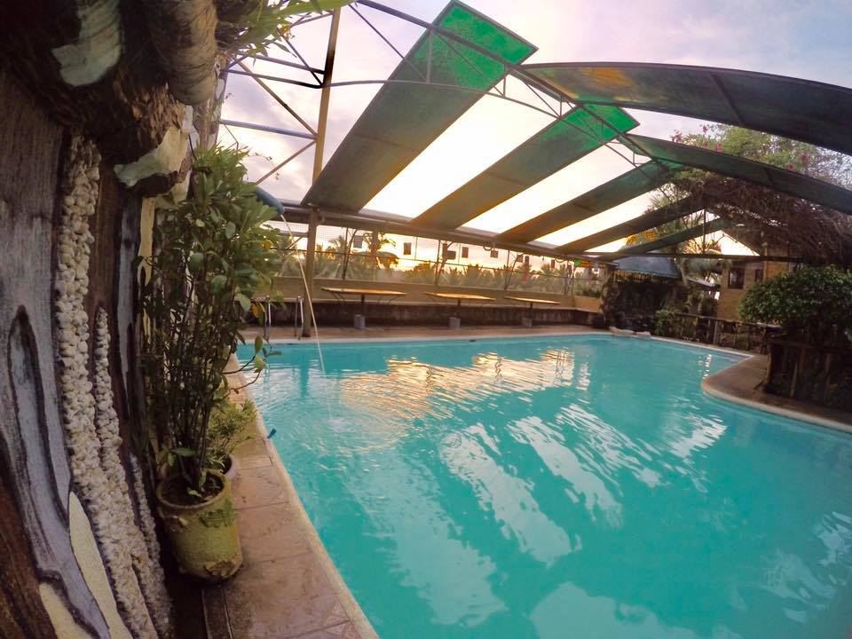

**LACASA ANTIGO RESORT PRIVAYE POOL**

**RESERVATION : 6000 WEEKEDAYS – 6500 WEEKENDS**

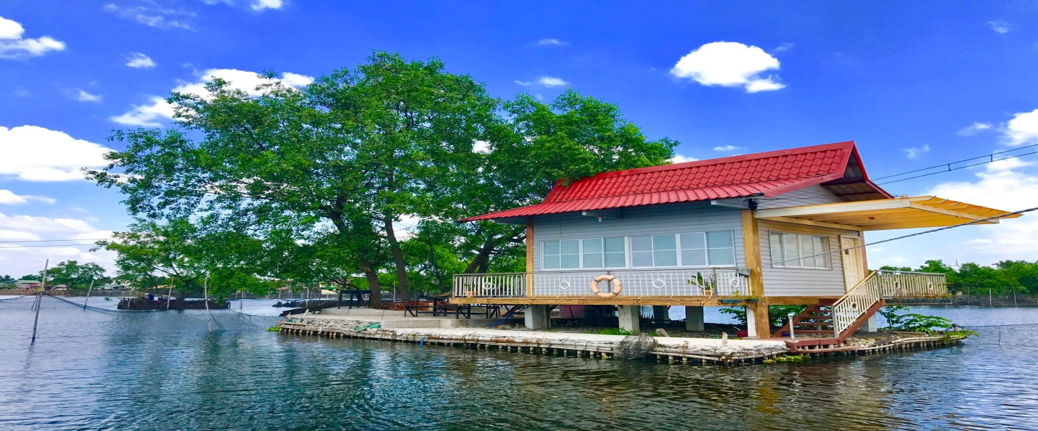

**LACASA ANTIGO RESORT FISHING VILLA**

**RESERVATION: 5000 WEEKENDS AND WEEKDAYS**

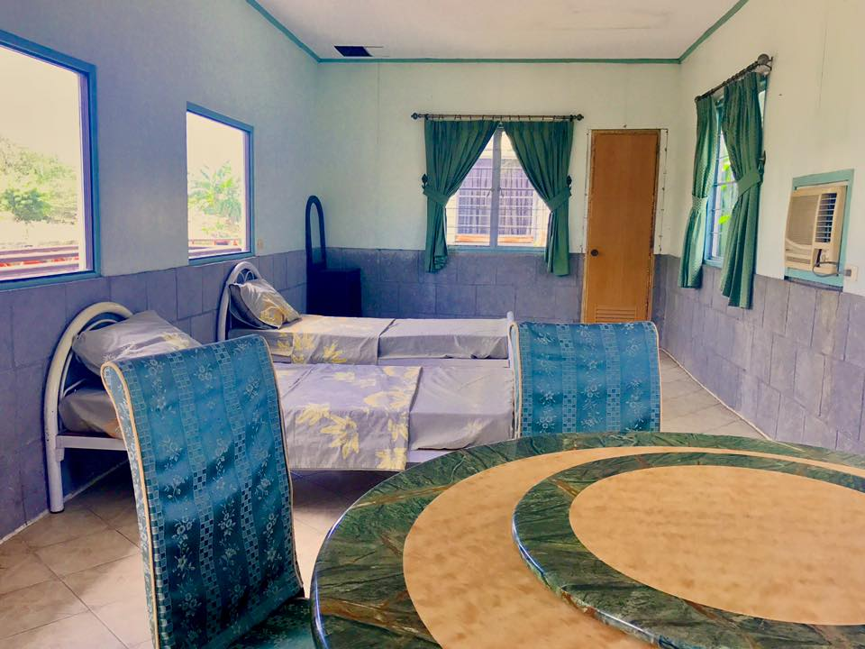

**LACASA ANTIGO RESORT LARGE COTTAGE**

**RESERVATION: DAY TOUR (8:00 AM TO 5:00PM) -700 NO AIRCON - 1000 WITH AIRCON**

**OVERNIGHT(2:00 PM TO 12:00 AM) 2000 NO AIRCON – 3000 WITH AIRCON**

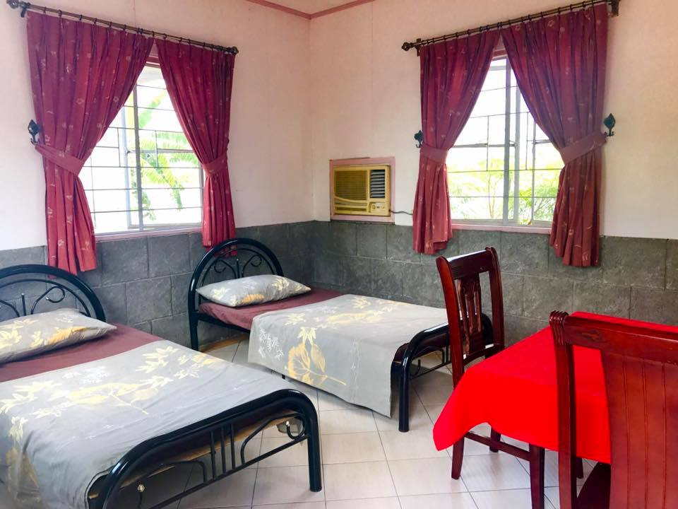

**LACASA ANTIGO RESORT SMALL COTTAGE**

**RESERVATION: DAY TOUR (8:00 AM TO 5:00PM) -500 NO AIRCON - 700 WITH AIRCON**

**OVERNIGHT(2:00 PM TO 12:00 AM) 1500 NO AIRCON – 2500 WITH AIRCON**

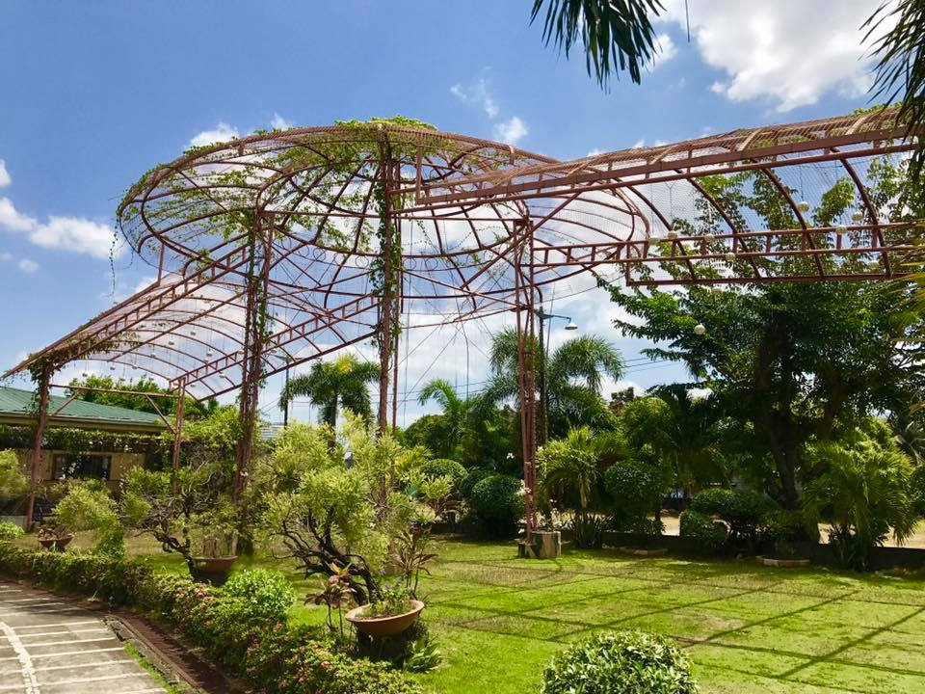

**LACASA ANTIGO RESORT PAVILION**

**GARDEN EVENT- 8000**