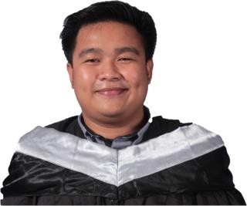

John Mark Bedonio Alcarde

Prk. Pagkakaisa, Brgy. Caloocan, Koronadal City, South Cotabato Philippines 9506

0935-803-1762

[alcardejohn3@gmail.com](mailto:alcardejohn3@gmail.com)

# OBJECTIVE:

I’m always willing to try new things and interested in improving efficiency on assigned tasks. Know how to follow given instructions. I’m Open with my co-worker’s feedback and appreciate team work for a merrier company.

# PERSONAL DATA:

Date of Birth: September 19, 1997 Sex: Male

Age: 27 Status: Single Weight: 75 kg

Height: 5”3’

Religion: Roman Catholic

Father's Name: Dennis Castor Alcarde Mother’s Name: Irene Bedonio Alcarde Language: Filipino/English/Hiligaynon/Ilocano

# SUMMARY OF SKILLS:

* Basic Knowledge on Programming Languages PHP, JavaScript, jQuery
* Advance Knowledge on CSS, HTML Markup Language, Bootstrap Tailwind.
* Five years of experience in WordPress Website Development
* Updating WordPress Core, Theme, and Plugins.
* Knowledge on using Elementor and Divi page builder
* Experience WooCommerce.
* Flexible in solving problems.
* Optimistic approach in handling tasks.
* Excellence in time management and emotion.
* Resourcefulness in handling and completing tasks.

# EDUCATIONAL ATTAINMENT:

Tertiary: Bachelor of Science in Information Technology

AMA Computer Learning Center College of Marbel , Koronadal City 2020

Secondary: Notre Dame of Lambayong

Lambayong, Sultan Kudarat 2014

Elementary: Mamali Elementary Lambayong, Sultan Kudarat 2010

# EXPERIENCE (Work/Trainings/Seminar Attended):

June 4, 2018 - September 14, 2018 Philhealth Regional Office XII

On the Job Training (OJT) Koronadal City

June 15, 2019 - August 20, 2022 Home Based Website Developer

Junior Developer Polomolok South Cotabato

December 19, 2022 - December 23 2022 ICT Literacy and Competency

Development Bureau

Web Development for Web Developer (Webinar)

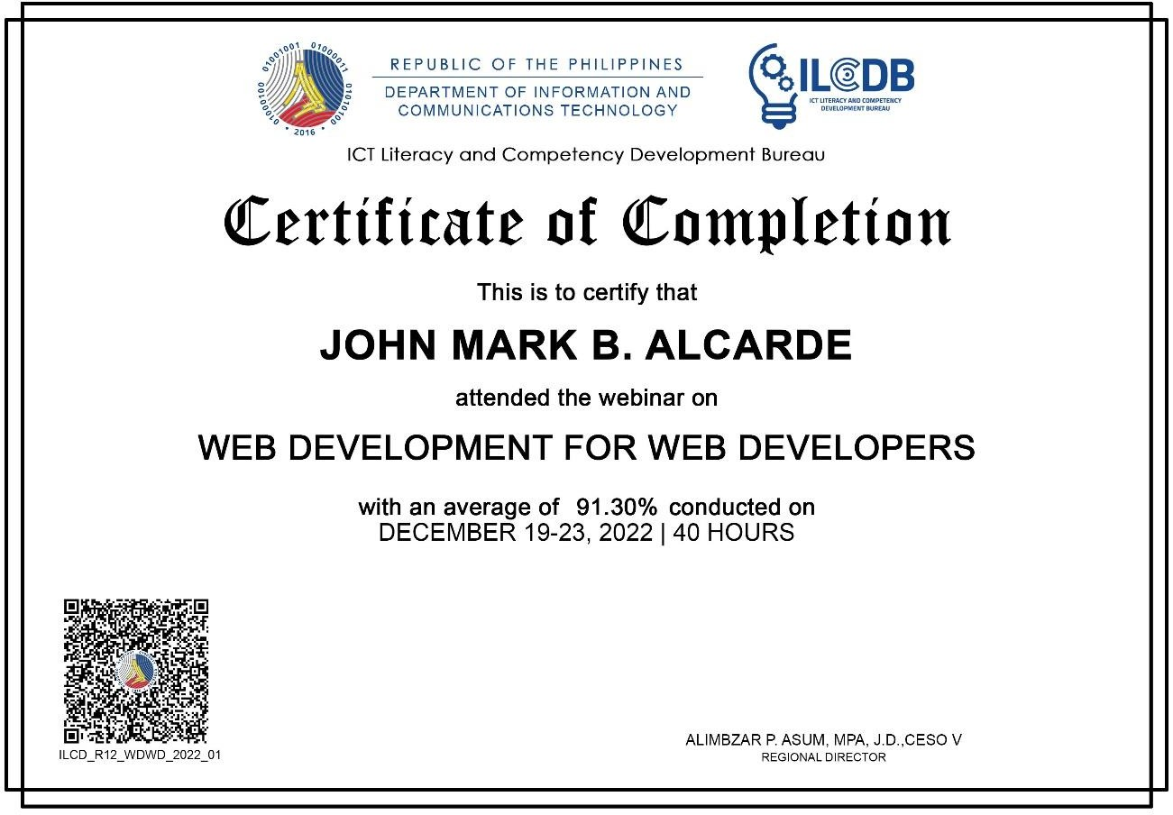

# WEBSITE THAT I HAVE WORKED BEFORE:

https://willabrands.com https://cordhavencapital.com [https://dianasmithbookstoinspire.com](https://dianasmithbookstoinspire.com/)

<https://dentanddingrepairsarasota.com/>  
<https://barefootconcretecoatings.com/>  
<https://www.drpizarro.com/>

https://thomasortho.com/  
<https://www.paul-donahue.com/>  
<https://www.arnoldautorepair.com/>

<https://www.bmwvolvoservice.com/>

<https://www.naturemaidsutah.com/>

<https://kellysdrycleaners.com/>

<https://havenhousethriftstores.com/>

# CHARACTER REFERENCES:

* **REMEGIO MABASA**

Senior WordPress Developer

+639098609129

# KENNY JUNE J. TABUCON

ACLC College of Marbel

+639187170323

# Raul Valenzuela

Junior Frontend Developer Home Based Website Developer

+639386878733