DEPARTMENT OF **MECHANICAL**



# ENGINEERING

## Junior Highschool

I studied in Hitudpan National High School from year 2015 to 2019. In junior high school, I was exposed to a wider range of subjects and activities that allowed me to explore my skills and passions. My interest in technology and problem solving grew as I discovered mobile games and coding, both of which became my hobbies.

**Achievements:**

* Graduated as class With Honor
* Leadership award
* Consistent honor student from 1st year to 4th year
* Elected as SSG president and YES-O president

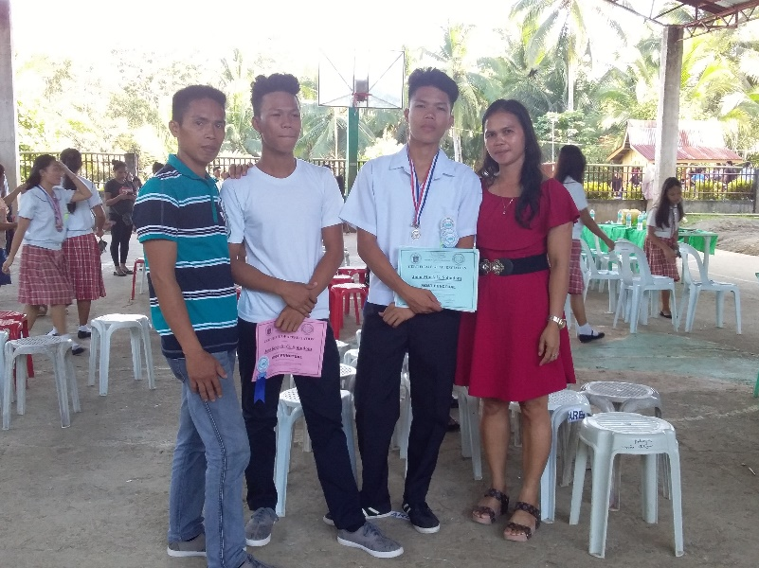

**Experiences:**

* Compete in science and math competitions
* School representative for poster making contestin Jaro National Highschool
* SSG president
* YES-O president



  
  
  