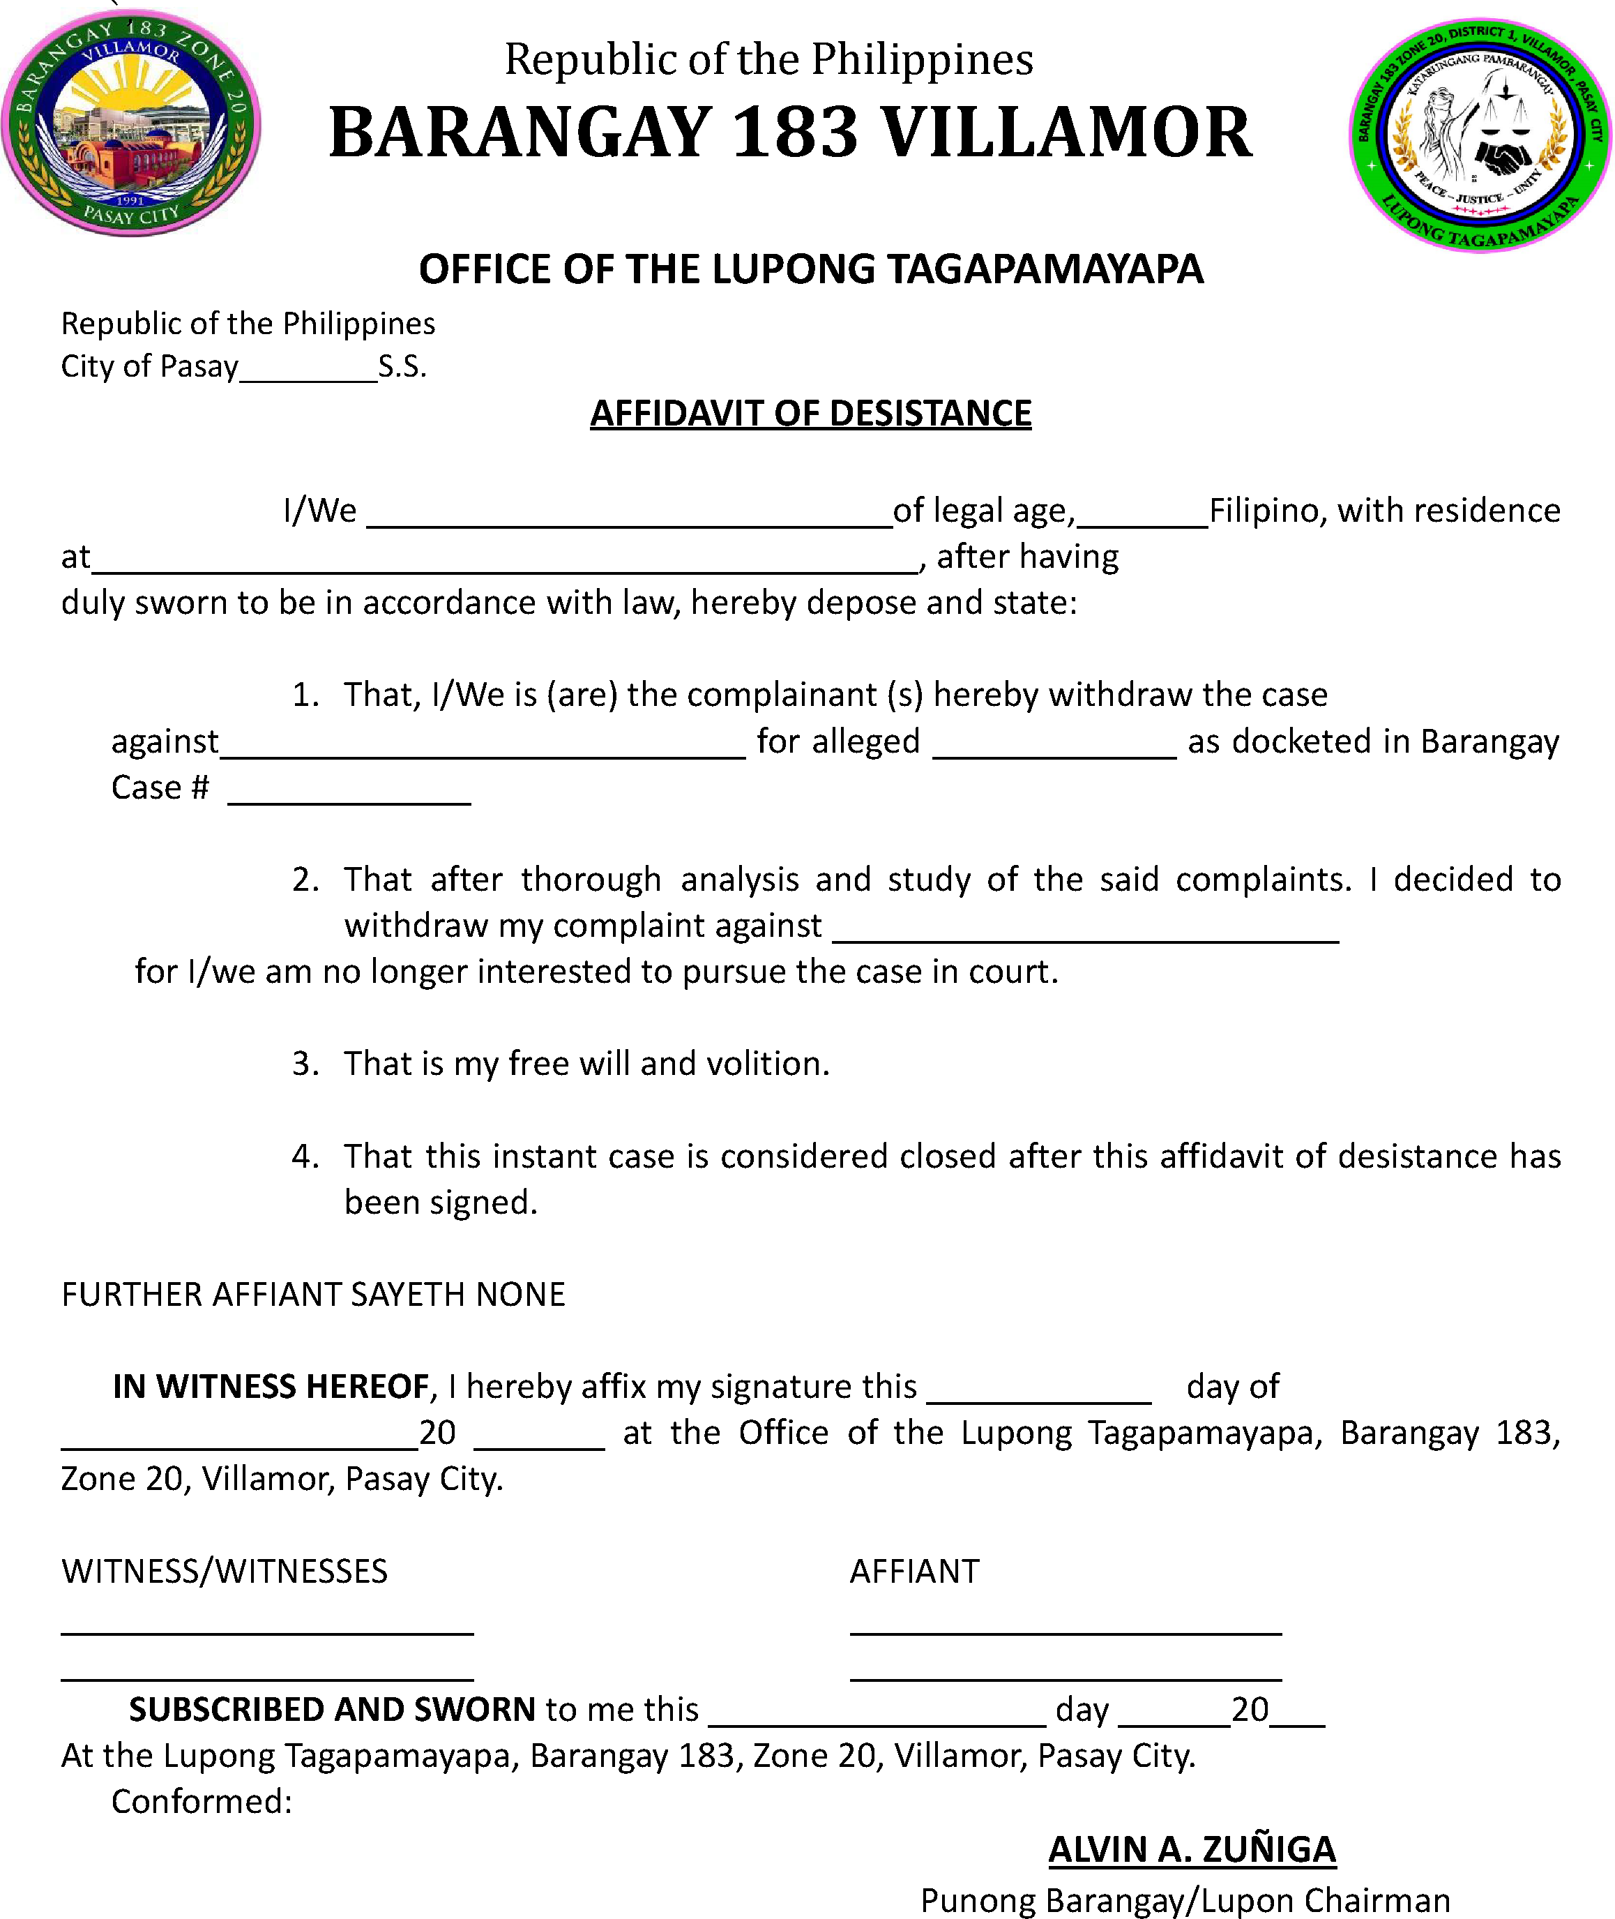

I, the undersigned complainant, do hereby freely and voluntarily desist from pursuing the above-captioned case.

