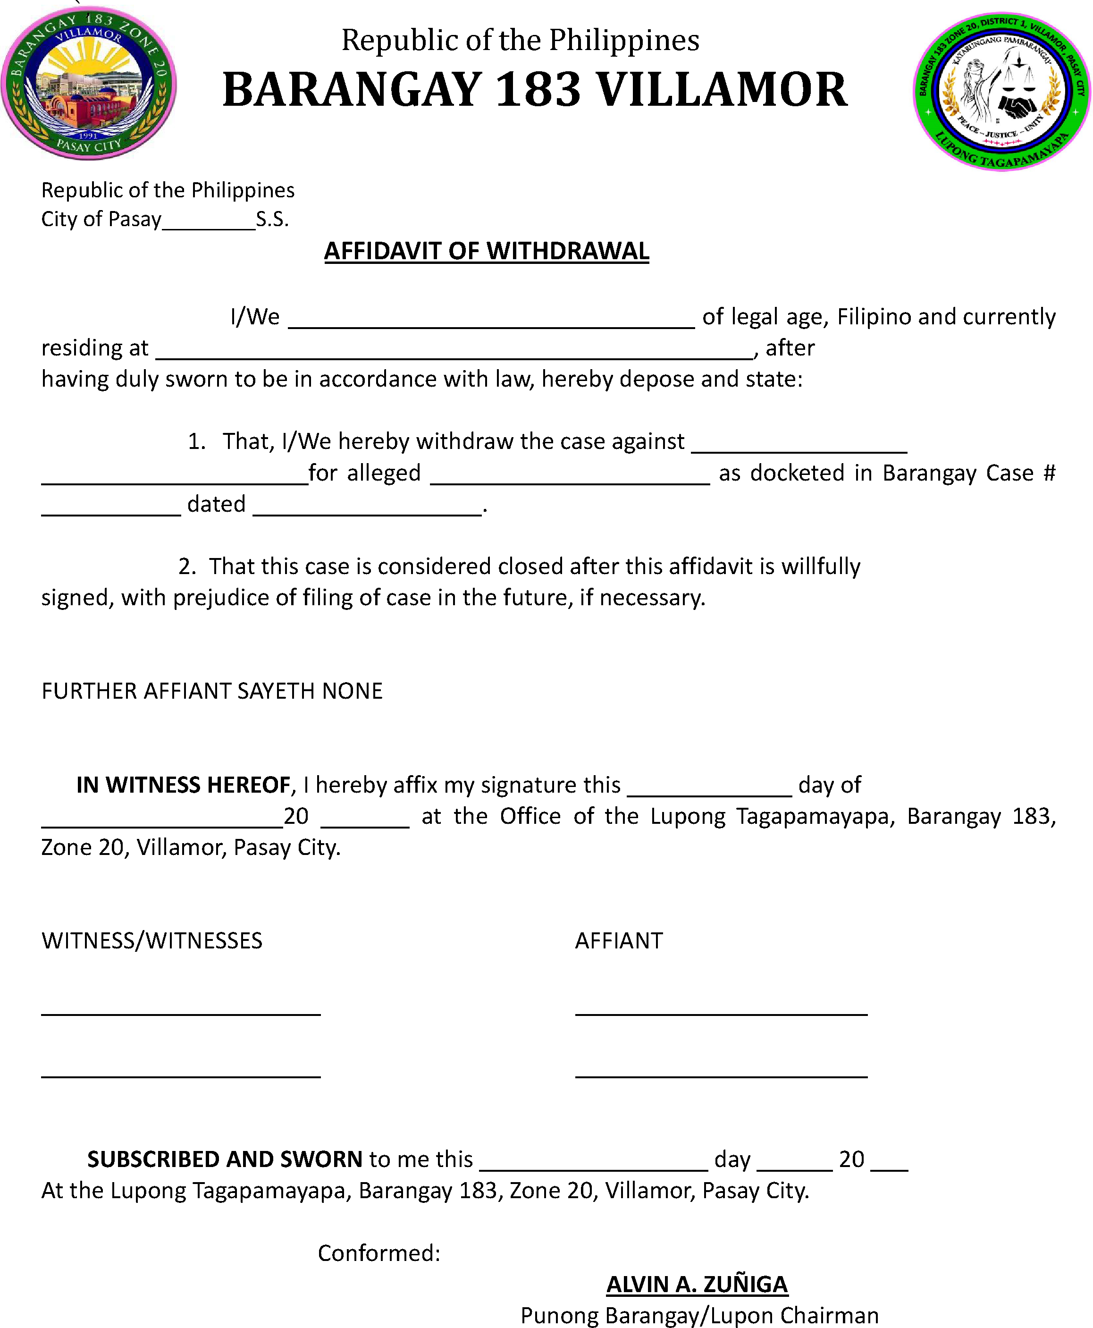

I, the undersigned, do hereby voluntarily withdraw the complaint filed against the respondent.

