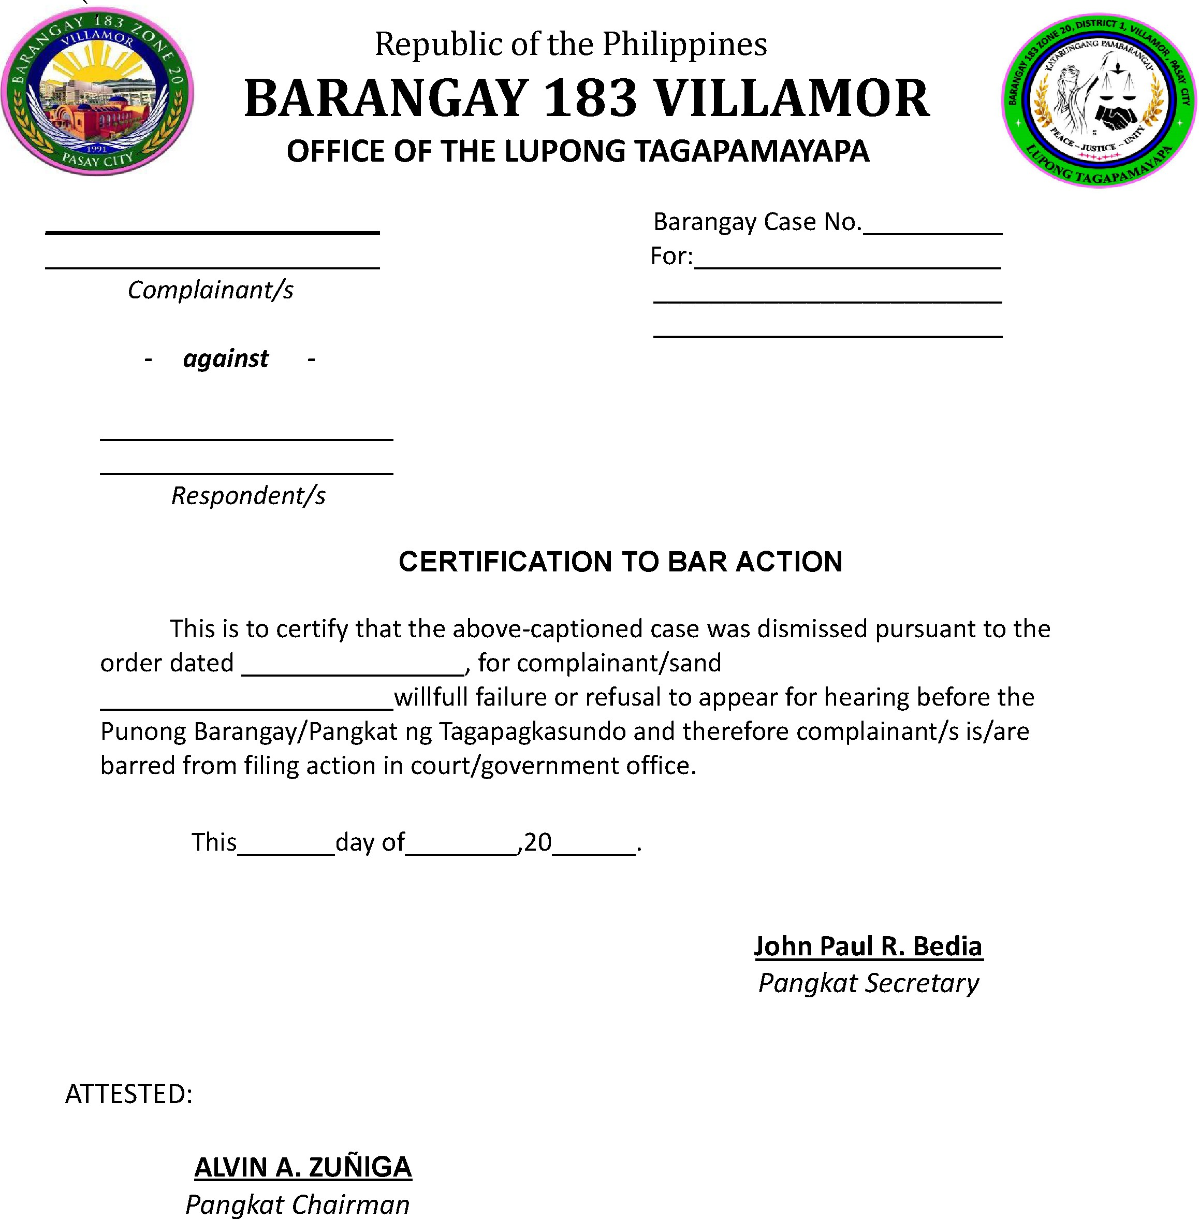

This is to certify that the dispute between the parties has been settled and no further action may be filed by either party.

