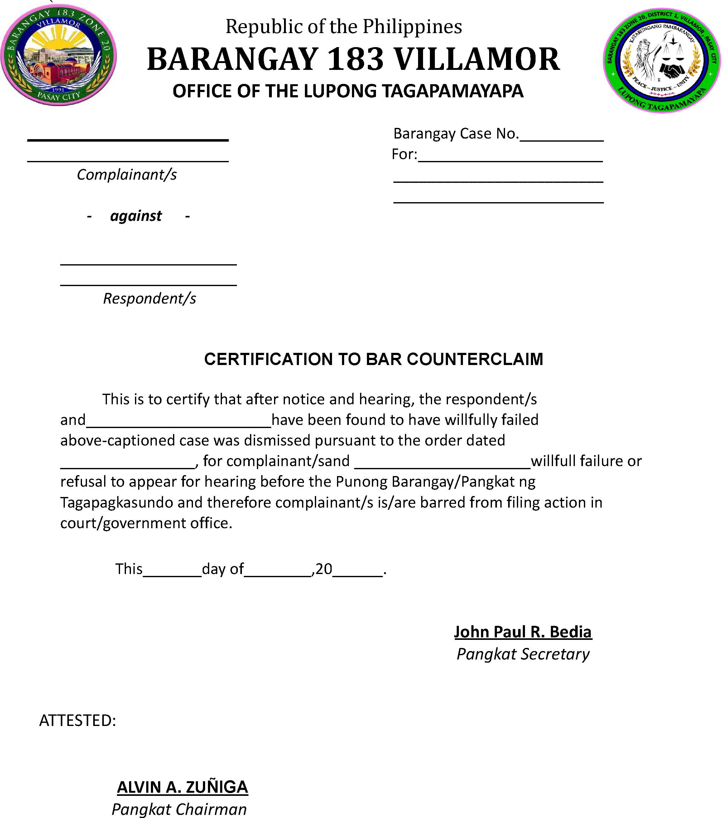

This is to certify that no counterclaim may be filed in connection with the above- captioned settled case.

