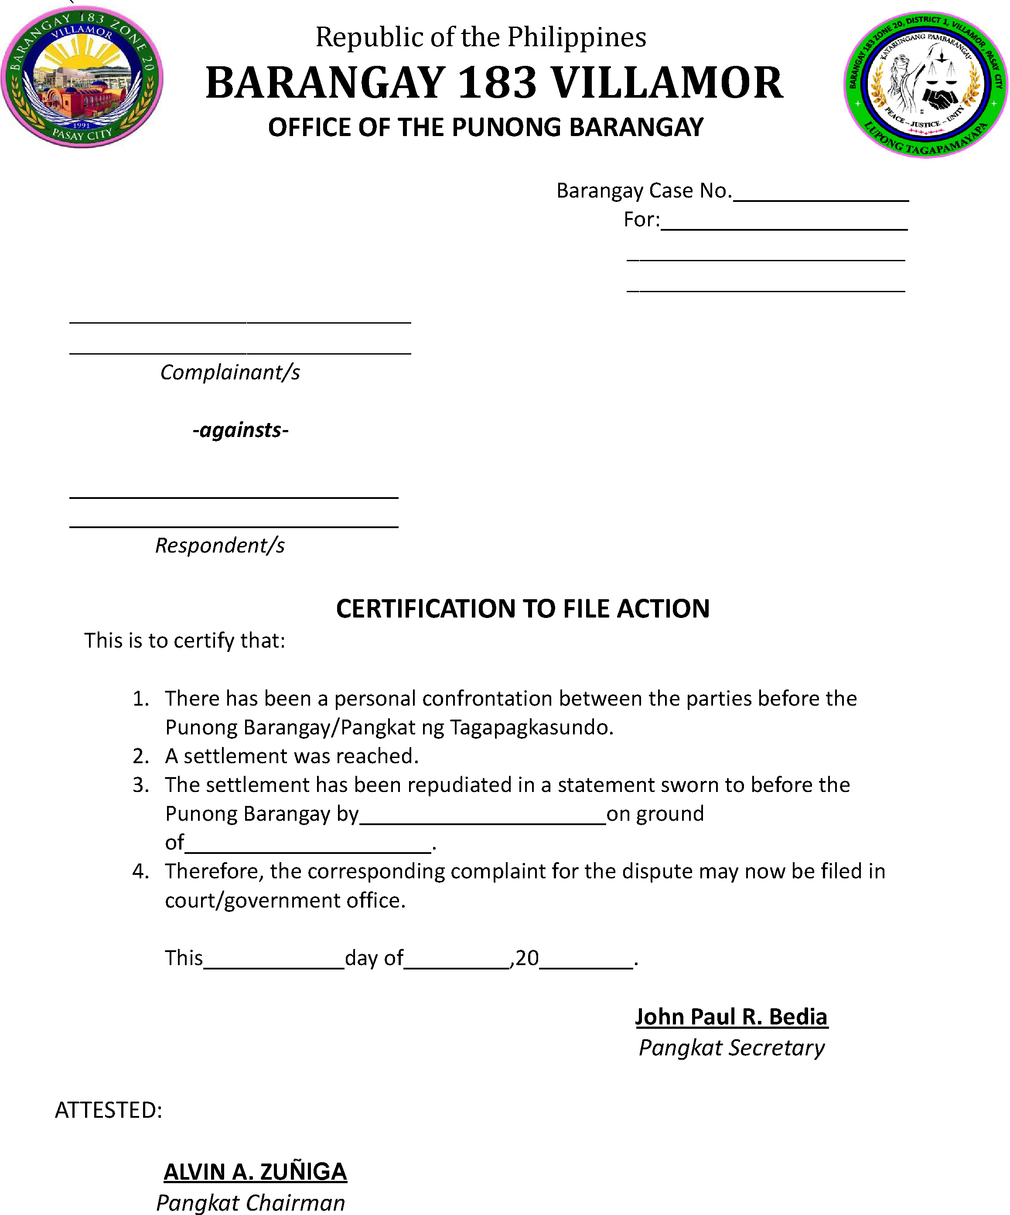

This is to certify that the above-captioned case was not settled before this Lupong Tagapamayapa and is hereby certified for filing with the appropriate government office or court.

