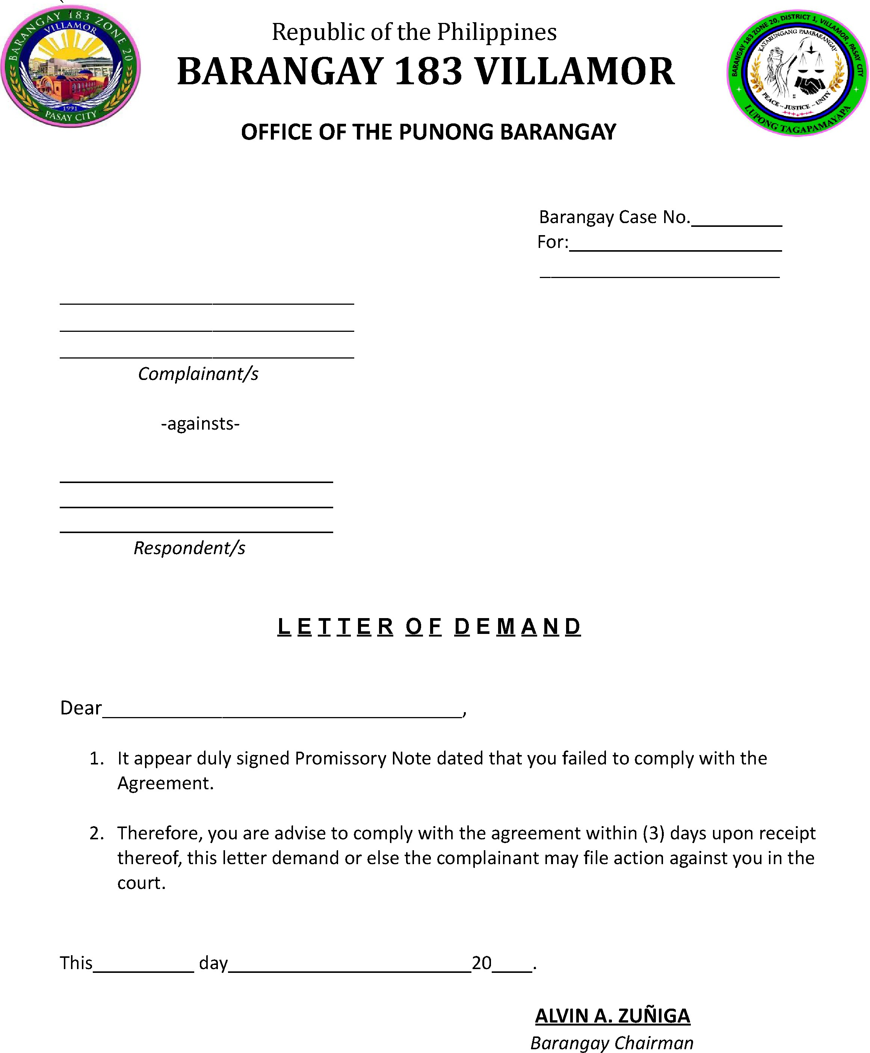

You are hereby formally demanded to fulfill your obligation within days from receipt of this letter.

