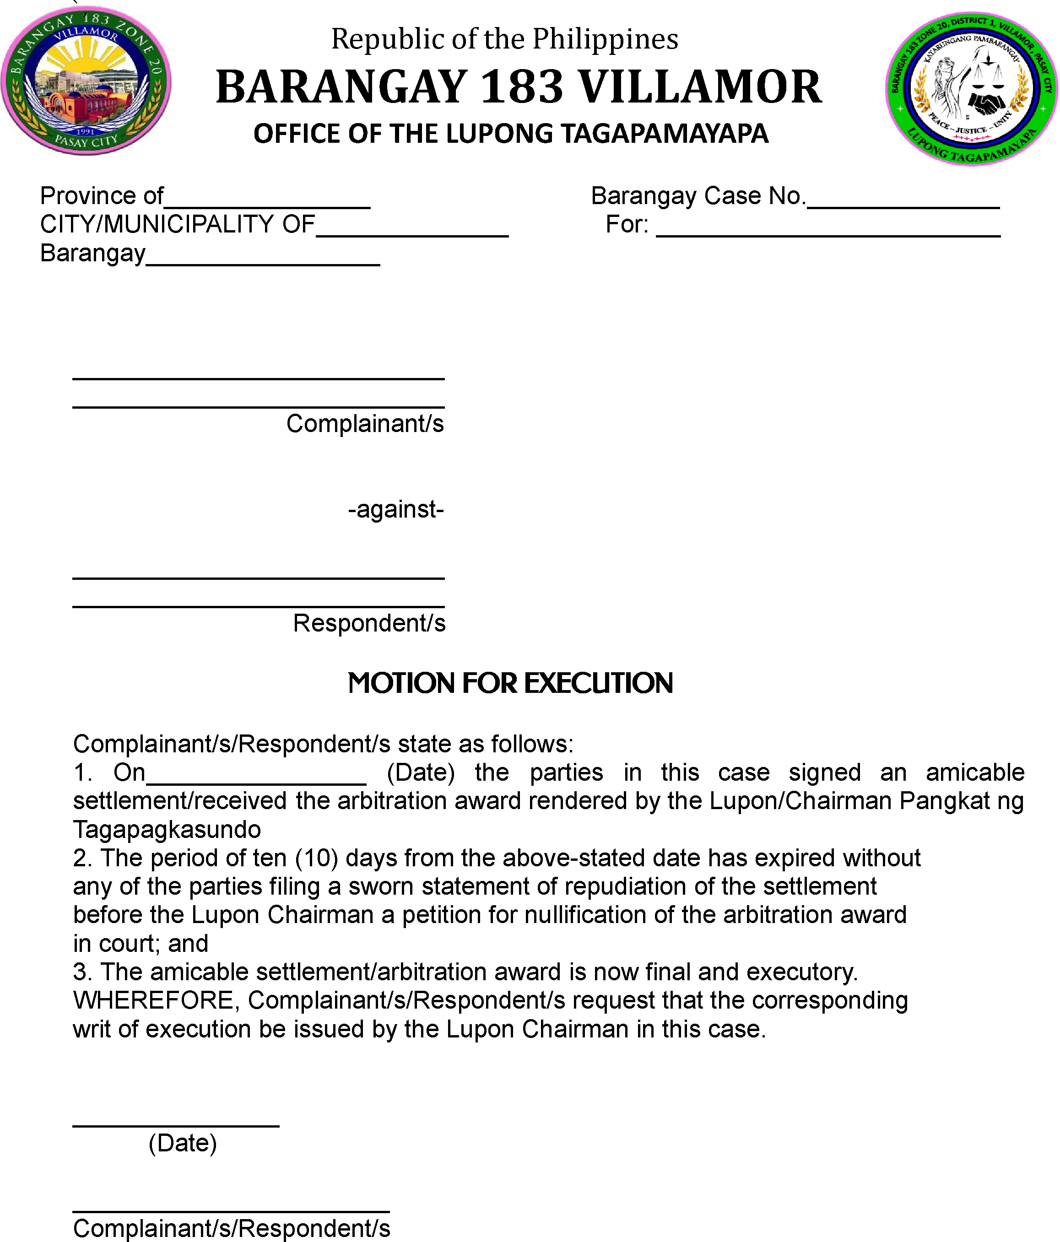

Movant respectfully prays that a writ of execution be issued to enforce the amicable settlement/arbitration award.

