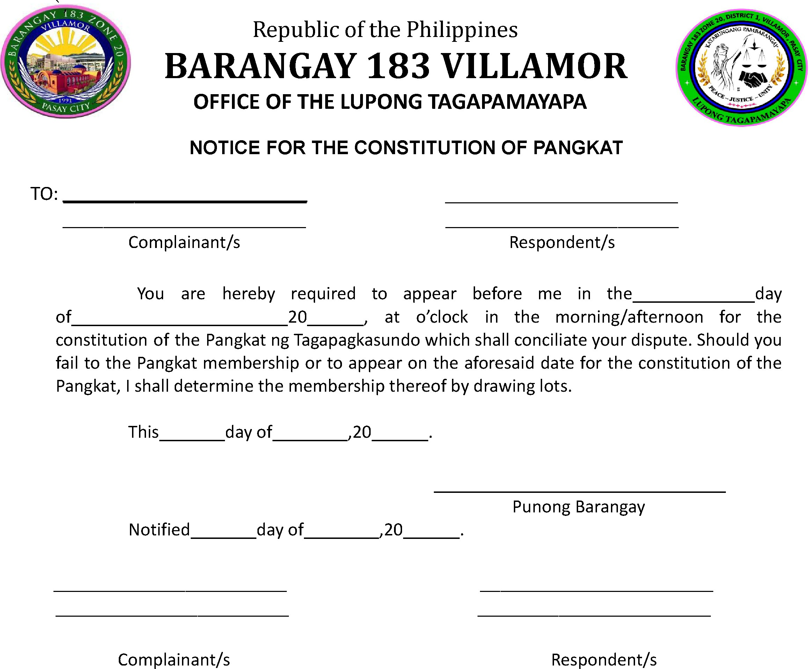

You are hereby notified that the Pangkat ng Tagapagkasundo has been constituted to hear and settle the above-captioned case.

