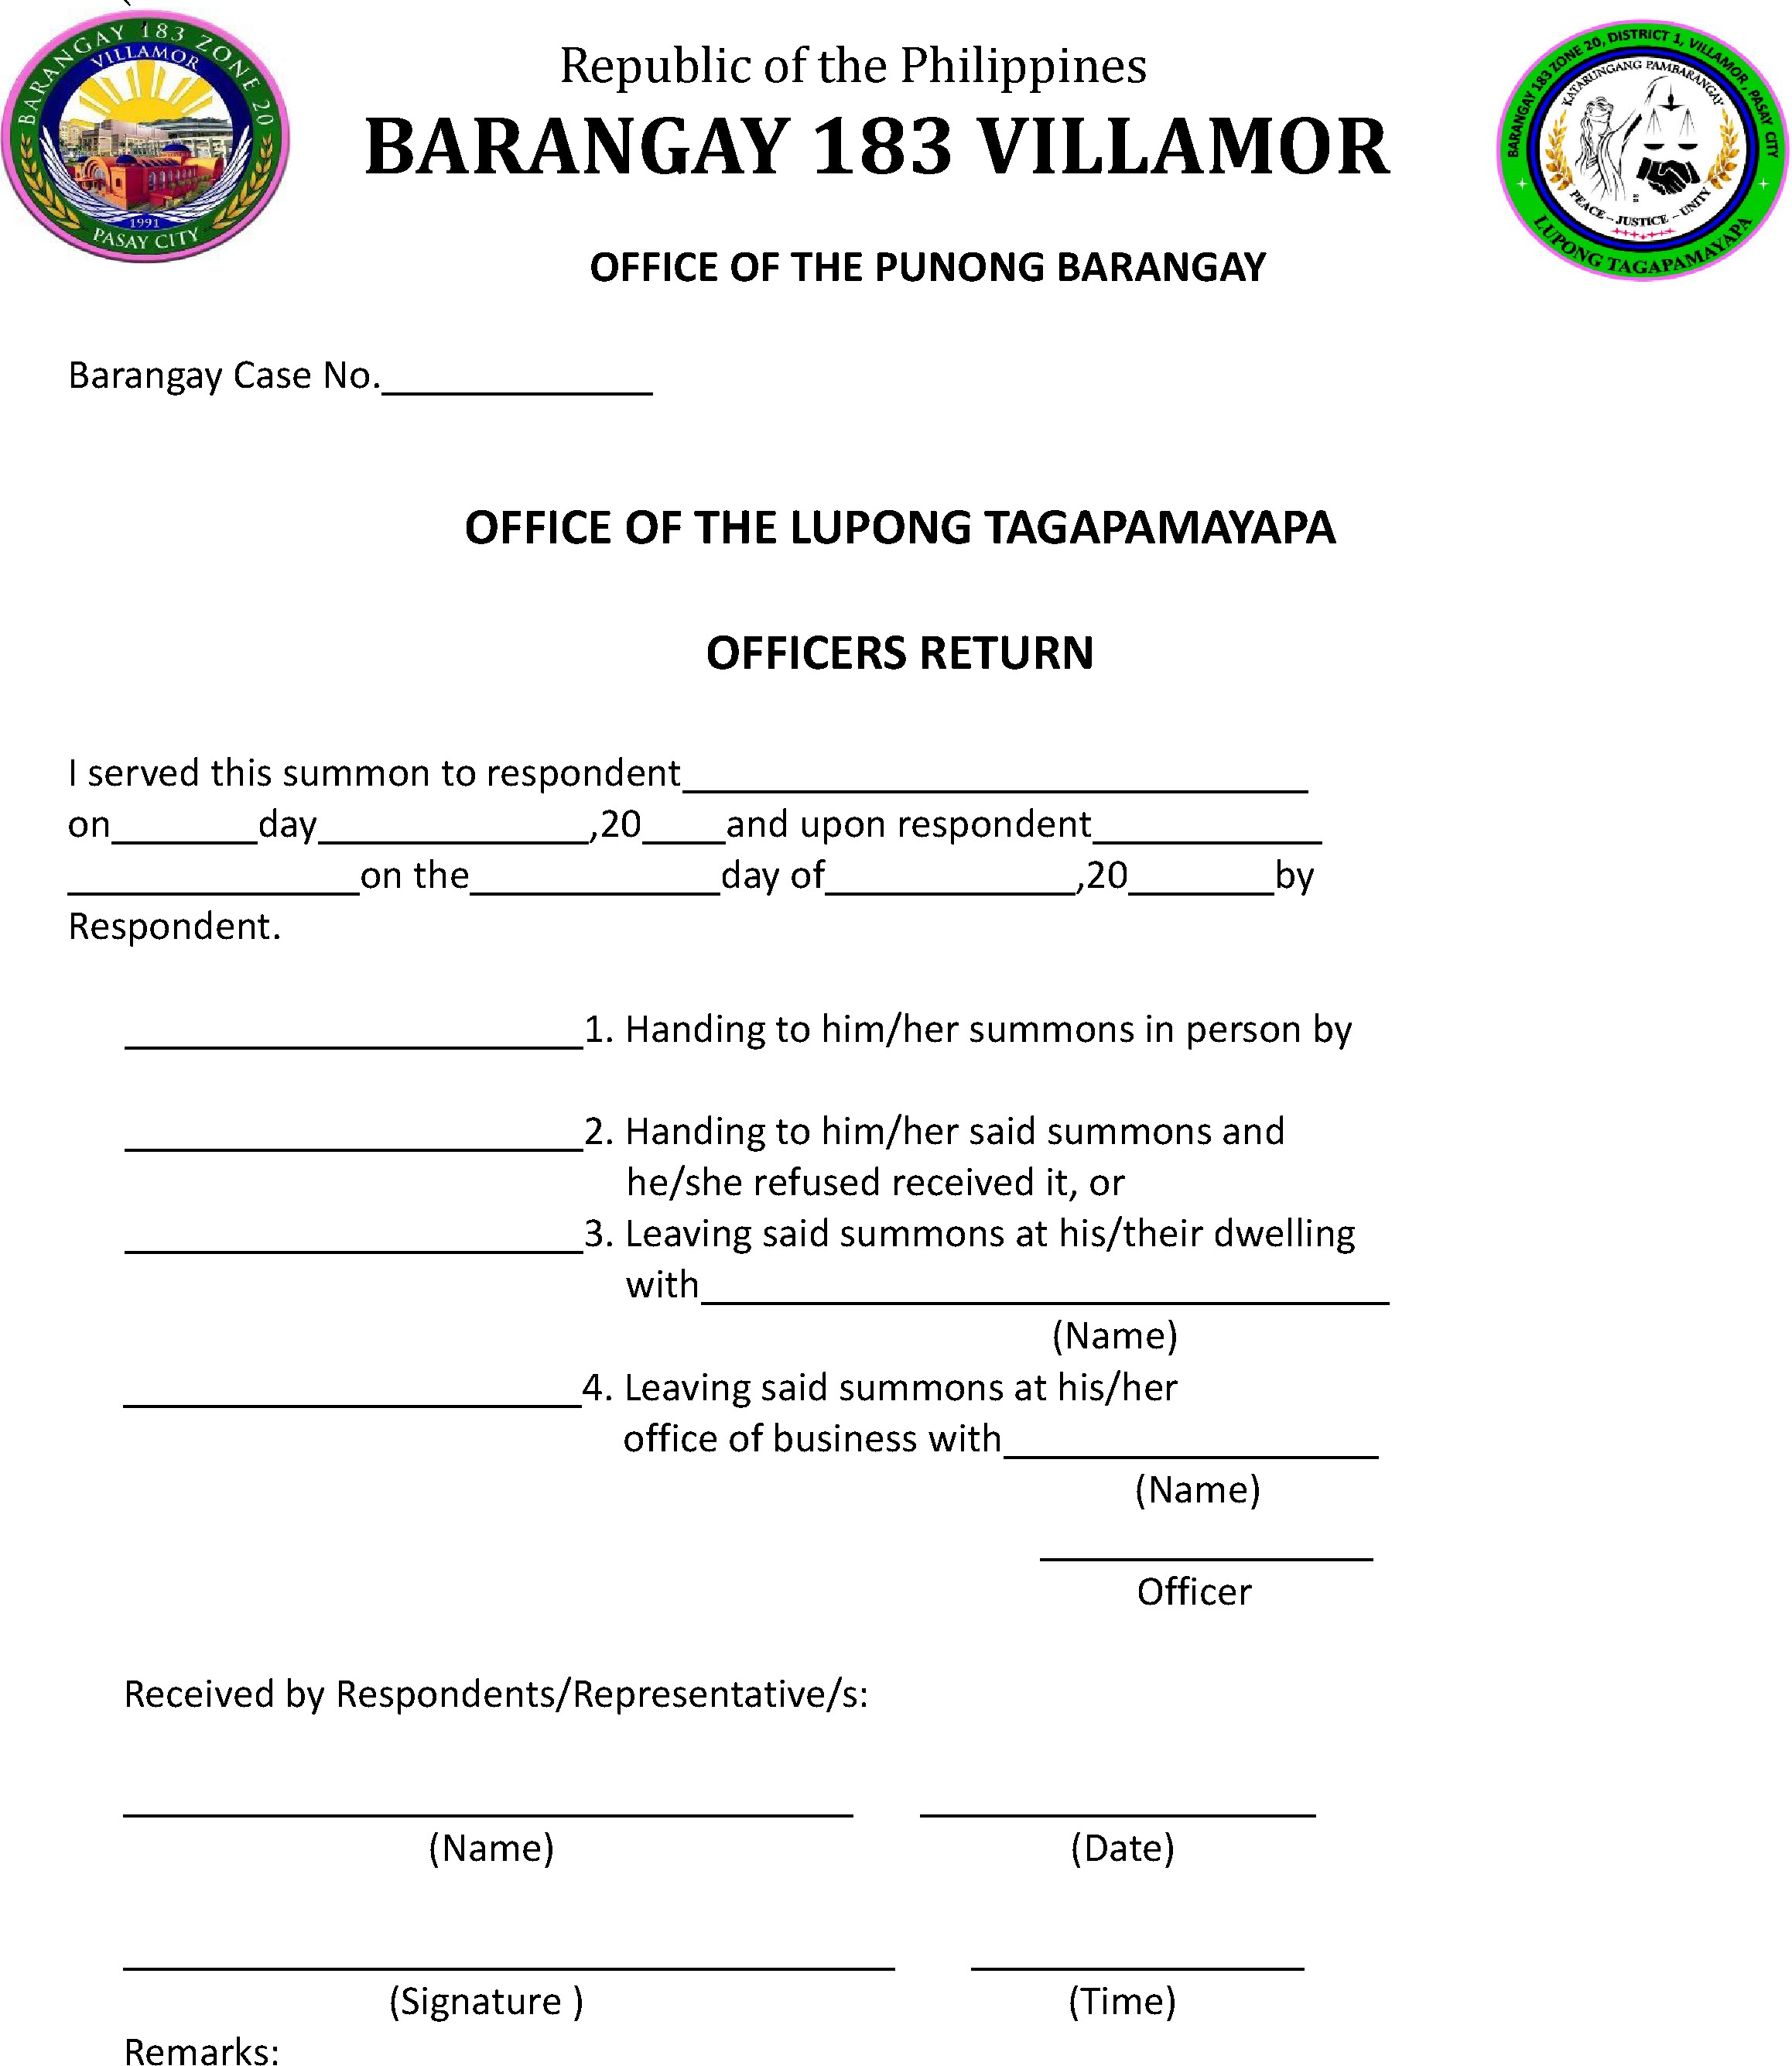

I hereby certify that I served the above notice/summons on the person named above.

