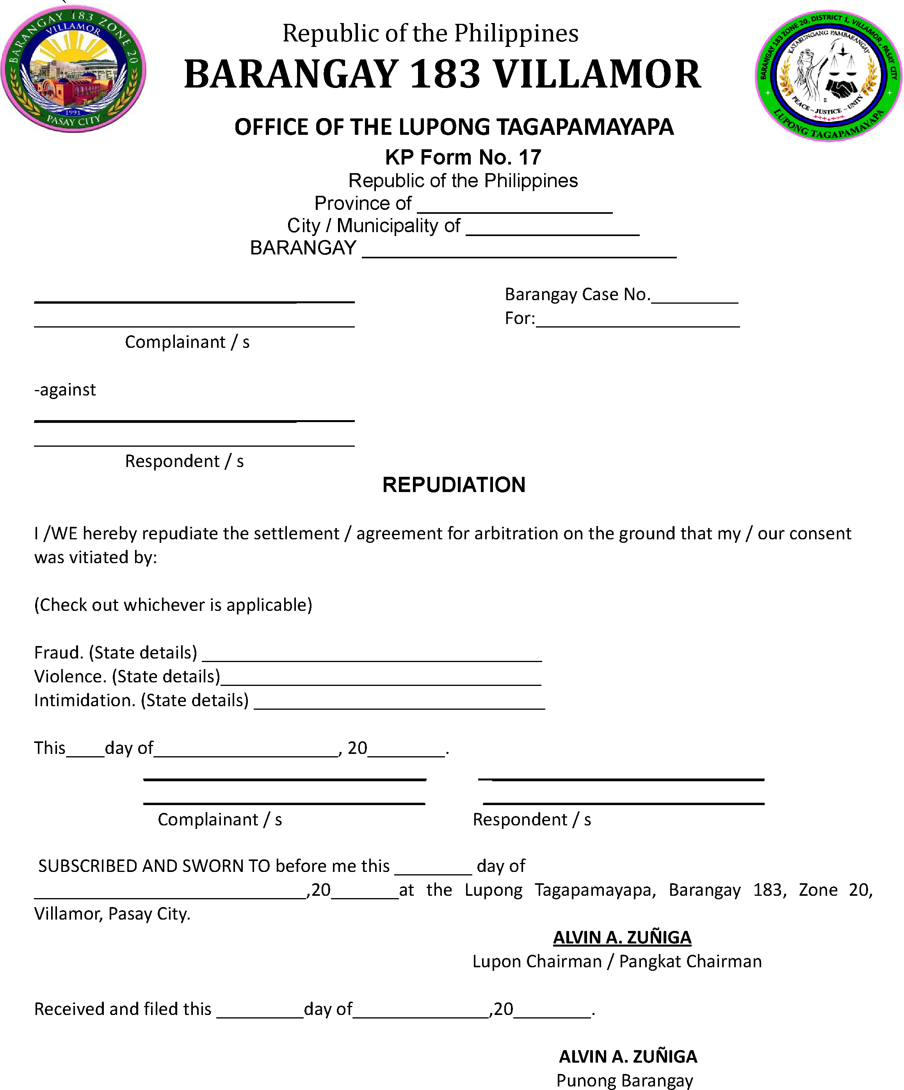

I hereby repudiate the arbitration award/amicable settlement on the grounds that my consent was obtained through fraud, violence, or intimidation.

