B-Tree Operations
Solution Set

Starting with the following B-tree of order 5, perform the indicated operations and show the result after each operation, and be sure to redraw the tree after a node split. When a node overflows, split it immediately. Do not use the method of giving a child to a neighbor node.

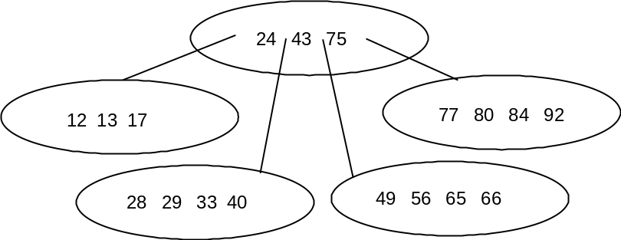

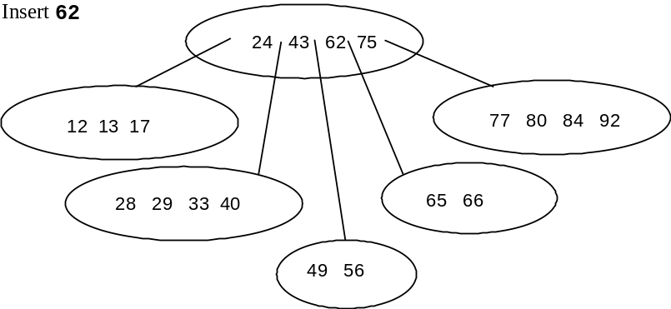

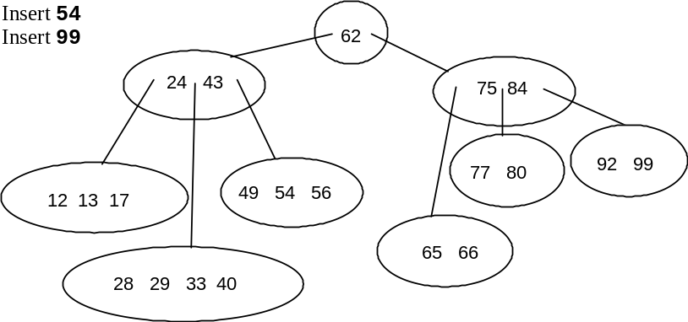

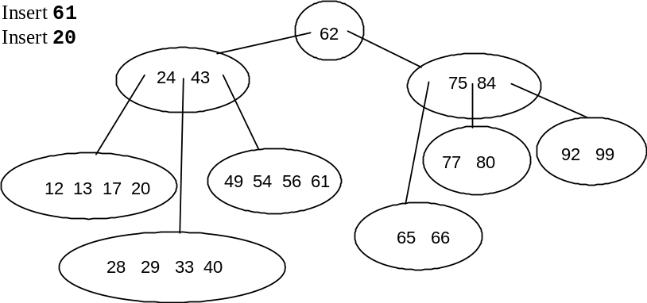

Starting with the following B-tree of order 5, perform the indicated operations and show the result after each operation, and be sure to redraw the tree after a node merge.

