CSDS 310

Professor Lewicki

John Mays, jkm100

**P1 Writeup**

Due on 09/30/21, Submitted 10/02/21

**1. Code Design**

**Basic Organizational Details:**

I have written my code in python with the only nonstandard library being the approved numpy. My zip contains a main.py file with the bulk of the code in it, an exceptions.py file for my custom errors, my test file: P1_jkm100_test_file.txt, and a .pdf of this writeup.

There are only a few global variables: the goal state, the “current” state, and the maximum number of nodes allowed.

The __main__ function calls a function named interpreter(), that takes the txt with filename specified in the command line as an argument, and executes the proper python commands based on what it determines the file is saying with simple string processing.

**Running Code, Briefly:**

So, in order to run my code, I would open my terminal, navigate to the P1 directory, type this command:

Python3 main.py P1_jkm100_test_file.txt

…and press enter. The output should show up in the terminal.

**The Data Structures:**

There are three important data structures that I created.

The first one is a node, which is essentially a container object for a 3x3 state matrix that has a pointer for a parent node, a path_length variable which is calculated on demand by tracing back to the root, and a move variable, which stores which move was taken to get to it.

The second important data structure are is my a_star_priority_queue. It stores individual nodes, has a very simple insert() function, and mildly complicated pop() function. The pop() function goes through all of the nodes it currently has and finds the one with the lowest evaluation function, which is a sum of the node’s path_length variable and a heuristic function that the priority queue is instantiated with.

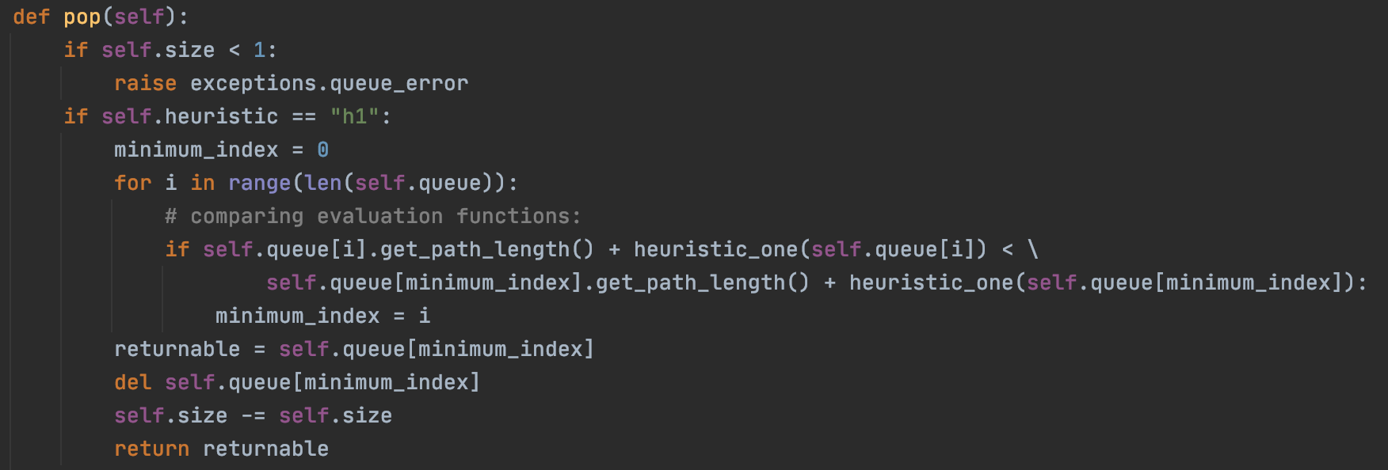

The implementation of the pop() function for h1.

**The Functions:**

There are quite a few helper functions, all of which are listed after the primary functions. There are small helper functions such as string_to_int_representation(), which converts a string such as “b12 345 678” to a 3x3 numpy matrix made of integers. But the important ones are as follows:

a_star_priority_queue(heuristic) and beam_priority_queue(heuristic)

…discussed already.

heuristic_one(node)

Given a node, observes its state, compares to goal_state and returns the number of misplaced tiles.

heuristic_two(node)

Given a node, observes its state and returns the sum of the Euclidean distances of tiles from their positions in the goal_state.

check_for_success(node)

An often-run function from the searches that compares the node’s state to the goal_state and, if equal, prints out the number of moves and the moves themselves by climbing back through the node.parent variables.

**A* Search:**

The A* search is fundamentally designed about the a_star_priority_queue.

Here is the pseudocode for my algorithm:

solve_a_star(heuristic)

create root node

create frontier

place root node in frontier

if root node is the goal state:

return success

while frontier is full & number of nodes has not exceeded max_nodes

cur_node = pop from frontier

create 2-4 children

if children are the goal state:

return success

else: add them to the frontier

return failure: the number of nodes has exceeded max nodes

This leaves out arguably the most important part: comparing the evaluation functions. It occurs within the priority queue. When the pop() function is called, the priority queue iterates through every element it has, calling the evaluation_function() function on all of them, and returns the one with the lowest value.

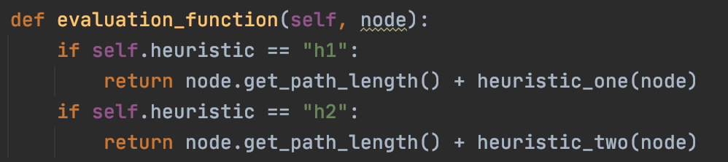

**Beam Search:**

My beam search is structurally similar in certain ways to my A* search. It uses beam_priority_queue, which is almost the exact same as a_star_priority_queue, except for the fact that it uses an evaluation function f(node) = h2(node), which is zero at the goal state and >2 everywhere else.

The pseudocode is as follows:

solve_beam(k)

create root node

create frontier (with beam priority queue)

place root node in frontier

if root node is the goal state:

return

while frontier is full & number of nodes has not exceeded max_nodes

for the elements currently in the frontier

cur_node = pop from frontier

generate children for it

if they are the goal state:

return

add parents back in

refine queue:

pop k nodes from queue

clear the rest of the queue

add the k nodes back in

return failure: the number of nodes has exceeded max nodes

**2. Code Correctness**

**Demonstrating** move() **and** setState()**:**

Here I first set the state and print it. After, I do some moves, the last of which should fail, I print again:

|  |  |
| --- | --- |
| Text Input: | Output: |
|  |  |

**Demonstrating A*:**

Given a fair number of maximum nodes, my A* always works. Here is an example with h1.

|  |  |
| --- | --- |
| Text Input: | Output: |
|  |  |

Here it is again with a new input and h2.

|  |  |
| --- | --- |
| Text Input: | Output: |
|  |  |

**Demonstrating Beam Search:**

Here, I give beam a k-value of 14.

|  |  |
| --- | --- |
| Text Input: | Output: |
|  |  |

**FAILURES:**

Two cases in which these searches fail are:

1. When the maximum number of nodes is smaller than the problem is large:

Here, I set the maximum number of nodes to twenty, and A* does not find a solution before hitting the max:

|  |  |
| --- | --- |
| Text Input: | Output: |
|  |  |

1. When the k for beam search is very large, it surpasses the node limit.

Here, I run the same search under the same conditions on the same state twice, except on the second time, I give k = 70. This is very large compared to 12. This leads to ineffective pruning, the proliferation of useless nodes, and a surpassing of the node limit much sooner than on the more limited version. Consequently, k = 12 succeeds and k = 70 does not:

|  |  |
| --- | --- |
| Text Input: | Output: |
|  |  |

**Note:** these examples are included in my test file, “P1_jkm100_test_file.txt”, in the order they appeared. Additionally, my RNG seed is set when the program is first run, so the same results should appear.

**3. Experiments**

**4. Discussion**

**a.**

A* search is optimal, because it always checks nodes with the lowest evaluation first, which implies that if it found a solution that solution would have the lowest path cost of any solution (given that the heuristic is admissible). Meanwhile the beam search does not necessarily have to return the shortest path. It returns the first solution it runs into, which could easily be a nonoptimal one, considering the fact that a whole set of nodes are given children and checked upon every iteration of the while loop, not just the one with the shortest path. Therefore, the A* search finds the shorter solutions, in general. On the other hand, beam search is superior in terms of time and space in plenty of cases. There are some cases in which beam search could throw out routes to solutions before exploring them, where A* would have gotten there beforehand, but because A* is optimal, beam tends to quit first. Additionally, the worst-case space complexity for A* is one in which the frontier could end up holding ~4d nodes, which becomes large very quickly. Meanwhile beam could only ever consider 4k nodes, which would remain quite small considering traditional k values. In conclusion, in this problem of the 8-puzzle, optimality is not the object of the game, simply finding a solution is. Therefore I would choose beam search based upon its ability to preserve computing resources and find a solution quickly.

**b.**

Implementing both of these algorithms presented a very big challenge for me. I would get to a point where I thought I wrote them properly, and then upon scrolling through random test cases, find a starting position that failed and made no sense. The most difficulty I had probably came from not having my heuristic 2 correct for a very long time. I initially had it calculating the Manhattan distance as opposed to the Euclidean distance. And not only that, but it also treated the blank tile as a tile for which to calculate the distance. Both of these errors contributed to its gross inadmissibility, which messed up both my beam and A*(h2) in quite a few instances.

Another thing that I found difficult was envisioning the proper way to organize my program. I wasted a lot of time on this assignment refactoring my code for silly constraints that I should have foreseen. I believe that if I had drawn out a modular diagram and written some pseudocode to begin with, I would have not made stupid mistakes such as designing several of my functions without the existence of a node object in mind. For projects as big as this, diving straight into the coding is definitely not the best approach, especially when certain parts of the algorithm are still unclear. So, for my next project, I definitely plan to allocate more time to pre-planning.