***John Mc Carthy***

Q1. select * from Jobs order by Max_Salary;

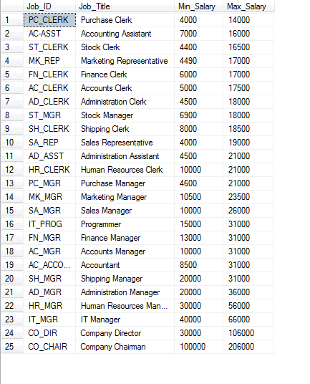

Q2. select first_Name, last_Name, job_Title, Annual_Salary from Employees, Jobs where Hire_Date > '1999' and Annual_Salary >= 7000 and Jobs.Job_ID = Employees.Job_ID order by First_Name desc;

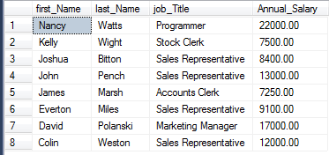

Q3. select * from Jobs order by Job_ID;

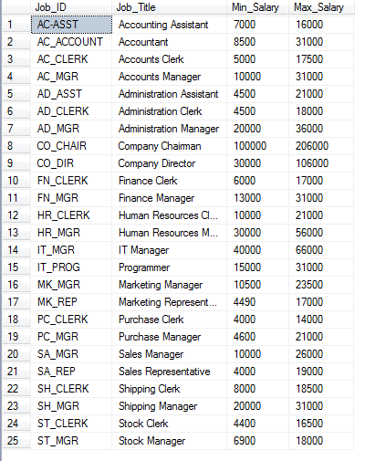

Q4. A. update Jobs set Max_Salary = Max_Salary + 2000;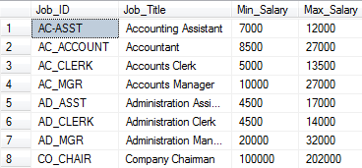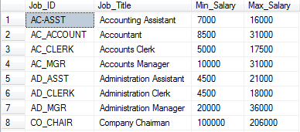

B. delete from Job_History where Employee_NO = 122;

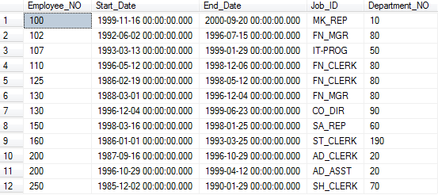

Q5. insert into Jobs (Job_ID, Job_Title, Min_Salary, Max_Salary) values ('AC-ASST', 'Accounting Assistant', 7000, 10000);

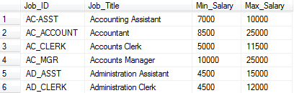

Q6. select First_Name, Last_Name, Employee_NO from Employees where (Job_ID ='SA_REP') AND (Hire_Date >= '1997-12-15') order by Last_Name;

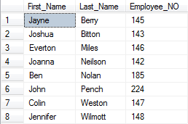

Q8. select Last_Name, First_Name, Job_ID from Employees where Commission_Percent >= 0.25 order by Last_Name asc;

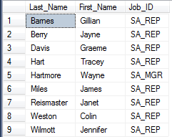

Q9. select Department_NO, Last_Name, Annual_Salary from Employees where Hire_Date between '1998-08-26' and '1999-11-16' order by Last_Name;

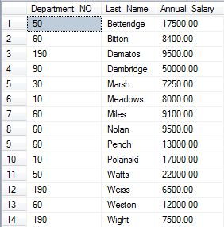

Q10. select * from Jobs order by Job_ID desc;

