FitnessJunction.ie

Project Management Report

John McCormack (x12100323), john.mccormack1@ncirl.ie

16 January 2013

**Highlights**

While not all of the features and requirements set out in the Project Proposal and Requirement Specification have yet been fully implemented, I feel there is now enough functionality and content to get a good idea of how the fully developed site would look and operate. A start has been made on working with XML data to create content for the site, and I would envisage this is an area that could be developed further now that the initial stumbling block of figuring out how to work with the data has been cleared.

Below are listed the requirements that have been fully or partially completed, while the following section will run through those requirements that were not completed.

#### Clear & Intuitive Layout

While the requirement for an intuitive layout is a subjective one, informal feedback has been positive about the layout of the site. The Profile page requires work on adjusting the layout, but as there is further development to be done in terms of content creation for this page, I have not made this a priority.

#### Advertising Space

Sufficient whitespace has been allocated on most pages for possible use as advertising space. There may be less space available on the Profile page once all features are fully developed.

#### Registration & Log in

This requirement has been successfully implemented. Users must register to access the site features, and once registered they can log in to the site to view their profile.

#### Profile Page

The Profile page has been developed to prototype stage, but has much functionality and content to be added yet. Some of this functionality depends on getting other aspects of the site, like the Course feature fully developed.

#### Create Activity

This requirement has been met to a basic level. Further features will have to be added to the model, such as notes, comments, courses, in order to see the full requirement being satisfied.

#### Map a Route

Using the Course and Trackpoint models, I have been able to plot a route on a Google map that is embedded in the site. This route is based upon latitude and longitude attributes contained in an XML file which has been converted from a GPS device format. This functionality took a lot longer to work through than I had hoped, and so work on other areas that depended on this were not completed, e.g. creating a segment, see below.

#### Search Facility

A search feature for Users has been implemented, and once the other models have been further developed, for instance the activity and course models, the search feature will be extended to these also.

#### Follow other Users

This requirement has been successfully implemented. A logged in user can search for other users, and then select to follow that user. Activities created by followed users will appear in the user’s feed on the profile page. Uses can also decide to “unfollow” a user.

**Issues**

Some issues were not completed due to time constraints or because of difficulties with third party APIs.

#### Upload Data from GPS device

The initial plan was to use a Garmin cycling computer to provide the data for the mapping elements of the site. I ran into a problem with this early on as the format of the file on that device was not easy to convert to XML. Knowing that I could convert the file on another website allowed me to move on and work on the next stage of development, i.e. mapping the data on the file to an embedded map. Obviously, converting the data to XML can be done as other sites are using the same devices to upload data, so this is an area I will have to return to at a later date.

#### Download route details to compatible GPS device

This requirement has yet to be completed for similar reasons to the requirement above. I will have to explore the Garmin API, and similar APIs for other devices, to get this functionality up and running.

#### Create Segments

This was a feature that was dependant on plotting a course on a map. The intention was that the user would be able to select a portion of the course and view their details over that section, for example the time taken to complete the segment, their average heart rate, etc. If any other user created a course that included that same segment, the application would compare both users performance and rank them accordingly. This would introduce a competitive element to the website’s features.

In terms of developing this feature, now that the course is plotted on a map, I need to find a way of allowing the user to select a point on that map and then to dynamically select a section of the route from that point. One of the gems that I used on this project (Gmaps4rails) has a feature that will allow the user to select a point on the map by adding a marker to it. How to go from there to letting the user select a portion of the course is something that will have to be investigated further.

#### Calendar

This requirement has yet to be completed due to time constraints. A jQuery date chooser plugin has been used in the New Activity page to allow the user to select a date from a pop-up calendar. The ease with which that calendar widget was implemented suggests that getting a calendar with details of user’s activities and events should not be a major difficulty.

#### Create Groups & Events

This requirement has yet to be completed due to time constraints.

**Progress**

Gantt chart. See below:

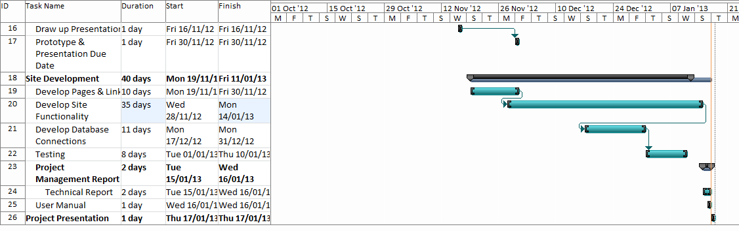

**Variance:**

The initial delivery date for the prototype was the 19-11-2012. This was pushed back to the 30-11-2012 with a knock on effect on the finish times for some of the tasks that followed. However, the 7 days that were allocated to developing the Pages and Links were initially planned as part of the Site Development stage. Much of this work had been completed by the time the prototype was submitted on 30-11-2012.

Development of the website functionality took a number of weeks longer than the projected timeframe, with work on developing functionality continuing up until 15-01-2013. The end date for the development was initially 10-01-2013, but with the Project Presentation pushed back to 17-01-2013, this allowed more time to continue with development & trouble-shooting. In addition, 11 days had been allocated to developing database connections which was a lot longer than was needed.

Testing was not carried out in the formal sense of running a suite of tests, but on-going tests were made of all functionality as the site was being developed. The 8 days allocated to testing were a combination of development work, testing and trouble-shooting.