FitnessJunction.ie

User Manual

John McCormack (x12100323), john.mccormack1@ncirl.ie

Date 16 January 2013

Intro
In order to access any of the functionality of the site, a user must be logged in. The only pages that are accessible to a user who is not logged in are the Home and About pages.

Registration
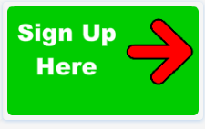
To begin registration, click on the “Sign Up Here” button on the home page. This will redirect the user to the Sign Up form. A link to the Sign Up form is also included on the Sign In page. Signing up is straightforward - just enter a name, email, password & password confirmation. Then click on Create my Account to complete the registration form. The email must be entered in a valid format (e.g. example@email.com) or else an error will be displayed.
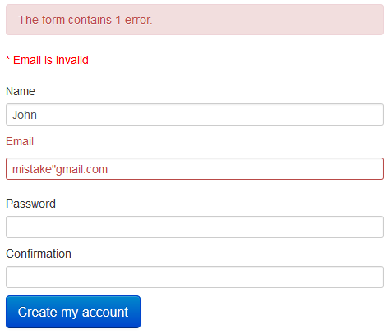
Once the user has successfully completed the registration, they will be directed to their profile page.

Sign In
Users who have already registered with the site can log back in using the Sign In button located in the header of the Home Page.

Profile Page
Once signed in, the user is directed to their Profile Page. Users can edit their profile by clicking on the link in the About Me section on the left of the page. The Edit page allows the user to update their name, email address, & password, as well as allowing them to add or change their profile photo. If selecting a photo, the Password Confirmation field must also be filled in. Once selected, the profile photo will appear in the About Me section.
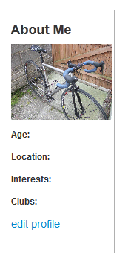

On the right of the Profile page, there is a link to the user’s followers and following users. The icons beneath are simply placeholders; it is intended to develop this part of the page in the future to include links to other users, clubs, events, etc.

To return to the Profile Page from any other screen, click on Home or Account>Profile.

Following Other Users
Details of other users on the site are available by clicking on the Users link in the menu bar at the top of the page. A search feature has been added which enables the user to search by name.
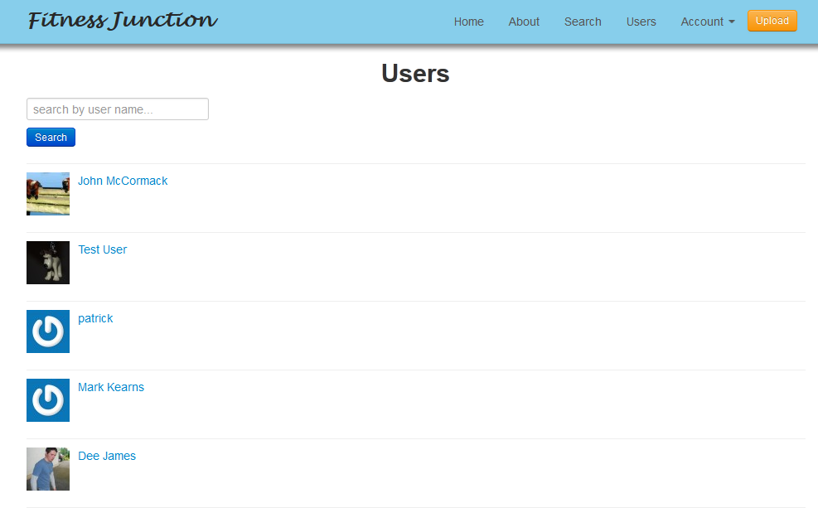
Once a user has been selected, click on the Follow button to add them to the list of followed users.
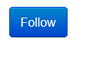

Creating an Activity
Click on the New Activity button in the Profile page to bring up the New Activity form.
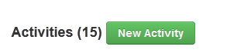

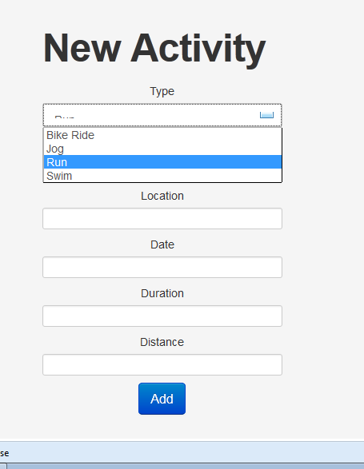

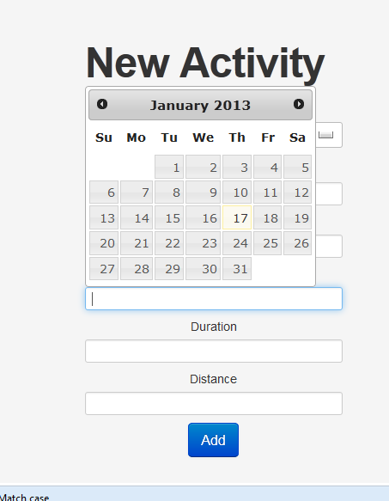
Uploading a Course from XML
Click on the Upload button, select a training XML file (provided in the root directory of the application), and click Upload. Upload may take some time depending on the size of the file.
Once uploaded, a confirmation screen will appear and a link will be provided to the course. Clicking the link will redirect to the course view.

