SCMS Simulator for Misbehavior Detection
The scms utility provides the simulated behavior of a SCMS when an OBE sends a misbehavior report (MBR) to the SCMS. The scms utility will accept the report and will provide an ACK. The ACK is the 16 bit encryption key provided with the MBR and is the last 16 bytes of the message. For test purposes the scms utility does not validate that the last 16 bytes are indeed an encryption key. Instead the utility simply extracts the last 16 bytes and sends those back to the sending device.

In a typical deployment the OBE will listen for a WSA from a RSE and will use the IP information from the WSA to establish a connection to the SCMS. The scms utility assumes a similar infrastructure is in place. However, the scms utility is only a backend utility. It accepts TCP connections and does not restrict the source IP, meaning any IP medium can be used.

For Misbehavior Detection testing and for validating that the scms utility works, a second utility called obe was developed for the OBE. The obe utility is a simple utility that sends MBRs to an IP and waits for an ACK. The obe utility operates on a WSU and uses wsu_routerd for the wireless interface. For end to end Misbehavior Detection testing a user may use both the obe and scms utilities with one of the following two setups.

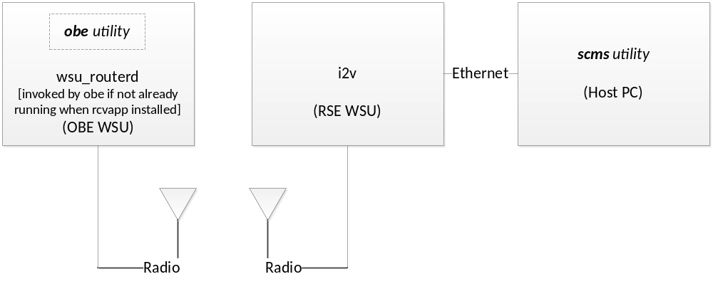
Figure 1 - OBE to SCMS with RSE

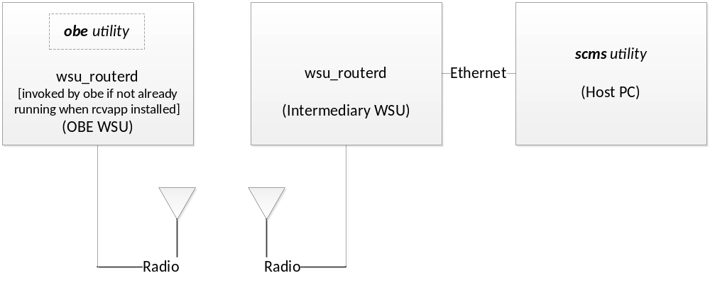
Figure 2 - OBE to SCMS with wsu_routerd

Either of the above two figures will work for Misbehavior Detection testing. The setup from Figure 1 is a closer representation to a typical deployment.

Build and Deploy
To build the scms utility and optionally the obe utility only requires a Linux system that can build WSU firmware images. A makefile is supplied with the source code. A user needs to only run the make command and both utilities are generated. The scms utility is for a host PC and if desired, can be recompiled for any platform (the source code is written for a Linux platform). The obe utility is only for WSUs. It can be compiled for either the WSU5001 or WSU1.0/1.5 with the makefile as long as the user has the proper compiler tools installed. If compiling for the WSU5001, simply define the target environment variable as wsu5001 (i.e. make target=wsu5001).

Each utility has a configuration file. The scms.conf file is expected to be placed in the same directory as the scms utility. The obe.conf file may be placed in any directory on the WSU. An optional command line parameter is available for the obe utility to specify where the configuration file may be found. If that parameter is omitted, the obe utility will check in the current directory (where it is located), and if not found will subsequently check in /rwflash/configs/.

Configuration
Both the scms and obe utilities accept all configuration parameters through command line options. If a user chooses this approach, the respective configuration files for each utility are not required. A user may type the program name followed by the –h option to list the available command line options. Alternatively, a user may use the configuration file for each utility. The parameters required for each are documented within the configuration files.

A general note about the configuration relates to the framework used (Figure 1 or Figure 2). With either approach there are manual steps required to ensure the end to end communication will work. The scms host PC must have IP connectivity to the RSE WSU or Intermediary WSU. The OBE WSU must also be able to communicate to the alternate WSU. This document does not explain all of the details but provides brief highlights for user setup.

RSE Approach
The RSE framework (Figure 1) requires the use of IPv6 for all elements. The DENSO RSE only supports IPv6 for IP forwarding (USDOT requirement). Thus the RSE WSU must have an IPv6 address on the Ethernet port. The DENSO RSE provides the ability to automatically enable an IPv6 Ethernet address in the i2v.conf file. See the Network Settings section in the i2v.conf file. The backend host PC will require an IPv6 address. Both the RSE WSU and the host PC must be on the same IPv6 subnet and it should be a different subnet from the IPv6 subnet used for the RSE radio. The following command may prove useful if a user needs to set an IPv6 address on the host Linux PC:

ip -6 addr add 2003::10/64 dev eth1

NOTES:
- Replace the 2003::10 with your desired IP address and do not forget the scope (subnet) qualifier (/64 in the example above).
- Replace eth1 with whichever Ethernet device on your system connects to the network shared with the RSE WSU.
- An actual IPv6 network is not required if using a private network. If using a switch or hub that supports IPv6 and your WSU and host PC are connected to the device, all that is required is setting the IPv6 addresses on each component.

Make sure the host PC has a route to the OBE. This must be manually added for proper operation. The following command shows an example:

ip -6 route add 2002::/64 via 2003::11

NOTES:
- Replace the 2002:: with your configured subnet of the OBE. It will match the same subnet used for the WSU radio. Do not forget the scope qualifier.
- Replace the 2003::11 with the IP you select for the RSE WSU Ethernet port.

An additional requirement for the RSE approach is to ensure the RSE is properly advertising the host PC IP in the WSA. For the DENSO RSE, you must set this information in the ipb.conf file. The IPv6ServerPrefix is the prefix (scope or subnet) and the IPv6ServerID is the qualifier. Set these to the same values used as the IP on the host PC. If using the example above, the IPv6ServerPrefix would be 2003:0:0:0 and the IPv6ServerID would be 0:0:0:10. The user must also set the IPBIPv6Prefix and IPBIPv6Identifier to the IPv6 address that will be used on the RSE radio. When using an actual V2V-I like application, these two settings can be any value. If using the obe utility, the subnet used for the radio must match what will be set for the OBE radio using wsu_routerd. Finally, make sure the IPBIPv6Port matches the port configured for the scms utility (this is only necessary for V2V-I like applications that actually use the WSA).

WSU_Routerd Approach
If using the setup from Figure 2, manual steps for IP configuration may not be required. Using this setup enables the use of IPv4 exclusively. Note that when using this approach, the two WSUs will both be using wsu_routerd and must have matching settings. The subnet for the radios must match between the two WSUs and must be a different subnet from the host PC. If a user chooses to use IPv6 with the wsu_routerd approach, the same rules mentioned above in the RSE Approach apply. The user will need to properly set up IPv6 addresses, including on the host PC. See above for further details.

With the wsu_routerd approach, the user must update the wsu_routerd.conf file on the intermediary WSU manually. For full details on wsu_routerd configuration, see the wsu_routerd documentation.

OBE Configuration
No matter which approach is used, the OBE must be properly configured to connect to the SCMS simulator. If using v2v-i, the dotap utility will perform the necessary configuration assuming the proper WSA has been received. Using this approach requires the use of the RSE framework. If using the obe utility, wsu_routerd will be used on the OBE. The obe.conf file contains configuration parameters for wsu_routerd. The obe utility will generate a wsu_routerd.conf file if one is not found on the WSU. Note that if one is present, the user MUST manually update the file with the appropriate settings or remove the file, if desiring to use the settings from obe.conf.

Be sure to follow the explanations within the obe.conf file. Note that there are indications in the file that mention only IPv6 should be used. If using the wsu_routerd approach, these warnings in the configuration file can be safely ignored if desiring to use IPv4.

Using the SCMS Simulator
The scms utility will run indefinitely until stopped by a ctrl+C. You should make sure that all configuration settings have been appropriately set before starting the utility. There are no additional prerequisites besides the initial configuration settings for operating the utility. When desired, simply start the utility, and you can leave it running uninterrupted. Note that for the utility to receive any data, assuming you are using one of the suggested frameworks from this document, you must start either i2v on the RSE WSU or wsu_routerd on the intermediary WSU. This additional step can be done asynchronously.

The scms utility provides a debug option for logging details. There are two supported debug levels (1 and 2). Debug level 1 will create a text log file capture basic details and any major runtime errors. Debug level 2 will capture additional data and will generate a csv file with the text file. Both files will be placed in the same directory as the utility. The csv file captures the data sent to the scms utility from OBEs. Data is time stamped for both the text and csv file to match the data to the client.

If optionally using the obe utility, you must start that utility on the OBE WSU after properly configuring the settings. Manual start of wsu_routerd is not required on the OBE WSU. The obe utility will start wsu_routerd if it is not already running. Once started, the obe utility will look in the configured MBR directory for any files, and will attempt to send them sequentially once a connection to the SCMS simulator is made. Once a file has been sent, the utility waits for an ACK. Upon receiving a matching ACK (the utility verifies it is the expected ACK), the file sent is deleted. A hidden –x command line option is available to suppress the auto deletion behavior. If the ACK does not match, the utility will stop transmitting and will wait for the next cycle. The obe utility operates in a cyclic pattern, waiting approximately one second before starting the process again. If a user chooses to leave the utility running, the user can optionally generate new MBR files, place them in the MBR directory, and the obe utility will automatically attempt to send them.

The obe utility will print out runtime errors to the console. Note that an expected recurring error message will relate to failures in connecting to the SCMS simulator. Radio traffic may interfere with the end to end process resulting in failures to communicate between the OBE and SCMS. Also note that at the time of writing, testing on channel 172 was not successful. The problem may have been specific to the WSUs used by the author (one of the WSUs experienced kernel panics). Other channels were successful however.

