**Product Scale Analysis**

Phase 2: Innovation

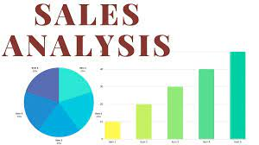

**INTRODUCTION:**

* This innovation leverages advanced technology, data analytics, and business intelligence to transform the way companies evaluate and improve their sales strategies.
* Product sales analysis innovation encompasses a wide range of methodologies and tools, including data mining, machine learning, predictive analytics, and more.
* It enables companies to gather and process large volumes of data related to their products, customers, and sales channels, helping them make data-driven decisions and achieve their sales goals more effectively.

**DATA SOURCE:**

* Product scale analysis relies on data from various sources to provide a comprehensive view of how users interact with your website.
* Here are some of the primary data sources for product scale analysis.

**Data Set Link:**

[**https://www.kaggle.com/datasets/ksabishek/product-sales-data**](https://www.kaggle.com/datasets/ksabishek/product-sales-data)

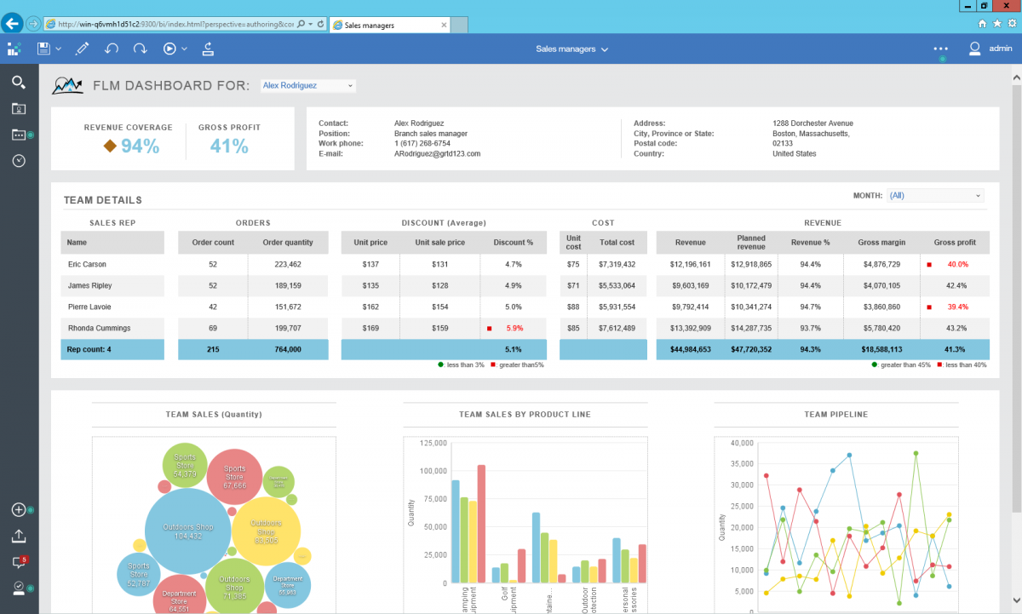

**Insights for product scale analytics:**

* **Predictive Analytics:**

Predictive analytics models use historical sales data to forecast future sales trends, customer behavior, and market demand. This enables companies to plan inventory, marketing campaigns, and sales strategies with greater accuracy.

* **Customer Segmentation:**

Sales analysis innovation allows for precise customer segmentation based on various parameters such as demographics, purchase history, and browsing behaviour. This segmentation helps companies tailor their marketing and sales efforts to specific customer groups.

* **Real-time Insights:**

Businesses can access real-time sales data and insights, enabling them to make quick adjustments to their strategies as market conditions change. Real-time reporting and dashboards are essential components of this innovation.

* **Competitor Analysis:**

Companies can use sales analysis tools to monitor and analyse the sales strategies of their competitors. This information can inform pricing decisions, product development, and market positioning.

**CONCLUSION:**

In conclusion, innovation in product sales analysis is essential for staying competitive and making data-driven decisions. It involves leveraging advanced analytics, machine learning, and AI techniques to gain deeper insights into customer behaviour, optimize pricing and inventory management, and predict future sales trends. This innovation can lead to improved customer experiences, increased revenue, and enhanced business efficiency, ultimately driving success in a rapidly evolving market.