TestDCOM
TestDCOM allows for testing of DCOM connection between machines.

Configuring for easier Testing
Although you can change these things in the GUI, you can make your life easier by configuring the config.ini file.

[CONFIG]
ipaddr = 192.168.1.100
user = auduser
pw = SUNRISE
clsid = {75d00afe-dda5-11d1-b944-9e614d000000}

[USERS]
0=None
1=.,auduser,SUNRISE
2=.,auduser,SUNRISE840D

Enter the ip address of the remote machine.
The classid is current set to the Siemens 840D OPC Server COM class id.
Under users you can add other user/password combinations, by
#=domain,accountname,password
Use domain “.” For workgroup domains (most likely on a CNC.)

Running TestDCOM
To run, double click the program, and you will see the following screen (with IP address different).
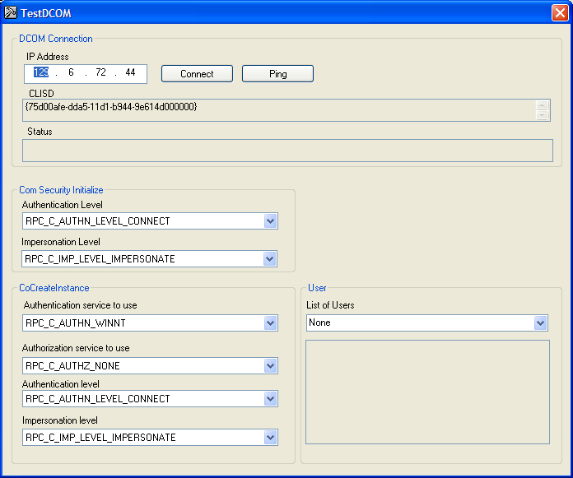

Hit the Ping button to see if there an actual connection to the remote IP address. You should see a ping reply:
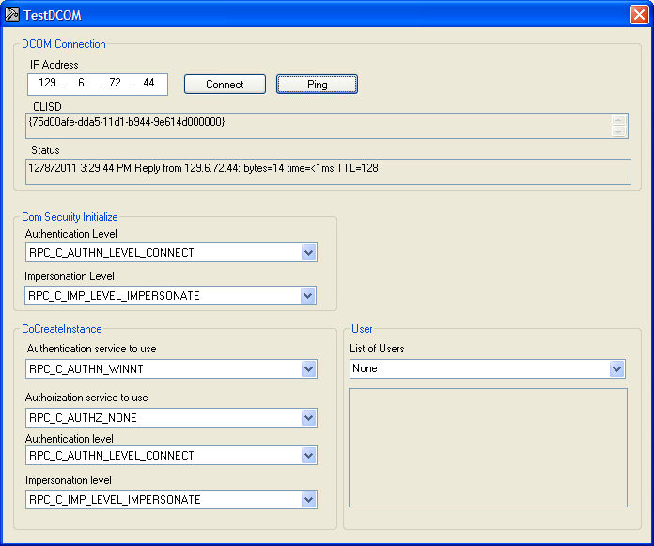

Hit the connect button and the Status field should change.
- If connected, a timestamp and the status message “Test DCOM Connection succeeded” will be displayed.
- If it fails you will see a time stamp and an error message like shown below, with CoCreateInstanceEx FAILED with error # and description – which as not very helpful.

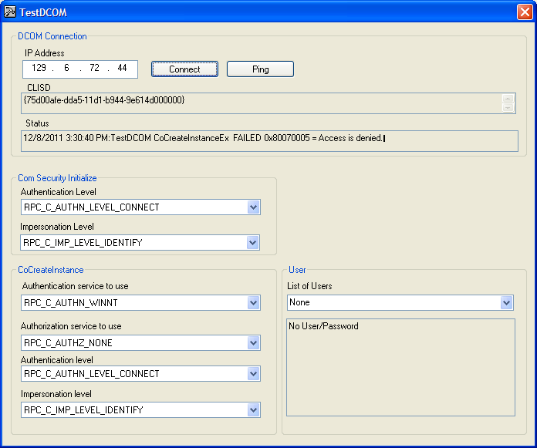
☹ Note:
DON’T CHANGE THE Authentication service to use from
RPC-C_AUTHN_WINNT
!!!!!!!!!

If you fail you can try various combinations of settings and user/password combination.

Change
Authorization service to use: to RPC_AUTHZ_NONE

Figure 1 TRY THIS - IT IS THE MOST LENIENT PERMISSIONS!!
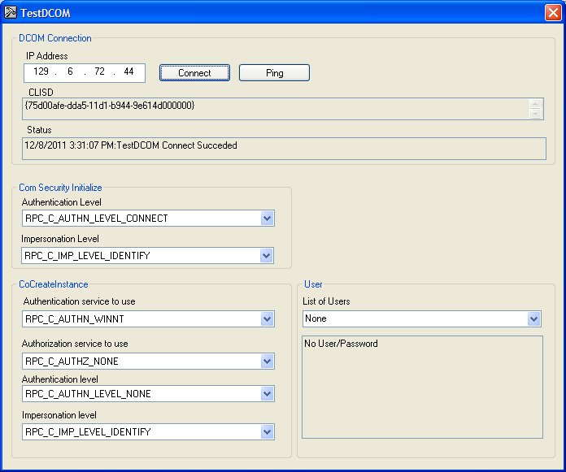

HINT:

0x800706ba - The RPC server is unavailable

Most likely Firewall problem!

