Proceedings of the 2014 IMECE
ASME 2014 International Mechanical Engineering Congress & Exposition
November 14-20, 2014, Montreal, Canada
IMECE 2014-xxxxx

J. Horst, H.Huang, J. Michaloski, and F. Proctor,
National Institute of Standards and Technology
Gaithersburg, MD USA
TOWARD THE IDEAL OF AUTOMATING PRODUCTION OPTIMIZATION

Abstract
MTConnect is a factory integration standard aimed at solving the islands of automation problem in discrete manufacturing. Machines adopting MTConnect can offer better data acquisition and thus offer the potential to better understand factory operation. However, properly assessing machine performance requires insightful metrics, such as Key Performance Indicators (KPI). The ISO 22400 standard, “Automation systems and integration Key performance indicators for manufacturing operations management” offers guidance through the definition, use, and benefits of resource and production KPI. The range and scope of ISO 22400 KPI is extensive and complicated so that understanding the standard can be useful in calculating the KPI for subsequent production improvement. In conjunction with MTConnect, this paper will explore the necessary MTConnect data requirements to satisfy ISO 22400 and then outline issues related to calculating and using the KPI. A case study of a simulated factory with of resources will be developed to show how a client MTConnect can calculate and use the KPI of ISO 22400 in a factory setting.

Nomenclature
ANSI American National Standards Institute
B2MML Business To Manufacturing Markup Language
CAEX Computer Aided Engineering Exchange
CAD Computer Aided Design
COM Microsoft’s Component Object Model
CMSD Core Manufacturing Simulation Data
CNC Computer Numerical Control
DES Discrete Event Simulation
ERP Enterprise Resource Planning
ISA International Society of Automation
HTML Hypertext Markup Language
KPI Key Performance Indicators
PLC Programmable Logic Controller
MES Manufacturing Execution Systems
MTBF Mean Time between Failure
MTTR Mean Time to Repair
MTTP Mean Time to Processing
OEE Overall Equipment Effectiveness
OEM Original Equipment Manufacturers
PLC Programmable Logic Controller
SDK Software Development Kit
UML Unified Modeling Language
XML eXtensible Markup Language
XSD XML Schema Definition
XSD XML Schema Definition
MTConnect has been developed to satisfy the requirements of “Manufacturing in the Internet Age” so that Measured KPI are necessary, but not sufficient, in order to enact improvements.
INTRODUCTION
Key Performance Indicators (KPI) can serve as a basis for decisions (problem identification) and for performance benchmarks (target / actual comparison) to describe and understand important production elements. Since KPI can characterize the behavior of their production, this can help manufacturer's benchmark performance. Benchmarking can be used to compare current performance against historical performance, as well as a comparison against others in industry. Depending on the perceived KPI value, companies can choose to initiate subsequent solutions to improve efficiency or not.
KPI are metrics that provide a means to characterize productivity. To help understand and implement KPI, the International Organization for Standardization (ISO) has developed a draft standard ISO 22400, “Automation systems and integration Key performance indicators for manufacturing operations management”, that offers guidance with the definition, usage, application and benefits of production KPI and associated metrics. KPIs computed for benchmarks, comparisons, estimations and forecasts are described in terms of data pertaining to the process, the machinery and equipment, the product manufactured and its quality, the manufacturing personnel and other related manufacturing resources.
Measured KPI are necessary, but not sufficient, in order to enact improvements. For example, throughput is a KPI to measure the performance of a process, i.e. the quantity per unit time is produced and is an important indicator of production efficiency. Although, throughput KPI forms a necessary basis for improvements by better production information, unsatisfactory KPI values implies the need for more detailed data analysis, that most likely is not be directly discernible from the KPI itself. Instead, production data of finer granularity is required to understand the contributing factors that lead to the unsatisfactory KPI. For example, in one scenario the machine often sits idle blocked, waiting for the arrival of materials or tooling. In contrast, excessive machine or process faults cause prolonged unproductive periods of operations. In either case, understanding the type and severity of delays or faults within production are required to remediate process problems and improve OEE. Often the underlying analysis is more difficult to undertake and the data is more difficult to categorize and remediate.
Our research goals regarding KPI are to quickly synthesize KPI and then understand the underlying root causes of poorly performing KPI.
RelateD Work

Mailboxes
Proxy agents

Problem Statement
A typical concern of many enterprises is determining whether resources will be in place to handle an increasing number of parts as the number of customer orders increase. Capacity planning is the process of determining the production capacity needed by an organization to meet changing demands for its products. A disparity between the capacity of an organization and the demands of its customer's results is detrimental, either in under-utilized resources or unfulfilled customers.

Typical Capacity Planning for a Job Shop
- Industrial Engineer does Process Planning – allocate part machining to resource
  - Planner manually assigns jobs based on machine + operator + shift
  - Uses knowledge of how long part should take to setup and machine(from simulation)
  - Padding for break, faults, etc.
  - Schedule based on materials flow, part complexity, time
- Operator picks up assigned part and paperwork from Cart in holding area
- Sequence of work
  - Setup – appropriate for part, maybe get tooling and fixtures
  - Download program
  - Run – part of OEE
- Finish – take to Coordinate Measuring Machine holding area for inspection
- Inspect part by measuring key characteristics
  - If good, sign off to cart
  - If bad, liaison engineer determines why non-conforming to determine disposition
    - Liaison coordinates with all parties to determine go/no go
    - Reinspect
    - Rework, which requires re programming, and operator job sequence
    - Scrap – how is this noted in job schedule
    - Marginally ok, determine conformity

CASE STUDY

A large number of modeling factors are critical in effectively modeling a production system. Manufacturing systems involve a number of interrelated elements, including equipment strategy, number of product options, material handling systems, system size, process flow configuration, processing time of the operations, system and workstation capacity, and space utilization. The model must be combined with other constraints such as unpredictable machine breakdowns, varying operational requirements, schedule variation, and different production demands. The following lists some of the basic optimization parameters one would find in a manufacturing system:
  - Improve uptime, product delivery performance , product rate, quality rate, availability, OEE
  - providing better information how resource should be used
  - minimize resource contention and process dedication
  - minimize waiting time constraints
  - raise system performance and reduce production costs
  - supply chain improvement – reduce stock of raw materials and parts on hand of every kind needed to hedge against the risk of a shortage
  - improve spare part and scrap reordering tracking
  - Increase income, lower cost, reduce use of tied-up capital
  - Anticipate expected output from current level of resource and staffing

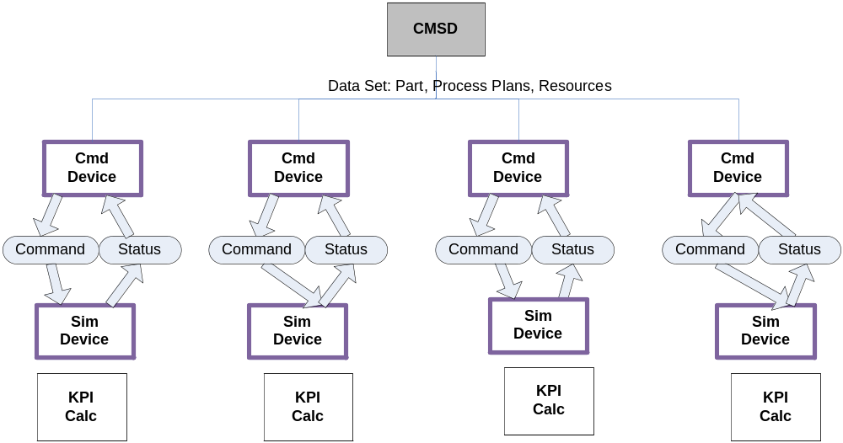

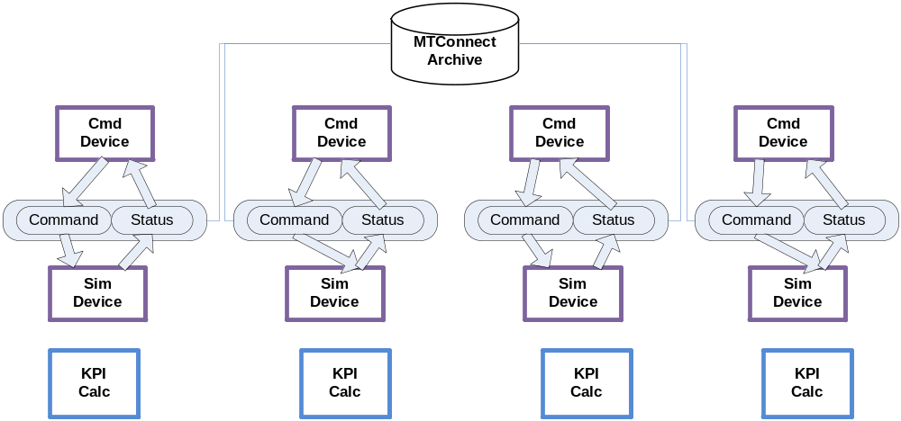

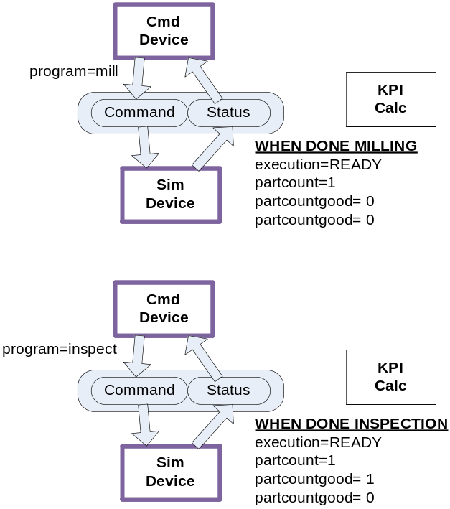
Capacity Planning
A desired increase in production outputs from the current baseline will require capacity planning in order to determine if there are the necessary resources, operators and schedule in order to fulfill the additional output. In CMSD, we need to answer the questions, “What do need to do if we need to ramp up production? Can we achieve the goals with our current setup? Are there any optimization strategies we can incorporate to increase output without additional cost?”

For simple capacity planning, CMSD can determine the output over time for a mix of parts.
In general, the Capacity Planner stochastically picks from the CMSD Part, calculates throughput and time, and quits when done. The Capacity Planning methodology assumed shifts as the metric for planning production, as the machines utilization is based on staffing considerations. In order to assign machines, the total time must be considered in the context of shifts. The Capacity Planner must assign operators to run machines based on shifts (3/day or 2/day or 1/day), so that over time the unit of measure for machine availability is based on shifts. Thus, the number of shifts is the fundamental measure of machine work. If we assume one machine is assigned to this workload, and further assume zero operator breaks, zero downtime, running at full 24/7 capacity, then the number of shifts divided by three is the number of days required to finish the work. Adding more machines will make the work go faster, but the amount of work as defined in shifts is constant. Adding idle time follows from this logic. Idle time, such as operator breaks, would need to be calculated per shift.

For simple capacity planning, CMSD can be used to determine the part output over time under a fixed job regime and an independent resource allocation. The relevant KPI data is collected from the equipment: MTTR, MTBF and for process–specific KPI data: part cycle time (MTTP). All the relevant data can be represented in CMSD, without any problem.

However, CMSD is a literal information modeling language, and once a definition is in place, it is assumed to be statically defined and hence immutable. One of the features that would make CMSD more powerful is the ability to dynamically change how a part is made and to select from the best alternative. This would require CMSD to support changing a part-> process plan -> process to add, merge, or subtract

Out of scope for the lean computation in this case study are the transportation time and cost (moving of material) and any inventory (includes all finished product not being processed). Further, we will assume that much like the SMCO casting facility the operation is in effect operator less so that optimizating motion (people or equipment moving to perform the processing).

Criteria for Lean
• What to record:
– Waiting time (waiting for the next production step)
– Overproduction (production performed ahead of demand)
– Over processing (rework due to poor tool or product design)
– Defects (the effort involved in inspecting for and fix

• Key Business Drivers
► Key business drivers are the areas of performance that are most critical
to an organization's success
• Available To Promise
► Requires detailed knowledge of available capacity
• Reduced Cycle Time
► Major performance indicator with a direct impact on corporate profitability
• Supply Chain Optimization
► Optimizing the manufacturing link in the supply chain – agile &
responsive
• Asset Efficiency
► Requires detailed knowledge of actual use
• Agile Manufacturing
► Requires ability to quickly synchronize planning and pr
Benefits to End Users
► Integration projects went from over one year to under
6 weeks
► Success rate for projects went from less than 50% to
over 90%
• Benefits to Vendors
► Integration costs reduced because of a standard
format
► Less custom code to develop and support
• Benefits to System Integrators
► Standard tools and methods can be applied
► More opportunities for integration projects

Effective operation of manufacturing is difficult to explain and compare
► Impossible to compare operations at different plants and determine best practices
► Difficult to explain end user requirements to vendors, requirement projects took years
► Difficult for vendors to explain solutions to end users, sales took years
► Difficult to compare MES solutions
► MES (Manufacturing Execution Systems) had no common definition

The energy consumption of machine tool is calculated as follows.

Electric consumption of machine tool (Ee)
Ee = k_ (SME+ SPE +SCE+CME +CPE
+TCE1+TCE2+ATCE+MGE+VAE) (2)
k: EI of electricity [kg-CO2/kWh]
SME: EC of servo motors [kWh]
SPE: EC of spindle motor [kWh]
SCE: EC of cooling system of spindle [kWh]
CME: EC of compressor [kWh]
CPE: EC of coolant pump [kWh]
TCE1: EC of lift up chip conveyor [kWh]
TCE2: EC of chip conveyor in machine tool [kWh]
ATCE: EC of ATC [kWh]
EI: Emission intensity
EC: Electric consumption

Our goal is to develop a DES energy and emissions model of the material removal process. From [14], the basic definition of a controlled discrete-event process is defined by

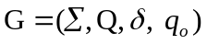

Here  is the set of states, 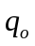is the initial state,  is a finite set of output symbols, and 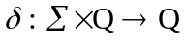 is the state transition function. For a material removal, G defines a function so that a machine that starts in the state and generates a sequence of events, i.e. state transitions, subject to the range of transitions permitted by the function . Each event results in an output from the set .
The DES model of the machine tool behavior can be equivalently described by a Finite State Machine (FSM), which is a more common paradigm to modeling the machine control logic. A FSM models is a set of finite states together with a set of state transitions, a machine controller as being in one of a finite set of the possible states, known as the state-space, at any given time. The machining energy models found in the literature hint at the FSM methodology, establishing an “Idle” or “Ready” machine energy baseline for power consumption, and implicit in the model is a “Machining state” as well. We will attempt to formalize the Machine component based on enumerating the states required for the machine removal process. Error: Reference source not found shows FSM formalism for DES model using three basic states: DOWN, IDLE, and MACHINING. DOWN refers to the machine being off due to inactivity or machine breakdown. IDLE refers to the state where the material removal process is paused, a tool change is occurring, or is in manual model during setup. MACHINING refers to the state where the material removal process is underway. The formalism could be more expanded to a more detailed analysis by including such states as DRY MACHINING, WET MACHINING, TOOL CHANGE, etc.

Detailed information contained in the system model of the production line should include:
- number of resources,
- number and size of buffers,
- type of parts,
- estimated energy required to make parts,
- general high level overview of material in parts,
- transport between resources, conveyor speeds,
- and overview part routes between resources.

In our experiments, the model characterization was as follows. (1) was a given by the layout of the equipment although the CMSD Process Plan with its operation steps (or Process) each had a given resource. (2) for our buffers we assumed each buffer was part of a resource, so that buffer sizes could change (and each resource could have a growing input or output buffer) but bounded buffer size as would be expected by the shops (as were reflected with marginal change captured by our CMSD optimization routines) (3) only 1 part was produced within the factory, although the number of parts could vary from day to day. What was found was that 1 part implied a static configuration of equipment in its production, and therefore, CMSD Process Plans and subservient Process steps (and layout) were fixed,

Alarms

Detection and prevention of “unit” resource downtime is an important KPI. Whenever downtime is encountered, productivity of a resource is lost and preventing this occurance can lead to direct improvments and opportunities. In general, alarms are the cause of machine downtime. Alarms can be informative non-productivity reducers, such as warnings, but can be productivity reducers with no manufacturing possible since the machine is faulted. In MTConnect, alarms are packaged as conditions which provide a more machine neutral mechanism in which to describe the fault. Not only is the detection of the fault important, but the time wasted in attempting to get maintenance personnel to fix the problem as described by the alarm a big waste.

The alarm algorithm algorithm is based on detecting MTConnect condition and reacting and recording fatal events. Each cycle machine’s MTConnect Agent status is read for conditions, and when a condition is a Fault, then an alarm is tripped and recorded into the data base. For each condition, MTConnect returns an element to describe the current state: Normal, Warning, Unavailable or Fault. If the condition has a Fault element, then alarm data is collected as follows:
- Raised At – time when MTConnect recorded the Fault condition
- Shift – shift number (in the day, numbered 0..n-1) as determined by the time
- Raised By – machine that raised the Fault condition
- Severity – MTConnect returns the numeric internal severity of the Fault condition in the agent
- Description – MTConnect returns the textual description of the Fault condition in the agent
- Resolved At – time when MTConnect recorded the Fault condition was resolved
- Program – program running when the Fault condition occurred. Excessive faults for one program archetype may signal problems with the program, tooling or operator handling of the part.
- Time Between Fails – duration between the last MTConnect Fault condition and the current MTConnect Fault condition
- Time To Repair – duration between when MTConnect first signaled the Fault condition and the time when the Fault condition was resolved.

DISCUSSION

IBM helps manufacturers by providing:
- Supply chain planning applications for network design and inventory optimization
- Supply chain scheduling applications for integrated production planning and detailed scheduling in process and semiconductor manufacturing
- Pre-built, best-in-class optimization models for integrated production planning and detailed scheduling in process and semiconductor manufacturing
- Custom planning and scheduling solutions—based on custom optimization models—that fit your unique decision-making challenges, eliminating the compromises that sometimes come with generic applications or Excel-based solutions
- Scheduling precision—by the minute, rather than by the hour or day
- Metrics and trend analyses that capture both operational efficiency and financial performance
- State-of-the-art "what-if" analysis, scenario comparison and goal balancing
- The ability to make decisions based on data stored in multiple systems

DISCLAIMER
Commercial equipment and software, many of which are either registered or trademarked, are identified in order to adequately specify certain procedures. In no case does such identification imply recommendation or endorsement by the National Institute of Standards and Technology or Boeing Aerospace, nor does it imply that the materials or equipment identified are necessarily the best available for the purpose.
References
[1] T. Gutowski, A. Taplett, A. Allen, A. Banzaert, R. Cirinciore, C. Cleaver, S. Figueredo, S. Fredholm, B. Gallant, A. Jones, J. Krones, B. Kudrowitz, C. Lin, A. Morales, D. Quinn, M. Roberts, R. Scaringe, T. Studley, S. Sukkasi, M. Tomczak, J. Vechakul, and M. Wolf, “Environmental Life Style Analysis (ELSA),” IEEE International Symposium on Electronics and the Environment, San Francisco, CA, United states: 2008.
[2] Environmental Protection Agency, “Life Cycle Assessment (LCA) | System Analysis | Sustainable Technology | Risk Management Research | Research and Development | US EPA,” Feb. 2010.
[3] International Energy Agency (IEA), Tracking Industrial Energy Efficiency and CO2 Emissions, Paris: OECD/IEA, 2007.
[4] T. Gutowski, J. Dahmus, A. Thiriez, M. Branham, and A. Jones, “A thermodynamic characterization of manufacturing processes,” IEEE International Symposium on Electronics and the Environment, Orlando, FL, United states: 2007, pp. 137 - 142.
[5] B. McLellan, G. Corder, D. Giurco, and S. Green, “Incorporating sustainable development in the design of mineral processing operations - Review and analysis of current approaches,” Journal of Cleaner Production, vol. 17, 2009, pp. 1414 - 1425.
[6] P. Sheng, D. Bennet, S. Thurwachter, and B.V. Turkovich, “Environmental-Based Systems Planning for Machining,” CIRP Annals - Manufacturing Technology, vol. 47, 1998, pp. 409 - 414.
[7] A.A. Munoz and P. Sheng, “An analytical approach for determining the environmental impact of machining processes,” Journal of Materials Processing Technology, vol. 53, 1995, pp. 736 - 758.
[8] D. Fratila, “Macro-level environmental comparison of near-dry machining and flood machining,” Journal of Cleaner Production, vol. In Press, Corrected Proof, 2010, pp. -.
[9] Z. Chen, A. Atmadi, D.A. Stephenson, S.Y. Liang, and K.V. Patri, “Analysis of Cutting Fluid Aerosol Generation for Environmentally Responsible Machining,” CIRP Annals - Manufacturing Technology, vol. 49, 2000, pp. 53 - 56.
[10] T. Gutowski, J. Dahmus, and A. Thiriez, “Electrical Energy Requirements for Manufacturing Processes.”
[11] A. Dietmair and A. Verl, “A Generic Energy Consumption Model for Decision Making and Energy Efficiency Optimization
in Manufacturing,” International Journal of Sustainable Engineering, vol. 2, Jun. 2009, pp. 123–133.
[12] J.B. Dahmus and T.G. Gutowski, “An environmental analysis of machining,” American Society of Mechanical Engineers, Manufacturing Engineering Division, MED, Anaheim, CA, United states: 2004, pp. 643 - 652.
[13] H. Narita, N. Desmira, and H. Fujimoto, “Environmental burden analysis for machining operation using LCA method,” MANUFACTURING SYSTEMS AND TECHNOLOGIES FOR THE NEW FRONTIER, M. Mitsuishi, K. Ueda, and F. Kimura, eds., 2008, pp. 65-68.
[14] P.J. Ramadge and W.M. Wonham, “Modular Feedback Logic for Discrete Event Systems,” SIAM Journal on Control and Optimization, vol. 25, 1987, pp. 1202-1218.
[15] U.S. DOE Energy Information Administration, “Electric Power Monthly - Average Retail Price of Electricity to Ultimate Customers by End-Use Sector, by State.”
[16] M. Lanz, M. Mani, K. Lyons, A. Ranta, K. Ikkala, and N. Bengtsson, “2010 ASME International Design Engineering Technical Conferences (DETC),” Montreal, Quebec, Canada: ASME, 2010.
[17] H.C. Frey and M.J. Small, “Integrated Environmental Assessment, Part I Estimating Emissions,” Journal of Industrial Ecology, vol. 7, 2003, pp. 9-11.

McLean, C., Y. T. Lee, G. Shao, and F. Riddick. 2005.
Shop Data Model and Interface Specification. Technical report NISTIR 7198, National Institute of Standards and Technology, Gaithersburg, Maryland.

This paper presents an integrated simulation and activity-based management approach for determining the best sequencing scheme for processing a part family through a manufacturing cell. The integration is illustrated on a loop or U-shaped manufacturing cell and a part family consisting of four part types (A, B, C, and D). Production requirements for the cell demand that part batches be processed one type at a time. For example, all part A’s are processed until weekly demand is met, then part B’s, etc. The objective of this example is to determine the best part sequence (e.g., ABCD, DCBA or CABD). In addition to traditional measures, the simulation model produces detailed activity-based costing estimates. Analysis of cost and performance parameters that indicates part sequence CDBA provides the best overall choice. This sequence achieves a low per unit manufacturing cost, minimizes average time in the system and in-cell inventory cost, and maximizes unused production capacity. Although the scope of this effort was restricted to a small scale manufacturing cell, the costing concepts have general applicability to manufacturing operations at all levels.

The shop characteristics are described below with the following symbols.
n – number of products manufactured in a CMS
Di – demand of product i, which is a random variable i = 1, 2, …, n.
φ _{1i} – finished product (final assembly) i
u_{i} – number of make items contained in the bill of material of the product φ_{1i} . If the entire items required for the product φ_{1i} are not manufactured in house, the number of items in the bill of material of the product is greater than u_{i} . The product i, which is the final assembly, is represented in the bill of material as φ_{1i} .
φ _{ib} – a make item required for making the product φ_{1i} ; b = 2,3, …, u_{i} .

