**How to setup web application (JM.SCI.Salespromo.Web)**

1. The client app developed using Angular 6
2. Install Angular cli 6 and Node js as below. If you have already installed node JS and angular cli then follow the below steps to upgrade it to latest version using command tool. Run the below command under your root web app folder i.e. **JM.SCI.Salespromo.Web** folder
3. npm uninstall -g @angular/cli
4. npm cache clean
5. # if npm version is > 5 then use `npm cache verify` to avoid errors (or to avoid using --force)
6. npm install -g @angular/cli@latest

EX:

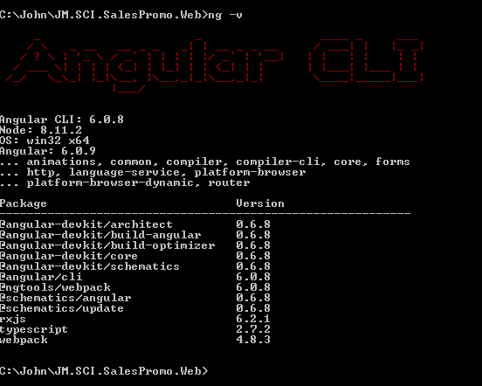

1. Uninstall your old node js(**v 8.11.2**), if any, and install it again LTS version 8.11.2 or above (**https://nodejs.org/en/).** I think there is no option to upgrade the node js version from windows OS. Ex:
2. 
3. If you want to change default api Uri for the web app then change it from the config.service.ts file from **(../app/src/app/shared/settings/ config.service.ts**)
4. Go to the project root folder ie **JM.SCI.Salespromo.Web** folder and run the **npm install** command to install the client side packages.
5. Once it is successful then run the **ng serve –o** to launch the web app automatically in your default browser ( default 4200 port being used(**http://localhost:4200/**), if the port is being used by some other web app then change it to some other port number ex: **ng serve --port 4201 -o**)
6. Don’t forget to run the web api project before you the web app.

**How to setup Api Service**

1. Rebuild the solution to install all the sever side package
2. Change the **SCIDbConnection** connection string from **app.config** in **JM.SCI.SalesPromo.Api** to connect your local/remote database
3. Run the **update-database** command on package manager console from the VS 2015 or above o as shown below. Note the default project should be **JM.SCI.Salespromo.Data**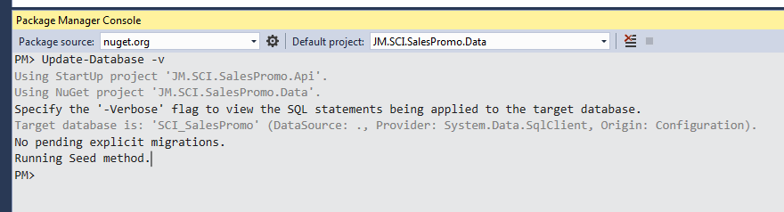
4. Run the Api service i.e **JM.SCI.SalesPromo.Api** which will be hosted by Katana using OWIN interface.
5. The service is configured to host on **http://localhost:8500/**
6. So it runs as a console app. don’t close the console app until you finish your testing in the client app
7. You can change configured service uri in Program.cs file, if you change the uri then you need to make the same changes in web/client app

**How to setup Test project**

1. **Integration Testing(JM.SCI.SalesPromo.Test.Int) - SpecFlow has been used for TDD/BDD**
2. Rebuild the test project
3. Change the SCIDbConnection connection string from app.config in JM.SCI.SalesPromo.Test.Int
4. Run the test using MS Test
5. Setup seed campaign data before you run the test. Since time constraint I could not setup seed data for test project. Or Just run the **campaign feature** first and then run **winner features**
6. Install Spec flow extensions (better use VS 2015) if you have any issues while running test cases.

**Assumptions & Incomplete tasks**

1. **Client app/Web App**
2. UI Testing is not implemented
3. Authentication and authorization is not implemented
4. No admin module to manage winners and campaign
5. General message and exception services are not implemented
6. Experimented new UI CSS framework as an alternative to bootstrap css called **materializecss** (<https://materializecss.com/footer.html>). There is some known issues on smaller devices.

1. **Web Api service**
2. Validations are not implemented .I had to planned to use **Fluent Validator** for api validation.
3. Due to time constraint, I could not write test cases to cover all the possible scenarios.
4. Authentication and authorization is not implemented
5. Prime number logic needs to be changed as it only works for natural numbers and if there is any fraction number after division, it will be round off to nearest number to find prime number.
6. Needs to add few property in the winnerCampaign table like isPrizedDlivered and DeliveredDate.
7. WinnerCampaign entity is added to separate the user’s basic information from the winning details. Otherwise, we can have all this information in winner table itself.