<Candy Dispenser>: Team 12
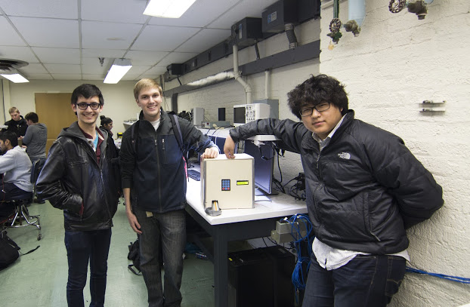
Team members, left to right are: John Lee, Josh Wroblewski, and Kyunghoon Jung.

Name | Class No. | Honors
Kyunghoon Jung | 5413-J | N
Josh Wroblewski | 0902-W | N
John Lee | 5528-L | N

MINI-PROJECT GRADING CRITERIA | Regular Students | Honors Contract Students
Originality, creativity, level of project difficulty | 20 | 10
Technical content, succinctness of report | 10 | 5
Writing style, professionalism, references/citations | 10 | 5
Project functionality demonstration | 20 | 10
Overall quality/integration of finished product | 10 | 5
Effective utilization of microcontroller resources | 10 | 5
Significance of individual contributions* | 20 | 10
PCB hardware schematic | N/A | 10
PCB top and bottom copper illustrations | N/A | 10
PCB functionality demonstration | N/A | 20
PCB written report | N/A | 10

*scores assigned to individual team members may vary

Scoring Multiplier:
1.0 | Excellent – among the very best projects/reports completed this semester
0.8 - 0.9 | Good – all requirements were amply satisfied
0.6 - 0.7 | Average – some areas for improvement, but all basic requirements were satisfied
0.4 - 0.5 | Below average – some basic requirements were not satisfied
0.1 - 0.3 | Poor – very few of the project requirements were satisfied

TABLE OF CONTENTS
1.0 Introduction | 1
2.0 Interface Design | 2
3.0 Peripheral Utilization | 3
4.0 Software Narrative | 4
5.0 Packaging Design | 5
6.0 Summary and Conclusions | 6
7.0 References | 7
Appendix A: Individual Contributions and Activity Logs | 8
Appendix B: Interface Schematic | 17
Appendix C: Software Flowcharts | 19
Appendix D: Packaging Design | 21
Appendix E: Honors Contract Deliverables (if applicable) | N/A

- Introduction

The Candy Dispenser is a way to protect your post-Halloween leftover candies from little intruders who sneak your candies away. This machine gets the preset 4-digit passcode input and dispenses set amount of candy by rotating the servo. The passcode is reprogrammable through the set combination in case the passcode is forgotten.
The Candy Dispenser uses PWM output to control the servo to rotate the dispenser when the correct combination of passcode is entered. The passcode is entered through 12-key keypad, which gets input from 7 different wires for 4 columns and 3 rows, which determines the vector of the signal. The LCD Display shows what the combination is when it is entered through the keypad, and displays whether the combination is right or wrong.
John was our Software Leader, who took initiatives to code the framework and details of the Candy Dispenser. He wrote codes for majority of the system, including PWMs, ATD conversions, and debugging in general. His role was pivotal in the debugging process. Josh was our Interface Leader, who studied the interrupts needed for the program and wrote the code with John. He took charge of the interfacing peripherals along with Kyunghoon, who was the Peripheral Leader. Each one of us participated in each section, whether it was software, interfacing, or peripherals. The coding process took a long time because there were several peripherals to take considerations of and combining all the functionality was a hard process.
- Interface Design

We used four different external interfaces: a motor servo, GAL22V10C used as 8-bit shift register, two-line LCD display interfaced via GAL22V10C, and the 12-key keypad. The OrCAD schematic is attached at Appendix B.
The motor servo is attached to the system via PWM output directed to Port 0. The voltage used on this servo is 5V, so we used the power supply that is used to power other peripherals as well.
The GAL22V10C is used as an 8-bit shift register for transferring data bits to the LCD display. It obtains the data bits from the microcontroller and send it to the input pin of the programmable logic device. This sends the information received to the LCD display to be displayed.
The LCD gets information from both the microcontroller and the 8-bit shift register, and as shown in the previous experiments in the lab, this device displays the information that were requested to be displayed.
The 12-key keypad is interfaced to 7 different input pins. This is done because each inputs have characteristics from 4 rows and 3 columns when a key is pressed. The vectors were planned to be interfaced via 74C922 shift register, but it didn’t arrive in time so we decided to connect the keypad directly to the microcontroller.
Microcontroller Resource Utilization

Pretty much of our entire code utilizes RTI interrupt service routine. The RTI controls the scanning of the keypad inputs and determines when the input is a correct combination, or resets when a key is pressed or an incorrect combination is pressed. It also has a mechanism of changing the passcode when a secret code has been entered. All of our program is stored in flash memory so it would work in a turn-key fashion.
The peripherals that utilize ATD is the 7 different segments from the keypad and determines which row and column of the keypad is pressed. Each input lines have to obtain a higher threshold value that suggested to block out unnecessary noise being captured by the ATD. The keypad still had too much noise being generated when the power supply didn’t provide an absolute ground, so each column pins were hooked up with capacitors to reduce noise. The SPI inputs were used by the LCD display. The 8-bit shift register through GAL22V10C provided MOSI and SCK inputs from the microcontroller and fed the information to the two line LCD display. The motor servo that is used utilizes PWM input of duty cycle to determine the position of itself..
To summarize, we utilized RTI interrupt system to control overall system continuously, PWM to control the servo, SPI to control the 8-bit shift register to send information to the display, ATD to control the inputs from the keypad.
- Software Narrative

Describe what the software does and how it is organized/structured (i.e., event-driven, state machine, etc.). Submit your complete software listing on-line separately. Include a flowchart to document program structure in Appendix C.

Length should be about one page.

- Packaging Design

The packaging design approach was to seal the box and isolate the system. We have the electrical system with microcontroller controlling the LCD, motor servo, and the keypad. The motor servo controls the Candy Dispenser’s door, thus is buried in the box. The keypad and the LCD can be seen outside of the box to for the users. The box, made out of plywood, stands at 12 inch height, 12-inch width, and 9-inch length. The box is big for the electrical system but just big enough to hold the candy reservoir.
The box has a small hole behind the box to get the 5V 1A DC power supply input directly connected to the breadboard. Each edge had a finishing touch with the duct tape, in order to prevent any openings. The top side was hinged via duct tape for the quick access to the system (and mainly to fill up those candies, which seem to be disappearing rather strangely quickly). The system was designed to secure the access to the valuables, in a very simplistic manner.
There are three holes in front of the box: a slim one for pulling the keypad interface, LCD screen hole for displaying purposes, as the LCD screen will be attached behind the front side of the box. There is a hole on the bottom left of the front side for releasing candy when the servo rotates to “open” position.
This box is made simple to represent the simplistic design philosophy when we undertook this Mini Project. However, the real functionality is applying the secure mechanism. The important thing is: this system can be applied not only to candies but many other things that need passcode integration.
- Summary and Conclusions

This project was called the Candy Dispenser to start with, but with time added, we managed to create something more than just a Candy Dispenser using a keypad. This is a fully secured system, which needs a password to bypass the system. This is the first iteration of our system towards security. The passcode is fully user programmable with given code “362” and then pressing “#”. The interface displayed on the LCD is easy enough to follow. The servo is programmed to rotate at a set speed, so it will give the right amount of candy when the passcode is entered.
This Mini-Project was a fantastic way to learn how working in a team creates such synergy to take on such a daunting and complex task, to create something useful while having fun. The system we made might not be the most eye-catching and fancy solution, but it utilizes a lot of the capabilities of the microcontroller. If we had more time, we would focus more on the security aspect of the software and improve all the hardware and finishing qualities. We spent a lot of time on coding, and didn’t have enough time, money, or resources on creating our packaging. The software wise, we could use TIM to lock out the user for set amount of time when the passcode entered is wrong for set amount of times consecutively. This would improve both the hardware and software security of the system. The ultimate goal of this project was not to just dump out candies, but rather to improve the overall security of our system, and as the result of it, we realized that we are merely utilizing candy dispenser for our security system.
References

List any references (e.g., data sheets, application notes, web sites) used in formulating your solutions. Be sure to cite these references in your report.

NOTE: Use IEEE format.

Appendix A:

Individual Contributions
and
Activity Logs

Activity Log for: <Kyunghoon Jung> Role: <Team/Doc/Peripherals Leader>

Activity | Date | Start Time | End Time | Time Spent

Written Summary of Technical Contributions: <Kyunghoon Jung>

Provide a concise but sufficiently detailed description of your technical contributions to the project.

Length should be about one page.
Activity Log for: <Josh Wroblewski> Role: <Interface Leader>

Activity | Date | Start Time | End Time | Time Spent

Written Summary of Technical Contributions: <Josh Wroblewski>

Provide a concise but sufficiently detailed description of your technical contributions to the project.

Length should be about one page.
Activity Log for: <John Lee> Role: <Software Leader>

Activity | Date | Start Time | End Time | Time Spent

Written Summary of Technical Contributions: <John Lee>

Provide a concise but sufficiently detailed description of your technical contributions to the project.

Length should be about one page.

Appendix B:

Interface Schematic

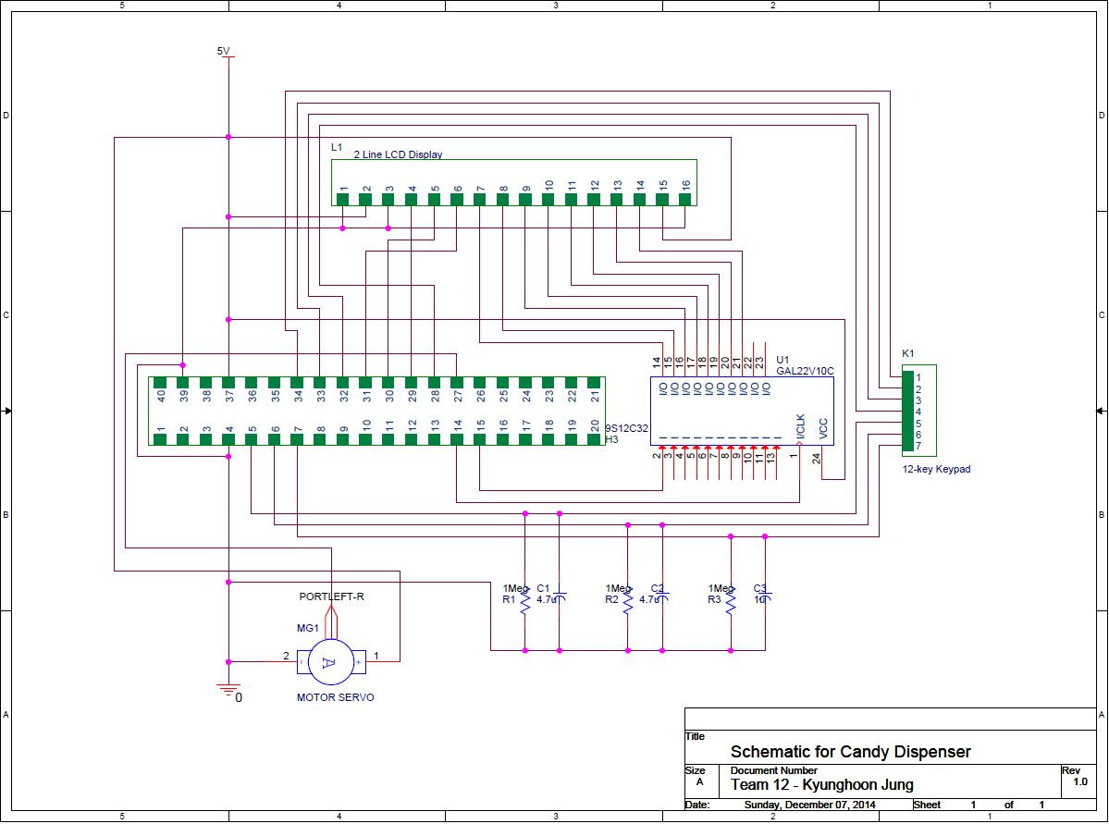

Appendix C:

Software Flowcharts

Include software flow diagrams and/or pseudo code here.

Be sure to clearly identify the team member(s) responsible for producing this documentation.

NOTE: Software source listing file must be submitted on-line and should NOT be included here.

Appendix D:

Packaging Design

Paste illustrations/pictures of your project packaging here.

Be sure to clearly identify the team member(s) responsible for producing this documentation.

NOTE: Use the on-line form on the Mini-Project website page to submit this report (.doc file) along with your source code file (.c or .zip)

Delete this text box before submitting your report! Also, delete all highlighted instructions provided in this skeleton file as you edit each section of your report.

