

**ENG127:** Business Correspondence

**SMP1:** Business Communication

**ENG148:** Business Correspondence

and Presentation

Author/s:

MS. GLORY C. LACUESTA

MS. RICHELLE LOU R. OSUMO

**Note:** This module is designed for NORSU students only. Any form of reproduction of this module for purposes apart from NORSU students' use is strictly prohibited.

NEGROS ORIENTAL STATE UNIVERSITY

COLLEGE OF ARTS AND SCIENCES

**DEPARTMENT OF ENGLISH AND LITERATURE**

**ENG127:** Business Correspondence

**SMP1:** Business Communication

**ENG148:** Business Correspondence

and Presentation

LEARNER'S MODULE

2

**WRITERS:**

MS. GLORY C. LACUESTA

MS. RICHELLE LOU R. OSUMO

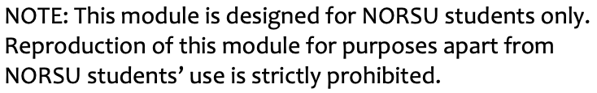



MODULE 2

Business Correspondence/Communication

(ENG127/SMP1)

***INTRODUCTION***

Business letter writing plays an essential role in dealing with different business transactions. It is the businessman's tool in achieving effective communication to obtain business partnerships for the business to expand. The previous Module taught us the basic concepts we need to know and remember when writing a business letter. Those concepts are very helpful and would serve as your guide to skillfully accomplish the tasks in writing different types of business letters.

This lesson will help you familiarize different types of business letters for specific purposes. Written tasks are prepared for you to effectively practice business letter writing in almost all situations. The seven (7) basic parts introduced in Module 1 will be applied, and other formatting for the other types of business correspondence will also be introduced. The types of letters included in this module will surely help you in your future endeavors particularly in the business industry.

**COURSE LEARNING OUTCOMES**

At the end of the lesson, students should be able to:

*Knowledge*: Remember and understand the fundamental concepts of business letters

*Skill*: Articulate understanding of the essential parts and different types of business letters

through written tasks.

*Affective*: Value the role of a well-written business letter for an effective business transaction.

**CONTENTS OF THE MODULE**

This module contains the following lessons:

Lesson 1: Types of Business Letters (with the 7-Basic Part Format): Inquiry, Quotation, Order, Complaint, Request, Application

Lesson 2: Other Types of Business Correspondence: Memorandum and

Curriculum Vitae

DIRECTIONS ON HOW TO USE THE MODULE PROPERLY

To benefit profoundly from this module, please be guided by all the key points presented below.

1. This module contains 2 lessons. Each lesson is explained substantively. Read the explanations thoroughly so that you could understand the lesson fully.
2. Each lesson has the following sections:
   1. **Set the Route** contains specific learning outcomes. These are statements presenting the knowledge and skills explored in the module that we are expected to achieve at the end of it. Read them heartily.
   2. **Spur to Spark** contains questions, ideas, or a game that will activate your background knowledge, stimulate your interest, and prepare you to process the content, new information, and activities in the module.
   3. **Mat and Chat** contains the new information we will all learn together. Read them. If questions come to mind and you need answers, you may google them or contact me through chat or email. Let us do collaborative learning and work on these questions together.
   4. **Ink, Link to Sink In** contains learning activities designed to facilitate in-depth discussion and sharing of or experiencing the topics we are to learn. In other words, these activities are used to enrich your learning.
   5. **Work with Might** contains a test/task designed to assess whether you achieved the learning outcomes. For an objective-type of test/task, answers are provided at the end of the module. You could check your answers against those provided. Checking your own answers is done to track your learning – recognize what is learned and re-learn what you failed to understand. For the non-objective type of test/task, I will check your answers myself.
3. Feel free to chat, call, text, or email me if you have questions, reactions, or reflections about the module's contents or activities.

**LESSON 1 – Types of Business Letters (with the 7-Basic Part-Format):**

**Inquiry, Quotation, Order, Complaint, Request, Application**

***Set the Route***

At the end of this lesson, students will be able to:

* + 1. Internalize the importance of the types of business letters for specific business purposes.
    2. Articulate the types of business letters by developing a sample of each type.
    3. Apply concepts of the different types of business letters for proper communication in business transactions.

***Spur to Spark***

We already know that Business Letters are important for achieving success in the business industry. There are different situations in which business letters would help carry out effective communication in a local or international context. Different situations are provided in the table below. Read them carefully and identify what purpose is being described by putting a check mark (✓)

in the column you think the situation fits.

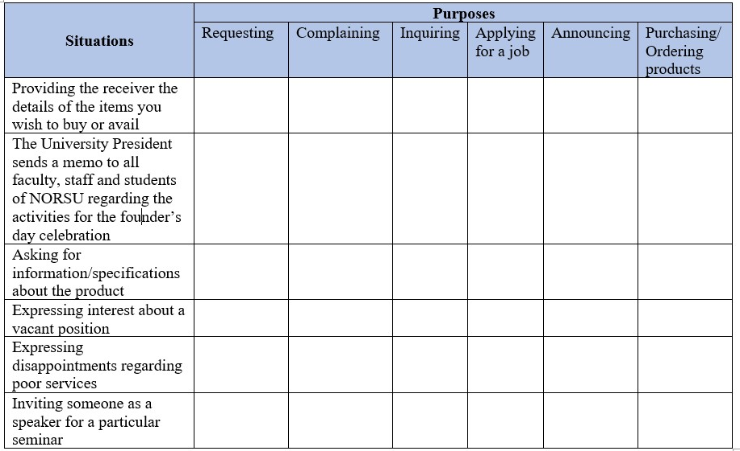

If the situations and purposes matched well, then you are now ready to learn the different types of business letters. Let's begin!

***Mat and Chat***

**Business Letters**

Business Correspondence (business letter) differs from personal correspondence (e.g., love letter, friendly letter). We already have learned that business letters should be brief, specific, and accurate rather than emotional or artistic. This difference does not make business letters better or less than the other styles or forms of writing. Rather, it shows the uniqueness of the purpose and things to consider when writing a business letter for a specific audience (University of South Carolina at Chapel Hill, n.d.).

On the one hand, a business letter is defined as written communication with professional contents, which means that formality should also be taken into account (Wickford, 2018). Described below are the different types that use formal business writing, specifically the 7-basic part format.

***Types of Business Letters***

**Letter of Inquiry**

When a businessman wants to know more about the product or services offered in the market, writing this type of letter is the first step to a continued exchange of information between the sender and receiver. Most of the time, buyers write this letter to ask for information about the products and services offered like the quantity, quality, price, mode of payment and delivery, color, size, design, etc. This should be written clearly with all the information that the writer/buyer needs (Toppr, n.d.).

Example:

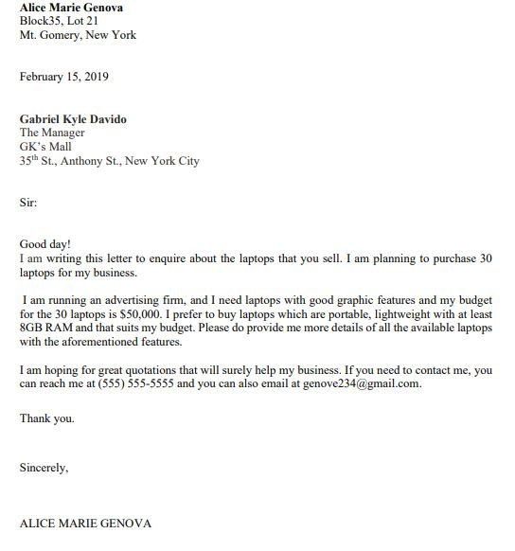

**Quotation Letter**

This is written after the business owner receives an inquiry letter. This will serve as an official answer to the questions asked by the potential buyer. The writers of this letter should reply promptly and carefully. All information must be indicated in the letter accordingly, including the discounts and promos offered. Often, brochures and price lists are attached to this letter.

Example:

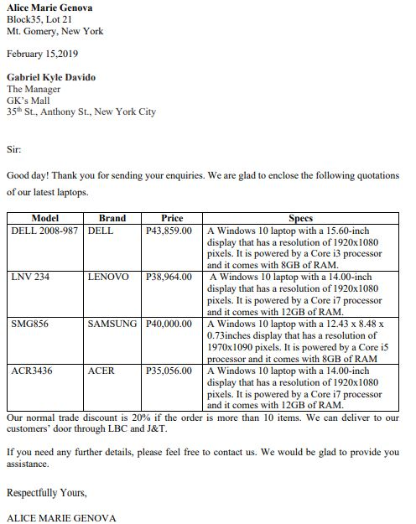

**Order Letter**

Suppose the quotations given by the seller meets the demands of the prospective buyer, then this would be the next letter that will be written. The customer will now purchase products/goods or services from a particular seller through an order letter. The buyer should put complete information regarding the goods/services, payment, and delivery – details to include would be based on the quotations given by the seller. Details must be discussed thoroughly in the letter to avoid confusion and problems. The sender might present the details in bullet or tabular format for the receiver to see things clearly and accurately.

Example:

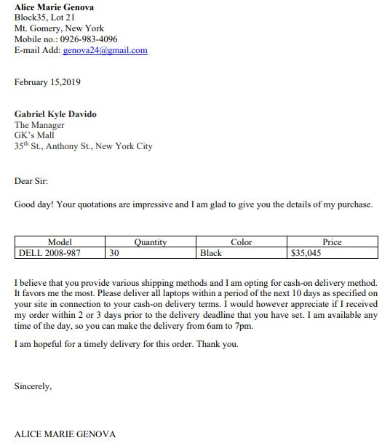

**Complaint Letter**

There might be times that circumstances in the business would occur. It could be a customer, disappointed with the poor services offered, such as delayed delivery or damaged item, an employee not given proper benefits by the agency, and many more. This letter is written to formally raise a concern and seek a prompt response or action from the authority or people involved. It should clearly describe and explain the problem or complaint. Keep in mind that this letter should be written with polite yet assertive words (Gupta, n.d.). Therefore, emotions while writing the letter should be controlled and foul words should not be used because they might be taken against you. Try your best to be calm and professional in your manner of writing.

Example:

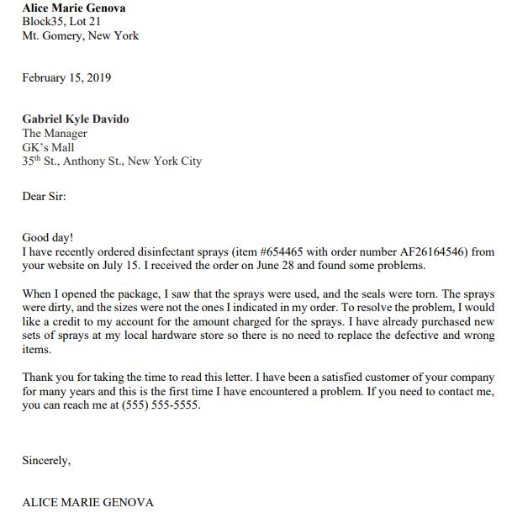

**Request Letter**

This is written to ask for favors or request for documents. Take note that this letter should sound polite and respectful, not demanding, for your request to be granted or acknowledged. The writer must include all the necessary details about the request or favor being asked (Target study, n.d.). Thus, the motive or intention of the request should be clear and outcomes or benefits of it should be discussed as well for the receiver to understand the matter at hand and be able to give immediate action.

Example:

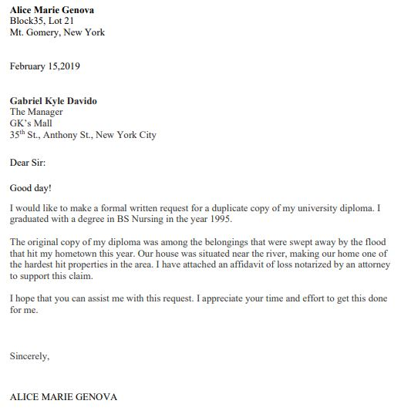

**Application**

Becoming a professional someday would open doors to wonderful opportunities in the business industry. A job title or position could not just be asked from a company or agency easily. You could not just go there, talk to them and tell them you want that job. There are application processes and procedures that you have to go through. Therefore, the application letter will help. It is a tool that allows applicants to sell themselves to an employer. In addition, it discusses the applicant's experiences, knowledge, and skills suited to the job position they are applying for. This is usually submitted with a CV and other supporting attachments (The balanced careers, n.d.).

Example:

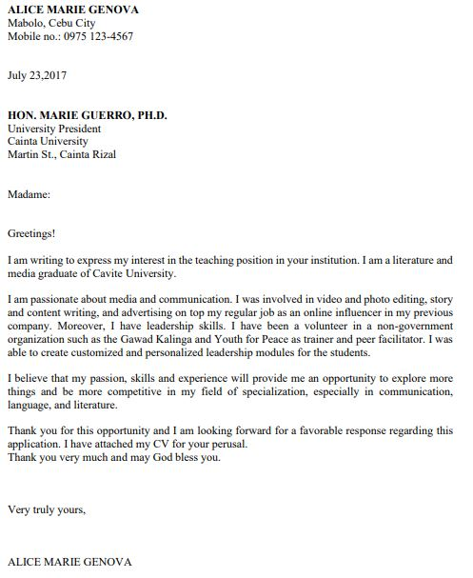

 ***Ink, Link to Sink In***

**Exercise 1.** Provided below are sentences, specifically the opening/introductory

part of the body of the letter. Read them carefully and identify what

type of letter they try to express. Write your answers on the spaces

provided.

1. "I would like to draw your attention to some of the missing items in the parcel you have delivered last November 15, 2020."

____________________________

1. "I have come across your job advertisement online regarding the Web Developer position. I would like to express my willingness to apply."

____________________________

1. "Thank you for sending us your enquiry dated October 30, 2020, regarding the specifications of the computers we have. Kindly look at the provided details below. We also have attached our brochure for further reference."

____________________________

1. "Our school is going to have its 20th Commencement Exercises on March 23, 2021, with the theme, 'Quality Education for All'. With this, we would like to invite you as our speaker for the said event."

____________________________

1. "Our company is excited to have our first purchase with you on the following items:"

____________________________

1. "A good friend of mine introduced to me the quality fabric your company produces. Could you send me quotations of all the types of fabric I could use for my clothing line"?

____________________________

1. "I am writing this letter to formally ask permission for a 5-day leave, from December 18-23, 2020."

____________________________

1. "My daughter is celebrating her 18th birthday on November 30, 2020. With this, I would like to inquire about your catering services."
2. "I am writing to inform you of the poor services provided by your restaurant last July 4, 2018."

____________________________

1. Your company has been known to be the best when it comes to manufacturing quality phone accessories. With this, I would like to have an order of the following items you manufacture:"

____________________________

***Work with Might***

 **Exercise 1.1.** Letter writing activity: On a separate sheet of bond paper, practice writing a

formal business letter following the instructions/situations provided below.

Take note of the prescribed formatting discussed previously. Make sure all the

details are clear, simple, and accurate. The body of the letter should contain

three (3) parts. The Heading and Inside Address are interchangeable, depending

upon the situation provided. So be careful. Do not be confused.

1. Inquiry Letter

Situation:

* You will be the sender. Therefore, you are to provide your personal information.
* You are going to send the letter to Mr. Reynald Smith, the Head of the Housekeeping Department of Hotel Essencia, located at Real St, Dumaguete, Negros Oriental.
* You are going to have a vacation in Dumaguete, and you want to inquire about the services they have. Think very well how you could successfully inquire about the services the hotel offers. Clue: you may ask for room rates, availability of rooms, transportation, food, and many more. Take note you are making an inquiry.

1. Quotation Letter

Situation:

* At this moment, assume that you are Mr. Reynald Smith, the Head of the Housekeeping Department of Hotel Essencia, answering the previous inquiry. You may do online research for the details you may provide in your quotation letter.

1. Order Letter

Situation:

* Now, you are to go back to your first role in the Inquiry Letter. Let us assume you were already given the details of the services offered by the hotel. Scanning through the quotations, you were convinced or persuaded with hotel Essencia's services and decided to book for a hotel reservation. Write an order letter confirming the details of your reservation such as the room you chose, date check in and out, and other services you wish to avail.

1. Complaint Letter

Situation:

* You had a wonderful stay at Hotel Essencia except for the last day, upon checkout, when the transportation services were not available for no enough reason, and that was the reason why your flight was delayed. Send a complaint letter to the manager of the hotel in a professional manner.

1. Application Letter:

Situation:

* Imagine that you are already professionals looking for a job related to your field of specialization (or your course). Search for a company, any company here in Dumaguete, Cebu, Manila, or across the globe, where you could send your application letter. Specify the position you wish to apply for and provide the qualifications that would make you the best candidate for the position.

LESSON 2 **– Other types of Business Correspondence:**

**Memorandum and Curriculum Vitae**

***Set the Route***

*After this lesson, students will be able to:*

*Knowledge*: Identify other formats of the other types of business correspondence.

*Skill*: Compose a business letter following the format provided.

*Affective*: Value the role of a well-written business letter for an effective business transaction.

***Spur to Spark***

Aside from the 7-part format of the types of business letters previously introduced to you, have you also encountered other types of business correspondence with a different format? Could you name even one of them?

Answer:_____________________________________________________________________________

***Mat and Chat***

In the previous lesson, you have learned about the different kinds of business letters in the business world. These letters have different purposes and functions, but with only one goal— the subject matter is clearly understood by the reader/recipient. You also have seen examples of the different types of business letters specifically those that follow the 7-basic part format. Below are two other types of business correspondence with different formats that also play a vital role in business transactions. Let us study them one by one.

**Memorandum**

Memorandum, commonly called a memo, is often used to disseminate information within organizations or institutions – in other words, an *internal communication*. Information indicated in a memo varies depending on its purpose. This includes announcing new policies, schedules, reminders, etc.

A well-structured memo *emphasizes only the important details* and follows a certain format (Nordquist, 2020).

Example:

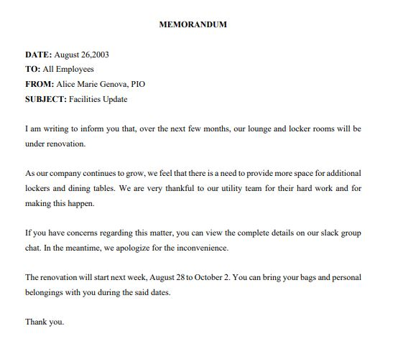

**Curriculum Vitae**

A curriculum vitae, CV for short, is a detailed document about the applicant's educational and professional experience. It should indicate the name, contact information, and academic interests of the applicant. Writing a CV can sometimes be overwhelming, so it is important to write only the relevant information and use simple language. The CV must be understandable and must tell a story (McKay, 2020), persuasive enough to showcase one's qualifications. CV is more formal and informative than biodata and resume. This is commonly used by professionals which means those who have completed their academic degree.

Example:

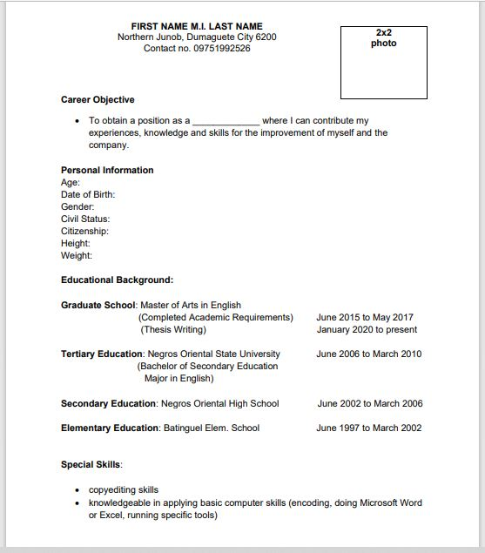

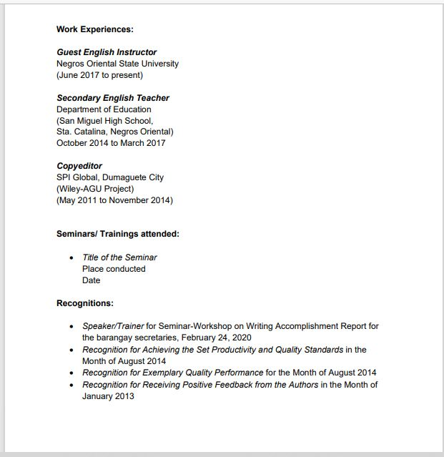

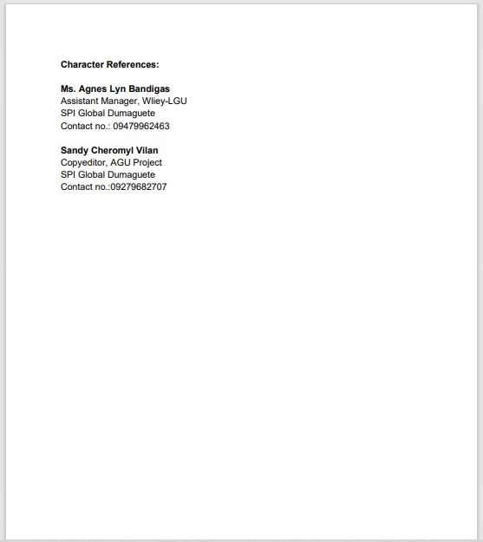



***Ink, Link to Sink In***

**Exercise 2.** As the secretary, you are asked by your boss, Ms. Angela Lazada,

to disseminate information to all the employees of the company

regarding the upcoming Christmas Party. Details of the memo are as follows: Theme: Winter wonderland; Date: December 18, 2020; Time: 6pm; Venue: Brooke's Place; Transportation: the company offers free ride (provide details on where to fetch the employees) and other matters you could add.

***Work with Might***



**Exercise 2.1.** Using the format for Curriculum Vitae, develop your own CV that

highlights your credentials as an applicant for the job you want to apply for.

Use a short bond paper and observe standard formatting.

**References:**

Gupta, R. (n.d.). *Complaint letter class 10 to 12, complaint letter format, example.* Success CDs. https://www.successcds.net/learn-english/writing-skills/complaint-letter.html

McKay, D. (2020, July 19). What is a curriculum vitae? The balanced careers. <https://www.thebalancecareers.com/curriculum-vitae-526158>

[Nordquist](https://www.thoughtco.com/richard-nordquist-1688331), R. (2020, February 5). *What is a memorandum? Definition and examples*. Thoughtco.

https://www.thoughtco.com/memorandum-memo-term-1691377

Target Study. (n.d.). *Request letter*. Target study.

https://targetstudy.com/letters/request-letter/

The Balance Careers. (n.d.). *Job application letter format and writing tips*. https://www.thebalancecareers.com/job-application-letter-format-2061567

University of South Carolina at Chapel Hill. (n.d.). *Business letters.*

<https://writingcenter.unc.edu/tips-and-tools/business-letters/>

Wickford, H. (2018, June 29). *10 types of business letters*. Chron.

<https://work.chron.com/10-types-business-letters-9438.html>

***Check your Answers!***

***Answer Key:***

Exercise 1.:

1.complaint

2. application

3.quotation

4. request

5. order

6. inquiry

7. request

8. inquiry

9. complaint

10. order

Exercise 1.1.: May vary content (types of business letters)

Exercise 2.: May vary content (Memo)

Exercise 2.1: May vary content (CV)

**Prepared by:** **GLORY C. LACUESTA**

**RICHELLE LOU OSUMO**