**Site Name: Temple Inn & Suites**

**Site Purpose: Providing paid lodging to travelling temple patrons at locations where church-provided patron housing is not available**

**Target Audience: Temple patrons who must travel long distances to attend temple sessions and wedding attendees/guests**

**Site Map:**

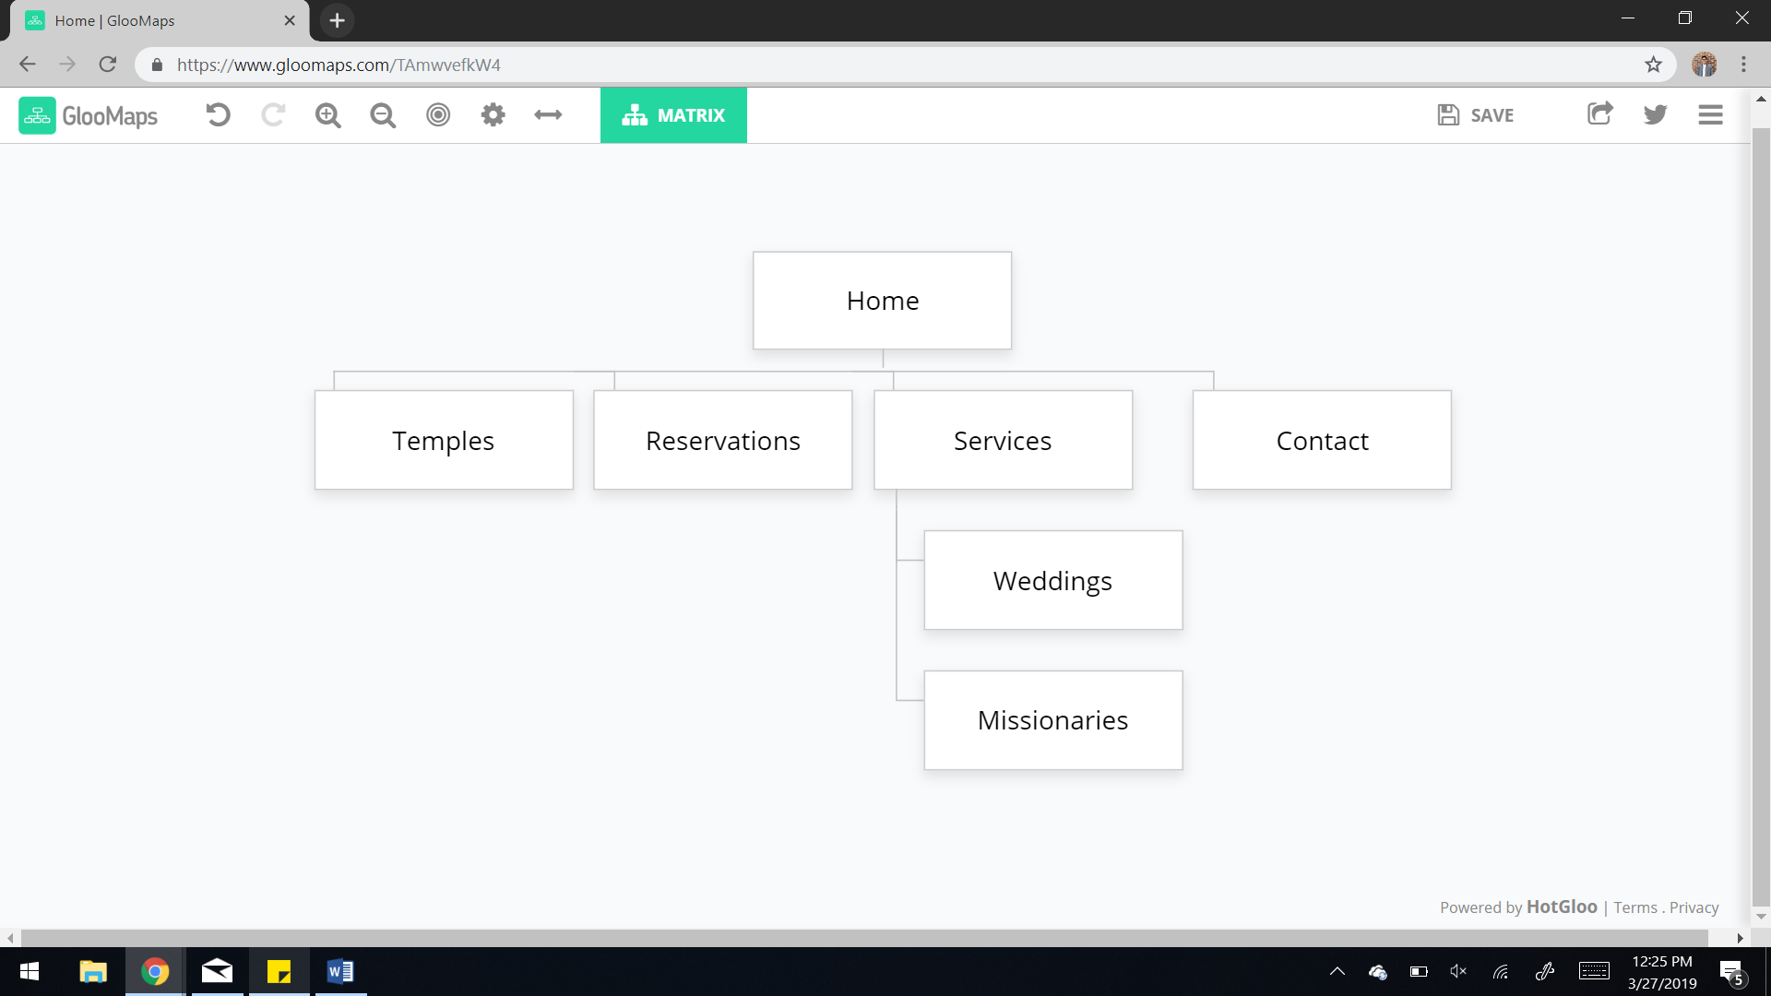

**Color Scheme:**

**This is my planned color palette. I may alter the colors a little depending on how they appear on the website. Use in order from left to right: accent, accent, background, accent, text. I’ll also be using black and white for certain parts of the website.**

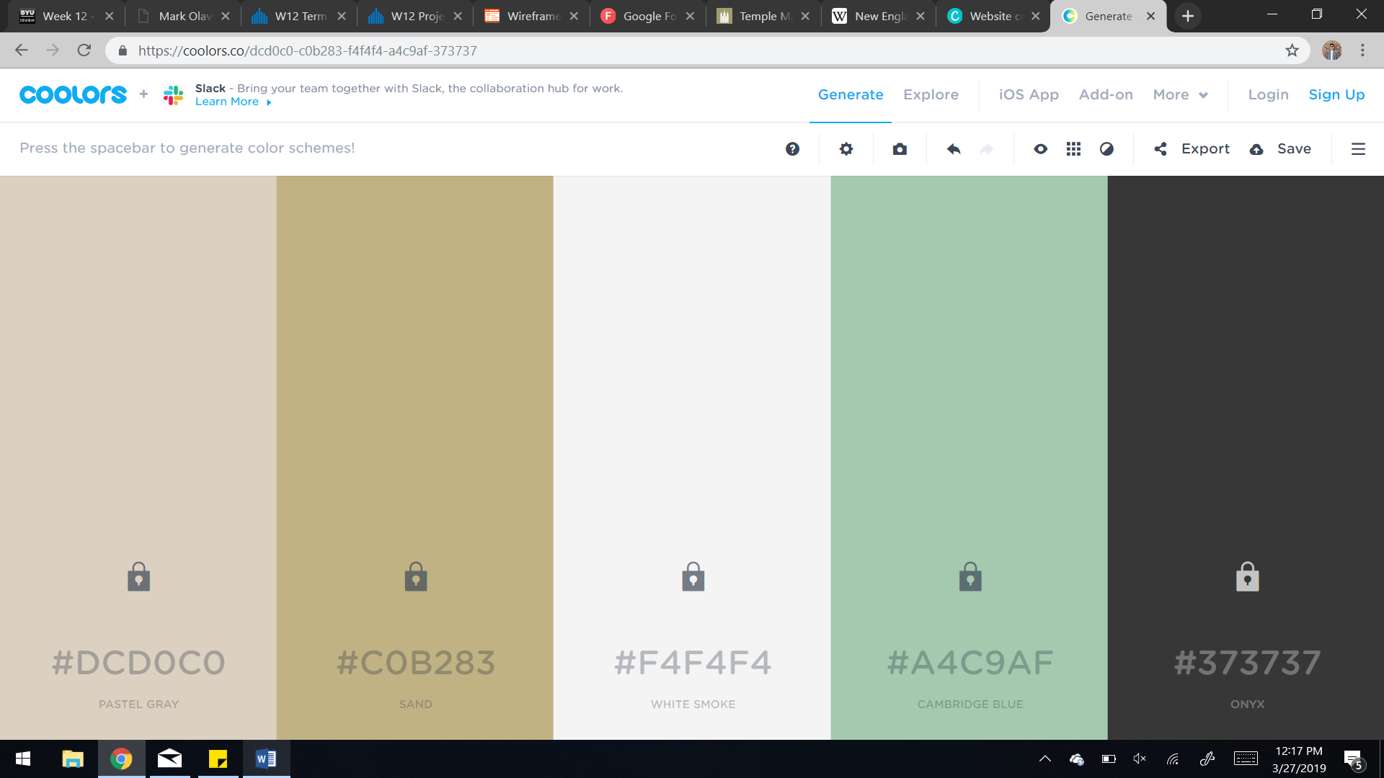

**Typography: These are two potential fonts I’ll be using. I’m going to pick the one I like better once I’ve created the basic website.**

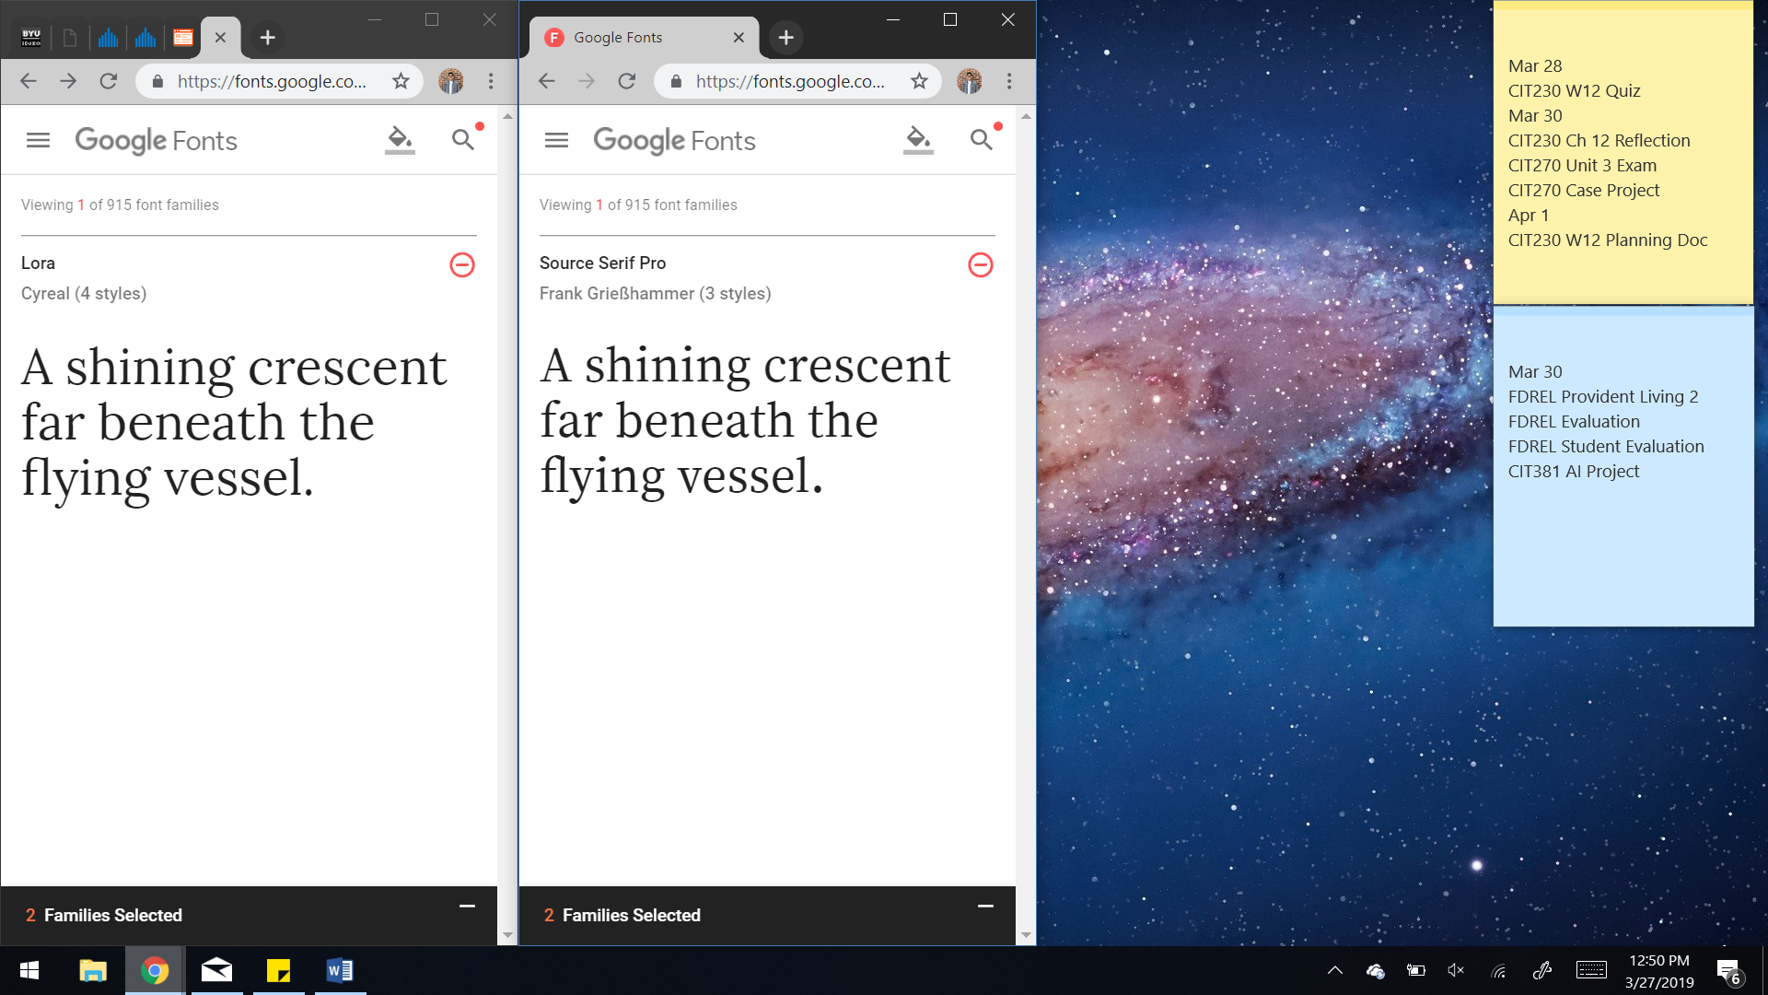

**Wireframe Sketches:**

**After brainstorming a little, I wanted to try a new design that would be clean and kind of unique looking. I’m hoping it turns out how I picture it.**

Large

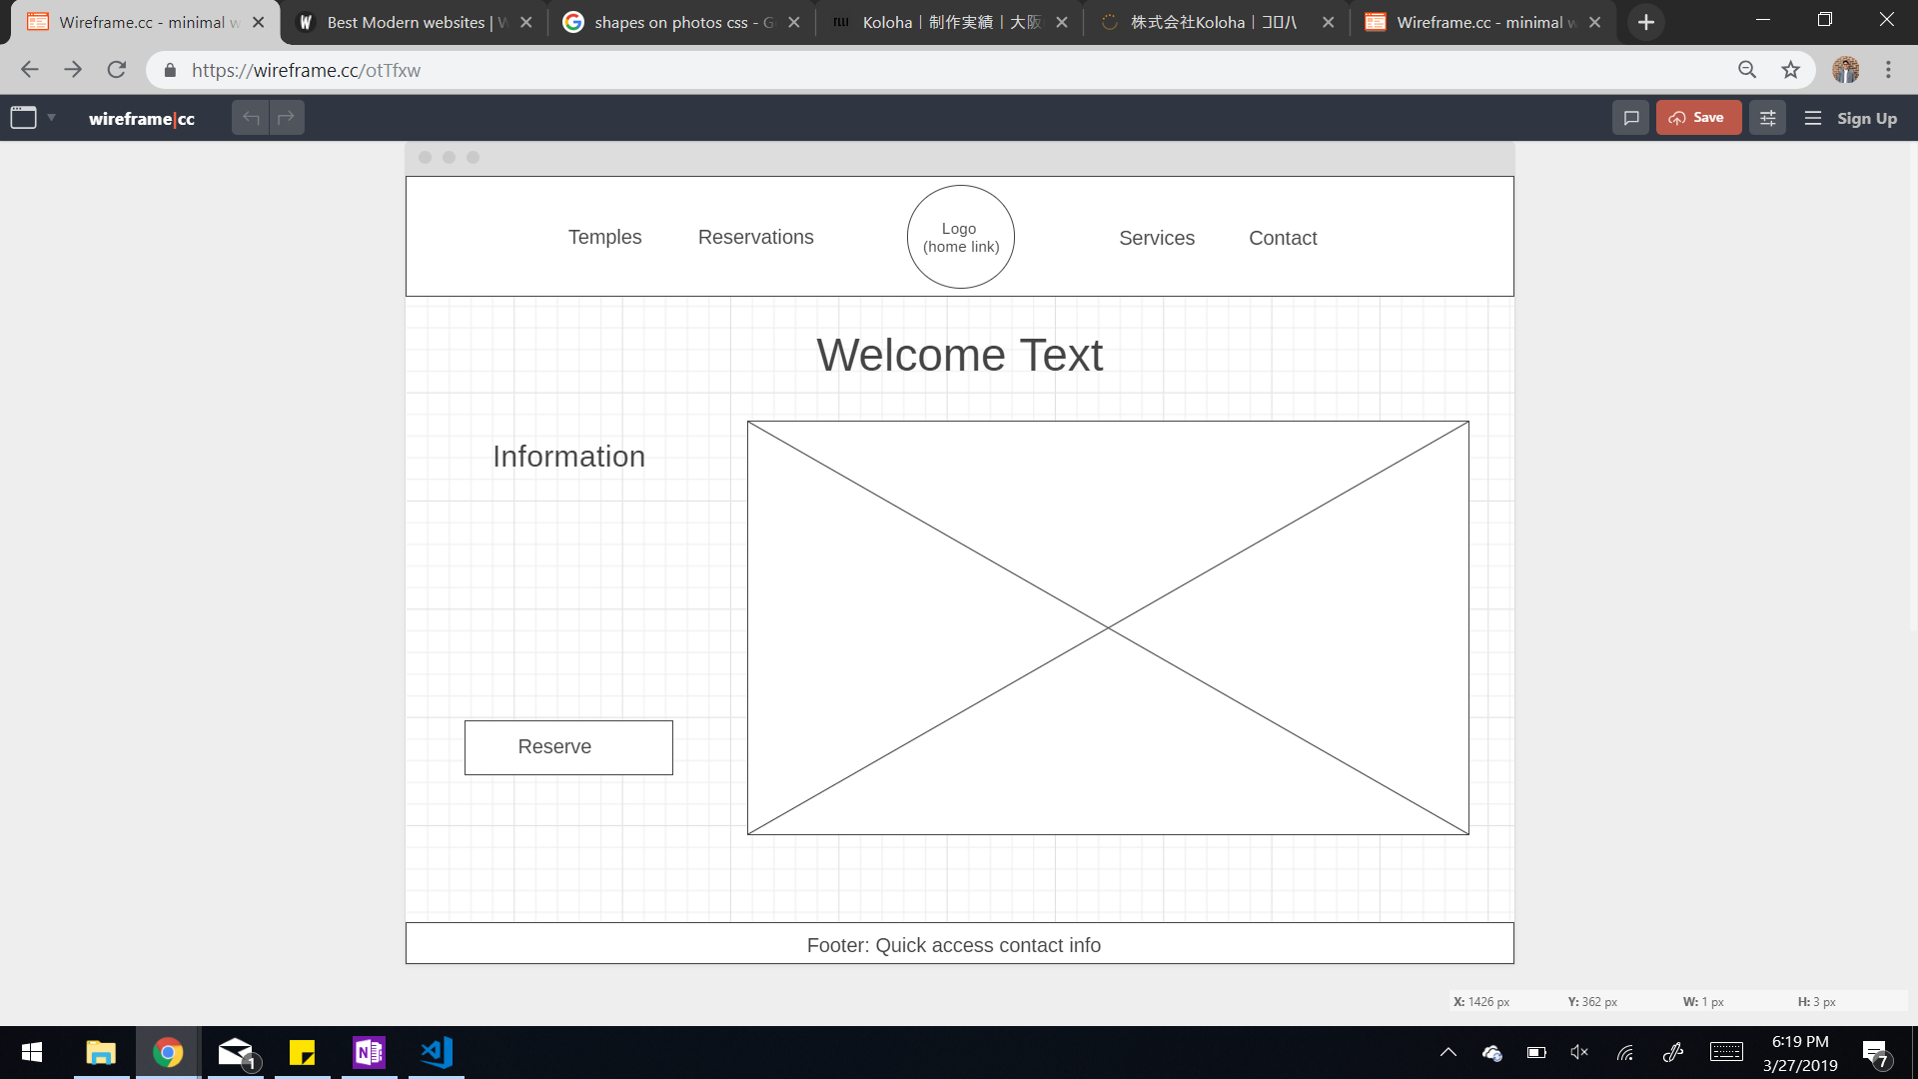

Medium and Small

