SMU Fintech Bootcamp

Project #1

June 20, 2020

Team Members:

* Marcus Kim
* John Millar
* Joe Swiderski
* Julas Hollie

Day 2: Submit your progress in a Word Document on Slack including:

**A link to your dataset and a description of it (size, columns, missing data, etc)**

Data sets to be used:

**1.** [**Dallas County appraisal data**](http://www.dallascad.org/DataProducts.aspx)

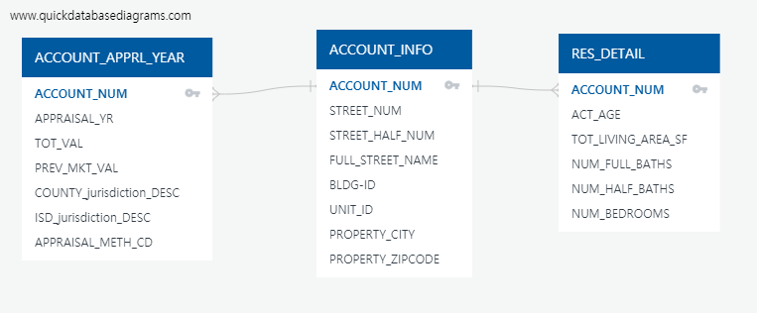

2. US economic data : [bureau of economic analysis](https://apps.bea.gov/api/data?&UserID=AD0F9F0F-9DE3-4D7F-986E-61D72F88D342&method=GETDATASETLIST&ResultFormat=JSON)

3. FFIC mortgage rates data : [Amazon AWS](https://s3.amazonaws.com/cfpb-hmda-public/prod/apor/YieldTableFixed.txt')

     By taking the mean of each weekly interest rates with a loan period of 15 and 30 years, respectively.

4. Yahoo Finance API

**The questions your project will address**

* analyzing the appraisal value trends of residential properties in Dallas County.
* consider the influence of other factors such as location, size, the economy and employment have on the appraisal value

**The packages you plan to use (pandas, scikit-learn, etc.)**

Pandas, SQL, Hvplot, Plotly Express, Matplotlib,  *Arcgis*, Geopandas, Mapbox

**The methods you plan to use (visualizing frequency, linear regression, time series, etc.)**

Linear regression, time series, visualizing maps of properties in terms of county, ISD.

Visualizing charts