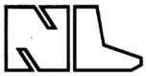
Newbury Laboratories

Terminals, Bears and Newbrains

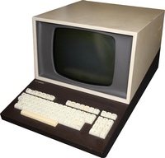

1972 Company formed in Newbury, Berkshire, UK

1977 Announced a microprocessor controlled visual display unit and printer

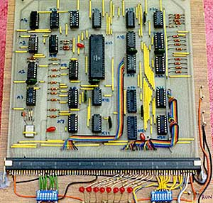
Late 1977 or early 1978 : Bear Systems was incorporated into Newbury Labs, the Bear 77-68 kit computer was renamed to the NewBear 77-68

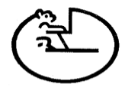

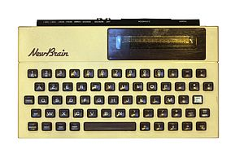
In the late 1970s Sinclair Radionics had started research on another computer, NewBrain; when Sinclair Research was established to develop the ZX80 microcomputer, the NewBrain project was transferred to Newbury Laboratories

1981 The NewBrain was considered for the BBC microcomputer project but was not selected. Newbury Laboratories decided to concentrate on computer peripherals. NewBrain was sold to Grundy Business Systems

Bear / Newbear 77-68 --- history of the letter heads ...

June 1977 ( Construction of 77-68 document published )

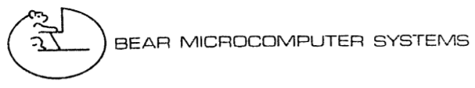

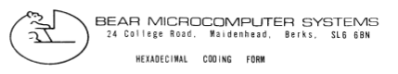

By April.1978 : Part of Newbury Labs

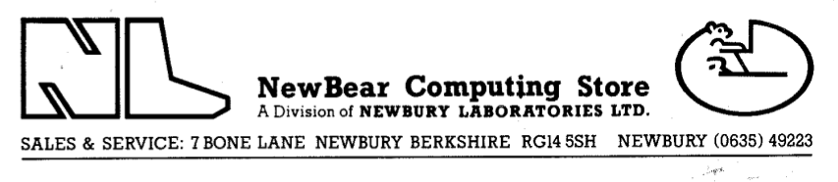

By July 1979 : Own company and premises, still under Newbury Labs umbrella

