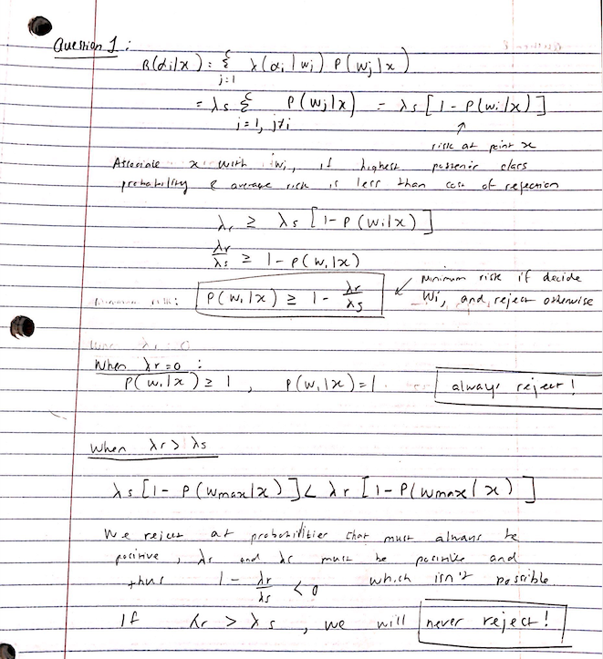

Question 2, Part 1:



Question 2:

The sampling procedure works by creating a dataset for both classes. The first step is to sample numbers from a uniform distribution where sample ~ Uniform(0,1). Then, more regions are generated so that the probability of a number belonging to that region is equal to the given priors stated. From the class labels, the Gaussian distributions are sampled for each class using the respective class parameters. This functionality is implemented using zero-mean identity-covariance Gaussian sample generators in MATLAB which takes in mu, sigma, the number of samples to be generated, and an array of priors and outputs simulated data along with a vector that has the class index for each datapoint. Below is the sampling function used.

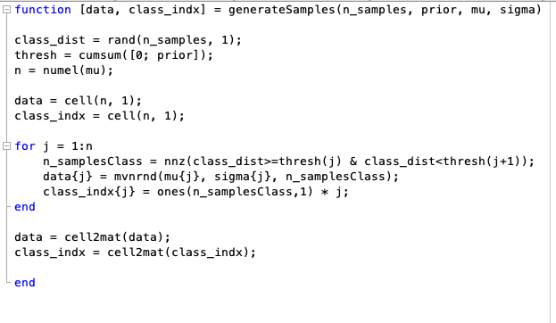

Question 2, Part 2:



Question3:











