DATA FLOW DIAGRAM

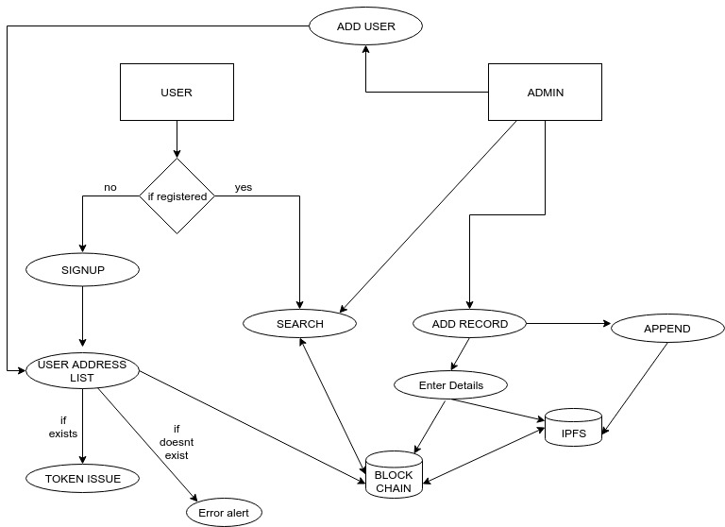

SOLIDITY LOGIC DIAGRAM
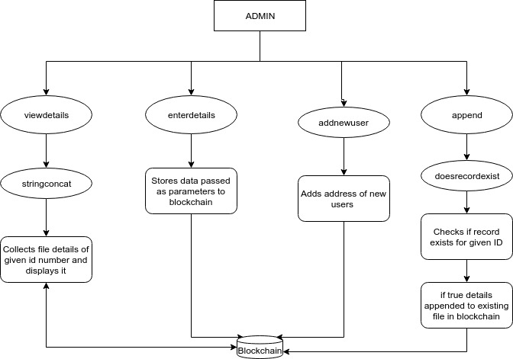

DOCUMENTATION OF CODE FLOW

