Project 1: Developers as Decision Makers
A modified version of the assignment created by Evan Peck at Bucknell University
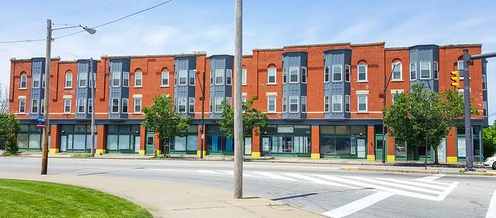
In this lab, we will create algorithms that determine housing for SFSU students.

When we say the word ‘algorithm’, we tend to ascribe agency to the computer. It is deciding things for us. But the reality is that there is no magic. There is software developers like you and me who design and create sets of rules that the computer carries out for us.

These algorithms are all around us, and they are constantly making decisions.

The decisions we make in code impact the lives of real people. For example, the Silicon Valley Triage Tool is an algorithm that identifies homeless people for whom giving them housing would cost the public less than keeping them homeless. So even as we learn the simple structures of code, we need to think about how we can make good decisions.

We are going to explore this idea in a more familiar context to you - university housing allocation. At SFSU, on-campus housing is in high demand but very limited. This has resulted in the university relying on a first-come first-serve policy: https://housing.sfsu.edu/apply. You might not think of it as one, but this method is an algorithm.

In this project, you will have the opportunity to design your own algorithm. We’re also going to begin dabbling with a human-centered design process to make sure that the decisions we make are never untethered from the people we impact.

In this project, you’ll practice...
- translating English rulesets into code,
- soliciting text input from people,
- *Applying conditionals (if, else if, else) to make decisions with a program*,
- using an accumulation variable to keep track of information in a program, and
- integrating basic human-centered design processes into your programs.

First: Is the first-come first-serve fair? Can we do better?
[R1] You must start by thinking if the existing way of things doing is fair. Is the first-come first-serve approach to housing allocation fair? Notice how you must think about what “fairness” involves.

I think first come first serve tactic is fair in my opinion since spaces are generally limited, it does not serve any and the announcement for openings are early. It is the simplest tactic everyone can understand and it prevents favoritism.

[R2] Who are the actors that may be at a greater disadvantage with the current system?

People who are on a schedule may be at a disadvantage since they might not be able to apply at the right time. Students who have long travel times from home can be a disadvantage, since they are at risk of travel uncertainties, causing them to fail classes due to unexpected occurrences like a time sensitive medical condition. Students who do not have access to technology is also at a disadvantage since they cannot keep track when to apply for housing.

[R3] Do you think there is a better way to allocate housing such that it is fairer? What ethical framework(s) guide your evaluation?

First come first serve is still into play but surveys around half a year should be shown to students to hold housing for them, here are some conditions that might allow them for housing
- documented medical needs/disabilities
- long commute distances/money spent on transportation
- students who are parents/caregivers
- students with financial hardships
- If you are above max credits for university, you are not allowed to apply for housing
- International student
- Long commute distance

The Decision-Maker: Who gets to choose their housing first?
Your job is to build an algorithm that helps determine the order in which students will get to select their housing. To simplify things, we’re going to use a point system.
- Students are awarded several points based on a variety of factors.
- Students with the most points get first choice at housing.

This real approach is used by many universities. For example, consider the following real point system used by another college in the United States:
- Current Freshman: 1 point
- Current Sophomore: 2 points
- Current Junior: 3 points
- Current Senior: 4 points
- 23+ Years of Age: 1 point
- Full-Time, Off-Campus Program Credit (e.g., student teaching): 1 point
- Academic Probation: -1 point
- Possible Academic Suspension: -2 points
- On Disciplinary Probation at Any Point during the Academic Year: -3 points

So, a junior (+3 points) who is 23 years old (+1 point) would have priority over a senior (+4 points) who is on academic probation (-1 point).

Overall goal: Create a program that assigns points to students to prioritize them in housing selection.

[R4] Before you Code, Assess the Needs of Your Users
While the list above was one college’s take, there are many more potential aspects to consider if you want to create a fair algorithm that considers the diverse needs of students.

You should not create a program that serves people without talking to people. Talk to other students in your class. Ask them about their needs. What other unique factors may be important in deciding who should choose housing first?

Group Work: Form a group of 3—4 students. Discuss the various factors to consider when deciding on housing allocation. Fill in the bullet-point list below with the factors that came up in the conversation. Give each one a numeric priority (-1 to 5 points).
- Factor 1: Time sensitive medical condition: 4 points
- Factor 2: >2 hour commute distance: 1 point
- Factor 3: Disciplinary probation: -2 point
- Factor 4: Between Freshman and Senior year: 4 points
- Factor 5: Student caregiver: 4 points
- Factor 6: Possible suspension: -2 points
- Factor 7: Full time student and working on campus: 3 points
- Factor 8: Documented financial hardship: 3 points
- Factor 9: Above max credits for university: -1 point
- Factor 10: Documented abusive households: 5 points
- Factor 11: Academic probation: -1 point
- Factor 12: Student for more than 4 years: -2 points

Notice that this is the learning phase of the human-centered design process shown in the following figure.
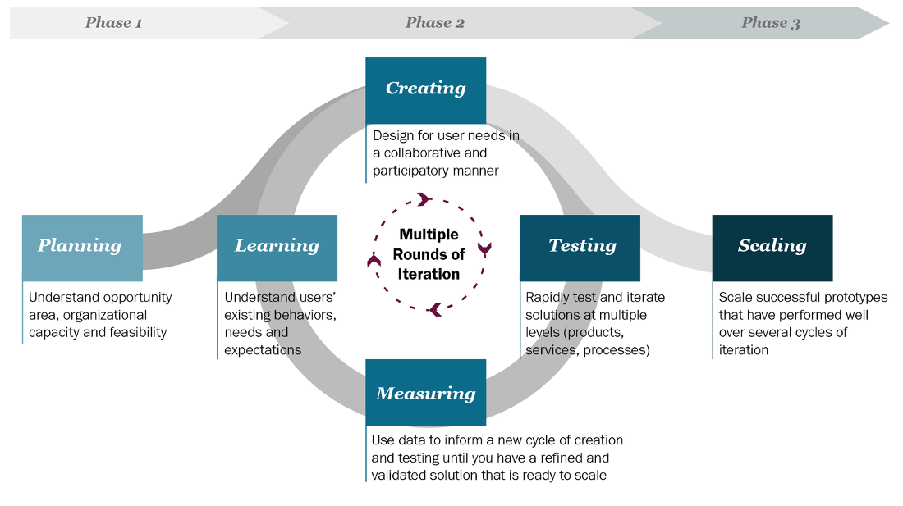
Talking to users, prototyping ideas, and then testing them with users, is part of what is known as the human-centered design process… a key process for developing useful and usable programs.

Assessing the Needs of Our Users

So far, you have discussed the factors amongst yourself. It is not enough; other people may think differently about what is fair.

Using the list that was prepared in your group, interview other people. Try to interview people outside the CSC 101 class. These can be family, friends, or classmates from a different class. Ask what factors are important to them. Show the factors that you had identified from group work and ask them about their priority.

Individual Work:

[R5] Results of the Interviews and Discussions: Factors that Matter.
I interviewed 3 SFSU students about their factors (full score can be earned when interviewing 3 or more different people).
Through discord chat with students in CSC101 class and a survey through google forms
https://forms.gle/AvYR27fLiLSqPtND6
MODIFY/ADD TO THE LIST BELOW WITH OBSERVATIONS FROM YOUR INTERVIEWS. You can add or delete factors. Provide a number with the factors to indicate which factors that you think are the most important. For example, if you think class year is the most important, place a “1” by that factor. If you think two or more factors are equally important, place the same number by those factors. You can use our factors from the group work to start with

Scale: -5 to 5; 5 highest priorities; -5 lowest priority

- Rank 2: Time sensitive medical condition: 4 points
- Rank 4: >2 hour commute distance: 2 point
- Rank 5: Between Freshman and Senior year: 4 points
- Rank 1: Student caregiver: 5 points
- Rank 5: Possible suspension: -2 points
- Rank 6: Full time student and working on campus: 3 points
- Rank 4: Workspace for academics: 2 points
- Rank 3: Documented abusive households: 5 points

[R6] Design and Plan Your Point-Assigning Algorithm
Now it is time to translate our student needs into a concrete algorithm. Be careful and limit yourself to the most important factors. You have a limited amount of time in this class!

Our overall algorithm will be the following:
- Ask students questions (like What class year are you?).
- Assign points based on their answers (like 4 points for seniors).
- Accumulate their total points across all answers (like You have 23 housing points).

Your goal: Create a bullet-point list that describes the factors you are considering, and how you are mapping those factors to point values (positive or negative). Please do your best to correctly fill out the list. When coding starts, this will serve as an outline for writing your prompts and how you will handle responses.

Writing Our Algorithm in English
(EDIT OR REPLACE THE FOLLOWING LIST TO REFLECT YOUR HOUSING PRIORITIES.)

- Question 1: What year are you in?
  - 4 points for freshman, sophomore, junior, and senior
- Question 2: Approximately, how long does it take for you to get to campus?
  - 2 points if greater than 2 hours
- Question 3; Are you a student caregiver/guardian?
  - 5 points if yes
- Question 4: Are you in possible suspension
  - -2 points if yes
- Question 5: Are you a full time or part time student?
- Question 6: Do you work on or off campus?

  - 3 points if full time and work on campus
  - 2 points if part time and work on campus
- Question 7: Are you in an abusive household?
  - 5 points if yes
- Question 8: Do you have a reliable workstation with internet access?
  - 2 points if no
- Question 9: Do you have a medical condition hindering your time to commute?
  - 4 points if yes

Maximum: 27
Minimum: -2

[R7] Before you Code, Make Sure it Works: User Testing
How will you know if your program serves people well? At a minimum, you should have tests considering different groups of people who may be affected by your program.
- Were the results what you expect?
- Did you discover any cases which you haven’t accounted for previously?

Your goal: Write at least 5 hypothetical test cases for your program. You may need to modify the given tests if they do not mention any of your factors. Five test cases must be listed in order to earn a full score for R7.

Test Cases
EDIT THE FOLLOWING LIST TO REFLECT YOUR PROPOSED POINT VALUES. You are required to add at least 2 test cases of your own. Make sure to modify the points and/or factors in the already given tests so that they match your factors.

- A senior and a freshman would both output 4 points
- A super senior does not get 4 points since it is not in the criteria
- A sophomore with a travel distance of 3 hours output 6 points
- A junior who does not have a reliable workstation for academia and is a guardian outputs 7 points
- A student who is on possible suspension but is in an abusive household outputs 3 points
- A super senior who is a guardian outputs 5 points

[R8] Write Code that Automates Your Decision-Making Process
Now it’s time to translate your algorithm into code.

Your goal: Implement the algorithm you designed in IntelliJ.

- Step 1: Follow the instructions posted on Canvas to create a new project for this assignment.
- Step 2: Implement your algorithm inside the main method.
- Step 3: Is it correct? You should check your code with the test cases you outlined above. You should run your program using the test cases as an outline for inputs. Your program, if implemented correctly and according to your algorithm, should produce the expected points value stated in each test case.
- Step 4: Submit a zip file with the Java file and this completed document.
During your creation, keep a couple of things in mind:
- Use comments to describe what was happening in the program.
- Choose variable names that clearly describe the data that they hold.
- Use spacing to group similar code.

[R9] Is Your Implementation Fair?
Your Code Works… but is it fair? Now Reflect on the Tradeoffs and Conflicts

You should never deploy real code without checking your assumptions.
Your test cases tested your technical assumptions, but not your social assumptions.
- Find classmates either inside or outside of the lab.
- Run your code with them.
- Get feedback on what worked and what didn’t.

Individual Work: Add your reflections to this document below.
- Which students are most likely to benefit from your algorithm?
- Student caregivers
- Students from documented abusive households
- First-year through fourth-year students
- Students with medical conditions hindering commute
- Full-time students working on campus
- Students without reliable workstations/internet access
- Students with reasonable travel time to campus (≤2 hours)
- People at any age pursing higher education

- Which students are most likely to be forgotten by your algorithm?

- Super seniors (fifth-year+ students)
- Part-time students not working on campus
- Students with long commutes (>2 hours) but without documented medical conditions
- Students working off-campus
- Commuter students who face challenges not captured by the criteria (like unreliable transportation)
- Students with financial hardships that aren't explicitly measured
- Students with undocumented household issues or abuse
- Students with disabilities that don't specifically impact commuting
- International or out-of-state students without clear consideration
- Students with temporary or changing living situation

If you are interested…
- Optional reading: What Happens When An Algorithm Cuts Your Health Care By Colin Lecher
- We created poverty. Algorithms won’t make that go away. By Virginia Eubanks

