Proton reconstruction (Roman Pot)

Carlos Munoz Camacho
Wang, Pu-Kai

Roman Pot Setup

The roman pot station has N square plates within square hole in the center. Each square plate is composed with two L shape plates. However, there is no L shape or similar geometry in Geant4, so I used 2 different square plates to make 1 L shape plate. The setup would like below:

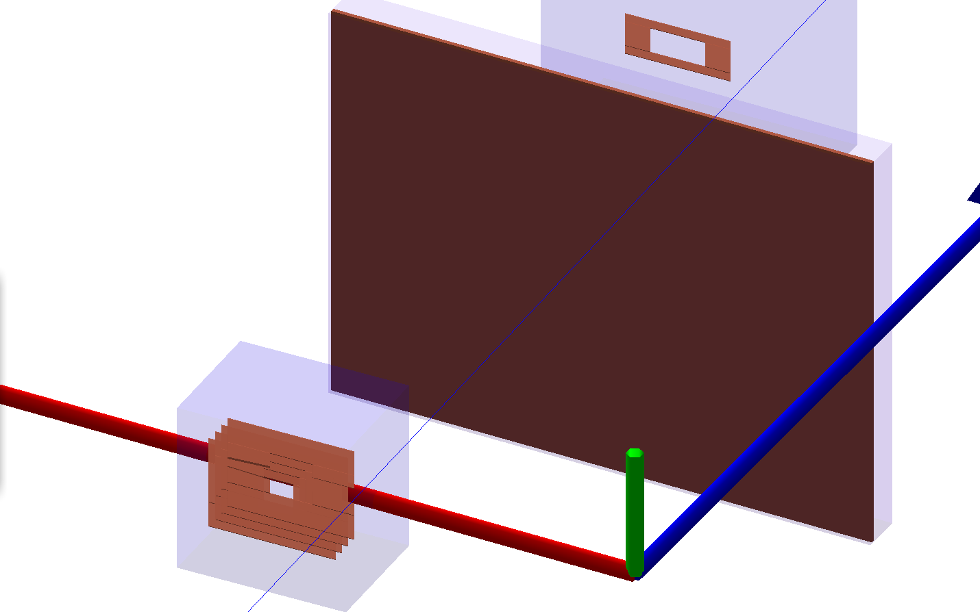

The left hand side plot is the cartoon to show how I construct each sensor layer. The right hand side plot is the g4e visualization of 2 roman pot station.

The size of plates and the number of plates are parameterized in g4e. In order to study the hit position of the protons, I change the parameters to create the larger plates without the hole, which make all protons can leave hit information on the plates. And the center position of 2 roman pot stations in the global coordinate system are:
[0.85m, 0, 26m] || [0.94m, 0, 28m] respectively. I will focus on the fist station in the following study.

Pure protons beam

In this case, I generate the pure proton events with crossing angle 25 mrad. Additionally, in order to increase the hit area and make it more easily to understand in the plots than just a point, I increase the cross section area of beam with the crossing angle 24 ~ 26 mrad. Below are the results,

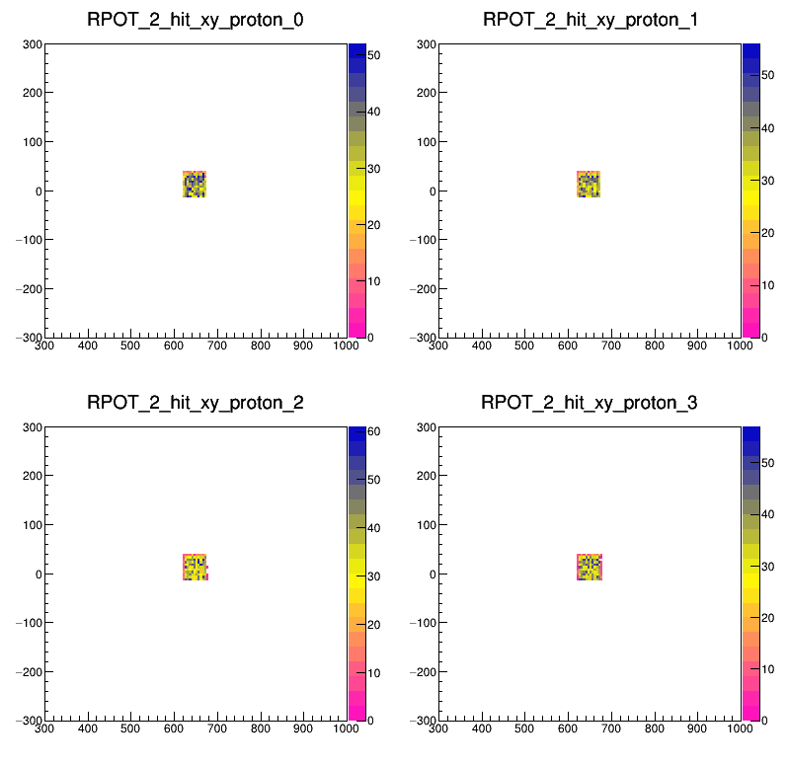

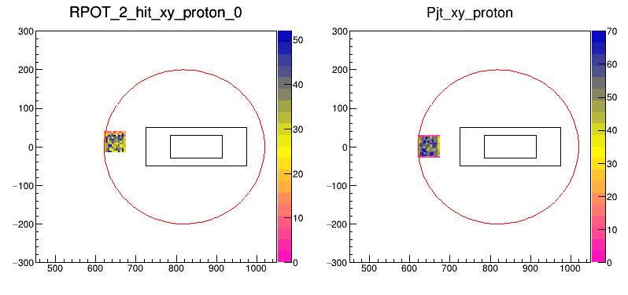

The upper 4 plots are the hit distribution of the 4 plates in the first station. There is a small shift, ~2 mm, in x direction in the hit distribution between plate_0 and plate_3, the distance between two plate is 90 mm. The shift is causing by the original crossing angle of the proton beam. In the lower 2 plots, the left hand side plot is the hit position of the proton and the right hand side plot is the projected position of the proton beam. Two different roman pot plates are drew here to make comparison, black one is proposed in the EIC yellow report and the red circle one is from Yulia. The x & y axis of these plots are the position, mm, in g4e global coordinate system.

DVCS events

From the pure protons simulated results, we can find the center position of the roman pot, laid on the trajectory of crossing angle 32.7 mrad, seems not at the supposed position, laid on the trajectory of crossing angle 25 mrad. We can find the similar results in the DVCS events
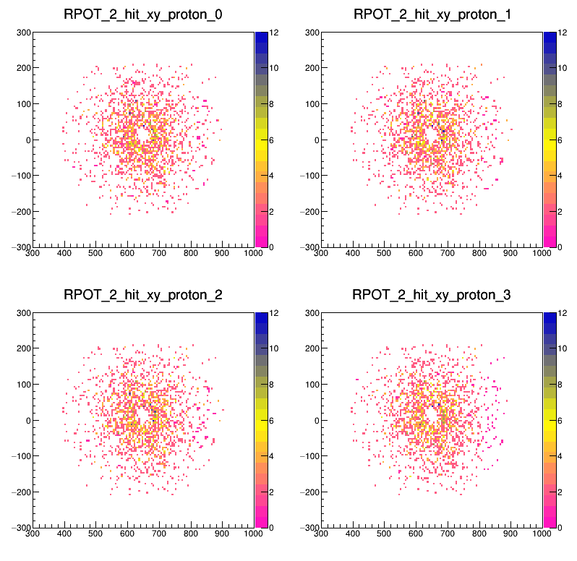

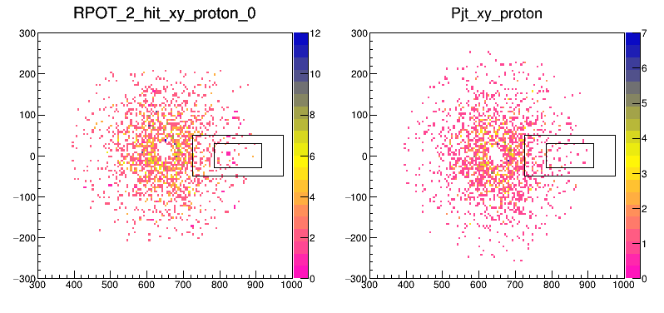

These 6 plots are placed in the same way as the pure proton one. In these plots, I extend the sensor plot as large as possible to collect all hits of the DVCS events. And we can deduce the crossing angle of the beam is still keep at 25 mrad from the calculation, the center hole x position of the beam is ~650mm and the plate_0 z position is ~25900, so the crossing angle of my DVCS proton beam is ~25.1 mrad.

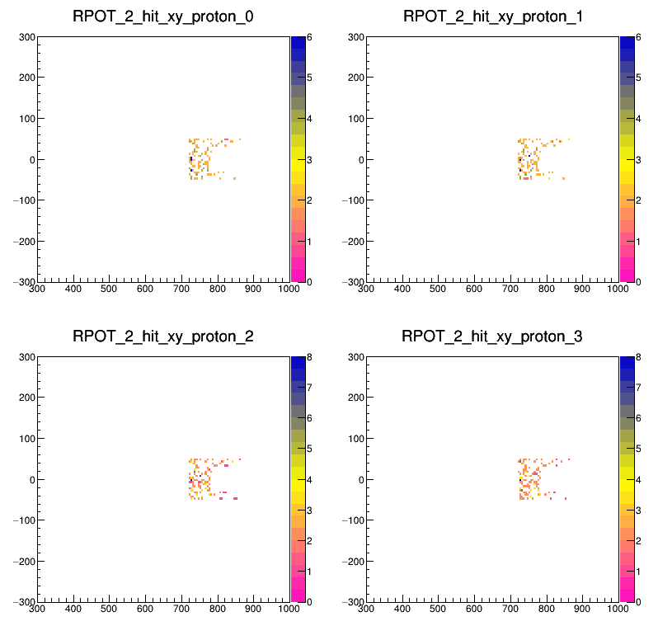

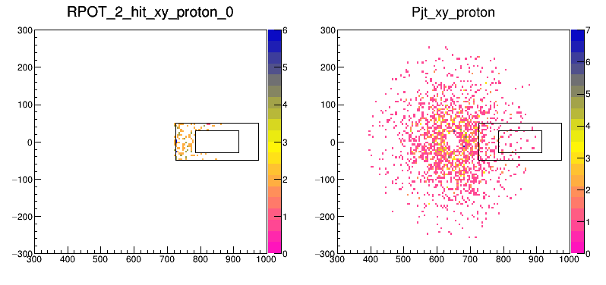

I modified the RPOT dimension to 25 x 10 cm² with a center hole 13 x 6 cm². Above plots are the hit distribution of the DVCS events. We can find the left corner plot, sensor plate dimension proposed in EIC yellow report, is consistent with left corner plot, really big plate to collect all hits, in the p.4.

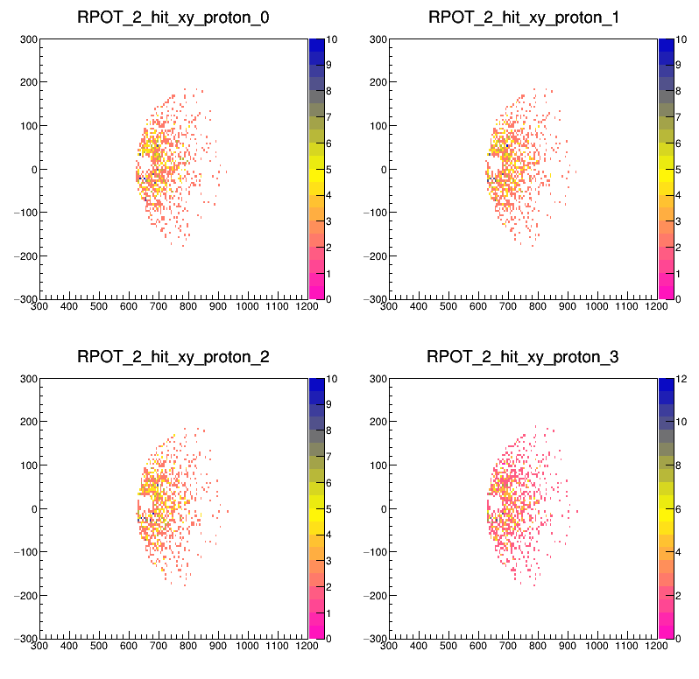

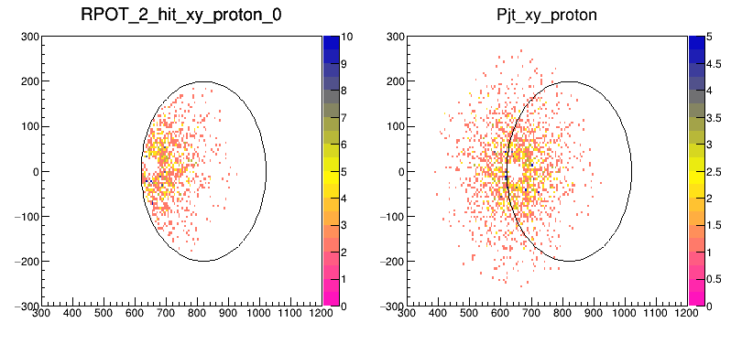

Here I show the sensor plates implement by Yulia to make the comparsion. The sensor plates are circle with radius 19.5cm and the circle center is at [0.82m, 0, 26.2m] in the global coordinate. The deformation of the circle is due to the different range of x and y axis.

