Reconstruction update

1.Reconstructed position issue

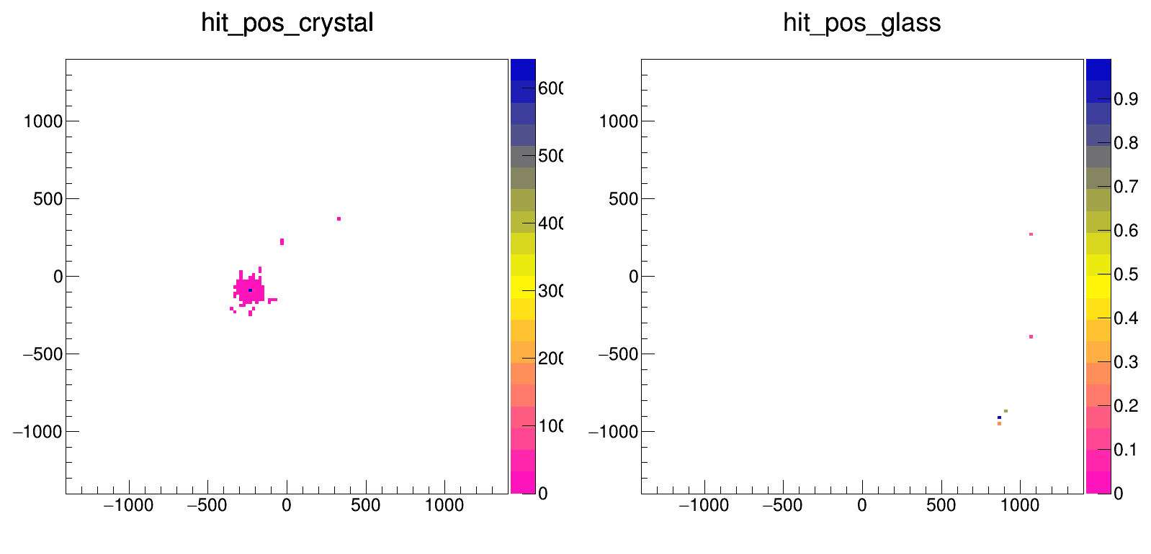
Let’s look the event about the primary photon hit on the crystal:

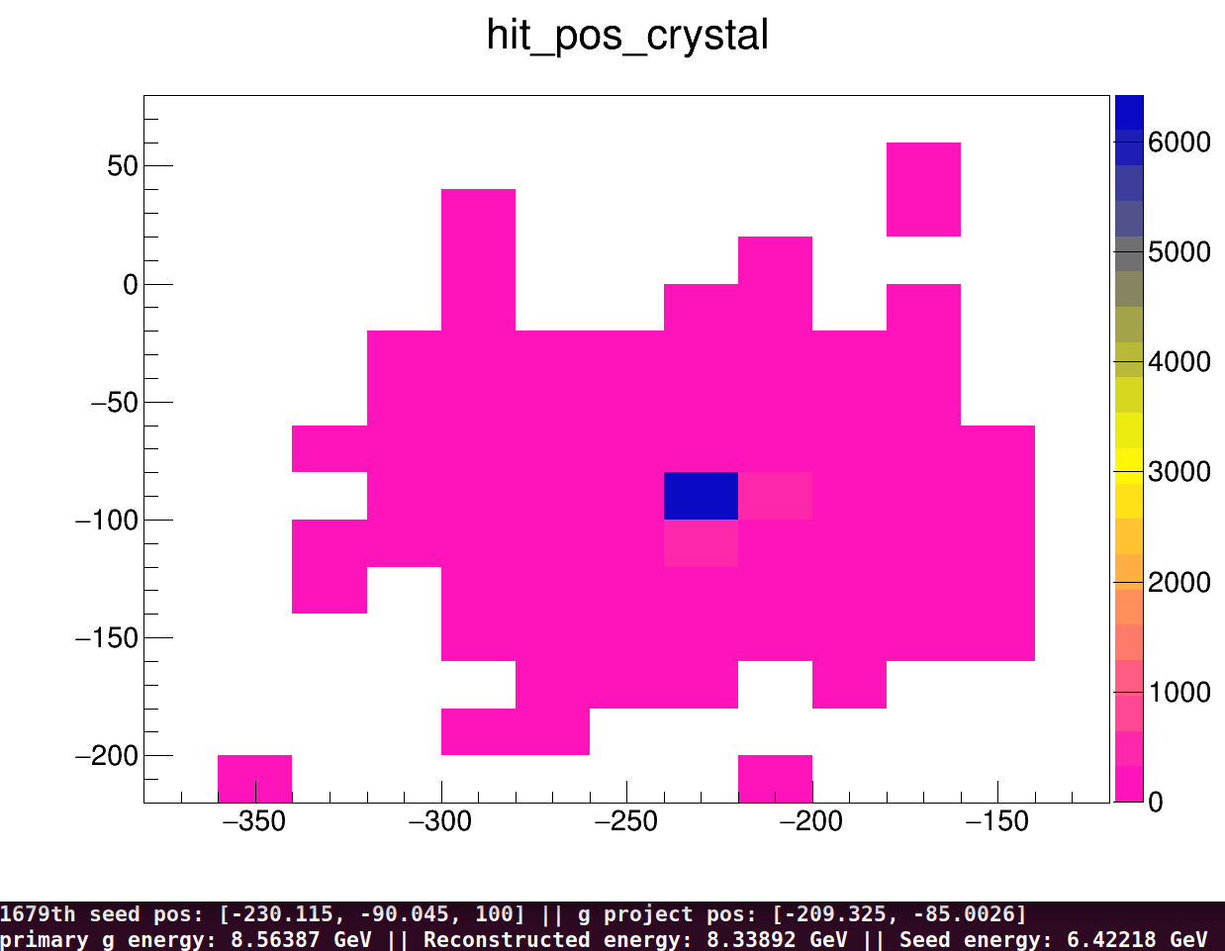

The upper plot is the hit distribution in the crystal region. The seed of that cluster [-230.115, -90.045], the blue square, and the project position of the photon [-209.325, -85.0026], marked with the black circle. The primary photon energy is 8.5638 GeV, and the reconstructed one is 8.3389 GeV, noticed that the seed energy is 6.4222 GeV

Let’s look into another case for the hit on the glass region.
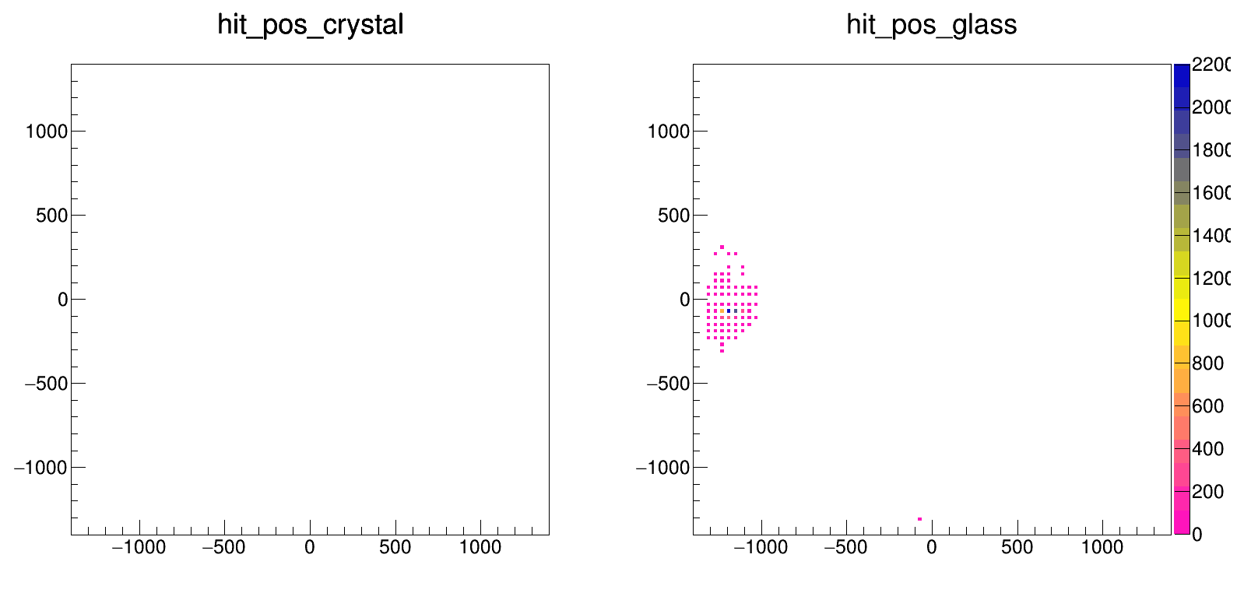
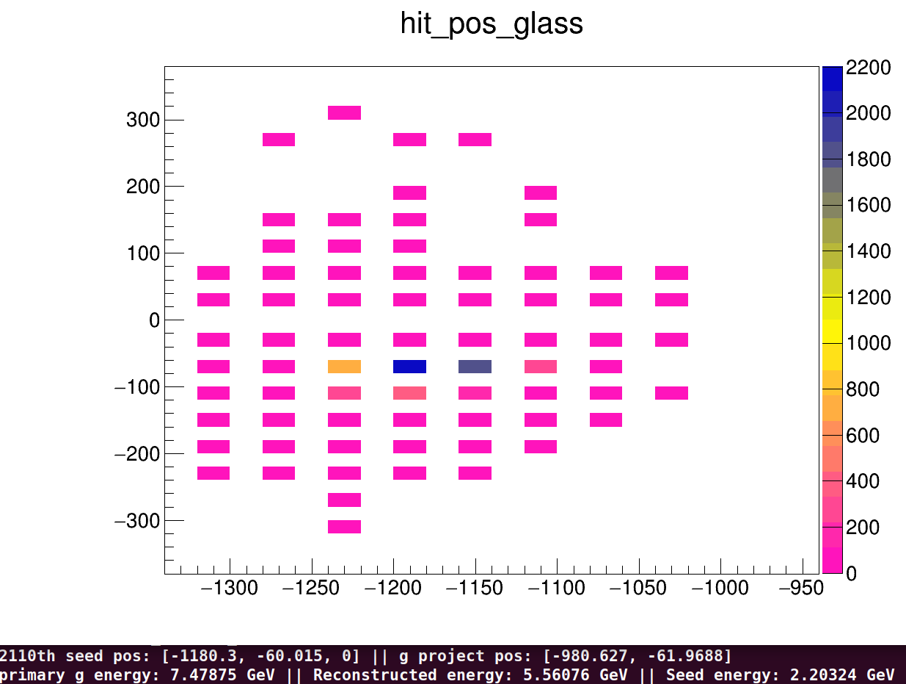

The upper plot is the hit distribution in the glass region. The seed of that cluster [-1180.3, -60.015], the blue square, and the project position of the photon [-980.627, -61.9688], marked with the black circle. The primary photon energy is 7.4788 GeV, and the reconstructed one is 5.5608 GeV, noticed that the seed energy is 2.2032 GeV. The reconstructed energy is so low is because the reconstructed range I used here is the crystal width (20mm) not the glass width (40mm), I have fixed it to the glass width and update to the later result.

Basing on these 2 cases, we can find the position reconstructed is getting worse as the hit is more far away from the emcal center, especially the glass region, since the radiation length of the glass is around 1/3 of the crystal. From the glass case, we can also found the seed energy is around 50% of the reconstructed one, as the primary photon with the large inclined angle and pass through several glasses on its way.

In a brief summary, the difference of the reconstructed and the primary is made by the inclined angle of the primary photon. So, I generated 2 simulation, one is fix hit x close to the center, and the other is swap the px and py of the original foam generator. Here shows the results:

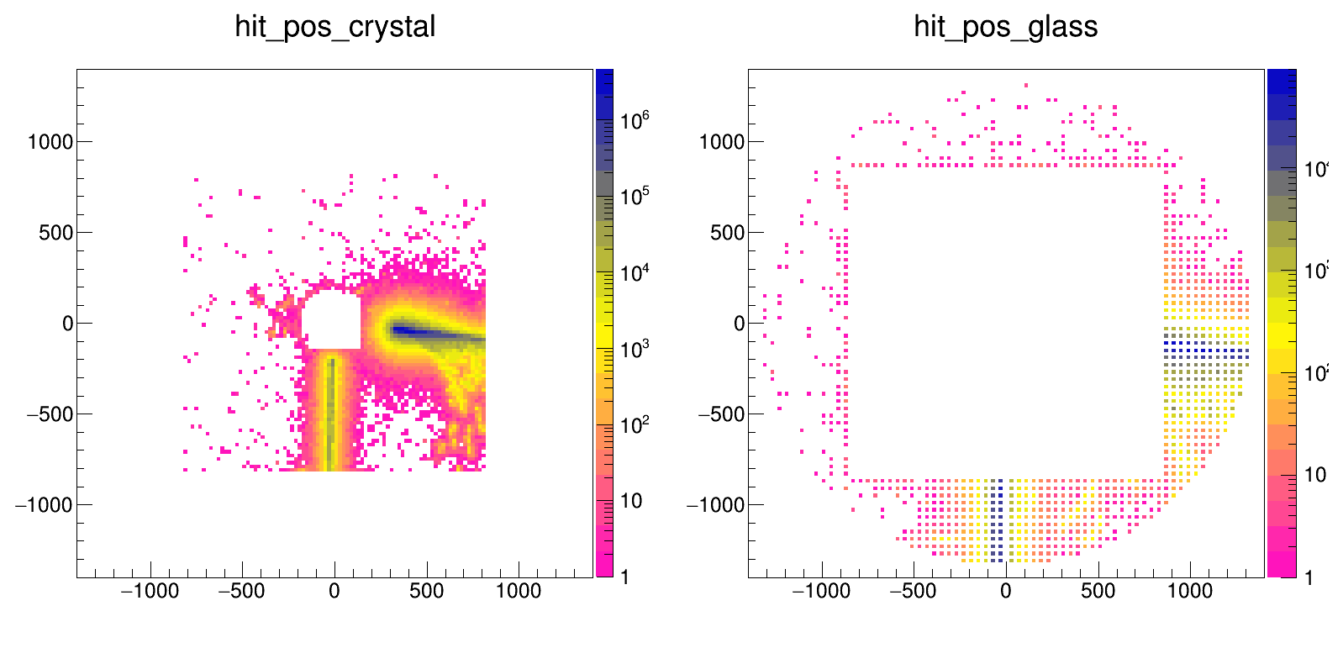
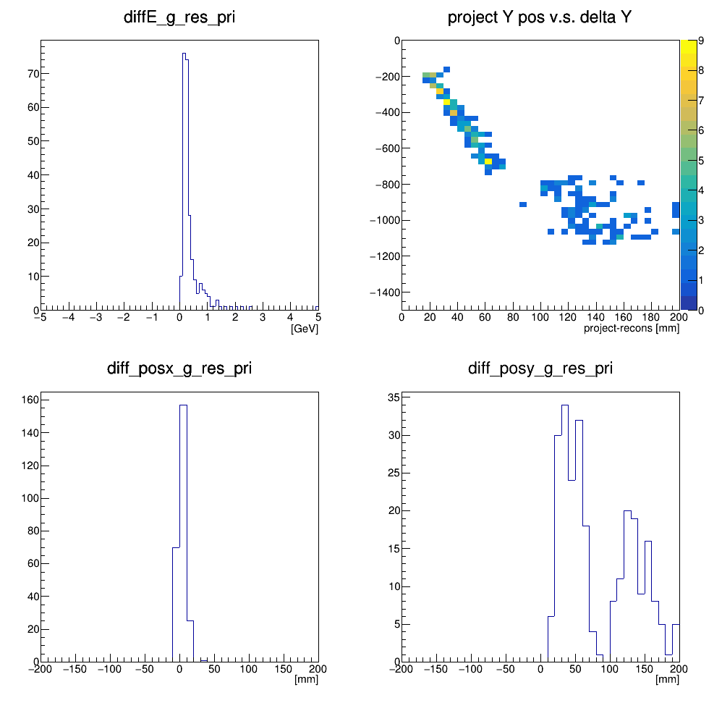

The upper 2 plots shows the hits distribution of the emcal. From which, we can find the hit x position of primary photon is really close to the 0. The lower 4 plots shows the reconstructed compare the primary one, the difference is calculated from the primary - reconstructed. We can find the x component is really good since the primary photon don’t have the significant inclined angle in x component. And there shows 2 peak in the y component, one is in the crystal region and the other is in the glass region. This shift in the crystal region is around 2 crystal width and the 4 glass width in the glass region.

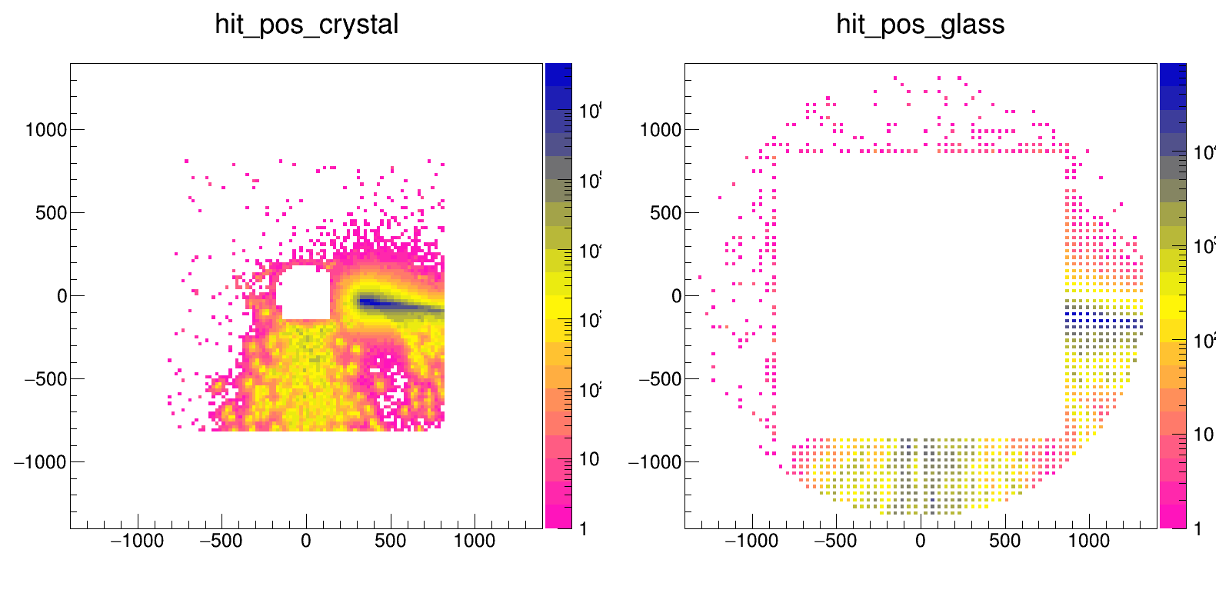

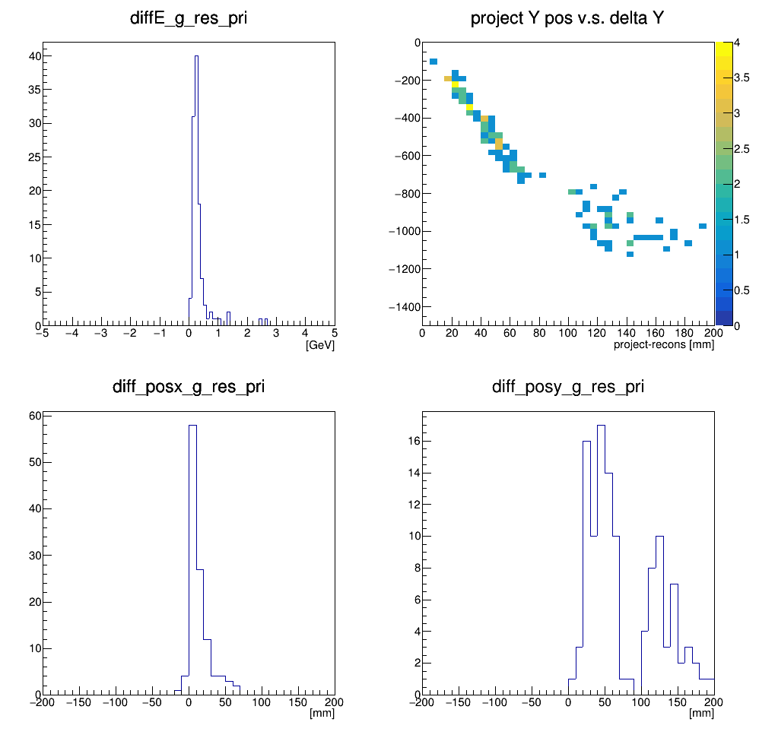

The upper 2 plots shows the hits distribution of the emcal. The lower 4 plots shows the reconstructed compare the primary one, the difference is calculated from the primary - reconstructed. We can find the similar result from the previous one, but the difference of the X position reconstructed and the primary, left lower plot, is not symmetry, which seems caused from the hit distribution of the primary photon, photons hit on the X>0 region is not equivalent to the X<0 region, I will check about that.

